Short term lesson plan

Unit of a long term plan:  Unit 3 Our Countryside |  |  |  | School:
Date: |  |  |  | Teacher's name:
CLASS: 6th |  |  |  | Number present: | absent:
Lesson title |  | My country: National parks.
Learning objectives(s) |  | 6.1.3 respect differing points of view  6.4.6 recognise the attitude or opinion of the writer on a growing range of unfamiliar general and curricular topics, including some extended texts  6.6.14 use prepositions to talk about time and location; use prepositions like to describe things and about to denote topic; use prepositions of direction to, into, out of, from, towards on a limited range of familiar general and curricular topics familiar general and curricular topics  6.3.7 use appropriate subject-specific vocabulary and syntax to talk about a limited range of general topics
Lesson objectives |  | All learners will be able to:  - Identify the theme, new words and use them as the basis for discussion.  - Demonstrate basic knowledge for usage of the Present Tenses.  - Identify some of the main ideas and specific information correctly in text and use some target vocabulary correctly in response to prompts  - Offer constructive peer-feedback using rubric.  Most learners will be able to:  - Select, compile, and synthesize information for an oral presentation  - Provide a point of view in conversations and discussions;  - Identify most of the main ideas and specific information correctly in text and use a range of target vocabulary correctly in response to prompts  Some learners will be able to:  - Respond to and discuss the reading passage using interpretive, evaluative and creative thinking skills.  - Apply the correct form of the Present Continuous Tense in the context;  - Identify all of the main ideas and specific information correctly in text and use a range of target vocabulary correctly in response to prompts
Level of thinking |  | Higher order thinking skills (according to the revised Bloom's taxonomy).
Assessment criteria |  | - Read the given text and identify the general information.  - Demonstrate skills of organizing and expressing ideas accurately.  - Illustrate a viewpoint in a discussion.
Target language |  | National park, landscape, animals and plants, environment, species, willows, honeysuckles, vertebrates, paradise, eagles, attractions, sand dune, organ, signs, the paintings on the rocks, archaeological sites.
Values links |  | Responsibility, Global Citizenship, love too flora and fauna
Cross-curricular links |  | Natural Science, Social Science.
Previous learning |  | Vocabulary relating to people's activity and animal's life and actions
Plan
Planned timings | Planned activities (replace the notes below with your planned activities) |  |  |  |  |  | Resources
Start | Pre-learning (W)  Teacher greets the class and suggests playing the game to the learners. Teacher explains the rules for this game.  - Game “Back to Blackboard” Rules:  One person stands back to the picture of an animal;  Classmates should not name the animal;  Classmates can give some associations with the animal’s name;  Classmates can mime the animal’s name;  Classmates can sing some lines from the songs.  - Teacher can organize competition between two teams, when the first team mimes, the second should guess the word  The teacher introduces the objectives of the lesson.  Teacher informs that they are going to take a new material about national parks and asks Sts. if they know some parks in Kazakhstan.  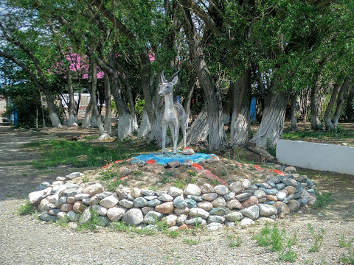 |  |  |  |  |  | Slide (useful phrases)  Pictures  Presentation
Main part | The main part of the lesson.  - Teacher suggests doing a translation exercise connected with a popular national park. This task should be done in pairs or groups.  Altyn-Emel "is a state national natural park in the valley of the Ili river on the territory of the Almaty region of Kazakhstan. The park was organized on April 10, 1996. The purpose of the park is to preserve the unique natural complex, archaeological, historical and cultural monuments, rare and endangered plant and animal species, and develop ecological tourism. The flora of the park numbers about 1800 species of plants, among them 21 species are included in the Red Book of Kazakhstan. The habitat of 1658 species of invertebrates has been established. The park is inhabited by 78 species of mammals, 260 species of birds, 25 species of reptiles, 4 species of amphibians, 26 species of fish.  Алтын-Емел »- бұл Алматы облысы аумағындағы Іле өзені аңғарындағы мемлекеттік ұлттық табиғи парк. Саябақ 1996 жылы 10 сәуірде ұйымдастырылды. Саябақтың мақсаты бірегей табиғи кешенді, археологиялық, тарихи және мәдени ескерткіштерді, сирек кездесетін және жойылып бара жатқан өсімдіктер мен жануарлар түрлерін сақтау және экологиялық туризмді дамыту болып табылады. Саябақтың флорасы өсімдіктердің 1800-ге жуық түрін құрайды, оның 21 түрі Қазақстанның Қызыл кітабына енгізілген. Омыртқасыздардың 1658 түрінің тіршілік ету ортасы белгіленді. Саябақта сүтқоректілердің 78 түрі, құстардың 260 түрі, бауырымен жорғалаушылардың 25, қосмекенділердің 4, балықтардың 26 ​​түрі мекендейді.  What other national parks do you know?  This is a list of national nature parks in Kazakhstan:  - Altyn-Emel National Park  - Bayanaul National Park  - Burabay National Park  - Buiratau National Park  - Charyn National Park  - Ile-Alatau National Park  - Karkaraly National Park  - Katon-Karagay National Park  - Kokshetau National Park  - Kolsay Lakes National Park  - Sayram-Ugam National Park  - Zhongar-Alatau National Park  - Working with the text "Altyn - Emel National Park". Read the text and do ex. 1 - 2. Fill in a table:  Animals (fauna) Plants( flora)  1. 1  2. 2.  3. 3.  4.  5.  - What can you say about flora and fauna of this park?  - Flora and fauna here is unique.  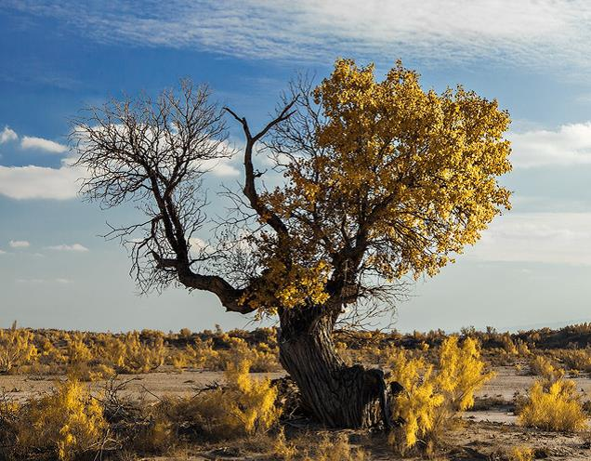  Taranga tree  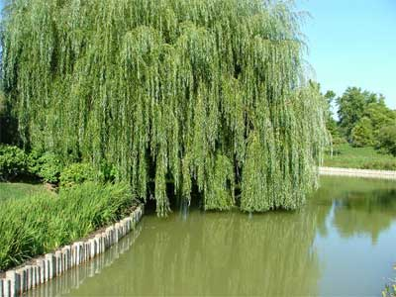 Willows  Honeysuckle  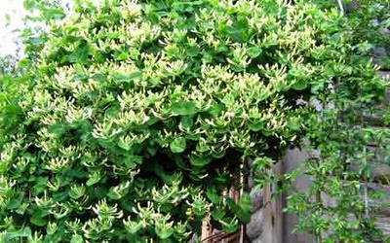  3 groups will speak about unusual plants.  Ex. 4 - 5 p. 40. |  |  |  |  |  | Whiteboard  Writing  Worksheet  invertebrates, reptiles, amphibians, mammals, rare and extinct  A list  Student's Book p. 40  A table  Pictures  Posters
End | Home task. Write essay about one national park.  Students express their attitude to the lesson and give self-assessment using the method: “Six thinking hats”:  - Green: How can you use today's learning in different subjects?  - Red: How do you feel about your work today?  - White: What have you leant today?  - Black: What were the weaknesses of your work?  - Blue: How much progress have you made in this lesson? (Now I can, I still need to work on, I've improved in, Today I learnt... )  - Yellow: What did you like about today's lesson? |  |  |  |  |  | Slide (Homework)  Slide "Six thinking hats"  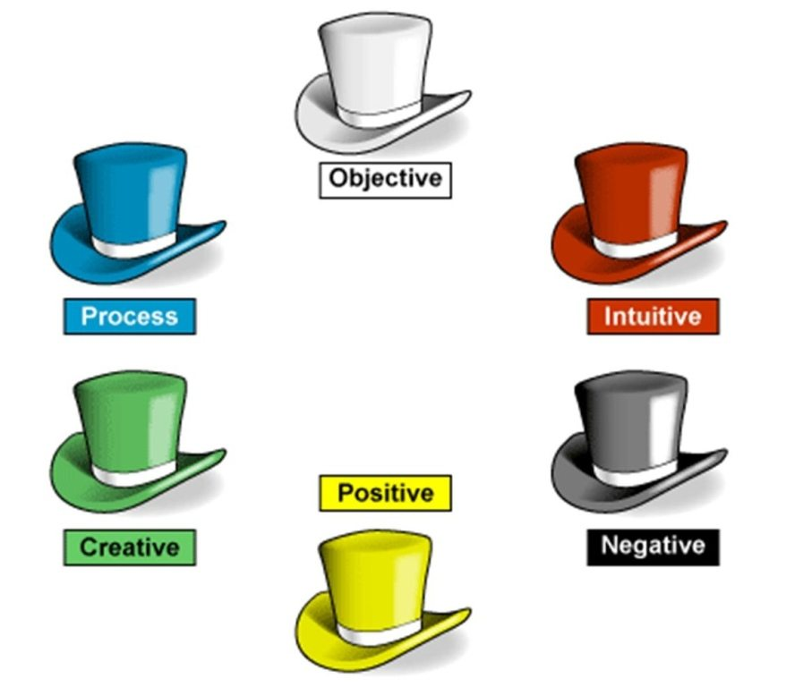
Additional information
Differentiation – how do you plan to give more support? How do you plan to challenge the more able learners? |  |  | Assessment – how are you planning to check learners’ learning? |  |  | Health and safety check
Differentiation can be achieved through content (Based on the theory of Multiple Intelligences different tasks are used with the same text).  By support:  Less able learners will be supported through step-be-step instructions, glossaries, thinking time.  By task:  For more able learners additional leveled tasks are offered. |  |  | Assessment criteria:  - Read the given passage and identify the general information.  - Demonstrate skills of organizing and expressing ideas accurately.  - Illustrate a viewpoint in a discussion.  Descriptors:  A learner  - reads the text for global understanding;  - selects meaningful information, constructs the answer;  - presents information in the group discussion.  - evaluates the peers’ answers.  Teacher's observation using observation checklist (Appendix 2 - reference to the resource "Literature Circle Role Sheets" by Christine Boardman Moen. p.28) and monitoring.  Self-assessment. |  |  | Health saving technologies.

Appendix1
Teacher observation checklist

Student's name ________________________________________

Positive Aspects
- Completed the individual role-card.
- Used extracts from the text to support his/her ideas.
- Asked open-ended questions.
- Listened while others talked.
- Encouraged peers to share their ideas.
- Added his/her own comments and ideas to other student's comments and ideas.
Negative Aspects
- Didn't complete the individual role-card.
- Didn't appear to be listening or interrupted when others were speaking.
- Did not use text to support his/her opinions.
Comments ___________________________________________________

Student Self-Assessment Checklist Student
Name: ________________________
Date: ______________________ Think about how well you are working in your group.
Place a check mark beside the skills you demonstrate in your role.
I listen attentively to others.
I express my thinking clearly and concisely.
I take turns. I encourage participation of all group members.
I show respect for alternative points of view.
I disagree agreeably.
I synthesize information from others.
I analyze ideas of others.
I remember significant information.
I identify issues.
I make connections to prior knowledge and experiences.

