План урока по биологии на английском языке
Lesson № 1 Grade: 9^{h}

Theme: ‘Микроскоп.’ \ ‘ The Microscope’

Цели обучения, которые необходимо достичь на данном уроке: развитие навыков говорения; введение нового лексического материала и закрепление в речи;

Цели:
Учащиеся смогут:
-знать значения новых лексических единиц в объёме 9 слов
Большинство учащихся будут уметь:
-заполнять пробелы необходимыми по смыслу словами
Некоторые учащиеся смогут:
-анализировать и составлять предложения

Методы: словесный, наглядно-иллюстративный, частично-поисковый.

Ключевые слова и фразы: 1 – eye piece 2 – arm or body 3 – revolving nose piece 4 – lens or objective 5 – clip 6 – stage 7 – coarse focus knob 8 – fine focus knob 9 – light or lamp

Оборудование: раздаточный материал; карточки с заданиями, интернет ресурсы, словари.
Steps

I. Приветствие. Эмоциональный настрой урока и актуализация знаний.

The teacher says: to watch the video and tell what it was about.
Students watch the video and tell what it was about.

-Определение темы урока: ‘The Microscope’
Work in 4 groups and write as many words as you can with the word ‘Microscope’.

-Совместная постановка целей урока.

II. Основная часть.
Задание №1.
The teacher says: Label parts 1 – 9 of the microscope using the words provided. Translate the new words. Students label parts and translate the new words.
Arm or body Clip Coarse focus knob Eye piece Fine focus knob Lens or objective Light or lamp Revolving nose piece Stage
Check the answers.
1 – eye piece 2 – arm or body 3 – revolving nose piece 4 – lens or objective 5 – clip 6 – stage 7 – coarse focus knob 8 – fine focus knob 9 – light or lamp
Оценивание по стратегии «светофор» Group work
Задание №2.
The teacher says: make a slide. (Place statements A – E in the correct order)
The students make a slide. (Place statements A – E in the correct order).

How to use a microscope
____________ the microscope slide ____________ your specimen on it on the stage. ____________ the ____________ in place ____________ the clips. Adjust the mirror ____________ lamp or turn on the light if this is built in to ____________ microscope. Place the smallest objective lens over the hole in the stage. This is the lowest power magnification lens. Looking from the side of the microscope, turn the coarse focusing ____________ to make the objective lens as close to the stage as ____________ Now look into the eyepiece lens. Turn the coarse ____________ knob until what you see is clear, always moving the stage and lens away from each other. ____________ the object is in focus, use the fine focus to ____________ the ____________ really clear.

WORD BANK: with focusing make and image knob slide using once possible the hold place

The teacher says: fill in the gaps ‘how to use a microscope’.
The students fill in the gaps ‘how to use a microscope’.
- Gently lower the coverslip.
- Add a drop of stain.
- Lay them on the slide.
- Make sure the sample lies flat.
- Take a thin layer of cells.

The teacher says to answer the questions. The students answer the questions. 5 min
Answer the questions:
1. How do you put the cover slip on a slide without getting bubbles trapped under it?
2. How are air bubbles recognized when viewing a slide?
3. When you are focusing on an object, in which order should the three objective lenses always be used? Why?
4. When focusing on an object, why do we always start with the objective lens near the specimen and move the lens away?
5. Which is more powerful: a X10 eye-piece and a X20 objective or a X7 eye-piece and a X40 objective?
6. How should a microscope be a) carried safely? b) put away correctly?

Check the answers.
ANSWERS
Making a slide: E Æ C Æ D Æ B Æ A
Оценивание по стратегии «смайл» Individual work

Задание №3.
The teacher says: Look at the labeled diagram of the microscope and complete the sentences below with appropriate preposition.
Students look at the labeled diagram of the microscope and complete the sentences below with appropriate preposition.
Next to, below, at the top of, below, on, above, behind, below, in front of, between , at, on, below, at the bottom of, under.

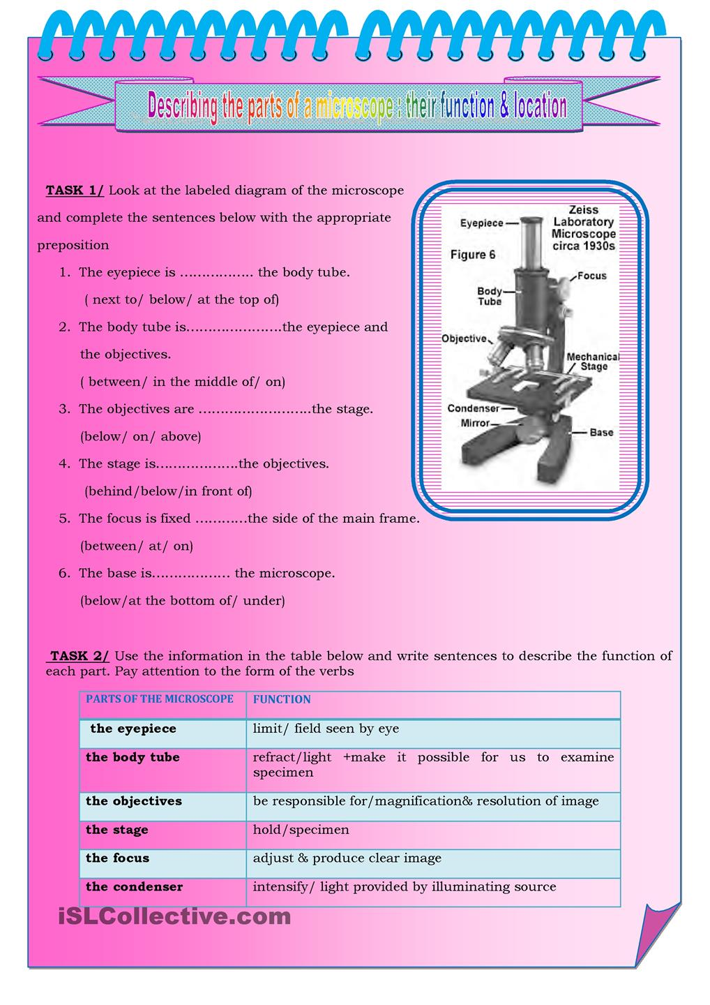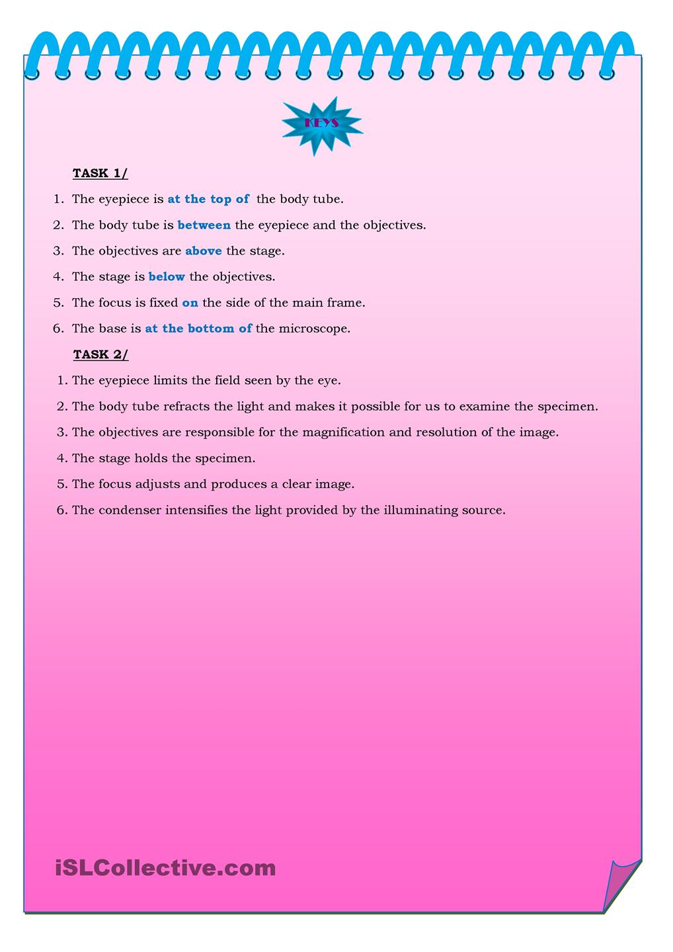

The teacher says: to use the information in the table below and write sentences to describe the function of each part. Pay attention at the form of the verbs.
The students use the information in the table below and write sentences to describe the function of each part. They pay attention at the form of the verbs.

Оценивание по стратегии «большой палец руки» Pair work

III. Заключение.
-Выставление оценок. The teacher says to the students their marks and explains why the get such marks.
-Рефлексия:

