Module 6: Healthy world  Theme: Save our animals |  | School: Bozoi secondary school
Date: 16. 03. 2021. |  | Teacher name: Syrlybayeva A
CLASS: 4 “A” |  | Number present: | absent:
Learning objectives(s) that this lesson is contributing to | 4.2.7.1 contribute a growing range of suitable words, phrases, and sentences including giving opinions during short pair, group and whole class exchanges;  4.4.1.1 plan, write and check sentences with support on a range of basic personal, general and some curricular topics;  4.4.2.1 begin to use joined-up handwriting in a limited range of written work;  4.5.1.1 use singular nouns, plural nouns – including some common irregular plural – and uncountable nouns, possessive ‘s/s’ to name, describe and label things;  4.1.3.1 understand the main points of short supported talk on an increasing range of general and some curricular topics;  4.2.3.1 give short, basic description of people and objects, begin to describe past experiences on an increasing range of general and some curricular topics;  4.3.2.1 read and understand with some support short simple fiction and non-fiction texts;  4.4.5.1 link with some support sentences using basic coordinating connectors
Lesson objectives | All learners will be able to:
 | recognise and use some target language correctly and show comprehension of some written and spoken familiar words in simple sentences To explore other subject areas (Geography); to I talk about endangered animals.
 | Most learners will be able to:
 | recognise and use most target language correctly and show comprehension of most written and spoken familiar words in simple sentences To explore other subject areas (Geography); to I talk about endangered animals.
 | Some learners will be able to:
 | recognise and use target language correctly with clear pronunciation and good comprehension of written and spoken familiar words in simple sentences To explore other subject areas (Geography); to I talk about endangered animals.
Previous learning | Learners will need to be familiar with/reminded of subject, the use of adjectives in describing objects and feelings, and the formation of Language in use: Can I have a packet of biscuits and a can of cola, please? Here you are! How much is that?
Cross-curricular links | Food and containers
ICT skills | Using videos & pictures, working with URLs
Plan
Planned timings | Planned activities |  |  | Smiles  Resources
Beginning the lesson | Organizational moment  Teacher greets students; students respond to greeting and take their places.  Hello boys and girls!  How are you?  What is the day today?  Warming up  “The circle of Joy”  First off all let’s dividing the class into 3 groups. Come here and take the cards in thread.  Dividing the class into 3 groups:  1-group: “Panda”  2-group: “Dolphin”  3-group: “Rhino”  The method is called “A, B, C, D”.  I’ll give you cards. There are new words of last lesson. Words have written in English you should choose wright version. If you’ll choose wright version, you have got points.  Video: Extinct and Endangered animals  - What about is this video?  - What types of animal do you see in the video?  - Can you name them?  New words  Panda – панда  Polar bear – полярлық аю  Dolphin – дельфин  Rhino – мүйізтұмсық  Gorilla – горилла  Green turtles – жасыл тасбақа  THE NOUN – ЗАТ ЕСІМ  Зат есім – заттардың, нәрселердің атын білдіретін сөз табы.  The noun – is a word expressing substance.  Зат есімдердің көпше түрінің жасалуы  Ереже Rules Жекеше түрі Singular Көпше түрі Plural  Зат есімнің көпше түрін жасау үшін түбірге –s (-es) жалғауы жалғанады. The plural of nouns is by adding the ending –s, (-es) to the singular a table a dog a cat two tables two dogs two cats  Зат есімдер in –ch, -s, -ss, sh, tch, -x әріптеріне аяқталса, -es жалғауы жалғанады. If the noun ends in –ch, -s, -ss, sh, tch, -x the plural is formed by adding –es to the singular a dish a match a class a box two dishes two matches two classes two boxes  Зат есім –у әрпіне аяқталып, оның алдында дауыссыз тұрса –es жалғауы жалғанады да, -у әрпі –і әрпіне айналады. If the noun ends in –y preceded by a consonant, -y is changed into before -es a story a city two stories two cities  Practice  Animal + s = __________  Dolphin + s = __________  Panda + s = ____________  polar bear + s = ________  gorilla + s = ____________  Work with book  Exercise: 26. Page: 92  What animal am I? Read and write. Explain the activity. The pupils look at the pictures, read the sentences and say the names of the animals. Allow the pupils some time to complete the activity. Check their answers.  Answer key  rhino  dolphin  panda  polar bear  gorilla  Then individual pupils read out the texts.  Limbering up  “Animals”  Work with workbook  Exercise: 15. Page 64.  Read and match.  The method is called “Think, join, inform”  I’ll give you pictures and definition about animals. Let’s make posters and to defend.  Formative assessment  Task 1. Write singular and plural of the words.  Singular Plural  Bear  Tigers  Rabbit  Bird  Animal |  |  | Video  Stickers  Video  Worksheets  Pupils book p 92  Audio  Video  Activity book
Ending the lesson | Reflection  The method is called “Reflectively target”  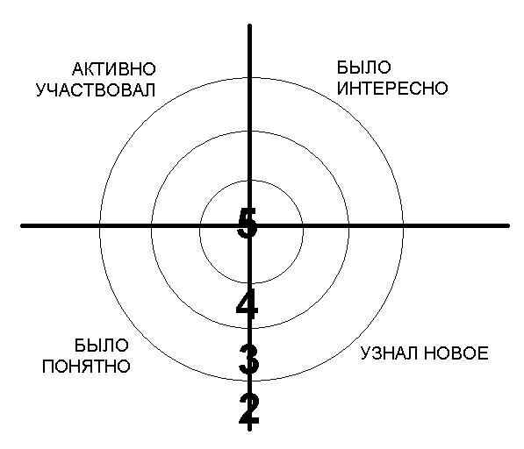  Home work: To learn by heart new words | ACTIVITY BOOK (Optional)

