# 7 form Summative assessment (unit “Holidays and Travel)

**Task 1 (3 points).** Listen to the conversation twice and answer the questions.

* 1. What this talk is about?
  2. How many people are in a talk?
  3. What preferences do a caller request?

**Task 2 (5 points).** Choose the right answer A, B, C or D.

***Example:* 0. What date is flight reservation going to be?**

* + 1. 21 B) 22 **C) 23** D) 24

1. **What is the man's destination?**
   1. Salt Lake City, USA
   2. New York City, USA
   3. Helsinki, Finland
   4. Stockholm, Sweden
2. **When is the man's departure date?**
   1. the twenty-first
   2. the twenty-second
   3. the twenty-third
   4. the twenty-fourth
3. **What is the flight number for the second half of his journey?**

A) 555 B) 90 C) 1070 D) 830

1. **How long is the man's layover between flights?**
   1. less than an hour
   2. less than two hours
   3. less than three hours
   4. more than three hours
2. **What request did the man make regarding his flight?**
   1. He asked for a specially-prepared dinner.
   2. He wanted an aisle seat.
   3. He requested a bassinet for his baby.
   4. He asked for a seat near the front of the plane.

**Task 3 (4 points).** Write a postcard to a friend about your town. Use **modal verbs*, Pr. Perfect and Past Simple***

***Example of the postcard Sample sheet for Postcard***

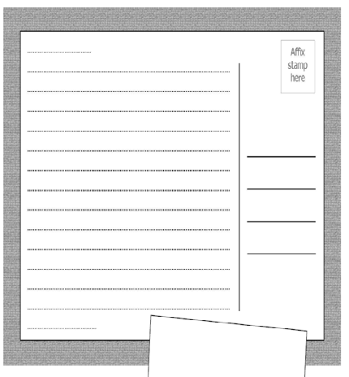 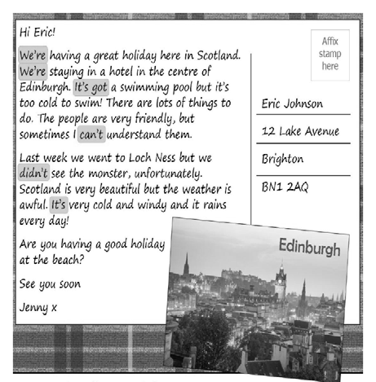

**Task 4 (2 points). Complete the sentences.**

1. He … **(can’t/couldn’t)** open the window as it was hot.
2. Interpreters … **(may/must)** translate without dictionaries.
3. … **(Can/May)** I use me your bike for today?
4. Take an umbrella. It … **(may/can)** rain.

**Task 5 (6 points). Complete the sentences.**

1.  I … (never/ be) to the USA. I … (want) to go there last summer but I couldn’t.

2.  He …. (live) in this street all his life.

3.  His father … (come back) to London last Sunday.

4.  Yan …. (write) a letter to Nick two days ago.

5.  He …. (send) his letter yesterday.

6.  They  ….  (just/ buy) some postcards.

***Total – 20 points***