SHORT TERM LESSON PLAN FOR 5TH FORM

LESSON 3: Unit 5. Creativity. Types of films |  |  | SCHOOL-LYCEUM №64
DATE: 17.01.2019 |  |  | TEACHER NAME: Yedilova Gulsim Tuleevna
CLASS: 5 M |  |  | NUMBER PRESENT: 12 |  | ABSENT:0
Learning objective(s) that this lesson is contributing to: |  | 5.S1 Ask simple questions about a limited range of general topics.  5.S7 use new vocabulary to talk about types of films  5.L4 understand the main points of supported extended talk on a range of general and curricular topics
Lesson objectives: |  | All learners will be able:  - To speak about the types of films  - To use new vocabulary  - To revise Present Simple  Most learners will be able:  - To put the words in order correctly  - To talk in pairs about types of films  - To recognize the types of films by pictures  Some learners will be able:  - To speak about types of films  - To describe films using new words  - Correct and find mistakes
Language objective: |  | - Word order; present tenses
Assessment criteria: |  | - Peer assessment
Value links: |  | - Appreciate art
Cross curricular links: |  | - Literature, history
ICT skills: |  | - PPT, Interactive board, i-ebook Excel 5
Previous learning
PLAN
Planned timings | Planned activities |  |  | Aims |  | Formative Assessment | Resources
Beginning  3min  5min  6 min  Middle  10min  5 min  2 min  5 min  4 min  End  2min | Organizational moment  Good afternoon, pupils!  How are you?  Thanks. Sit down, please.  Well, I want to distribute pictures and divide into two groups using pictures.  1-group “Cartoons”  2-group “Films”  How is your mood? Look at the blackboard and show your feelings and mood by the drawing the sun.  Let’s draw the face of the sun  -How do you think is our sun happy or sad?  Well ,let’s begin our lesson with good mood  Game: “Can you guess the name of film?”  -How do you think what about our today’s  lesson ?  T. Introducing the lesson objectives. Now boys and girls the theme of our new lesson is Types of films. Today we are going to speak about the types of films using adjectives.  Checking-up the home-task:  Suggested Answer Key  Centaurs were half human half bird. (half human half horse)  Centaurs lived by the sea. (in the mountains and forests)  The Phoenix was a golden bird with a red tail. (red bird with a golden tail)  The Phoenix was from Greece. (India and Egypt)  The Chimera had three heads from three different animals:a lion, a dog and a snake. (lion, goat, snake)  It could breathe ice. (fire)  Lead-in  Group work  Learners say what their favourite kind of film is e.g. comedy, cartoon, adventure, horror, science fiction and so on and say why.(I)They should give two examples: name of films and characters.  Learners are asked when they use capital letters  a word begins with a capital letter when it goes either at the beginning of the sentence, or it is a proper noun, i.e.name  e.g Harry Poter,Sherlock Holmes,Agent 007,Dracula  Task 1  Match the titles to the types of films. Make sentences.  • Go through the list of film types and explain/elicit  the meanings of any which are unknown.  • Ss complete the task. Check Ss’ answers. Point out  that some types of films do not take the word ‘film’  after them (e.g. western, horror, musical etc).  Answer Key  2 j 4 i 6 c 8 h 10 d 12 f  3 b 5 e 7 k 9 a/g 11 g/a  ‘Cowboys’ is a western (film).  ‘Mickey Mouse’ is an animated cartoon (film).  ’Detective Mallory’ is a detective film.  ‘Dracula’ is a horror (film).  ‘Funny Faces’ is a comedy (film).  ‘Space Station’ is a science-fiction film.  ‘Love Story’ is a romance.  ‘The Explorers’ is an action/adventure film.  ‘Queen Victoria’ is a historical film.  ‘The Search’ is an adventure/action film.  ‘Let’s Dance’ is a musical.  Wake uр  physical exercise with a song and dance  “I am a Gummy Bear”  Task 2 Pair work.  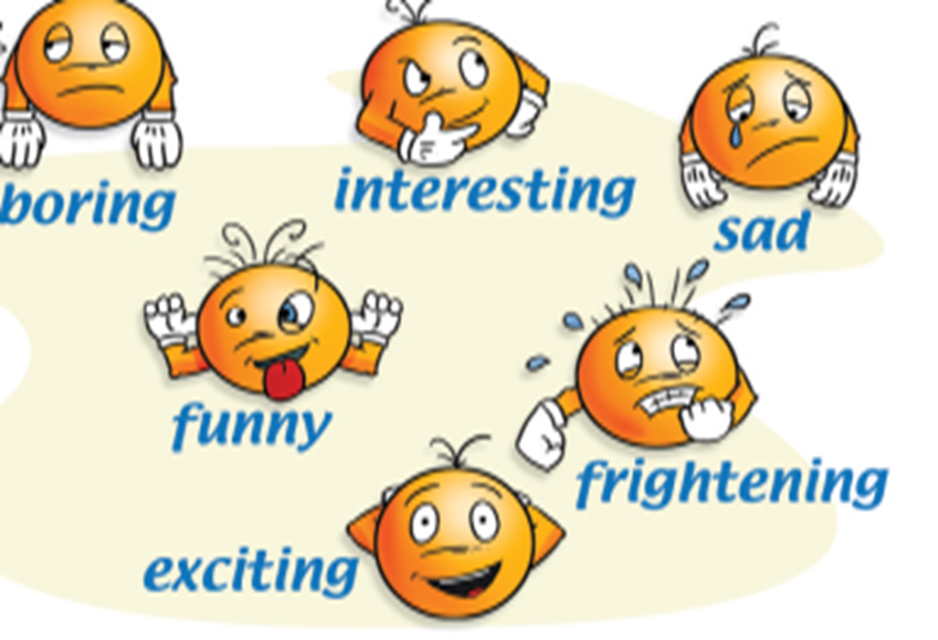  -talk about types of films, about your taste in films  -Use the adjectives to talk about the films in pictures  Suggested Answer Key  A: ‘Cowboys’ was on TV last night.  B: Really? What was it like?  A: It was very interesting.  A: ‘Mickey Mouse’ was on TV last night.  B: Really? What was it like?  A: It was very funny.  A: ‘Detective Mallory’ was on TV last night.  B: Really? What was it like?  A: It was very interesting.  A: ‘Dracula’ was on TV last night.  B: Really? What was it like?  A: It was very frightening.  A: ‘Funny Faces’ was on TV last night.  B: Really? What was it like?  A: It was very funny.  A: ‘Space Station’ was on TV last night.  B: Really? What was it like?  A: It was very frightening.  A: ‘A Love Story’ was on TV last night.  B: Really? What was it like?  A: It was very sad.  A: ‘The Explorers’ was on TV last night.  B: Really? What was it like?  A: It was very boring.  A: ‘Queen Victoria’ was on TV last night.  B: Really? What was it like?  A: It was very interesting.  A: ‘The Search’ was on TV last night.  B: Really? What was it like?  A: It was very exciting.  A: ‘Let’s Dance’ was on TV last night.  B: Really? What was it like?  A: It was very exciting.  Task 3  Game: Team A – Team B  Task 4  Listening  Listen to Kim talking to Steve about a film they are planning to see and choose the correct answer A, B or C  e.g. At the weekend Kim was ...  A at home.  B at a party.  C in the country.  1 Kim and Steve decide to see a(n) …  A comedy film.  B action film.  C horror film.  2 The name of the film is …  A Yes Man.  B Yes Woman.  C No Man.  3 They decide to see the film at …  A the Palace.  B the Empire.  C the Majestic.  4 The film starts at …  A 5:00.  B 6:30.  C 7:00.  5 Kim and Steve decide to meet …  A outside the cinema.  B at the sweet shop.  C at Steve’s house  Answer Key: 1.A 2.A 3.B 4.C 5. B  All learners put stickers into three groups according their  understanding of the lesson  Feedback “Open microphone”   1.What makes you proud of yourself?  2. What task was easy and what was difficult at the lesson?  3.Who was very active in your group?  4. Do you like this lesson?  Homework: to learn new vocabulary, w.b p.37 |  |  | Formation of a positive image  “Stop -frame method”  To consolidate information from a text  “Cluster”  To present types of films  Descriptor:  -Apply the new vocabulary and match the pictures with the correct answers.  To practise agreeing/disagreeing about pupil’s taste in films  To present adjectives and practice using  them to describe films  “Open microphone”  Descriptor:  A learner  Understands  Translates the given words  Completes the sentences  To develop intellectual skills in students  To consolidate the introduced material  To develop students listening skills  Descriptor:  A Learner  -chooses the correct answer |  | “Good”  “Well done”  Peer assessment  Descriptor:  1. Read and find out 2 mistakes in the sentences  Group assessment  Descriptor  A learner  • uses vocabulary and grammar while speaking;  • gives feedback to his/her partner’s answers’;  “Well done”  “Excellent”  Peer assessment  Peer assessment  Group assessment  Self assessment | Divide into groups with the pictures of cartoons and films  Poster, markers  Video about films  https://www.youtube.com/watch?v=CEvlUtQ8a_M  Excel  i-ebook  Poster, markers  Interactive board  Excel  i-ebook  Interactive board  Excel  i-ebook  Interactive board  Excel  i-ebook  ICT, pictures,  audio-player ,A4 papers  stickers

Additional information
DIFFERENTIATION – how do you plan to give more support? How do you plan to challenge the more able learners? | ASSESSMENT – how are you planning to check learners’ learning? | Cross-curricular links
- More support can be given at the start and in middle of lesson by providing less-able learners with story vocabulary in a word list so they can read examples of words seen or heard. | - Monitor groups of learners as they agree on discussion. Do they take turns to speak? Do they contribute appropriate language for discussion | - Literature  - History

Reflection  Were the lesson objectives/learning objectives realistic?  What did the learners learn today?  What was the learning atmosphere like?  Did my planned differentiation work well?  Did I stick to timings? What changes did I make from my plan and why? | Use the space below to reflect on your lesson. Answer the most relevant questions from  the box on the left about your lesson.
Summary evaluation

What two things went really well (consider both teaching and learning)?

1:

2:

What two things would have improved the lesson (consider both teaching and learning)?

1:

2:

What have I learned from this lesson about the class or individuals that will inform my next lesson?

