**ПЛАН - КОНСПЕКТ УРОКА АНГЛИЙСКОГО ЯЗЫКА В 5 КЛАССЕ ПО ТЕМЕ «THERE IS NO PLACE LIKE HOME»**



Методическая разработка урока английского языка в 5 классе  по теме «My Flat»

Ларионова Марина Владимировна

учитель английского языка высшей категории ВКО, г. Усть-Каменогорск, КГУ, «Школа-лицей № 11»

**Аннотация**

Бесінші сыныпта "There is no place like home" тақырыбы бойынша ағылшын тілінің ашық сабағының әдістемелік әзірлемесі. Осы сабақ оқушылардың сөйлеу үлгілерін сауатты пайдалану дағдыларын және оқылған тақырып бойынша сөйлеудегі грамматикалық құрылымын қалыптастыруға бағытталған қорытынды сабақ болып табылады.

Методическая разработка открытого урока английского языка в пятом классе по теме "There is no place like home". Данный урок является завершающим и направлен на формирование навыков учащихся грамотного использования речевых образцов и грамматических структур в речи по изученной теме.

Methodical development of the open lesson of the English language in the fifth class on the topic "There is no place like home". This lesson is the final and is directed on formation of skills of the pupils of competent use of speech and grammatical structures in a speech on the studied topic.

**Разработка открытого урока по английскому языку на тему: "There is no place like home" (5 класс)**

Цель: Формирование навыков учащихся грамотного использования речевых образцов и грамматических структур по теме ‘My Flat’.

Задачи: *Образовательные:*

продолжить формировать лексические навыки;

совершенствовать навыки аудирования, диалогической и монологической речи;

закреплять грамматические навыки и умения употребления в речи

оборота there is/ there are;

способствовать выработке умений формировать устные высказывания с опорой на источник информации, на свой жизненный и речевой опыт.

*Развивающие:*

развивать навыки разговорной речи с использованием лексических и грамматических структур на основе пройденного материала;

формировать у учащихся навыки понимания устной иноязычной речи.

*Воспитательные:*

воспитывать у учащихся чувства любви и ответственного отношения к своему дому, родному очагу;

формировать положительные черты характера: доброжелательность, активность, толерантность, умение уважать мнение других и выслушать собеседника; поддерживать интерес к изучению английского языка.

Тип урока: комбинированный

Оборудование и оснащение урока: мультимедийный проектор, интерактивная доска, компьютеры, электронные пособия, презентация к уроку, видеоматериал, раздаточный материал.

Ходурока.

1. Организационный момент. Organization stage.

Good morning, children! I’m glad to see you again. How are you? What date is it today? What day is it today? Let’s start our work.

1. Речевая и фонетическая зарядка
2. Language skills. Let’s speak about houses and rooms. I live in a flat…

* Have you got a flat or a house?
* How many rooms are there in your flat?
* Have you got a living room in your flat? Kitchen? …
* Is there a computer in your bedroom? a TV set? …
* How many windows are there in your bedroom?
* Do you like your flat?

1. Phonetic drill: Let’s sing a song: The House Song

(<http://www.youtube.com/watch?v=DR5qPNPGCmY>)

1. Transcription. Name the sound, check and translate.

( <http://www.macmillanenglish.com/methodology/phonetic-chart.htm>)

III. Тема, цели урока. Introducing of the theme, objectives.

I think you like the flat, where you live. Today we will be speaking about our homes, flats, furniture. We will remember all words what we know about your houses. The theme of our lesson is «My flat». They say “There is no place like home.” Аэтозначит: Вгостяххорошо, продолжите…

1. «There is no place like home»

2. «East or West - home is best»

3. «Home, sweet home»

4. «Home is where the heart is» (Слайд с пословицами)

IV. Проверка домашнего задания. Checking home work.

1. Vocabulary. Look at the slides and tell me:

* What room is this?
* Is this a kitchen?
* Is this a living-room or bedroom?
* It’s a dining room, isn’t it?

1. Match the words and the sentences.

We sleep in this room It’ a bedroom

We cook dinner in this room It’ a kitchen

We learn our lessons in this room It’ a study

We relax and watch TV in this room It’ a living-room

We have lunch in this room It’ a dining room

We take a bath in this room It’ a bathroom

We wash up dishes in this room It’ a kitchen

V. Чтение. Reading. Text: Rooms in the flat. Choose the card you want, read the text. The other must guess the room.

**1**.This room is very interesting. There is a soft carpet on the floor. There are many toys on the carpet and many books on the shelves. There is one bed, a table, a wardrobe and some small chairs in the room. There are four pillows on the bed. There is a computer on the table.We learn our lessons in this room. What room is this?

**2**. This room is not very big. It hasn’t windows. It’s walls are white. There is a sink on the left.

There is a big mirror on the wall. There are small shelves near the mirror. There is a blue rug on the floor. We wash our hands and face in this room. And we like to take a bath or a shower in this room too. What room is this?

**3.** This room is very nice. There is a fridge, a cooker, a sink, a dishwasher and a washing machine in this room. There is a table in the middle of this room, there are many chairs round the table. There is a cupboard on the wall. We usually cook dinner in this room. And we have breakfast or lunch in this room. What room is this?

**4.** This room is large and beautiful. There is a sofa and two armchairs in the room. A small table is near the sofa and armchairs. On the wall over the sofa there is a picture. The TV set is in front

of the sofa. There is a red carpet on the floor. There are two large windows and five green flowers in the room. We like to relax, watch TV and talk to our family.

1. Физминутка. Relaxation. Выполнение физических упражнений с исполнением песни.

Let’s have a rest. Let's go in this room. What room is this? Now, let’s sing a song and do exercises all together.1) Stand up 2) shake your legs and hands 3) inhale — exhale 4) do exercises 5) step around 6)bend **«**Gummy Bear - Bubble up with lyrics» (<http://www.youtube.com/watch?v=IAIMBQ7D82o>)

VI. Аудирование. Listening. Now I invite you in the Robinsons’ house. Let’s watch and listen.

Answering the guestions:

* How many rooms are there in the Robinsons’ house?
* What are they?
* How many bedrooms has their family?
* What is there in the Robinsons’ kitchen?
* Where is Mr. Robinsons? … Julie? … Ms. Robinsons?
* What Mr. Robinsons is doing?

Video: Homes in Britain. ( <http://www.youtube.com/watch?v=Q1V9qegtglw>)

VII. Работа над диалогом. Speaking.

Now, let’s talk. Choose the picture of room you like. And make up the dialogue:

* What room do you like? I like a … because I relax in this room.
* What room is this? This is a …
* What is there in your room? There is a … in this room.
* What about you? I like … because …

VIII. Повторение грамматики. Grammar aspect.

* Grammar: THERE IS / ARE (повторение, slide)
* Working with a computer: Click the correct word. (flash-game, Way Ahead-I)
* Fill in there is / there are (в форме презентации)

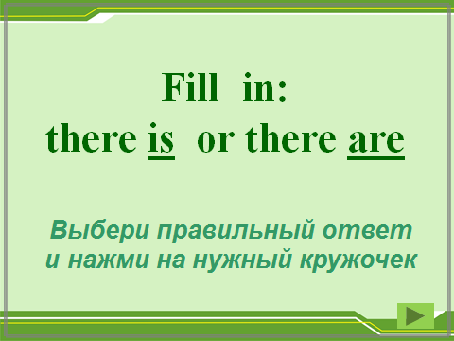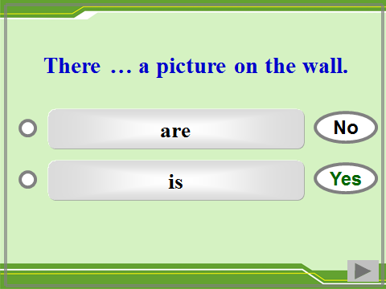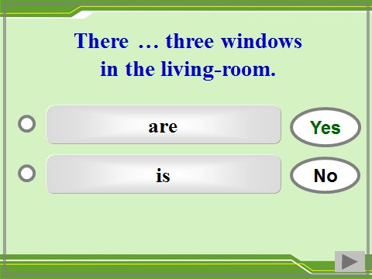

IX. Домашнее задание. Home assignment. Write the words. P 124 ex. 3

X. Итог. Now, let’s make the sums of our lesson. Today at the lesson we’ve repeated all we know about the homes.You’ve worked well. Your marks are…

XI. Reflection. So, how did you like this lesson? O’K, thank you for your hard work. The lesson is over. Good bye!!!