Lesson plan

Unit 2 Communication&Technology |  |  |  |  | School: 28
Date:19.10 |  |  |  |  | Teacher name:Kamesheva Marzhan
CLASS: 7 |  |  |  |  | Number present: |  |  | absent:
Lesson title |  |  | Debate about technologies
Learning objectives(s) that this lesson is contributing to (link to the Subject programme) |  |  | 7. R1 understand with little support specific information and detail in short , simple texts on a limited and curricular topics  7.W2 write with support a sequence of short sentences in a paragraph on a limited range of familiar general topics  7.L1 listen with support for specific information  and ideas on a limited range of familiar general topics
Level of thinking skills |  |  | Knowledge, Understand, Application
Lesson objectives |  |  | All students will be able to:  Understand the texts  Most of the students will be able to:  Give answers ,using topical vocabulary  Some of the students will be able to:  Give feedback to their classmates about the topic
Assessment criteria |  |  | -Study and use in the sentences topical vocabulary
Values links |  |  | Friendly communication with each other, support and listen to others carefully, don’t break classroom rules
Cross-curricular links |  |  | Technology
Previous learning |  |  | Technology&Communication
Plan
Planned timings | Planned activities (replace the notes below with your planned activities) |  |  |  |  |  |  |  | Resources
Start | Teacher’s activities |  |  |  |  | Students’ activities
 | Good day students! Today the theme of our lesson: Debate about technologies. Today in our lesson we’ll  - read for specific information  - listen for specific information  and ideas  - make a poster  Warm-up  Guess the word  -We use it to print  Documents  -We use it to move around  the screen  - We use it to make a copy  of photo  -We use it see files  -We use it to type  Task 1. Watching the video  Read the text and study new words |  |  |  |  | -printer  -mouse  -scanner  -screen  -keyboard  tool инструмент  topic тема  chat Беседовать,разговаривать  harmful вредный  damage повреждать,портить  distract отвлекать  neglect пренебрегать  sensibly разумно,благоразумно
Task 2. Give answers
1.What advantages does Wendy
mention?What examles does she give?
2.What are the disadvantages?What examples does Wendy give?
3.What is Wendy’s recommendation?

 | Task 3. Listening  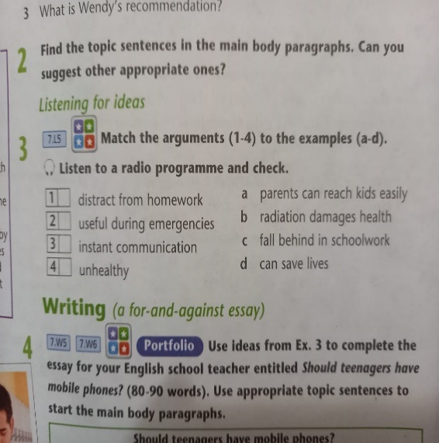 |  |  |  |  | emergency-чрезвычайная ситуация  instant- мгновенный  fall behind- отставать  Check yourself  1.C  2.D  3.A  4.B
 | Task 4.Read the sentences about smartphone etiquette and mark the sentences V (I agree) or X (don’t agree).Tell the class. Give reasons
Task 5
Make a poster
1.Advantages/disadvantages of using internet
2. Advantages/disadvantages of using mobile phones

End | PLENARY  - Come back to the lesson objectives and summarize with students if they met the lesson objectives. Encourage them to give the feedback.  What have you learnt at the lesson today? Tick the gap.  - I can use topical vocabulary  - I know new words  - I can make a poster
Additional information
Differentiation – how do you plan to give more support? How do you plan to challenge the more able learners? |  |  |  | Assessment – how are you planning to check learners’ learning? |  |  | Health and safety check
Task 1 is Differentiation task by outcome for more able and less able Students  Task 3 is Differentiation task by outcome for more able Students |  |  |  | Peer Assessment – Firework,  Teacher’s feedback,  Success stairs,  Peer Assessment,  STAR on the Wonderwall |  |  | Don’t break classroom rules and be carefully during pair work
Reflection  Were the lesson objectives/learning objectives realistic?  Did all the learners achieve the lesson objectives/ learning objectives? If not, why?  Did my planned differentiation work well?  Did I stick to timings?  What changes did I make from my plan and why? |  | Use the space below to reflect on your lesson. Answer the most relevant questions from the box on the left about your lesson.
Summary evaluation

What two things went really well (consider both teaching and learning)?

1:

2:

What two things would have improved the lesson (consider both teaching and learning)?

1:

2:

What have I learned from this lesson about the class or individuals that will inform my next lesson?

