Unit 3:  Time |  | Times of my day
Teacher name: |  | Nurzhanova Sh.A
Date: |  | 08-09/11
Grade: |  | 3 V,G,D,E
Theme of the lesson: |  | Times of my day
Learning objectives (s) that this lesson is contributing to |  | 3.1.8.1- understand short, narratives on a limited range of general and some curricular topics;  3.2.1.1- make basic statements which provide personal information on a limited range of general topics;  3.4.1.1- plan, write and check short sentences with considerable support on a limited range of personal, general and some curricular topics;  3.5.2.1- use cardinal numbers 1 -100 to count and ordinal numbers 1 – 10;
Lesson objectives |  | - To talk about daily routine;  - To talk about location.
Plan
Time | Teacher actions |  |  | Pupil actions |  | Assessment | Resources
5 min | Greeting of the learners and introduces the Lesson Objectives in a simplified manner |  |  | Greets teacher
35 min | 1. Warm up:  - Hello, children!  Asks:  How are you?  What date is it today?  What day is it today?  Checking homework  2.New words  get up,  have dinner  go to school,  come home from school,  watch TV,  have breakfast,  go to bed,  do my homework.  Differentiation: teacher’s support  Inclusive learners: listens and pronounces  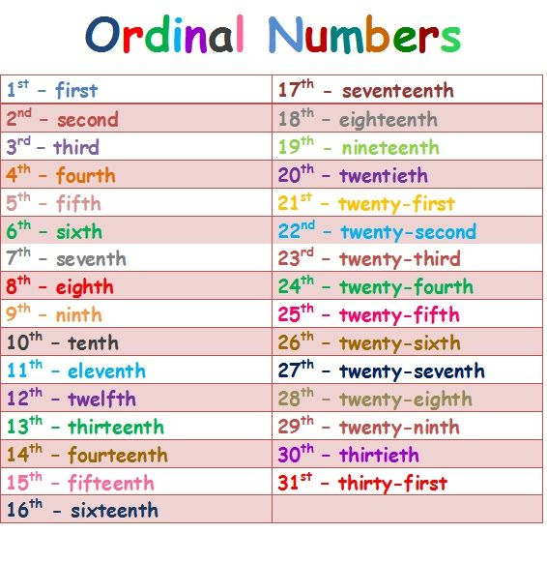  Differentiation: teacher’s support  Inclusive learners: listens and pronounces  3. Speaking. ex.2 p.35 Look, read and say yes or no.  Explains the activity. The pupils read the sentences and complete the activity  Answer key  1 no 3 no 5 no  2 yes 4 yes  Differentiation:  More able learners read the sentences and  complete the activity  Less able learners will get teacher’s support and guidance more  Inclusive learners: answers orally  4. Writing. Ex.3 p35, Talk with your friend.  Reads the example and explain the activity.  Differentiation:  More able learners will complete the tasks more independently  Less able learners will get teacher’s support and guidance more  Inclusive learners: teacher’s support |  |  | Responds to greeting and takes their places.  Listens to the teacher and answers the questions  Repeats after teacher and tries to remember  Repeats after teacher and tries to remember  The pupils read the sentences and  complete the activity.  The pupils,  in pairs, ask and answer questions as in the example, read the sentences and  complete the activity  Finds the places of objects  Makes and writes 5 sentences. |  | Descriptors :  1. answers the questions  Oral feedback  Descriptors :  Listens and repeats after teacher  Oral feedback  Descriptors :  Listens and repeats after teacher  Teacher’s assessment  Descriptors:  1. looks at the picture  2. chooses the correct answer  Teacher’s assessment  Descriptors:  1. looks at the picture  2. answer to the questions  3. Makes sentences correctly  Teacher’s assessment  Descriptors:  1. looks at the picture  2. answer to the questions  3. finds the places of objects  4.Makes 5 sentences correctly | https://www.youtube.com/watch?v=zzd  z7mDW0eI  blackboard  PB 35  PB 35
5 min | Homework : ex 1p32PB learn and write the new words
Differentiation – how do you plan to give more support? How do you plan to challenge the more able learners? |  |  | Assessment – how are you planning to check learners’ learning? |  | Health and safety check
- More able learners will complete the tasks more independently.  - Encourage students to use more complex vocabulary.  - Less able learners will get teacher’s support and guidance more. |  |  | With the self assessment, mutual assessment using descriptors; individual assessment with different kinds of Formative assessment (with words: Good work! How clever of you! Excellent! etc.; with stickers and smiles) |  | Pupils have the opportunity to move around the classroom.  ICT links  Using the interactive board
Reflection
Were the lesson objectives/learning objectives realistic?
Did the learners achieve the LO?
If not, why?
Did my planned differentiation work well?

I`vegot..- У меня есть
Book- книга
Pen- ручка
Pencil-карандаш
Rubber- ластик
Ruler- линейка
Schoolbag- школьная сумка

I`vegot..- У меня есть
Book- книга
Pen- ручка
Pencil-карандаш
Rubber- ластик
Ruler- линейка
Schoolbag- школьная сумка

I`vegot..- У меня есть
Book- книга
Pen- ручка
Pencil-карандаш
Rubber- ластик
Ruler- линейка
Schoolbag- школьная сумка

I`vegot..- У меня есть
Book- книга
Pen- ручка
Pencil-карандаш
Rubber- ластик
Ruler- линейка
Schoolbag- школьная сумка

I`vegot..- У меня есть
Book- книга
Pen- ручка
Pencil-карандаш
Rubber- ластик
Ruler- линейка
Schoolbag- школьная сумка

I`vegot..- У меня есть
Book- книга
Pen- ручка
Pencil-карандаш
Rubber- ластик
Ruler- линейка
Schoolbag- школьная сумка

I`vegot..- У меня есть
Book- книга
Pen- ручка
Pencil-карандаш
Rubber- ластик
Ruler- линейка
Schoolbag- школьная сумка

I`vegot..- У меня есть
Book- книга
Pen- ручка
Pencil-карандаш
Rubber- ластик
Ruler- линейка
Schoolbag- школьная сумка

I`vegot..- У меня есть
Book- книга
Pen- ручка
Pencil-карандаш
Rubber- ластик
Ruler- линейка
Schoolbag- школьная сумка

I`vegot..- У меня есть
Book- книга
Pen- ручка
Pencil-карандаш
Rubber- ластик
Ruler- линейка
Schoolbag- школьная сумка

