Lesson plan

LESSON: Module 7 World1 |  | School:№ 28
Date:10.03 |  | Teacher name:Kamesheva M.M.
CLASS:5 |  | Number present: | absent:
Learning objectives(s) that this lesson is contributing to | 5.4.2.1- understand independently specific information and detail in short, simple texts on a limited range of general and curricular topics;  5.3.7.1- use appropriate subject-specific vocabulary and syntax to talk about a limited range of general topics, and some curricular topics
Lesson objectives | All learners will be able to:  Read and understand the text
Most learners will be able to:
Mark the sentences, use topical vocabulary
Some learners will be able to:
Give feedback about birds
Previous learning | talk about mythical creatures
Plan
Planned timings | Planned activities |  | Resources | Teacher  Notes
Beginning the lesson | - - Good day, boys and girls! Nice to see you. How are you today?  - What date is it today?  - What’s the weather like today?  The aims of our lesson:  -study and use new words  -know more information about birds |  | PPT
Main Activities | 2. Listen and repeat.Which of the birds in the pictures live:in the forest?in the city?in the mountains? on the coast?at a lake?  3. Present and practise new vocabulary  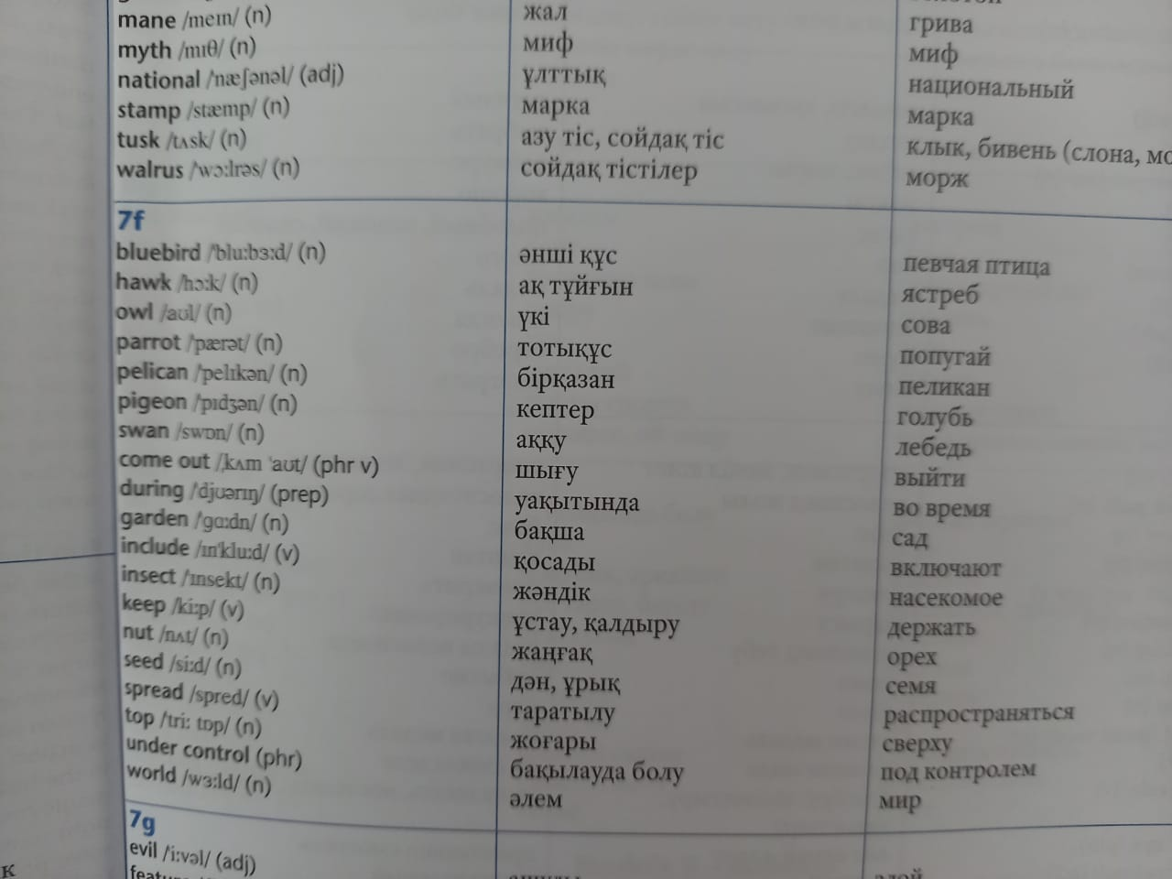  4.Consolidate new vocabulary  Unscramle words  1. wahk  2.nsaw  3.torarp  4.lipenac  5.ongepi  6.argned  7.lodrw  Answers:  1.hawk  2.swan  3.parrot  4.pelican  5.pigeon  6.garden  7.world  5.Watch the video https://youtu.be/cX0JMzyTyz0 Birds life video  Read the text  6.Answer for the questions  1.How many types of birds are there in the world?  2.Where do they live?  3.What do they eat?  4.Why are the birds are important? |  | video

7.Quiz Birds

1.What is our national bird?
Eagle
2.Why are birds able to fly in the sky?
Because they have wings
3.Which bird can see in the dark?
Owl
4.Which is the biggest bird?
Ostrich
5.How many legs birds have?
2 legs
6.Name 2 birds can swim.
Swan,duck
7.Name 3 wild birds?
Owl,eagle,swan
8.Can a hen fly?
No
9.Which bird is called the king of birds?
Eagle

Ending the lesson | Choose one sentence from the list and complete it.
Additional information
Differentiation – how do you plan |  | Assessment – how are you | Cross-curricular links
to give more support? How do you |  | planning to check learners’ | Health and safety check
plan to challenge the more able |  | learning? | ICT links
learners? |  |  | Values links
monitor less able groups in writing task and provide support through further modelling and providing sentence starters |  | monitor accuracy and pronunciation in eliciting views and then feedback to whole class before final task | Why we should travel
challenge more able learners to write a text
Reflection |  | Answer the most relevant questions from the box on the left  about your lesson.
Were the lesson objectives/learning objectives realistic?
Did I stick to timings?
What changes did I make from my plan and why?

