What is Physics?

 | Құзіреттілікке бағытталған тапсырмалар
Сабақтын тақырыбы: | “What is Physics?”
- Translate and Read the text «What is Physics?» and entitle each paragraph of it.
What is Physics?
1)Physics is the science that deals with matter and energy and the relationships that exist between them. Physics is the most comprehensive of the natural sciences because it includes the behaviour of all kinds of matter – from the smallest particles to the largest galaxies. The word «physics» originates from a Greek word meaning natural things. Physics was originally called natural philosophy and included all natural science. As a large amount of knowledge was collected on a particular subject within natural philosophy, that subject branched off and developed into a separate science.
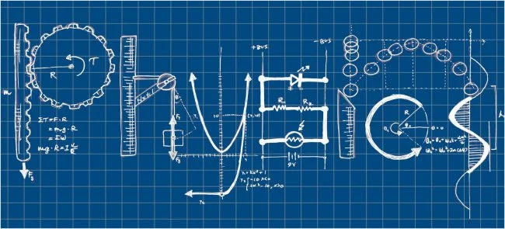
2) The various laws of physics are attempts by physicists to explain the behaviour of nature in a simple and general way. Even the most accepted laws of physics, however, are subject to change. Nature's behaviour does not change, but techniques for determining its behaviour do change and become more accurate. At the beginning of the 20th century, the laws of physics were tested extensively and were found to be too narrow to explain many of the new discoveries. A new body of theories was started. The older body of laws is called classical physics; the new is called modern physics.
3) Classical physics is based primarily on the laws of motion and gravitation of Sir Isaac Newton and the theory of electromagnetic radiation of James Clerk Maxwell. In classical physics matter and energy are two separate concepts. Matter is anything that occupies space and has mass. It exists in three basic forms. Plasma – highly ionized gas – has been called a fourth form. Energy is the capacity to move matter; as more commonly stated, it is the capacity to do work. Energy exists as mechanical energy, chemical energy, radiant energy, and nuclear energy. Some of the most important laws in classical physics are the conservation laws. Classical physics is usually divided into several branches, each of which deals with a group of related phenomena (mechanics, dynamics, hydromechanics, statics, optics, thermodynamics, acoustics, the study of electricity and magnetism).
4) Modern physics is based on the theory of relativity of Albert Einstein and the quantum theory of Max Planck and others. Matter and energy are not separate concepts, but are alternate forms of each other. The theory of relativity states that matter and energy are interchangeable and that mass and time can vary. Quantum theory states that light and other forms of electromagnetic radiation behave as though they have a double nature. Sometimes they behave as waves; at other times they behave as particles. Small particles of matter also have a double, or wave-particle, nature. Modern physics is broken up into various fields of study (atomic physics, nuclear physics, high-energy physics, or particle physics, ultrasonics, solid-state physics, plasma physics).

- То Find all verbs in this text
- Translate this words in picture:
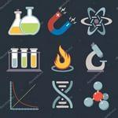
- Physics Quiz “Physical Kaleidoscope “
1. When it is necessary to pour juice from a tin jar through a the ship?
4. What physical error is allowed in the next poem?

- Describe this picture in English:
1)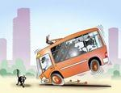

2)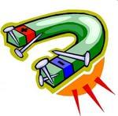
- Choose the main idea of the text «What is Physics?».
1. Physics is really the study of how the world works, and, it might be considered the most fundamental of all the sciences.
2. Physics is divided into different branches, such as mechanics, electromagnetism and optics, thermodynamics, quantum physics, atomic physics, nuclear physics, particle physics, and relativity.
3. Physics is the most comprehensive of the natural sciences that deals with matter and energy and the relationships between them and can be divided into classical and modern physics.

Тапсырманы орындалу технологиясы: | - Translate thе text:  - То Find all verbs in this text  - Translate this picture:  - Physics Quiz “Physical Kaleidoscope “  - Describe this picture in English  - Choose the main idea of the text «What is Physics?».
Тапсырманы орындау үшін қажетті құралдар: | Қағаз, қалам, интерактивті тақта, оқулықтар, сөздіктер

