Short term lesson plan

Unit 8 Travel and tourism  Lesson plan |  |  |  | School: 17
Date: |  |  |  | Teacher’s name: Bekmambetova A.T.
Class: |  |  |  | Number present: | Number absent:
Lesson title |  |  |  | Holiday advice  Talking about travelling. p.94
Learning objectives(s) that this lesson is contributing to |  | 9.C2 use speaking and listening skills to provide sensitive feedback to peers  9.L5 recognise the attitude or opinion of the speaker(s) in unsupported extended talk on a wide range of general and curricular topics, including talk on a limited range of unfamiliar topics  9.S3 explain and justify their own and others’ point of view on a range of general and curricular topics  9.R8 use a wide range of familiar and unfamiliar paper and digital reference resources to  9.W1 plan, write, edit and proofread work at text level independently on a range of general and curricular topics
Lesson objectives |  | All learners will be able to:  - *develop speaking skills through communication about holiday advice; a modern city  - * improve reading skills through recognising typical features at word;  - * write instructions during holidays, use right grammar tenses.  - Most learners will be able to:  - *Select, compile, and synthesize information from the reading passage for an oral presentation.  Some learners will be able to:  *Respond to and discuss the reading passage using interpretive, evaluative and creative thinking skills.  - *Demonstrate the ability to find correct information without any mistakes;  *Respond to and discuss the reading passage using interpretive, evaluative and creative thinking skills.  - *Apply topic related vocabulary in speech with grammar accuracies.
Value links |  | Loves to the place they live, Cooperation, respect each other's opinion, functional literacy.
Crosscurricular links |  | Social Science, Psychology, Geography, Information Technology, History.
Previous learning |  | Talking about a dream holiday.
Useof ICT |  | Smart board for showing a presentation, getting additional information, playing the audio files.
Intercultural awareness |  | Discuss what not to do on holiday.
Health and Safety |  | Breaks and physical activities used. Everyday classroom precautions will ensure that safety measures are provided to prevent the exposure of electrical power cords.
Planned timings | Planned activities |  |  |  |  | Resources
Beginning of the lesson  7 min. | The lesson greeting.  Look at the board. I'd like to start our lesson with proverb "I get more tired by travelling than anything". What do you think these words mean? What did the author want to say by it?  What do you think will be the theme of our lesson?  Formulating the aim using Bloom taxonomy.Identify, recommend.Watching the pictures, the learners are asked to predict the topic of the lesson.  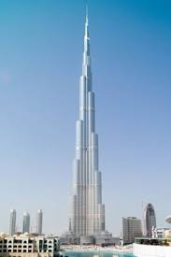  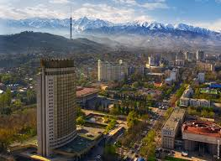  Warm up.Free talk about visiting the cities. |  |  |  |  | Slide (useful phrases).  Pictures  PPT  Student Book p.94  Writing  Worksheet  Pictures  PPT  Slide (useful phrases).
Main  Activities  15 min.  12 min | Main part  What do you usually take with you when you go on holiday?  In pairs, write a list of things to take and be ready to explain why?  Look at the title and headings in the text. What advice or tips would you give people? Ex.1 – 2.  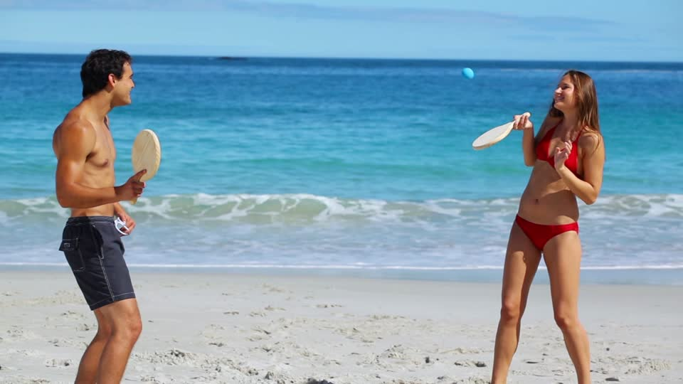  VOCABULARY WORK.  Differentiation  Read the words with the class which are usually confused.  In a weaker class, give brief definitions with the examples; in a stronger group ask to write sentences with the words.  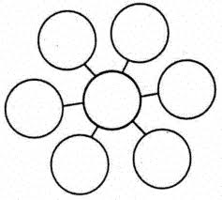  Have a good trip! Air travel is less dangerous. My voyage on that ship was wonderful!  Give synonyms to these words. Ex. 3 – 4 p.94.  Creative ex. 5. Speak about tips for travelling.  We hope this list of our best travel tips will inspire and help you to travel and travel more often!  - 1. Make Travel a Priority  - 2. Spend More Time in Fewer Places  - 3. Don’t Expect Things to Be Like They Are at Home  - 4. Travel Does Not Have to Stop Once You Have Kids  - Top Tips for Traveling with kids:  - 5. Plan it Together  - 6. Talk to the Locals  - 7. Learn the Basics of the Local Language  - 8. Travel In Your Own Backyard  - 9. Do the FREE Stuff  - 10. Stay in Apartments or Airbnb (and share the costs)  - 11. Fly Where the Deals Are  - 12. Blow Your Budget  - 13. Be Flexible  - 14. Don’t Travel Without Travel Insurance  - 15. Working Holidays Are a Great Way to Experience the World  - 16. Pack Smart  - 17. Have More Than One Way To Access Your Money  - 18. Use Credit Card Reward Points  - 19. Get Up Early  - 20. Put Down Your Phone and Camera |  |  |  |  | Student Book p.94  Writing Worksheet  CD. 3.12.  Writing  Worksheet  CD. 2.36.  Pictures  PPT  Teacher's Book p. 116.  A Table  Student Book p.94  Writing  Worksheet  Teacher's Book p. 116.
Ending the lesson  6 min. | Giving the home task. Ex.5p.94 (w), My trip (composition)  Students express their attitude to the lesson and give self-assessment using the method: “Six thinking hats”:  - Green: How can you use today's learning in different subjects?  - Red: How do you feel about your work today?  - White: What have you leant today?  - Black: What were the weaknesses of your work?  - Blue: How much progress have you made in this lesson? (Now I can, I still need to work on, I've improved in, Today I learnt... )  Yellow: What did you like about today's lesson?  Slide (Homework)  Slide "Six thinking hats"  
Differentiation –  how do you plan to give more support? How do you plan to challenge the more  able learners? |  |  | Assessment –  how are you planning to check learners’learning? |  |  |  | Critical thinking
Differentiation can be achieved through the selection of activities, identification of learning outcomes for a certain student, provision of individual support to learners, selection of learning materials and resources based on the individual abilities of learners. |  |  | Assessment criteria:  - Identify the main idea in extended talks with little support.  - Apply topic related vocabulary in speech appropriately arranging words and phrases into well-formed sentences.  - Demonstrate the ability to participate in a conversation.  Descriptor:  A learner:  - selects an appropriate answer.  - completes the task.  - uses appropriate subject-specific vocabulary while speaking.  - discusses questions and answers the questions within the group.  - Observation  - Feedback on the work  - Peer-assessment |  |  |  | Students think critically, exploring, developing, evaluating and making choices about their own and others’ ideas

Student Self-Assessment Checklist Student
Name: ________________________
Date: ______________________ Think about how well you are working in your group.
Place a check mark beside the skills you demonstrate in your role.
I listen attentively to others.
I express my thinking clearly and concisely.
I take turns. I encourage participation of all group members.
I show respect for alternative points of view.
I disagree agreeably.
I synthesize information from others.
I analyze ideas of others.
I remember significant information.
I identify issues. I make connections to prior knowledge and experiences.

Appendix1
Teacher observation checklist

Student's name ________________________________________
Positive Aspects
- Completed the individual role-card.
- Used extracts from the text to support his/her ideas.
- Asked open-ended questions.
- Listened while others talked.
- Encouraged peers to share their ideas.
- Added his/her own comments and ideas to other student's comments and ideas.
Negative Aspects
- Didn't complete the individual role-card.
- Didn't appear to be listening or interrupted when others were speaking.
- Did not use text to support his/her opinions.

Do you know any proverbs about travelling?
"The world is a book and those who do not travel read only a page.”
"The more you travel the more you see, the more you see the more you know."
"You travel East, you travel West, but remember your Home is best".)

