**УДК**

**О РОЛИ ПЕДАГОГОВ В КАЗАХСТАНЕ И ТУРЦИИ: СРАВНИТЕЛЬНЫЙ АНАЛИЗ**

Г. Кайрат1, С. А. Алтун2

1Ph.D., заместитель директора Департамента аналитики, мониторинга и оценки, АО «Национальный центр исследований и оценки образования «Талдау» им. А. Байтурсынұлы», г. Астана, Казахстан

+77079888014, *[gulsaule.kairat@iac.kz](mailto:gulsaule.kairat@iac.kz)

2Доктор, профессор, декан Факультета образования, Башкентский университет, г. Анкара, Турция

[akbabas@baskent.edu.tr](mailto:akbabas@baskent.edu.tr)

**Аннотация**

Основной целью исследования является проведение сравнительного анализа систем образования в Казахстане и Турции с особым акцентом на роль и статус педагогов. Сравнительное исследование включало анализ реформ и нормативных актов в области образования в каждой стране, обзор рабочих документов и отчетов ОЭСР и анализ результатов международных исследований, таких как TALIS-2018, а также использование национальных статистических данных.

Исследование показывает, что, несмотря на различия в результатах международного исследования TALIS-2018, в системе подготовки учителей обеих стран есть сходства (такие как сертификация/вступительные экзамены выпускников университетов для приема в профессию, внедрение системы наставничества для профессиональной поддержки и руководства новым сотрудником)., политика и реформы в области образования, направленные на повышение статуса профессии педагога в обществе.

**Ключевые слова:** педагог, реформы образования в отношении учителей, подготовка учителей, прием на работу.

**ҚАЗАҚСТАН ЖӘНЕ ТҮРКИЯ ЕЛДЕРІНДЕГІ ПЕДАГОГ РӨЛІ ЖАЙЫНДА: САЛЫСТЫРМАЛЫ ТАЛДАУ**

Г. Қайрат1, С. А. Алтун2

1Ph.D., «А. Байтұрсынұлы атындағы «Талдау» ұлттық зерттеулер және білімді бағалау орталығы», Талдау, мониторинг және бағалау департаменті директорының орынбасары, Астана қ., Қазақстан

+77079888014, *[gulsaule.kairat@iac.kz](mailto:gulsaule.kairat@iac.kz)

2Доктор, профессор, Білім беру факультетінің деканы, Башкент университеті, Анкара қ., Түркия

[akbabas@baskent.edu.tr](mailto:akbabas@baskent.edu.tr)

**Түйіндеме**

Зерттеудің негізгі мақсаты педагогтердің рөлі мен мәртебесіне ерекше назар аудара отырып, Қазақстан мен Түркиядағы білім беру жүйелеріне салыстырмалы талдау жүргізу болып табылады. Салыстырмалы зерттеуге әр елдегі білім беру саласындағы реформалар мен нормативтік актілерді талдау, ЭЫДҰ-ның жұмыс құжаттары мен есептеріне шолу және TALIS-2018 сияқты халықаралық сауалнамалардың нәтижелерін талдау, сондай-ақ ұлттық статистиканы пайдалану кірді.

Зерттеу көрсеткендей, TALIS-2018 халықаралық зерттеуінің нәтижелеріндегі айырмашылықтарға қарамастан, екі елдің педагогтерді даярлау жүйесінде ұқсастықтар бар (мысалы, мамандыққа түсу үшін университет түлектерін сертификаттау/қабылдау емтихандары, кәсіби қолдау және жаңа қызметкерді қолдауға арналған тәлімгерлік жүйесін енгізу, қоғамдағы педагог мәртебесін көтеруге бағытталған білім беру саласындағы саясат пен реформалар).

**Кілт сөздер:** педагог, мұғалімдерге қатысты білім беру реформалары, мұғалімдерді даярлау, жұмысқа қабылдау.

**BEİNG A TEACHER İN KAZAKHSTAN AND TÜRKİYE: A COMPARATİVE ANALYSİS**

G. Kairat1, S. A. Altun2

1Ph.D., Deputy Head of the Department of Analysis, Monitoring and Evaluation, National Center for Research and Evaluation “Taldau” named after A. Baitursynuly, Astana, Kazakhstan

+77079888014, *[gulsaule.kairat@iac.kz](mailto:gulsaule.kairat@iac.kz)

2Dr. Professor, Dean of the Faculty of Education, Başkent University, Ankara, Türkiye

[akbabas@baskent.edu.tr](mailto:akbabas@baskent.edu.tr)

**Abstract**

The main purpose of the study is to conduct a comparative analysis of the education systems in Kazakhstan and Türkiye, with a particular focus on the role and status of teachers. The comparative study involved analysing each country’s education reforms and regulations, reviewing OECD working papers and reports, and analysing the results of international surveys such as TALIS-2018, as well as utilizing national statistical data.

The study shows that, notwithstanding the differences in the results of the international study TALIS-2018, there are similarities in both countries’ teacher training system (such as certification/ entrance examination of graduates of the universities to entry the profession, implementation of mentoring system to support and guide professionally a fresh staff member), education policies and reforms directed to enhance and boost teacher profession’s status in society.

**Keywords:** teacher, educational reforms on school teachers, teacher training, teacher recruitment.

**Introduction**

“A good teacher is like a candle – it consumes itself to light the way for others”, once said Mustafa Kemal Atatürk, the founder and first president of the Republic of Türkiye. Admittedly, the status of a teacher, who raises younger generation and inculcate them with knowledge, holds a special role in any society, in any culture. Widely considered, a teacher is a mirror of society.

Conducting comparative studies and analyses among other Turkic countries, such as this research work in the field of education, is of particular importance. Comparative analyses carried out in the field of education between individual countries serve various decentralized goals. These goals include understanding the educational policies pursued in their own country and other countries, conducting research to improve, develop, and reform education policies and experiences, predicting the impact of achievements and changes in education, and developing tools to facilitate the implementation of these initiatives within a theoretical framework (Kilimci, 2009). At the same time, it is evident that cooperation between Turkic countries can be instrumental in addressing global challenges, such as the COVID-19 pandemic. This collaboration allows for the pooling of efforts among countries, enabling swift problem-solving and fostering a productive partnership.

The main purpose of this article is to conduct a comparative analysis in the field of education in Kazakhstan and Türkiye, specifically focusing on the role of school teachers and school practices. To achieve this goal, an analysis was conducted on the reforms implemented in both countries’ education systems, teacher training programs, and specific requirements for teacher recruitment. The analysis aimed to assess the effectiveness of the reforms implemented in each country and the societal status of teachers.

To start, we would like to provide some statistics on teacher staff in both countries. According to the official data of the Organization for Economic Cooperation and Development (OECD) for 2020, there were 689 878 teachers in Türkiye, including secondary and primary school teachers (17,2% of them are under the age of 30 whereas 11,9% are at the age of 50 and above) (OECD, 2023b). In Kazakhstan, this indicator showed 322,508 teachers working in secondary schools subordinate to the local executive body (of which 17% are young specialists under the age of 30, whereas 27,4% teachers are at the age of 50 and above) (IAC, 2022).

Despite the implementation of state programs and reforms in Kazakhstan, the salaries of teachers in the country remain significantly lower than those in European countries. According to the statistics from OECD for 2021, a secondary education teacher with 15 years of experience in Türkiye earns $35,365 per year (OECD, 2023a). In contrast, in Kazakhstan, a teacher in the secondary education system and elementary school earns an average of $7,122 per year, based on data from the National Bureau of Statistics (IAC, 2022).

To establish a highly skilled and professional teaching staff, it is crucial for each country to prioritize attracting qualified teachers, as well as developing and sustaining professionalism in the field. The educational policies of each country should be built on this foundation. The most successful education systems are able to engage highly qualified teachers who are acknowledged as professionals and experts in their field. Therefore, the working conditions provided for teachers and school principals play a pivotal role in elevating the status of the teaching profession (OECD, 2020a).

The TALIS-2018 (Teaching and Learning International Survey) conducted by the OECD is one of the pioneering and comprehensive studies focused on examining the educational environment and working conditions of educators in schools. This study, encompassing 48 countries in 2018, provides valuable insights for teachers and principals to contribute significantly to the analysis and formulation of educational policies in their respective countries. By understanding the challenges and opportunities identified through TALIS-2018, policymakers can make informed decisions to improve the quality of education and enhance the working conditions for educators.

According to the international TALIS-2018 studies, Kazakhstan is among the countries where the status of a teacher is highly appreciated in society, with a rating of 63% (Viet Nam – 92%, Singapore, UAE – 72%, Korea – 67%) (fig. 1). This can be attributed to the effective reforms that have been implemented and are currently underway in the country. Conversely, Turkish society has a lower assessment of the status of teachers, with a rating of 26% (compared to the OECD average of 25%) (OECD, 2020a). These findings highlight the importance of societal recognition and appreciation for the teaching profession, which can have a significant impact on attracting and retaining highly qualified educators.

**Fig. 1.** Teachers’ views of how society values their profession by TALIS-2018, 2018 (%) (OECD, 2020a)

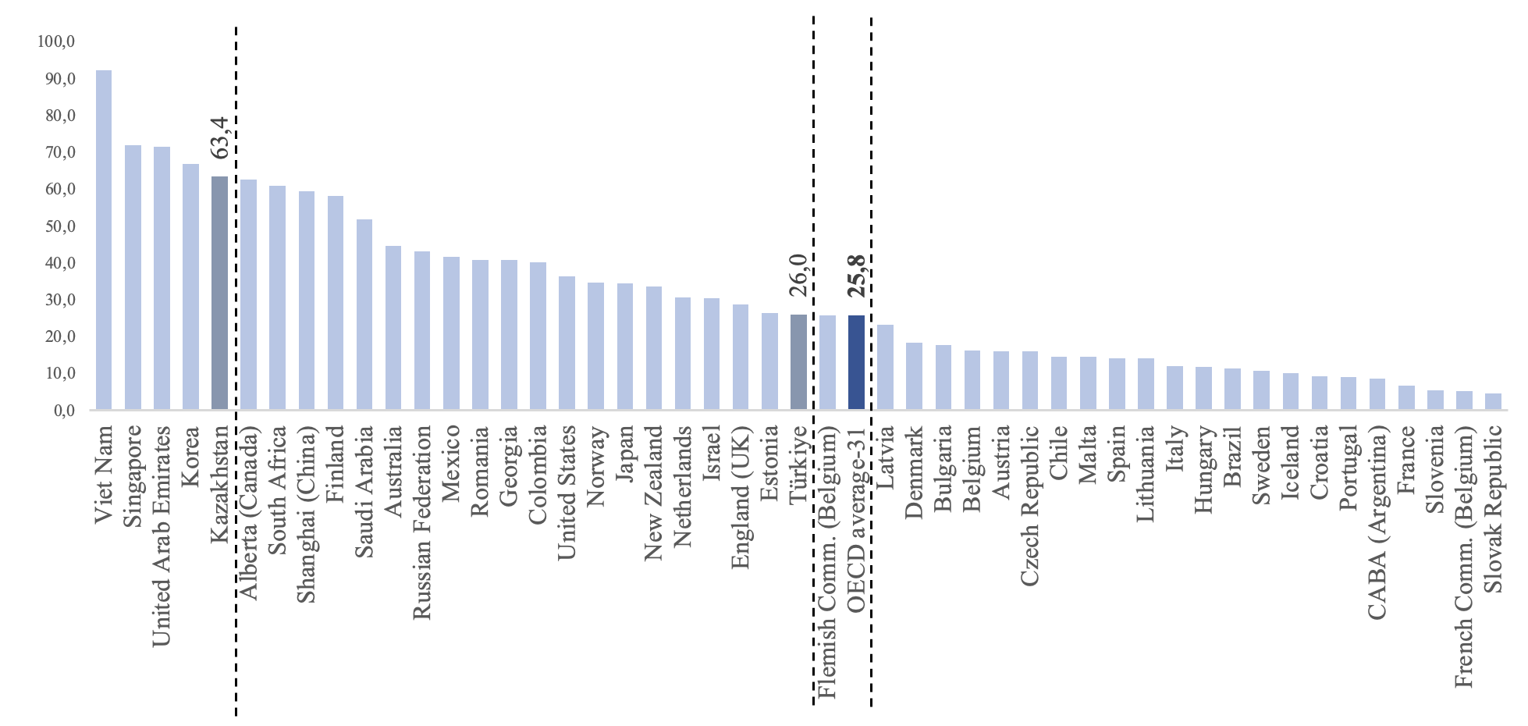

Pedagogy is indeed a complex and hard profession that entails various forms of psychological, emotional, and intellectual stress for teachers. According to the study TALIS-2018, in Kazakhstan, 14% of teachers in schools experience significant stress in their work, while 52% reported not experiencing any stress. In contrast, 23% of Turkish educators reported experiencing high levels of stress from their work, with only around 16% indicating that they do not experience any work-related stress (OECD, 2020a).

Kazakhstani teachers identify several causes of stress, including a heavy administrative workload (36%) and the responsibility for student achievement (33%) (Saugabay and Nurmukhamed, 2021). On the other hand, Turkish teachers cite responsibility for student achievement (39%), the need to comply with requirements and the impact of changes made by educational authorities at the local and central levels (36%) as the main sources of stress (OECD, 2020a).

Yet, the reported levels of stress among teachers can also be influenced by the economic development of a country, as well as the specific needs, goals, and cultural factors within individual countries and communities. It is important to consider these factors when analyzing stress levels in the teaching profession. In a study conducted by Diener and Tay in 2015, it was demonstrated that countries with higher levels of stress among their population may also exhibit higher levels of income, life expectancy, and life satisfaction (OECD, 2020a). This suggests that stress levels in a society can be influenced by various interconnected factors, and a comprehensive understanding of the context is necessary to address and manage stress effectively in the teaching profession.

**On the Status of “Teacher” in Kazakhstan**

Since the country’s Independence, the Government of Kazakhstan has been implementing a series of reforms with the objective of creating a free education market and decentralizing administrative control and reporting. These reforms aim to strengthen the collaboration between the education sector in Kazakhstan and the international education community, using education as a means of connecting countries together. By fostering closer interaction with the global education system, Kazakhstan seeks to enhance educational standards and promote international cooperation in the field of education.

The education system of the Republic of Kazakhstan is tightly regulated by a range of legislative measures, including Presidential decrees, acts of Parliament, and ministerial laws and resolutions, which are adopted in the capital of the country. The primary legal framework governing the field of education in Kazakhstan is the Law of the Republic of Kazakhstan “On Education”, initially introduced in 2007, with subsequent amendments made in 2011 and 2015. These legislative provisions establish the current legal structure and guidelines that govern the various levels of the education system in the country.

In the centralized education system of Kazakhstan, the Ministry of Education (previously known as the Ministry of Education and Science until 2022. In 2022 the Ministry of Education and Science were split into two separate ministries: the Ministry of Education and the Ministry of Science and Higher Education) is responsible for various areas, including preschool and secondary education, technical and vocational education policy, as well as the protection of children’s rights and digitalization in education. These sectors fall under the purview of the ministry, which is tasked with formulating policies, implementing regulations, and ensuring the effective administration of education at the preschool and secondary levels. Additionally, the ministry plays a role in safeguarding the rights of children and integrating digital technologies into the education system.

In 2019, Kazakhstan enacted the Law “On the Status of a Teacher” (Law of the Republic of Kazakhstan dated December 27, 2019, No. 293-VI). This law introduced measures aimed at improving the working conditions of teachers and elevating the status of the teaching profession. It outlined the rights and obligations of Kazakhstani teachers and addressed various aspects such as enhancing their status and prestige, reducing their workload, protection against unfair inspections, and eliminating non-teaching duties. The law also included annual measures to increase wages, provide incentives and rewards, and expand the availability of grants and scholarships for individuals pursuing pedagogical specialties. These measures have had a significant impact on raising the status of educators within Kazakhstani society.

The state also prioritizes training issues as part of its efforts to enhance the quality of personnel preparation. Starting from 2021, admission requirements for pedagogical specialties have become more stringent, with an increase in the threshold score. Scholarships for students pursuing pedagogical studies have been set at the highest level compared to other fields. Moreover, all educational programs have been revised and updated to align with the professional standards of teachers and the expectations of employers.

Another significant development is the introduction of a requirement for graduates to obtain a qualification certificate along with their diplomas from universities. This measure ensures that graduates possess the necessary qualifications and certifications to meet the standards and demands of the teaching profession. These initiatives collectively aim to improve the quality of teacher training and reinforce the significance of pedagogical specialties within the education system.

**On the Status of “Teacher” in Türkiye**

In the 21st century, the importance of high-quality knowledge is paramount. In Türkiye, education holds a central position on the national economic agenda. The Basic Law on National Education, which was adopted in 1973, establishes the fundamental principles and regulations that govern the national education system in Türkiye. This law serves as a guiding framework for educational policies and practices, ensuring a standardized and structured approach to education across the country. By emphasizing the significance of education, Türkiye recognizes the pivotal role it plays in driving economic development and preparing individuals to meet the challenges of the modern world.

Similar to Kazakhstan, educational policy and its implementation in Türkiye follow a highly centralized management structure under the Ministry of Education. The ministry oversees the establishment, monitoring, and closure of educational institutions in the country. It also plays a significant role in designing and organizing the curricula used in schools. While there may be some limited autonomy granted to certain schools, overall, the educational system in Türkiye operates within a centralized framework. This approach ensures consistency and standardization in educational practices across the country (EC, 2022).

Established in 1982, the *Council of Higher Education* (CoHE, Yükseköğretim kurulu) is an important institution in Türkiye responsible for various aspects of higher education. Alongside its focus on ensuring quality education, the CoHE plays a role in defining the standards for faculty members and curricula in higher education institutions. It contributes to shaping the structure of teacher training programs, which ultimately aims to train qualified teachers. By setting and maintaining these standards, the CoHE seeks to enhance the quality and professionalism of the teaching profession in Türkiye (Grossman, Sands and Brittingham, 2010).

As outlined in the Basic Law of National Education in Türkiye, teaching is recognized as an ‘expert profession’. In recent years, Türkiye has made notable strides in attracting teachers to the profession and enhancing the skills and qualifications of educators, as highlighted in the OECD reviews (OECD, 2019). However, there have been challenges related to the quality of teacher training and a lack of opportunities for professional development. In response to these issues, the Ministry of Education introduced the New Pedagogical Strategy, specifically the *Teacher Strategy Paper for 2017-2023*, which aims to address these shortcomings and improve the overall quality of teaching (Directorate General for Teacher Training and Development, 2017).

The Teacher Strategy Paper for 2017-2023 encompasses three main goals. Firstly, it aims to attract highly qualified and competent teachers to the profession by enhancing the quality of teacher training programs and establishing high standards for university graduates entering the field. Secondly, the strategy aims to create opportunities for individual and professional development for teachers. This involves assessing the needs of teachers regarding professional development and implementing measures to enhance the quality and effectiveness of these development programs. Lastly, the strategy seeks to increase the status of teachers in society. This goal involves improving the working conditions of teachers, reducing disparities between institutions and regions, and developing an incentive system to recognize and reward teachers. By enhancing the status of teachers, the strategy aims to promote a culture of respect and appreciation for the teaching profession within society. In addition, in Türkiye the Teachership Profession Law was enacted in 2022 with the Law number 7354 and was published in the Official Gazette with the number 31750. The purpose of this Law is to regulate the appointments and professional development of teachers in charge of carrying out education and training services, and their advancement in career ladder.

Indeed, the measures outlined in the Teacher Strategy Paper and Teachership Profession Law, Teacher in Türkiye and the Law “On the Status of a Teacher” in Kazakhstan share a common objective of enhancing the status and prestige of teachers within their respective societies. By recognizing and valuing the crucial role that teachers play in education, both countries aim to improve the overall quality of education and achieve better educational outcomes.

Both Kazakhstan and Türkiye have recognized the importance of *mentoring* in the development of young professionals and have implemented mentoring systems to support new teachers in their transition into the teaching profession.

In Kazakhstan, the concept of mentoring is explicitly defined and supported by legislation, particularly in the Law “On the Status of a Teacher” and the Order No. 160 of the Ministry of Education and Science “On the organization of mentoring and requirements for mentor-teachers”. The mentoring process is formalized, and there may be provisions for mentors to receive compensation for their mentoring services. A mentee-teacher gets support and guidance from his/her mentor during one academic year.

The program implemented in Türkiye in 2016, known as “Öğretmen göreve başlama programı” (Training program for newly appointed teachers), demonstrates a commitment to supporting young professionals in their teaching careers. Under this program, newly appointed teachers undergo a six-month training period in collaboration with their assigned mentor and school administrator (Çobanoğlu and Ayvaz-Tuncel, 2018). In addition, Turkish Teachership Profession Law item 5 is also related with mentoring for candidate teachers.

The teacher, starting from entering the profession, continuously improves their qualifications in order to effectively carry out their activities and increase their level of professional development. Advanced training for teachers is a form of professional training that allows them to gain new knowledge to improve the quality of instruction, as well as to maintain, expand, deepen, and enhance previously acquired professional knowledge, skills, and competencies.

The quality of education is closely linked to the quality of teachers’ work. As a result, every country places significant emphasis on enhancing the qualifications of teachers. The findings of the study further indicate a high level of advanced training and knowledge among both Kazakhstani and Turkish teachers (fig. 2).

**Fig. 2.** TALIS-2018. Teachers’ participation in professional development activities, 2018 (%) (OECD, 2019)

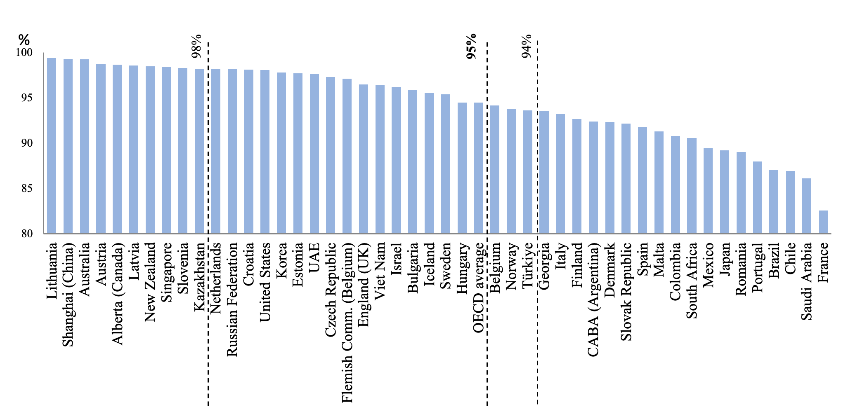

**Prerequisites for Entering the Teaching Profession**

The development of a country is closely tied to education, and teachers have a significant impact on the quality of education. Therefore, having highly qualified professionals is a crucial prerequisite for bringing about meaningful changes and accomplishments in the field of education. With that in mind, it is essential to consider the qualification requirements for individuals aspiring to become teachers.

The qualifications and competencies of teachers in both countries are established and defined by the respective ministries of education. These ministries play a crucial role in setting the standards and requirements for individuals seeking to become teachers. They determine the educational qualifications, certifications, and competencies necessary for entering and practicing the teaching profession.

The main prerequisite for entering the teaching profession in Türkiye is the successful completion of the exam for the selection and placement of candidates for professional positions in public organizations (KPSS, Kamu Personeli Seçme Sınavı). This exam was introduced in 2002 and is administered by the Center for Assessment, Selection, and Placement (ÖSYM, Ölçme, Seçme ve Yerleştirme Merkezi). The exam evaluates candidates’ knowledge in the field of education, as well as general subject and cultural issues. It serves as a means to assess the candidates’ qualifications and suitability for teaching positions in the public education system.

In terms of the test structure, the exam consists of three main parts. The first part comprises 120 questions, with the following distribution: general education (50%), Turkish language (50%), mathematics (50%), Atatürk’s principles and revolutions (40%), fundamentals of citizenship (15%), social and economic questions in the world and Türkiye (10%), questions on Turkish culture and civilization (30%), and questions related to the geography of Türkiye (30%). The second part of the test includes 80 questions related to the candidate’s knowledge in educational sciences, while the third part consists of 50 questions focused on pedagogy. These divisions ensure that various aspects of the candidate’s knowledge and skills relevant to teaching are evaluated during the exam (Ugulu and Yorek, 2015).

The candidates’ eligibility and suitability for teaching positions are assessed based on their performance and scores obtained in the national test. This test is conducted once a year and serves as a standardized evaluation method to ensure fairness and transparency in the recruitment process. The candidates’ scores determine their ranking and eligibility for available teaching positions within the education system.

Prior to 2021, the responsibility for hiring teachers in Kazakhstan rested with the school directors, which resulted in a lack of clear and standardized rules across the country. However, significant changes have been implemented since 2021 to address these issues. The Ministry of Education has introduced new regulations to ensure transparency, eliminate corruption risks, and establish merit-based hiring practices for teachers. These changes are aimed at improving the fairness and efficiency of the recruitment process. The competition for vacant teaching positions now follows the guidelines outlined in the Ministry of Education and Science’s Order, specifically the Order No. 57 dated February 21, 2012, with subsequent amendments made on December 22, 2022.

In Kazakhstan, as in Türkiye, graduates of pedagogical universities are required to undergo the National Qualification Testing (NQT), which has been conducted by the National Testing Center since 2021. The NQT is designed to assess the knowledge and skills of aspiring teachers. It consists of 100 test tasks divided into two blocks. The first block includes 70 tasks that assess the subject-specific knowledge of the candidates, aiming to evaluate their deep academic understanding, practical flexibility, and teaching skills. The second block consists of 30 tasks related to pedagogy and teaching methodology, covering areas such as educational methodology, the organization and management of the teaching process, fostering critical thinking, assessing educational achievements, and other relevant topics. The NQT serves as an important evaluation tool to ensure the competence and readiness of future teachers in Kazakhstan.

**Table 1**

Prerequisites and Qualification Requirements for Entering the Teaching Profession in Kazakhstan and Türkiye

|  |  |  |
| --- | --- | --- |
|  | Kazakhstan | Türkiye |
| The specific requirements for admission to higher educational institutions (for pedagogical specialties) | * Certificate of General Secondary Education * Passing the final school exam * Passing a United National Test (passing a special and/or creative exam in the field of education “Pedagogical Sciences” separately from general disciplines) | * Certificate of General Secondary Education * Passing the centralized examination (OSS, Öğrenci Seçme Sınavı) prepared by the Turkish Council of Higher Education |
| Requirements for entering the profession | * Higher education diploma (Pedagogy) * Certificate of passing the National Qualification Test * Participation in the competition (writing an application, filling out a scorecard, indicating all achievements and results, letters of recommendation) | * Higher education diploma * Certificate of passing the exam for the selection and placement of candidates for professional positions in public organizations (KPSS, Kamu Personeli Seçme Sınavı) * Oral examination before the commission created by the Ministry, tests the candidate’s profession, communication skills, novelty, and qualification. Candidates who pass the exams once are eligible to take the second exam within a year, while those who fail the exams twice are deprived of the opportunity to work in public organizations (EC, 2022). |

**Conclusion**

This study presents a review comparing the teacher education policies and hiring systems of two countries, Kazakhstan and Türkiye.

International studies, such as TALIS, have indicated that the status of teachers in Kazakhstan is higher than in Türkiye. Additionally, these studies have found that Kazakhstani teachers experience less stress compared to their Turkish counterparts. These positive outcomes can be attributed to the country’s educational policy and ongoing reforms, which aim to support teachers, enhance their authority, and provide annual allowances to them.

In both Kazakhstan and Türkiye, teacher training follows a similar model, where prospective teachers undergo a four-year bachelor’s degree program to become pedagogical specialists. However, it is worth noting that the pedagogical specialty still emphasizes the “transfer of knowledge” approach, which may hinder the development of university graduates as fully-rounded professionals.

Indeed, despite differences in specific outcomes of international studies, both Kazakhstan and Türkiye share a common focus on teacher training and the implementation of state policies aimed at enhancing the reputation and status of teachers. Both countries have introduced measures such as certification of young graduates entering the teaching profession, the implementation of mentoring systems in schools to support new teachers, and various initiatives to improve the overall image of the teaching profession. These efforts demonstrate a shared commitment to enhancing the quality of education and the professional development of teachers.

In conclusion, it is important to conduct more comprehensive and extensive studies, both qualitative and quantitative, among Turkic countries to assess the effectiveness of the policies and reforms implemented in their respective education systems. By engaging in the exchange of experiences and conducting comparative research, cooperating countries can bridge the gap in the field of education and learn from each other’s successes and challenges. Such collaborative efforts can lead to the identification of best practices and the development of strategies to further improve the quality of education in the region.

**References**

Çobanoğlu, F., & Ayvaz-Tuncel, Z. (2018). Teacher induction program: First experience in Turkey. *International Education Studies*.

Directorate General for Teacher Training and Development (2017). Teacher Strategy Paper for 2017-2023. Ministry of National Education, Republic of Türkiye. <https://oygm.meb.gov.tr/meb_iys_dosyalar/2018_05/25170118_Teacher_Strategy_Paper_2017-2023.pdf>.

European Comission (2022). Conditions of service for teachers working in early childhood and school education, Türkiye. Eyrydice, <https://eurydice.eacea.ec.europa.eu/national-education-systems/Türkiye/conditions-service-teachers-working-early-childhood-and-school>

Grossman, G. M., Sands, M. K., & Brittingham, B. (2010). Teacher education accreditation in Turkey: The creation of a culture of quality. *International Journal of Educational Development*, 30(1), 102-109.

Information-Analytic Center (IAC) (2021). Qazaqstan Respublikasy bilim beru juiesinin statistikasy. [Statistics in the education system of the Republic of Kazakhstan. National collection], <https://iac.kz/wp-content/uploads/2022/05/ns-2022.02.22.pdf>

Information-Analytic Center (IAC) (2022). Qazaqstan Respublikasy bilim beru juiesinin ahualy men damyi turaly Ulttyq bayandama (Tauelsizdiktin 30 jyldygy jane 2021 jyl ushin). [The National Report on the state and development of education system of the Republic of Kazakhstan (for the 30 years of Independence and 2021)], <https://iac.kz/wp-content/uploads/2023/01/national-report-2021-ru.pdf>

Kilimci, S. (2009). Teacher training in some EU countries and Turkey: How similar are they? *Procedia-Social and Behavioral Sciences*, 1(1), 1975-1980.

OECD (2019). TALIS-2018 Results (Volume I): Teachers and School Leaders as Lifelong Learners. TALIS, OECD Publishing, Paris, https://doi.org/10.1787/1d0bc92a-en.

OECD (2020a). TALIS-2018 Results (Volume II): Teachers and School leaders as Valued Professionals. TALIS, OECD Publishing, Paris, <https://doi.org/10.1787/19cf08df-en>.

OECD (2020b). Education policy outlook: Türkiye, https://www.oecd.org/education/policy-outlook/country-profile-Türkiye-2020.pdf.

OECD (2023a). Teachers’ salaries (indicator), doi: 10.1787/f689fb91-en: <https://data.oecd.org/teachers/teachers-salaries.htm>

OECD (2023b). Teaching staff (indicator), doi: 10.1787/6a32426b-en: <https://data.oecd.org/teachers/teaching-staff.htm#indicator-chart>

Saugabay, A. & Nurmukhamed, D. (2021). Mejdunarodnoe issledovanie prepodavaniya I obucheniya TALIS-2018: Rezultaty Kazakhstana. [Teaching and Learning International Survey TALIS-2018: Results of Kazakhstan. National Report. 2nd Volume]. The Ministry of Education and Science of the Republic of Kazakhstan, JSC Information-Analytic Center. Astana, 2021

Ugulu, I., & Yorek, N. (2015). Pre-Service Teachers' Comments toward Official Teacher Selection System (Civil Servant Selection Examination, KPSS) in Turkey: A Qualitative Analysis. *Online Submission*, 3, 182-189.