Lesson plan

Unit 1 Our class  Lesson plan 5 |  |  | School:№26
Date: |  |  | Teacher's name: Suiindik Zh.
CLASS: 6 |  |  | Number present: |  | absent:
Lesson title |  | What are you into?
Learning objectives(s) |  | 6.4.1.1 understand the main points in a growing range of short, simple texts on general and curricular topics;  6.5.1.1 plan, write, edit and proofread work at text level with some support on a growing range of general and curricular topics;
Lesson objectives |  | All learners will be able to:  - Identify the theme, new words and use them as the basis for discussion.  Most learners will be able to:  - Select, compile, and synthesize information for an oral presentation  - Provide a point of view in conversations and discussions;  Some learners will be able to:  - Respond to and discuss the reading passage "How do people communicate" using interpretive, evaluative and creative thinking skills.
Plan
Planned timings | Teacher’s activities |  |  | Pupil’s activities |  | Marks |  |  | Resources
Start | Pre-learning (W)  Teacher greets the class.  The teacher introduces the objectives of the lesson.  Teacher informs that they are going to meet basic rules for definite grammar points and do some exercises connected with the Present Simple in interrogative form.  What are you into? |  |  | Students respond to greeting |  |  | Emoticon  Formative assessment | Slide (useful phrases)  Pictures  https://www.youtube.com/watch?v=aWWF6kZIiv
Main part | The main part of the lesson.  - Teacher suggests revising a basic rule for the Present Continuous Tens.  - Sts work in groups and present a short information about this grammar rule.  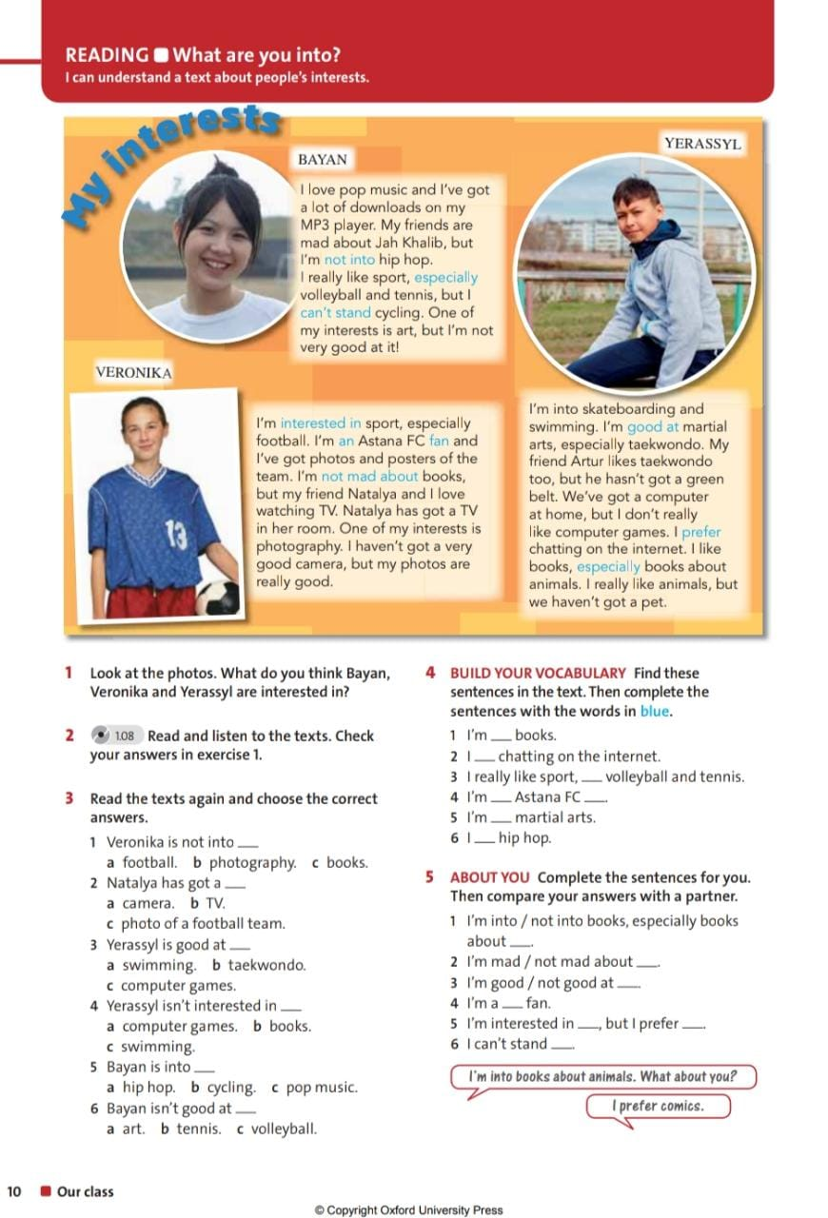  Read the text about people’s interests.  Look at the photo. What do you think Bayan, Veronika and Yerassyl are interested in? |  |  | Sts work and present a short information about this grammar rule.  Doing exercises |  |  | Emoticon  Formative assessment | ttps://onlinemektep.org/schedule/  Bilimland  Student Book p.10
End | Home task. WB p.10 ex. 5  Students express their attitude to the lesson and give self-assessment using the method: “Six thinking hats”: |  |  | Feedback  