  - School №29 named after A. Moldagulova
Out-of-class activity
Theme:
«Magic world of English language.»
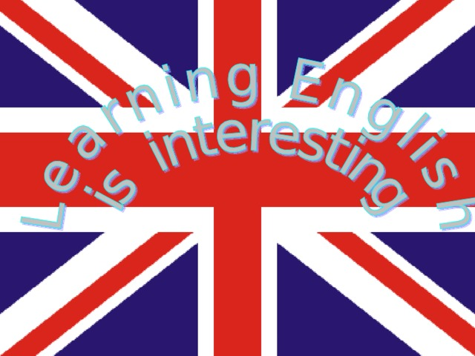

Form: 5
Date: 19.01.22
Teacher: Paiiz Zhansaya

Theme: «Magic world of English language».

Aims:
- development of thinking/ memory/ attention;
- develop pupil’s intellect imagination
- to stimulate interest in the subject;
Educational objectives:
- consolidate the knowledge of pupils on the topics studied and expand their general horizons.

Didactic materials: posters, slides, tests, cards, pictures and presents;

Types of the lesson: Competition

I. Introduction
Teacher: Good afternoon, children! I’m very glad to see you here. Now we shall organize a competition called « Magic world of English language». 2 teams will take part in a game of the most quick-witted and the cleverest.
Today all of you have a good chance to improve your English during the game.
The game has 5 contests, they are:
- The ABC Game
- Antonyms
- Parts and Holes
- In the Animal’s world
- Riddles
Well, I wish you success. Be active, honest and helpful! Remember 5 steps to success:
II. The main part
Teacher: And now we come to the 1st contest of the game called “The ABC game”. Kids, you’ll get some letters from the English alphabet. You must put the letters in the right order, to get the name of the English-speaking country. Each team can get 5 points.
(Карточки с буквами: 1. Е, N, G, L, A, N, D.,2. A, M, E, R, I, C, A).

Teacher: “Antonyms”
Our 2nd contest is Antonym. What are the opposite meaning of the words?
You will get 1 point for every right answer.
Black - white Hello - goodbye Good - bad
Yes - no Small - big New - old
Up - down Light - dark Long - short

Teacher: The 3rd contest is called “Parts and wholes”. I need 1 pupil from each team. You should combine these parts so as to get a popular name. Who will be the first? You can get 1 point for each right answer.
1. Mickey a) Claus
2. Mary b) Duck
3. Robinson c) Pooh
4. Peter d) Mouse
5. Donald e) Poppins
6. Winny-the- f) Crusoe
7. Santa g) Pan

Teacher: Our next contest is in the Animals’ world. You should name the animals in singular and plural form.
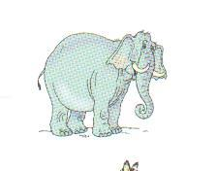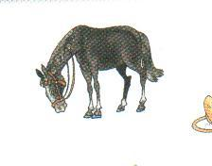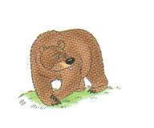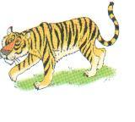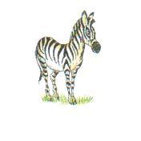
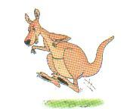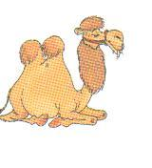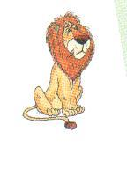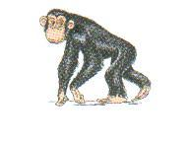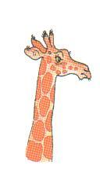

Teacher: The 5th contest is “Riddles”
Teacher: First you should listen to the descriptions of animals. Then you should choose from the collection of pictures and show me the picture of the animal as soon as you can. You will get 1 point for every right answer.
Model: It is a small animal. It likes fish. (a cat)
- It is orange. It is not big. It can run. It is very cunning. (a fox)
- This animal lives at home or in the street. It is a man’s friend. (a dog)
- It is green. It can swim and run. It can’t climb and jump. (a crocodile)
- It big and strong. It’s grey. It likes to help his friends. It lives in Africa.(an elephant)
- It’s clever. It can jump and climb. It lives in a tree. It’s very funny. (a monkey)
III. Conclusion
We have finished our competition « Magic world of English language».Thanks a lot to our participants for their active participation. I wish you success in studying English! Good bye!

