Short term plan

Unit of a long term plan: The world of work |  |  |  | School: Keller secondary school named after The Hero of The Soviet Union I.M.Berezhnoy.  Hero Soviet Union I.M.Berezhnoy  Hero Soviet Union I.M.Berezhnoy
Date: |  |  |  | Teacher name: Abdirova Saltanat Kalkamanovna
CLASS: 5 |  |  |  | Number present: |  | absent:
Lesson title |  | Professions 2
Learning objectives(s) that this lesson is contributing to (link to the Subject programme) |  | 5.L1. Understand a sequence of supported classroom instructions.  5.S4. Respond with limited flexibility at sentence level to unexpected comments on an increasing range of general and curriculum topics.  5.R7. Recognise typical features at word, sentence &text level in limited range of written genres.  5.W9. Punctuate written work at text level in a limited range of familiar general with some accuracy.  5.UE10. Use Present Continuous Forms with Pres./Future meaning on a limited range of family general & curricular topics.
Lesson objectives |  | All learners will be able to  -name types of professions;  -write questions with help of samples;  -make poster  -match the words with the pictures  Most learners will be able to  - make up 3 questions ;  - answer the open questions;  Some learners will be able to  - make up 5 questions without samples  - answer the questions with grammar accuracy  - write and tell about their future professions using Present & Future Tense
Assessment criteria |  | Recognise detailed information in a short conversation with some support
Values links |  | to respect somebody’s profession, each other, difference of view
Cross-curricular links |  | art, self-knowledge
Previous learning |  | Learners have already known types of professions and Present/Future Tenses
Plan
Planned timings | Planned activities (replace the notes below with your planned activities) |  |  |  |  |  | Resources
Start 3 min  3 min  Middle  8 min  10 min  6 min  7 min  End  4 min | Brainstorming.  Greet students. Ask students “How are you?” to find out their mood at the beginning of the lesson, students sing a song “How are you?”  Lead- in.  ( W, I )  Method "Who am I?". (eliciting )  Learners are to guess the professions using teacher's prompts, special equipment. Then say the theme of the lesson.  Introduce the lesson objectives to students.  ( I ) Written exercise with differentiated tasks.  Less able students match pictures with the words. (LOTS(remembering))   a pilot   a cooker   a vet   a teacher   a taxi-driver  More able students answer the questions using Present Continuous Tense by pictures. ( HOTS(applying))  - Who is he/she?  - Where is he / she working?  - What is he / she doing?  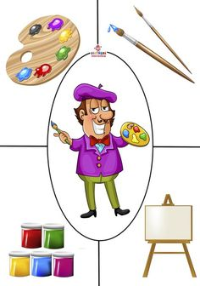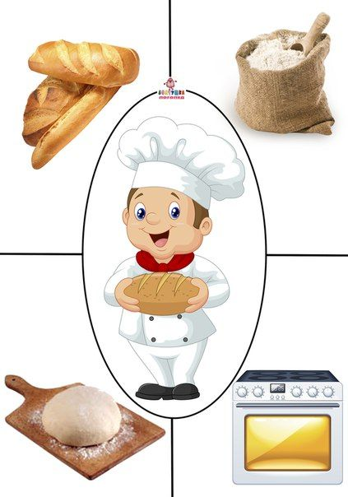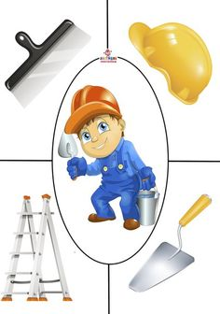  (G ) Role-play.  Divide class into two groups. Give name of one profession for each group. So the 1st group is "builders" &  the 2nd group is "doctors". Then they should make up questions to their peers' group. After this one representative from doctors’ group sits in front of class and answer teachers’ questions. Then they change roles.  ( I ) Missing words  Listen to the talk twice and complete the sentences.  CD1. Tapescript 4.  ( I ) Making a poster "When I grow up I want to be". (CLIL)  Learners should draw about that who they want to be and name of the profession, then show their poster to class and tell about it.  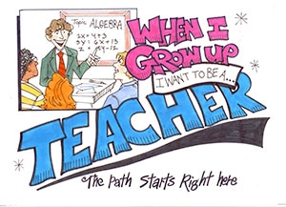  Reflection. “The muddiest point technique”  Ask students to write down what they find to be the least clear or what they disliked.  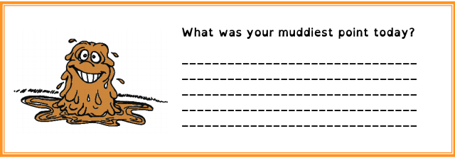 |  |  |  |  |  | PPT  Realia  Cards  Micro  Audio, handout  Postcards
Additional information
Differentiation – how do you plan to give more support? How do you plan to challenge the more able learners? |  |  | Assessment – how are you planning to check learners’ learning? |  | Health and safety check
By grouping, by task, by outcome.  Less able students are to match pictures with the words; make up questions with help of sample ; draw about their future professions and write one sentence about it.  More able students are to answer the questions using Present Continuous Tense by pictures, make up questions without sample; draw and tell about their future professions. |  |  | Formative assessment  Monitoring  Eavesdropping  Oral feedback  Peer assessment |  | Using physical exercise Jobs song (2 min )  "What do you do?"  Learners sing and dance

