Unit 6 Tradition and language  Lesson plan 60 |  |  | School: S. Serikov School
Date:05.02.20 |  |  | Teacher’s name: Pukhlova T.
Grade : 9 A |  |  | Number present:14 |  | Number absent:0
Lesson title |  |  | Reading: Marriage. p.70 “English plus” Oxford University Press Kazakhstan Edition (Ben Wetz, Diana Pye)
Learning objectives(s) that this lesson is contributing to |  | 9.S3 give an opinion at sentence level on a limited range of general and curricular topics  9.R5 deduce meaning from context in short texts on a limited range of familiar general and curricular topics  9.R6 recognize the attitude or opinion of the writer in short texts on a limited range of general and curricular topics  9.R7 recognize typical features at word, sentence and text level in a limited range of written genres  9.W8 spell most high-frequency words accurately for a limited range of general topics of familiar general topic  9.S7 use appropriate subject-specific vocabulary and syntax to talk about a limited range of general topics
Lesson objectives |  | All learners will be able to:  - Identify the theme, new words and use them as the basis for discussion.  - Demonstrate knowledge for usage of the Present Simple for retelling a story about arranged marriage. Transfer information from the given information into a graphic organizer.  Most learners will be able to:  - Select, compile, and synthesize information for an oral presentation  - Provide a point of view in conversations and discussions; speak about arranged marriages using active vocabulary.  Some learners will be able to:  - Respond to and discuss the reading passage using interpretive, evaluative and creative thinking skills.  - Make a presentation about marriages indifferent countries. Respond to and discuss the reading passage using interpretive, evaluative and creative thinking skills.
Value links |  | Cooperation, respect each other's opinion, support, functional literacy.
Cross curricular links |  | Social Science, Psychology, Information Technology, Geography, Biology.
Previous learning |  | Talking about traditional stories.
Use of ICT |  | Smart board for showing a presentation, getting additional information, playing the audio files.
Intercultural awareness |  | Students will be able to understand that people should keep their traditions and customs.
Health and Safety |  | Breaks and physical activities used.  Everyday classroom precautions will ensure that safety measures are provided to prevent the exposure of electrical power cords.
Plan
Planned timings | Planned activities |  |  | Resources
Beginning of the lesson  7 min. | The lesson greeting.    The teacher sets the lesson objectives, letting students know what to anticipate from the lesson.  We are going to read, listen and discuss some facts about love, marriage and arranged marriages using new words and our creative thinking skills.   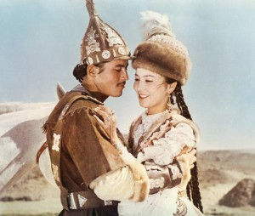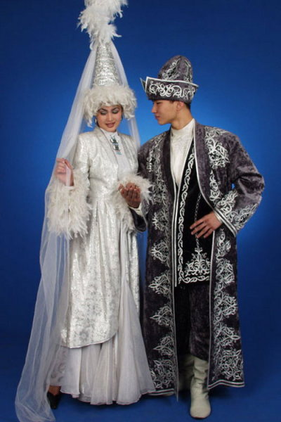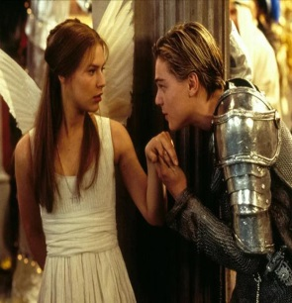  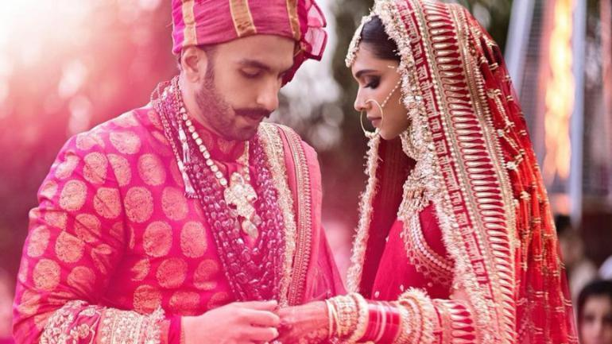  Warm up. Brainstorming  On the board you can see the words: LOVE-МАХАББАТ  Have you ever heard English or American (Kazakh)songs about love?  What words can tell us that they are about love? (Sweet. Honey, Dear, My heart, forever, My soul, Marriage, жаным, айналайын, арманың сезің)  Do you like to listen songs about love?  What is a first date?  What is a blind date?  How will you choose your future husbands /wives? |  |  | Slide (useful phrases)  Pictures  PPT  Slides, music
Main  Activities  15 min. | Before we start speaking about marriages will you discuss the following statements?(in groups Boys and girls).  How much do you know the difference between men and women? (True/False)  - Women are more romantic than men.  - Women fall in love faster than men do.  - Women tend to suffer more from a breakup than men do.  - When in love, women tend to reveal more of their feelings than men do.  - Women fall in love slower than men do.  - Women get the blues more often than men do.  - The rate of the suicide is higher among women than among men.  - Women are shier than men.  - Women daydream more often than men.  - If a woman exercised as often and with as much intensity as a man, she would develop muscle strength equal to that of a man.  1. False. New studies show that men are more romantic than women.  2. False. According to the latest research, men tend to fall in love faster and out of love more slowly than women.  3. False. Men suffer more, probably, because they don’t like to confide in someone about their emotions.  4. False. Men and women differ little in how much they are willing to reveal about themselves. They do differ, however, in the kinds of things they say. Men are more willing to reveal their strong points than their weak points. Women tend to disclose their weakness, their feelings about others.  - 5. False. Men tend to fall out of love more slowly than women.  - 6. True. Women suffer depression more often than men.  - 7. False. The suicide rate is higher among men than women.  - 8. False. Studies show that shyness is found equally among men and women.  - 9. False. There are very few differences between men and women in how often and where they daydream.  - 10. False.  ARRANGED MARRIAGE  What do you think about it?  - Arranged marriage were common in Europe in the past, especially among members of Royal families and aristocracy. In modern Britain, arranged marriage can be an important issue for young people who have grown up in Britain, but whose parents come from cultures where arranged marriages are expected. There can be a clash of cultures between young people who would prefer a “love marriage” and their parents, who want to arrange a marriage for them. “ Forced marriage”, in which a person is married without giving his/her agreement , is against law.  What about you? What do you prefer-“a love marriage” or “an arranged marriage”?  LISTENING TASK:  Look at the title and the photo.  Listen to the text and express your opinions using your own words.  Summarize each paragraph in one or two sentences:  Ex.2 p.70 True - false sentences.  Vocabulary work: find verbs with prepositions and make your sentences. Ex. 3 - 4 p.70.  Verb Preposition  Reading.  Here is a story for you to read. Think the title of the story. After reading the story, please, rank the characters from one to five (from the worst to the best one).  A girl  A wise man  A boatman  A rich man  A poor man  Once upon a time there was a beautiful girl who lived on the shore of the lake. She lived in a big house and had lots of nice dresses and jewelery. There were two young men who loved her. One of them was rich, the other was poor. They lived on the opposite shore of the lake. Both of them wanted to marry her. Each promised to give her his love if she crossed the lake to be with him.. Unfortunately, there was no bridge over the lake. So she went to the boatman to take her across. He said it was very dangerous to do and asked a lot of money for the voyage. The girl didn’t know what to do. She went to the wise man to ask for advice. The wise man said to her: ”Don’t listen to anyone. Listen to your heart and it will show you the best way”. The girl sold her big house, her nice dresses, her jewelery and gave the money to the boatman. He took the money and delivered her to the arms of the poor man. When she told him that she had sold everything in order to cross the lake, the poor man said that he couldn’t marry her then. Because she had no house, no nice dresses.,no jewelery. Heartsick and dejected, the girl went to the rich man and told him everything. The rich man was very angry and said that he couldn’t marry her because she went to the poor man first, At last, the girl realized that…….(finish the story)  If you put 5 to a girl-you are loving(1- you are afraid of love)  If you put 5 to a wise man-you are clever(1-you are afraid of being clever)  If you put 5 to a boatman-you are enterprising(1-you are afraid of being enterprising)  If you put 5 to a rich man-you are proud(1-you are afraid of being proud)  If you put 5 to a poor man-you are greedy(1-you are afraid of being greedy) |  |  | Group work  Writing  Worksheet  Checking (Active Board)  Presentation “ What do you know about these famous people? Is he (she) married?  What’s her name?  Her name is Alla Pugachova  Is she married? Yes, she is.  Who’s her husband? Heis Maxim Galkin……  Whole class  Teacher’s Book p.92 Background.  Student Book p.70  Ex.1  Pair work  Individual work  Checking on the Active board
Ending the lesson  3 min. | Giving the home task: S.B. Ex 5 p.70  Students express their attitude to the lesson and give self-assessment using the method: “Six thinking hats”:  - Green: How can you use today's learning in your life?  - Red: How do you feel about your work today?  - White: What have you leant today?  - Black: What were the weaknesses of your work?  - Blue: How much progress have you made in this lesson? (Now I can, I still need to work on, I've improved in, Today I learnt... )  Yellow: What did you like about today's lesson?  Slide (Homework)  Slide "Six thinking hats"  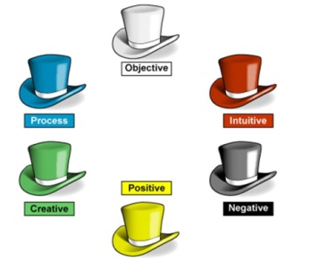
Differentiation –  how do you plan to give more support? How do you plan to challenge the more  able learners? |  |  | Assessment –  how are you planning to check students’ learning? |  |  | Critical thinking
Differentiation can be achieved through the selection of activities, identification of learning outcomes for a certain student, provision of individual support to learners, selection of learning materials and resources based on the individual abilities of learners. |  |  | Assessment criteria:  Identify the main idea in extended talks with little support.  Apply topic related vocabulary in speech appropriately arranging words and phrases into well-formed sentences.  Demonstrate the ability to participate in a conversation.  Descriptor:  A learner:  - selects an appropriate answer.  - completes the task.  - uses appropriate subject-specific vocabulary while speaking.  - discusses questions and answers the questions within the group.  - Observation  Feedback on the work  Peer-assessment |  |  | Students think critically, exploring, developing, evaluating and making choices about their own and others’ ideas
ПОЯСНИТЕЛЬНАЯ ЗАПИСКА
К плану урока английского языка в 9 классе по теме “Unit 6. “Tradition and Language. Marriage” Grade 9 Student’s book “English plus”

Тема урока соответствует содержанию образования, учебной программе, календарно-тематическому планированию.
Тема любви и отношений актуальна для учащихся этого возраста. У них сейчас сложный период в жизни, когда они находятся в конфликте с миром и для них важно обсуждать насущные для них проблемы.
Комплекс упражнений адекватен поставленной цели урока. Материал текста и упражнений является содержательны и соответствует возрастным интересам. Презентация слайдов с музыкой и ответы на вопросы о знаменитостях настраивают детей на атмосферу иноязычного общения и способствуют созданию положительного микроклимата. Дети должны не стесняться высказывать свое мнение.
Что касается соотношения упражнений, преобладают творческие упражнения. В процессе урока учащими должны быть выполнены упражнения: призванные помочь школьнику выделять основную мысль текста, смысловые связи, логику построения и которые подводят учащихся к осознанию текста как образца высказывания и упражнения , целью которых является- стимулировать учащихся выражать отношение к тексту и отраженной в нем проблеме.
Все упражнения работают на совершенствование лексических навыков по теме урока.
Последовательность выполнения упражнений соответствует стадиям формирования навыков и умений. На уроке используется групповая, парная, индивидуальная работа.
Тема урока интересна подросткам, и каждый может высказаться. Содержание материала является личностно- ориентированным и способствует желанию поделиться своим мнением. Учитель рационально распределила время на уроке. В конце урока учащимися выполняется задание на само-оценивание с помощью метода «6 шляп». Этап рефлексии имеет важное значение для получения обратной связи.

Анализ урока английского языка в 9-А классе «Traditions and languages. Marriage» учитель Пухлова Т.Ю. 05.02.20

Учитель эффективно составила цели урока, сочетая с репродуктивными задачами. Тема урока соответствует содержанию образования, учебной программе, календарно-тематическому планированию.
Учитель начинает урок с фраз повседневного общения, ставит перед учащимися цели. На доске нарисованы 2 сердца, ученики должны ответить какие слова используются в английских и казахских песнях о любви, и записать известные им слова на английском и казахском языке в форме кластера.
Комплекс упражнений адекватен поставленной цели урока.
Тема любви и отношений актуальна для учащихся этого возраста. У них сейчас сложный период в жизни, когда они находятся в конфликте с миром и для них важно обсуждать насущные для них проблемы.
Материал текста и упражнений содержателен и соответствует возрастным интересам. Дети заполнят анкету в группах «What do you know about opposite sex"и сравнивают свои ответы. Этим самым достигается воспитательная цель.
Презентация слайдов с музыкой и ответы на вопросы о знаменитостях настроят детей на атмосферу иноязычного общения и будут способствовать созданию положительного микроклимата. Дети не должны стесняться высказывать свое мнение.
Что касается соотношения упражнений, преобладают творческие упражнения. В процессе урока учащими будут выполнены упражнения: призванные помочь школьнику выделять основную мысль текста, смысловые связи, логику построения и которые подводят учащихся к осознанию текста как образца высказывания и упражнения , целью которых было стимулировать учащихся выражать отношение к тексту и отраженной в нем проблеме.
Все упражнения работают на совершенствование лексических навыков по теме урока.
Последовательность выполнения упражнений соответствует стадиям формирования навыков и умений.
Урок является целостным, динамичным, связным.
С помощью наводящих вопросов личностно-ориентированного направления и проблемных заданий стимулировалась внутренняя (мыслительная) активность учащихся;
С помощью ответов на вопросы, наводящих вопросов, в упражнениях, где ученики подбирали правильные варианты ответов, эквиваленты и обменивались мнениями, стимулировалась внешняя (речевая)активность учащихся;
Учитель использовала возможности для стимулирования речемыслительной активности.
На уроке использовались групповая, парная, индивидуальная работа. Учитель уделяла внимание ученикам с невысоким уровнем успеваемости. Она давала специальные задания, ориентированные на уровень таких учеников. Таким образом, каждый школьник внес свой вклад в организацию урока.
Учитель подбадривала учеников, если они стеснялись отвечать, стимулировала их активность. Учитель также использовала слова-поощрения:
Well done, Very good, Thank you, Yes, you are right, Good job, Good for you;
На уроке создавались условия для интеллектуальной напряженности, но ученики были обеспечены средствами ее снятия с помощью ключей . Оценивание деятельности включало взаимо- и самооценку, показывалась успешность выполнения задания.
Учитель использовала презентацию для объяснения и вовлечения всех учащихся в процесс работы, раздаточный материал.
Учитель затрагивала интеллектуальную и эмоциональную сферы учащихся. Тема урока была интересна подросткам, и каждый хотел высказаться. Содержание материала было личностно ориентированно и способствовало желанию поделиться своим мнением.
Судя по результатам урока и настроению учащихся, учебная цель была достигнута. В качестве домашнего задания нужно будет продолжить тему урока при ответе на вопросы.

Учитель рационально распределила время на уроке. В конце урока учащиеся выполняли сами оценили свою работу на уроке с помощью метода «6 шляп». Этап рефлексии имел важное значение. Учитель задала домашнее задание, и поблагодарила за участие в дискуссии.
Учитель давала четкую установку на выполнение всех упражнений.
Она смогла занять работой всех учеников и оценить каждого. Учитель использовала разные приемы исправления ошибок: наводящие вопросы, схемы.
Через монолог учеников, через диалог учителя и учеников, с помощью парной и групповой работы на уроке поддерживается атмосфера общения.
Поведение учителя можно расценивать как демократическое, учитель всегда была готова помочь учащимся, предваряла ошибки, подбадривала и хвалила.
Поведение учителя способствовало достижению целей урока. Учитель была доброжелательной и спокойной, но в то же время требовательной. Это создавало благоприятную почву для работы на уроке. Учитель проявляла актерские качества.
Речь учителя была выразительна. К родному языку он обращался в редких случаях, в основном, общение было на английском языке.

У учеников совершенствовались лексические навыки по теме:
«Traditions and language. Marriage», совершенствовались навыки чтения, грамматические навыки по использованию Present Simple для пересказа текста, а также развились произвольное внимание, слуховая память, логическое мышление, наблюдательность и догадка.

