7 The natural environment |  |  |  | School: Chkalov boarding school
Date: |  |  |  | Teacher name: IskakovaK.K
CLASS: 2 |  |  |  | Number present: |  |  | absent:

Theme of the lesson: Seasons and weather
Learning objectives(s) that this lesson is contributing to |  |  | 2.S3 pronounce familiar words and expressions intelligibly  2.R3 recognise and identify some familiar sight words from local environment
Lesson objectives |  |  | Learners will be able to:
- name four seasons
- recognise short basic instructions
- identify objects
- describe the pictures
Success criteria |  |  | Learners have met this learning objective R3, if they can recognise four seasons and identify 6-8 season pictures.
Value links |  |  | - Cooperation Respect : when students work in pairs, they will learn to be polite and respectful to each other
Cross curricular  links |  |  | - Knowledge of the world  - Art
ICT skills |  |  | - Smart board
Previous learning |  |  | Basic vocabulary for talking about the weather and seasons
Plan
Planned timings | Planned activities (replace the notes below with your planned activities) |  |  |  |  | Resources
Beginning | ORGANIZATIONAL MOMENT  Teacher: Good morning, boys and girls!  Pupils: Good morning!  Good morning!  Good morning to you!  Good morning!  Good morning!  We are glad to see you!  Teacher: I am glad to see you, too!  Today we will be learning about the four seasons.  WARM  Teacher has leaves in hands. Leaves are green, yellow, red brown. Teacher demonstrate them to pupils. They are to guess the theme of lesson.  Teacher presents the theme of the lesson Seasons and the weather.
Middle | INTRODUCTION  Teacher asks pupils to compare the leaves and separate them into four similar characteristic categories.  Pupils make four groups of different colours: yellow leaves, green leaves, red leaves and brown leaves.  Teacher: They are four seasons!  Teachers comments:  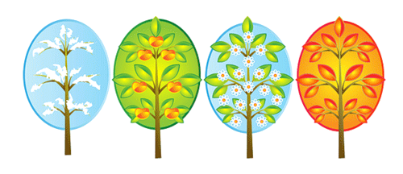  Spring has light green leaves on the trees  Summer has dark green leaves on the trees.  Autumn has yellow leaves on the trees.  Winter has brown leaves or no leaves on the trees.  Pupils get papers, magazines, then shows how to cut leaf shapes from the coloured paper.  Teacher gives pupils the task  1. draw a tree outline on the sheet of paper or poster.  2. cut flowers from the or flower shapes from the coloured paper.  3. paste leaves and fruit on the tree  SPEAKING  Learners describe their trees.  The tree is yellow. It is autumn.  LISTENING  Ex.9 p.92 Listen and draw lines.  Teacher reads the dialogue.  Answer  1.Berik like spring  2.Dana likes winter  3.Assel likes summer  4.Kairat likes winter  GIVING HOMEWORK EX.11 p.93  ASSESSMENT  Learners match one season name and two season pictures.  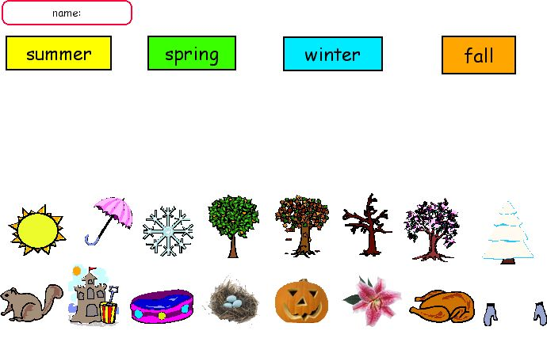 |  |  |  |  | Pictures with trees  Four seasons picture
End | FEEDBACK  Evaluation of the lesson by means of oral feedback from students – images of smiles.  Teacher asks guiding questions:  - Can you name four seasons?  - Can you describe trees?  - Do you know colours of seasons?  - Can you recite a poem about seasons? |  |  |  |  | Images of smiles
Additional information
Differentiation – how do you plan to give more support? How do you plan to challenge the more able learners? |  |  | Assessment – how are you planning to check learners’ learning? |  | Health and safety check  ICT links
- More support will be given to weaker learners by giving them a modified worksheets in some tasks with greater support |  |  | - Through feedback task  - through observation of pair working  - through formative task |  | - White board is used no more than 10 minutes  - Use water based pens  - Health promoting techniques  - Breaks and physical activities used.  - Points from Safety rules used at this lesson.  - Use video 10 minutes
Reflection  Were the lesson objectives/learning objectives realistic?  What did the learners learn today?  What was the learning atmosphere like?  Did my planned differentiation work well?  Did I stick to timings? What changes did I make from my plan and why? |  | Use the space below to reflect on your lesson. Answer the most relevant questions from the box on the left about your lesson.
Summary evaluation

What two things went really well (consider both teaching and learning)?

What two things would have improved the lesson (consider both teaching and learning)?

What have I learned from this lesson about the class or individuals that will inform my next lesson?

