Short term plan

Unit of a long term plan All about me |  |  |  | School: № 4, Zhitikara
Date: 22.06.2018 |  |  |  | Teacher name: Minyailo Elena Vyacheslavovna
CLASS: 2 |  |  |  | Number present: |  |  | absent:
Lesson title |  | My clothes and things
Learning objectives |  | S1 make basic statements related to personal information, people and objects on familiar topics and classroom routines.  L1 understand a range of short basic supported classroom instructions.  UE use common adjectives in descriptions and to talk about simple feelings.
Lesson objectives |  | All learners will be able to give personal information on the topic “My clothes and things” in 2-3 sentences using active vocabulary (dress, skirt, shorts, T-shirt, jeans, hat, gloves, sunglasses, boots, jacket ) and common adjectives in descriptions paying attention to the short basic supported classroom instructions.  Most learners will be able to describe clothes, people and objects on the topic “My clothes and things” in 4-5 sentences using active vocabulary (dress, skirt, shorts, T-shirt, jeans, hat, gloves, sunglasses, boots, jacket) and common adjectives in descriptions paying attention to the short basic supported classroom instructions.  Some learners will be able to select and compare the information about different people and things on the topic “My clothes and things” in 6-7 sentences using active vocabulary (dress, skirt, shorts, T-shirt, jeans, hat, gloves, sunglasses, boots, jacket ) and common adjectives in descriptions paying attention to the short basic supported classroom instructions.
Assessment criteria |  | Learners can give personal information on the topic “My clothes and things” and describe people and objects using active vocabulary (dress, skirt, shorts, T-shirt, jeans, hat, gloves, sunglasses, boots, jacket) and common adjectives in descriptions paying attention to the short basic supported classroom instructions.
Values links |  | “Mangilik Yel” – Common history, culture and language; cooperation, polite, respect, help, encourage.
Cross-curricular links |  | Kazakh language, Russian language, Art and Technology.
Previous learning |  | - active vocabulary (dress, skirt, shorts, T-shirt, jeans, hat, gloves, sunglasses, boots, jacket;);  - revision of colours;  - structure I’m wearing…, He/She is wearing…
Plan
Planned timings | Planned activities |  |  |  |  | Resources
Start  5 min | - Greeting: use three languages (English, Kazakh, Russian)  - Learner’s attention level: active method “Show me your mood”  In a circle learners show and say about their mood and feelings at the beginning of the lesson.  - Identifying the theme: active method “Choose the odd”  In three free groups learners circle the odd word. All chosen words are connected with the topic of the lesson “My clothes and things”  - Identifying the lesson objectives: at the end of the lesson learners will be able to give personal information on the topic “My clothes and things” in 2-3 sentences using active vocabulary (dress, skirt, shorts, T-shirt, jeans, hat, gloves, sunglasses, boots, jacket ) and common adjectives in descriptions paying attention to the short basic supported classroom instructions. |  |  |  |  | Appendix 1  PPT slide 1
Middle  3 min  5 min  2 min  5 min  2 min  7 min  6 min | - Revision of active vocabulary: active method “Inside and outside cirlce”  Learners in outside circle follow the trail in a clockwise direction and ask their partners in inside circle the words in Russian on the topic “My clothes and things”. In a minute learners in inside circle follow the trail in a clockwise direction and ask their partners in outside circle the words in English on the topic “My clothes and things”.  Assessment: through observation of the teacher and praising words  - Audio script “Look at my new blue hat”  Listen, sing and tick ( )  Learners listen to the track and sing a song. They listen to the music twice then do the task. Learners circle the correct picture in sheets of answers.  Checking up in pairs using PPT slide 2  Assessment: draw a smile    You are great! Not so good!  - Division into groups: active method “Puzzles”  Learners are divided into three groups making up the pictures of Scottish, Kazakh and Russian national costumes.  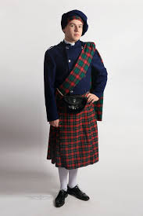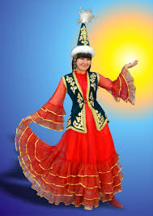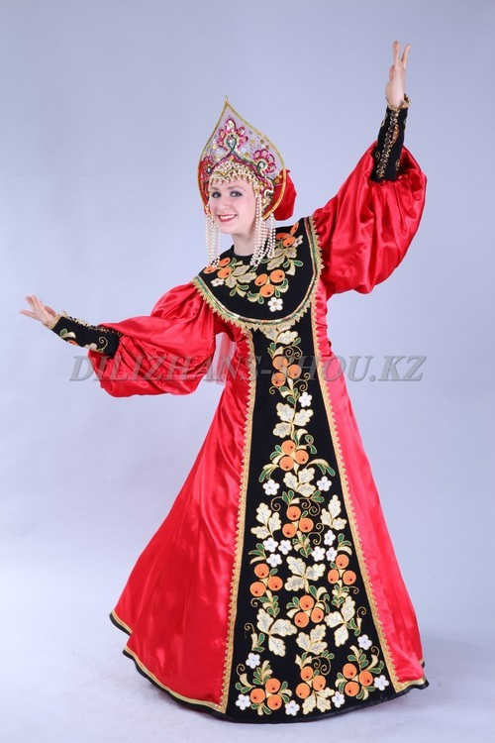  - Work in groups: active method “Domino”  Finish the sentence I’m wearing … adding the word combinations in a correct order.  Every group of learners has different word combinations. They should speak using active vocabulary.  E.g.: I’m wearing a blue hat.  Assessment: active method “2 claps”  1 clap – the answer is correct  2 claps - the answer is wrong  - Dynamic pause: active method “Show and say”  Learners repeat after teacher the sentence and show the clothes 2-3 times. (I’m wearing a hat. I’m wearing a skirt. I’m wearing boots. I’m wearing glasses.) They are shown incorrect clothes The task for learners is to be attentive and show the correct clothes 4-5 times.  - Differentiation (individual tasks by abilities and objectives)  Learners choose one task which they will be able to do.  - Presentation of answers  Formative assessment: active method “Big finger” |  |  |  |  | Smiles 2 Pupil’s Multi- ROM (Pupil’s CD/DVD track 30)  Appendix 2 (Smiles 2 Activity book, p. 87)  PPT slide 2  Appendix 3  PPT slide 3  Appendix 4  PPT slide 4  Appendix 5  PPT slide 5
  красные перчатки | blue hat | синяя шляпа | green jeans | зеленые джинсы | pink skirt | розовая юбка | black glasses
  черные очки | yellow scarf | жёлтый шарф | brown boots | коричневые ботинки | red gloves
  level | Tasks | Descriptors | Objectives
  A | Color, circle and say. | Learners color the picture, circle the correct word and make up 2-3 sentences using active vocabulary | give personal information on the topic “My clothes and things” in 2-3 sentences using active vocabulary (dress, skirt, shorts, T-shirt, jeans, hat, gloves, sunglasses, boots, jacket; colours; structure I’m wearing… )
  B | Read, color and describe. | Learners read the information, color the pictures correctly and describe these pictures in 4-5 sentences | describe clothes, people and objects in 4-5 sentences using active vocabulary (dress, skirt, shorts, T-shirt, jeans, hat, gloves, sunglasses, boots, jacket; colours; structure I’m wearing… )
  C | “Vienn Diagram” | Learners compare 2 pictures and find common and different things I 6-7 sentences | select and compare the information about different people and things on familiar topic in 6-7 sentences using active vocabulary (dress, skirt, shorts, T-shirt, jeans, hat, gloves, sunglasses, boots, jacket; colours; structure I’m wearing…, He/She is wearing… )
End  5 min | - Reflection: active method “Traffic light”  Learners choose one paper of different colour.  Red – I’m excellent! I know the theme!  Yellow – I’m so, so! I should revise!  Green – I’m sad! I need a help!  “Craft activity”  With the help of fingers learners tear a figure of a man looking at the teacher’s example.  - Home task  Cut or tear clothes and things for the figures using active vocabulary.  - Good bye in three languages (English, Kazakh, Russian) |  |  |  |  | PPT slide 6
Additional information
Differentiation – how do you plan to give more support? How do you plan to challenge the more able learners? |  |  | Assessment – how are you planning to check learners’ learning? |  | Health and safety check
Since 23 to 35 minutes of the lesson is differentiation.  It can be achieved by selection of learning materials and resources based on the individual abilities of learners (Theory of Multiple Intelligences by Gardner).  Low- motivated learners color, circle and speak.2-3 sentences.  Middle- motivated learners read, color the pictures correctly and describe these pictures in 4-5 sentences.  High- motivated learners compare 2 pictures and find common and different things (“Vienn Diagram”) 6-7 sentences. |  |  | - through observation  - praising words  - formative assessment (“Smiles”, “2 claps”, “Big finger”, “Traffic light”) |  | - health saving instructions  - physical exercise (dynamic pause)  - division into groups  - using ICT technology no more than 15 minutes

Appendix 1

1 group

apple hat banana apricot

2 group

dog elephant monkey T-shirt

3 group

sister family jeans mother

Appendix 2

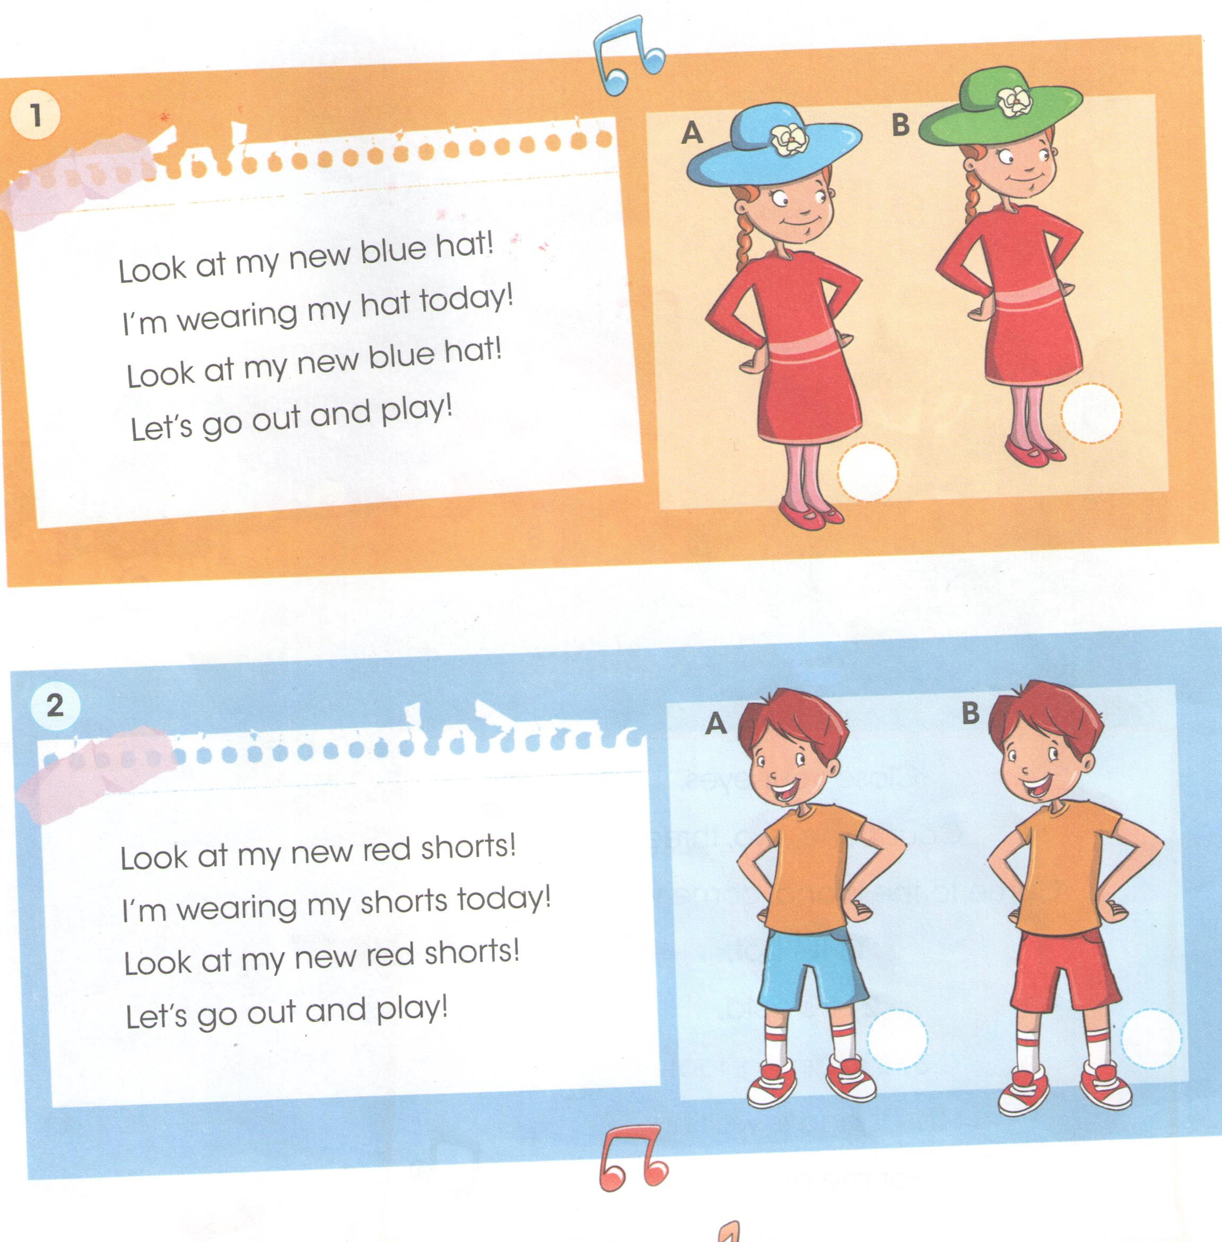

Appendix 3

Appendix 4

“DOMINO”

1 GROUP
красные перчатки | blue hat
синяя шляпа | green jeans
зеленые джинсы | pink skirt
розовая юбка | black glasses
черные очки | yellow scarf
жёлтый шарф | brown boots
коричневые ботинки | red gloves

2 GROUP

синие перчатки | pink hat
розовая шляпа | brown jeans
коричневые джинсы | red skirt
красная юбка | black glasses
черные очки | green scarf
зеленый шарф | white boots
белые ботинки | blue gloves

3 GROUP

розовые перчатки | yellow hat
желтая шляпа | blue jeans
синие джинсы | red skirt
красная юбка | brown glasses
коричневые очки | white scarf
белый шарф | black boots
черные ботинки | pink gloves

Appendix 5

Level A

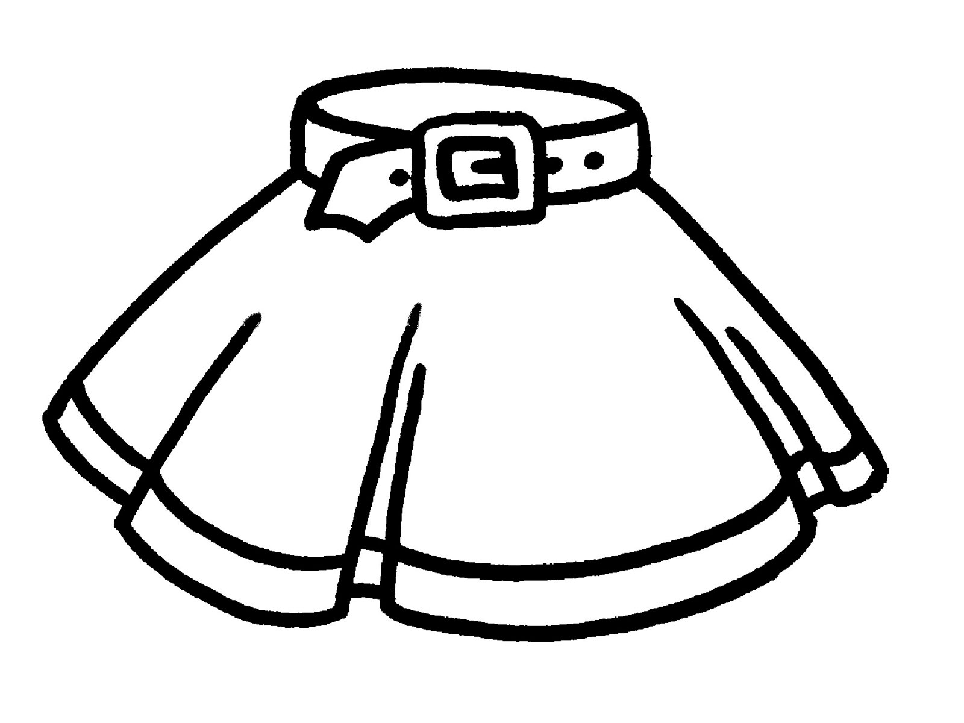
shorts / skirt 1
2
3

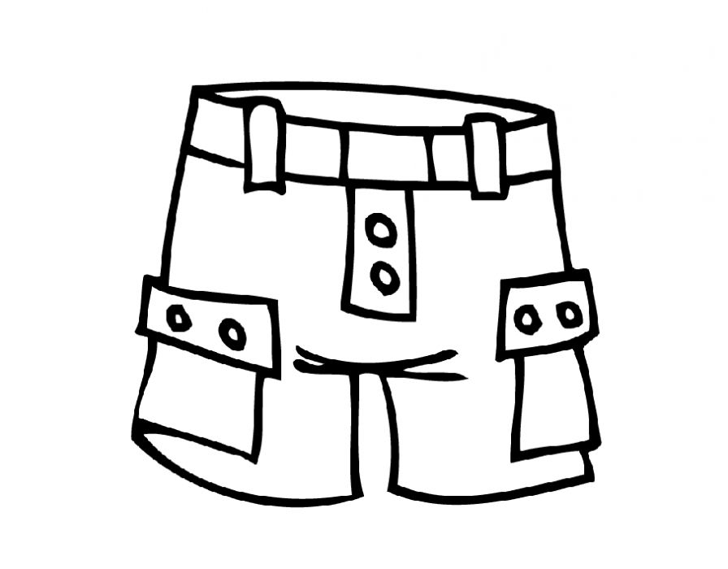
shorts / skirt 1
2
3

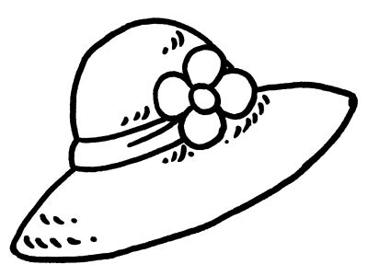
dress / hat 1
2
3

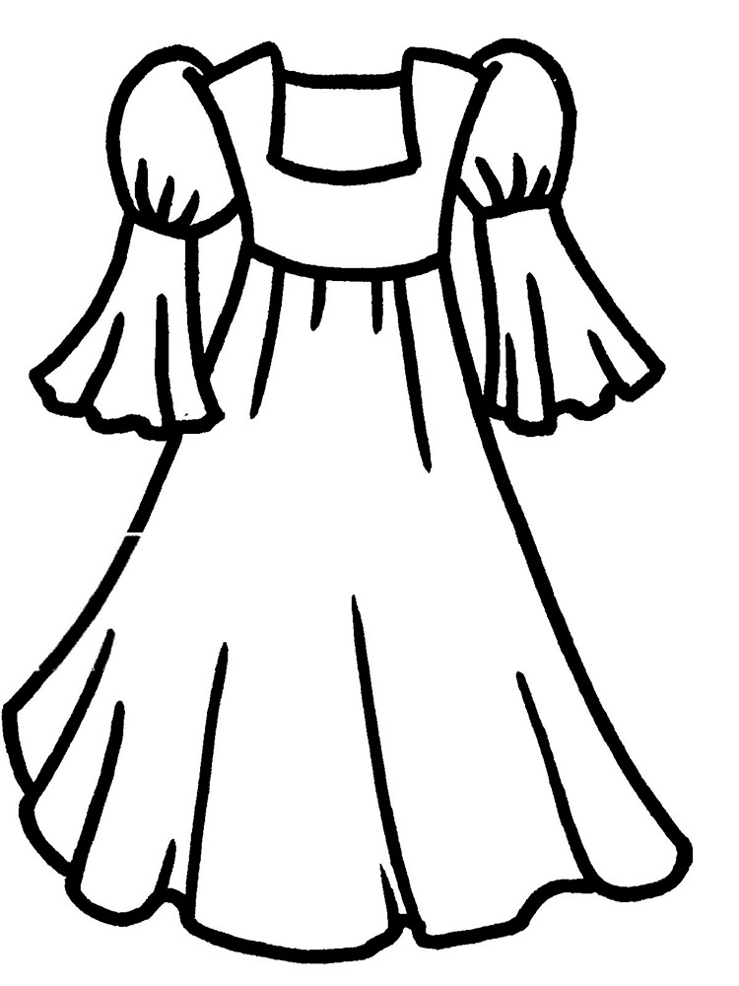
dress / hat 1
2
3

Level B
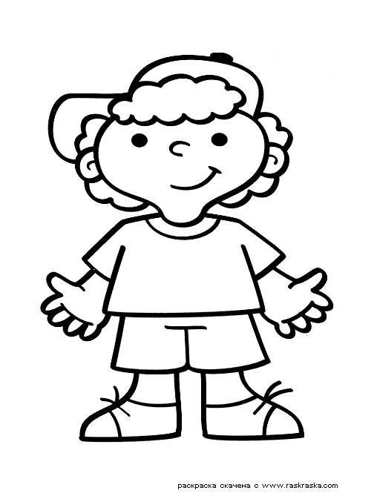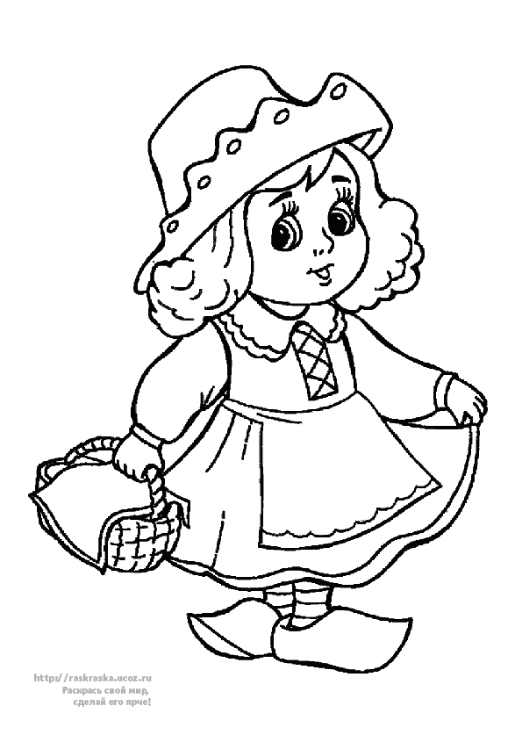
This is a boy. His name is Mark. He is wearing a yellow T- shirt and blue shorts. His boots are brown.
This is a girl. Her name is Aigul. She is wearing a red hat and a green dress. Her boots are pink.
1. 2. 3. 4. 5.

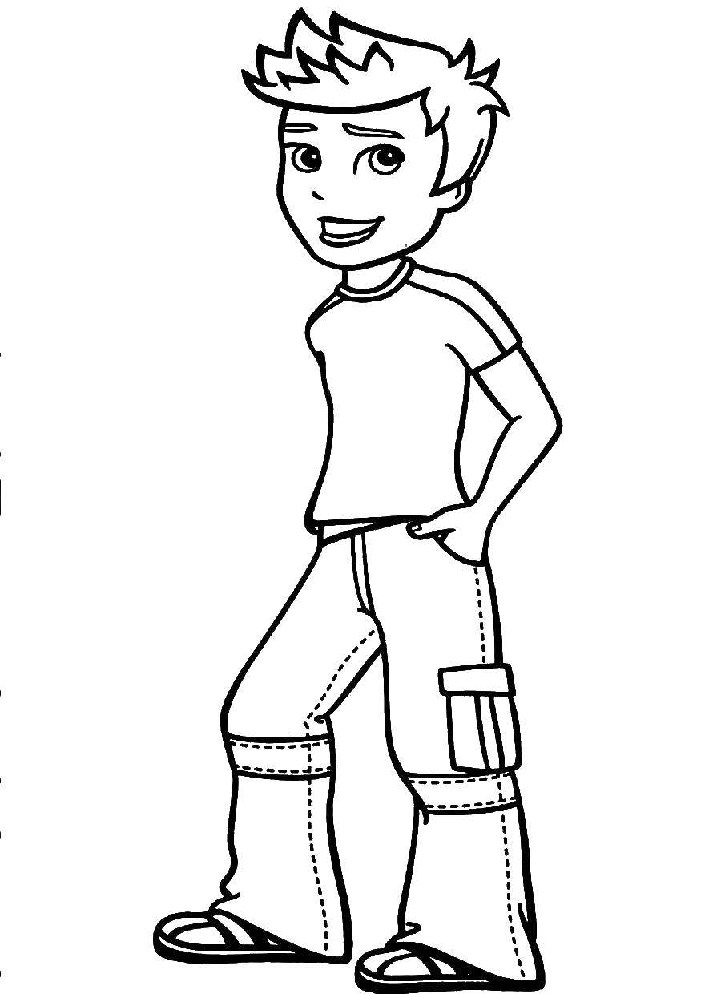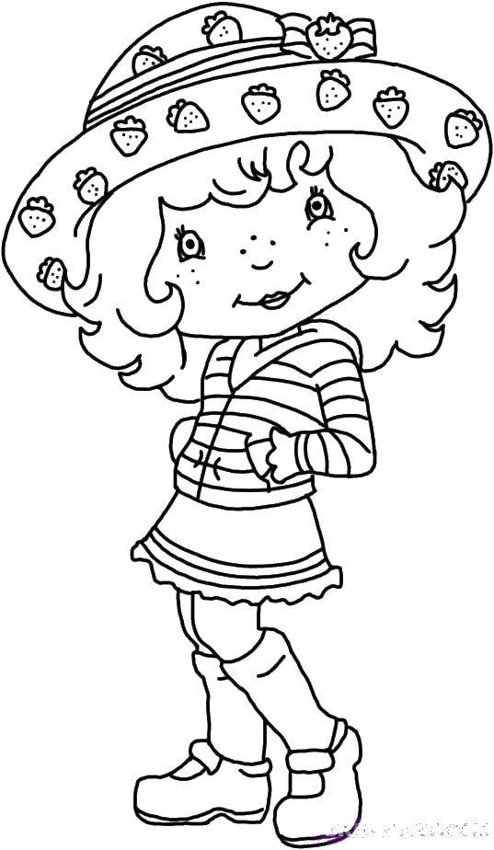
This is a boy. His name is Steve. He is wearing a green T- shirt and grey jeans. His boots are black.
This is a girl. Her name is Helen. She is wearing a yellow hat and a red skirt. Her jacket is blue.
1. 2. 3. 4. 5.

Level C
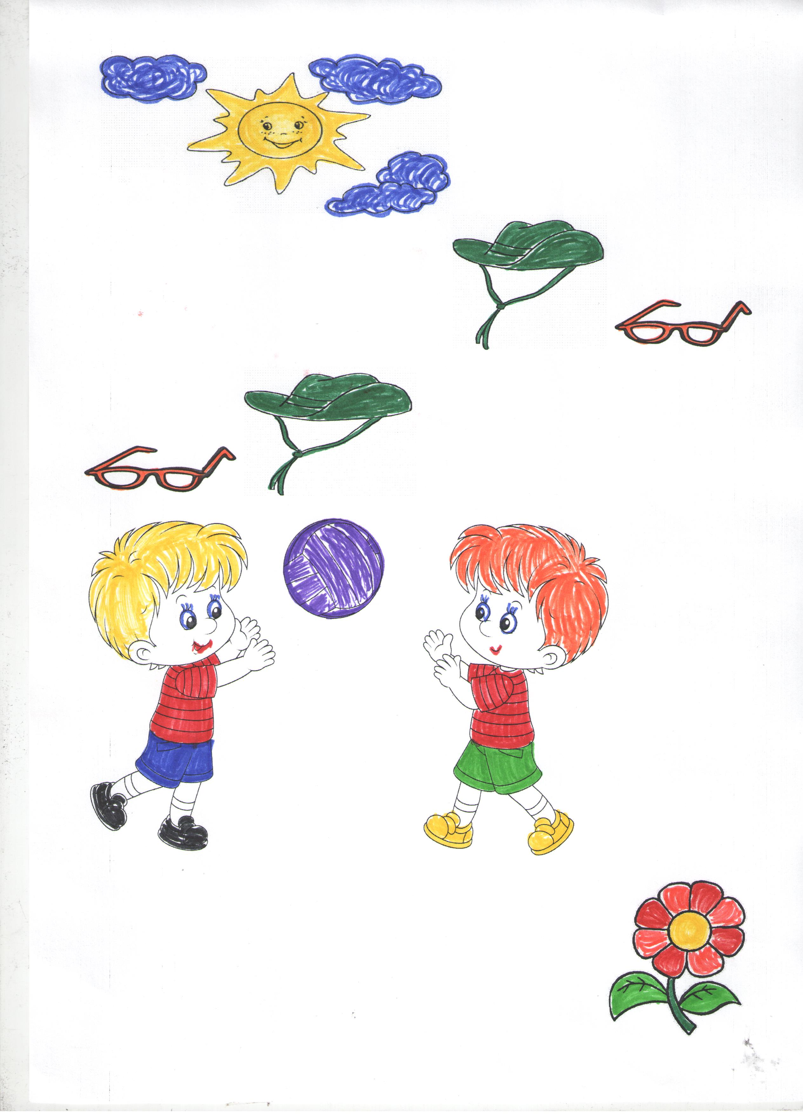

PPT slide 1

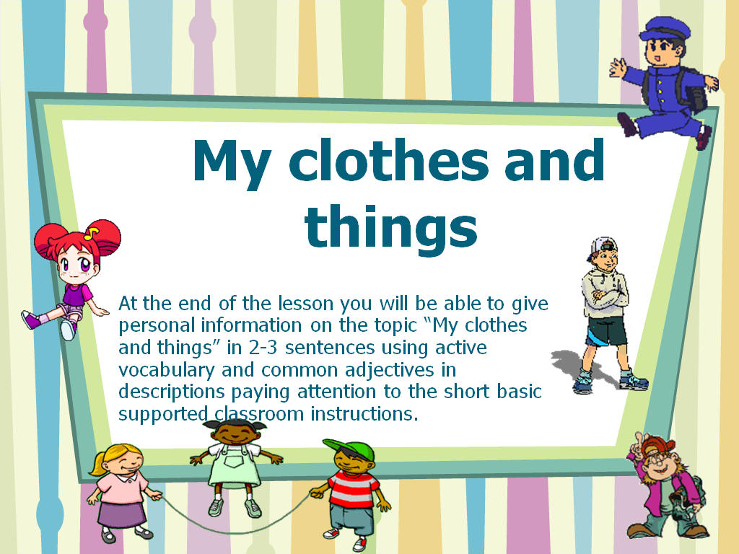

PPT slide 2

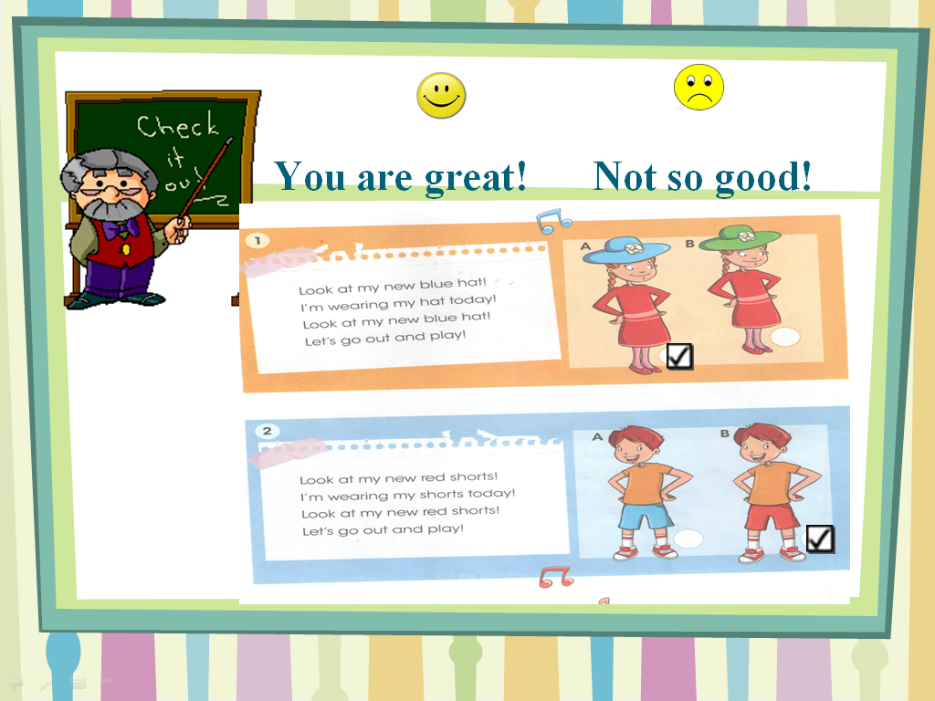

PPT slide 3

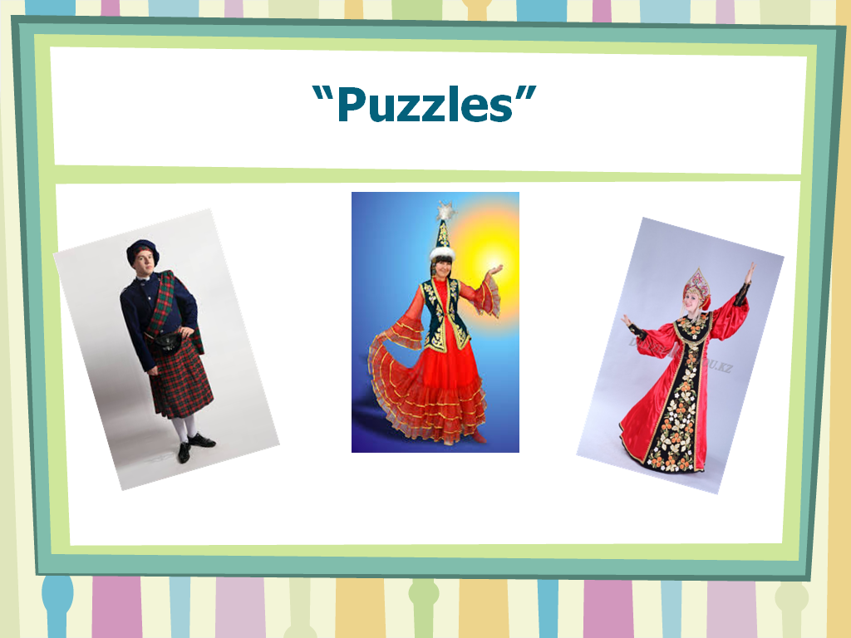

PPT slide 4

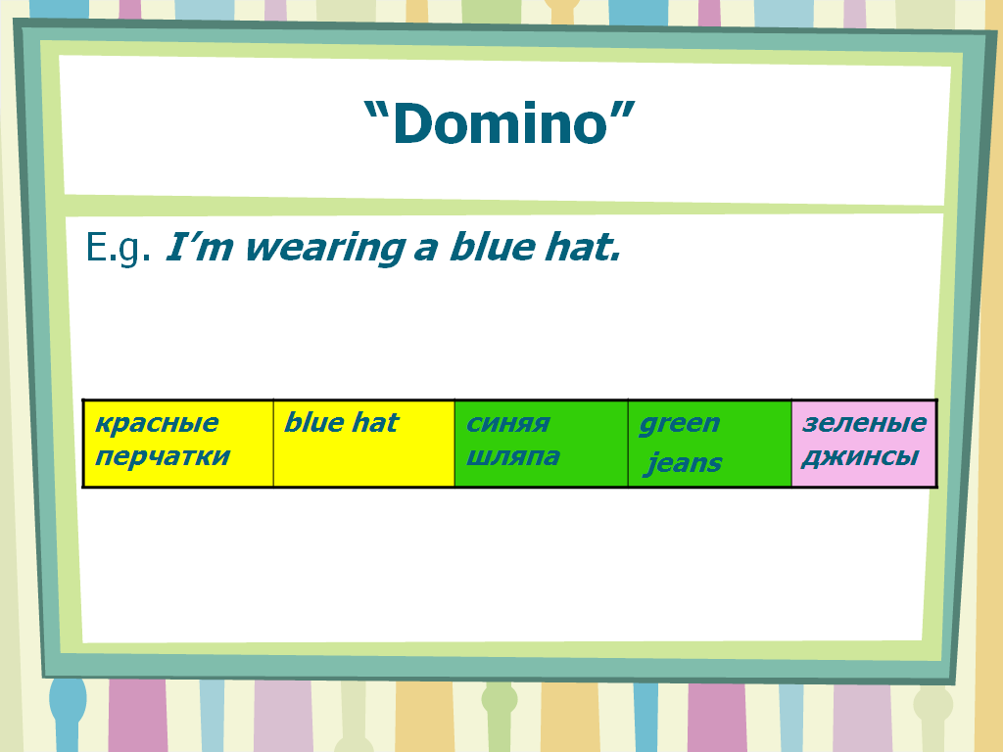

PPT slide 5

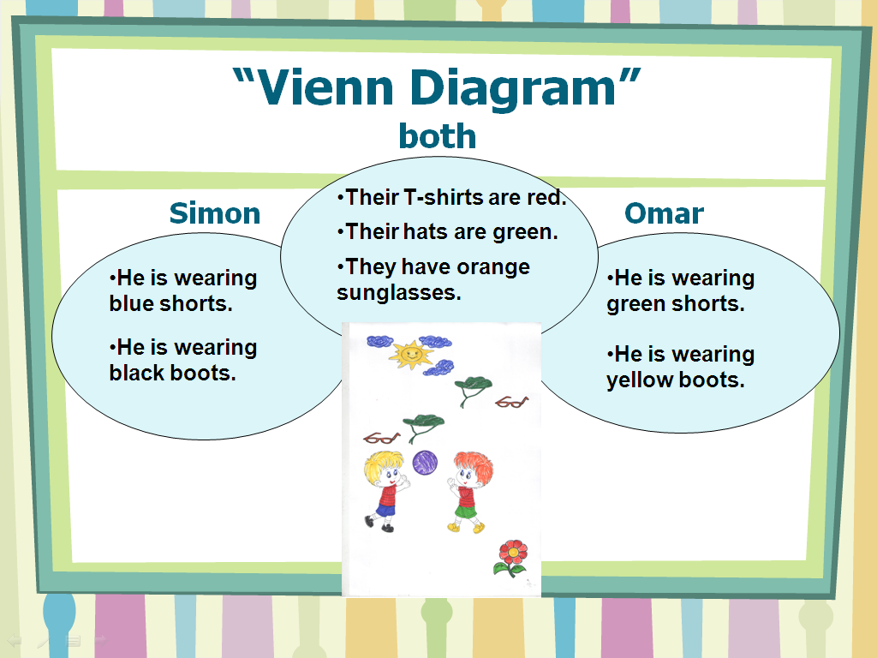

PPT slide 6

