Lesson plan

Unit 1. Animals |  | School: № 26
Date: |  | Teacher name: Serikova Dilyara
Grade: 3 a |  | Number present: |  | absent:

Theme of the lesson: Animal types 1
Learning objectives that this lesson is contributing to |  | 3.1.5.1 distinguish between phonemically distinct words;  3.2.1.1 make basic statements which provide personal information on a limited range of general topics;  3.5.5.1 use interrogative pronouns including: which, what, where, whose, how many, what kind of … on a limited range of familiar topics;  3.5.14.1 use prepositions of location and position: at, behind, between, in, in front of, near, next to, on, under, above to describe where people and things are, use prepositions of time: on, in, at to talk about days and times and no preposition last week
Lesson objectives |  | Learners will be able to:
Name animals and tell which animals live in water/on land providing basic information.
Identify animals which have legs/no legs
Comprehend and recognize habitat of animals using prepositions of location and positions
Assessment criteria |  | Learners have met the learning objective (3.5.5.1 / 3.5. 14.1) if they can:
  Describe the basic functions and habitat of animal features.
  Write five sentences using topic vocabulary describing location and position of animals
Value links |  | Animal cognition
Cross - curricular links |  | Introduction to science. Geography
ICT skills |  | Using videos& pictures
Previous learning |  | Graft project 1
Plan
Planned timings | Planned activities |  |  |  | Resources
Beginning  5 mins | Warm up  Teacher asks children to draw pictures of the animals which live in Kazakhstan and then have them illustrate it. Ask the children to move around like different animals.  Students watch a video and try to guess the topic of the lesson
Middle  30mins | Presentation of the concept of animal habitats  Where do this animal live?  Teacher sticks 3 flashcards (land, air, water) to the board and draws a graphic organizer. Teacher explains that animals live in different places and asks  Teacher 'Where does a (lion) live?' and asks a pupil to come to the board and match a flashcard with the animal to the habitat.  Differentiation:  Teacher asks a high level thinking question: Are there any animals that live both in the water and on the land?  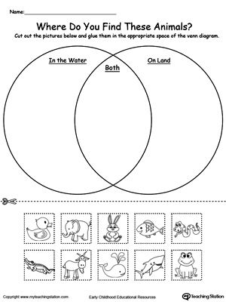  Discussion. Speaking  Learners answer the questions about animals` habitats.  e.g. Where does the lion live?  Does the camel live in the sea?  Writing  Students draw the animal in its habitat and writing a simple sentence about it  The purpose of this activity is to encourage students to choose the animal they like and draw it in its natural habitat. The teacher writes a model of the sentence on the board 'A ____ lives ____' and fills it in with an example.  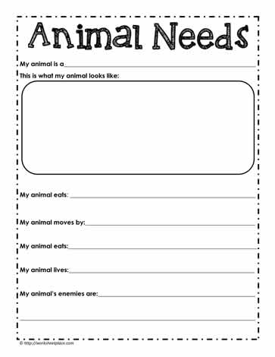 |  |  |  | PPT  DIDACTIC MATERIAL 1  DIDACTIC MATERIAL 2
End  5 mins | Reflection  Play this sorting game to learn which animals live on land and which live in water. Place the land and water sorting mat in front of all of the players. Players shuffle the cards and deal the same amount to each player. Take turns spinning the spinner to land on land, water, spin 2 times, or lose a turn. If a student lands on land or water, they must find a matching animal in their deck and place on the sorting mat. If they do not have a match, their turn is skipped. The first player to get rid of all of their cards wins! After game play, draw a picture of your favorite land and water animals on the worksheet provided.
Additional information
Differentiation – how do you plan to give more support? How do you plan to challenge the more able learners? |  |  | Assessment – how are you planning to check learners’ learning?
Less able students – greater support by means of prompts, visuals or writing difficult words on the board  More able students – independent work on definite tasks with little/no support  Allow for flexible groupings and cooperative learning, depending on the appropriateness to the task  Allow for extra time for students needing it, when appropriate  Give extra text or visual support to students needing extra English support  Create small learning groups for students needing extra support or enrichment with the co-teacher, when appropriate |  |  | through observation
Reflection
Were the lesson objectives/learning objectives realistic?
What did the learners learn today?
What was the learning atmosphere like?
Did my planned differentiation work well?
Did I stick to timings? What changes did I make from my plan and why?
Summary evaluation
What two things went really well (consider both teaching and learning)?
1:
2:
What two things would have improved the lesson (consider both teaching and learning)?
1:
2:
What have I learned from this lesson about the class or individuals that will inform my next lesson?

