School №29 named after A. Moldagulova

Out-of-class activity

Theme: «BRAINIACS»


Form: 8
Date: 19.01.22
Teacher: Karymbaeva N.K.

Theme: «Brainiacs».
Aims:
- development of thinking/ memory/ attention;
- develop pupil’s intellect imagination
- to stimulate interest in the subject;

Educational objectives:
- consolidate the knowledge of pupils on the topics studied and expand their general horizons.

Didactic materials: slides;
Types of the lesson: Competition

I. Introduction
Teacher: Good day, children! Welcome to the lesson. It’s very nice to see you! Ready for the great intellectual game? Yeah?! We are going to answer different questions about The UK history and also you should demonstrate your general knowledge in different fields of every day life. This intellectual game’s name is « BRAINIACS». 3 teams will fight for the title of the most educated pupils. This battle will help you increase not only English language knowledge but also in different spheres.
As you see in this slide we have 5 different thematic sections. Each section has 4 cells with various questions and scores. You choose a cell and if you answer correct you get the written score on it.

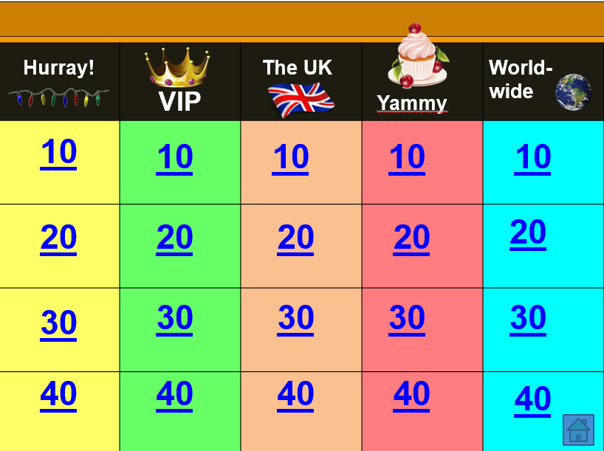

Let’s start then! Wish you good luck and high speed.
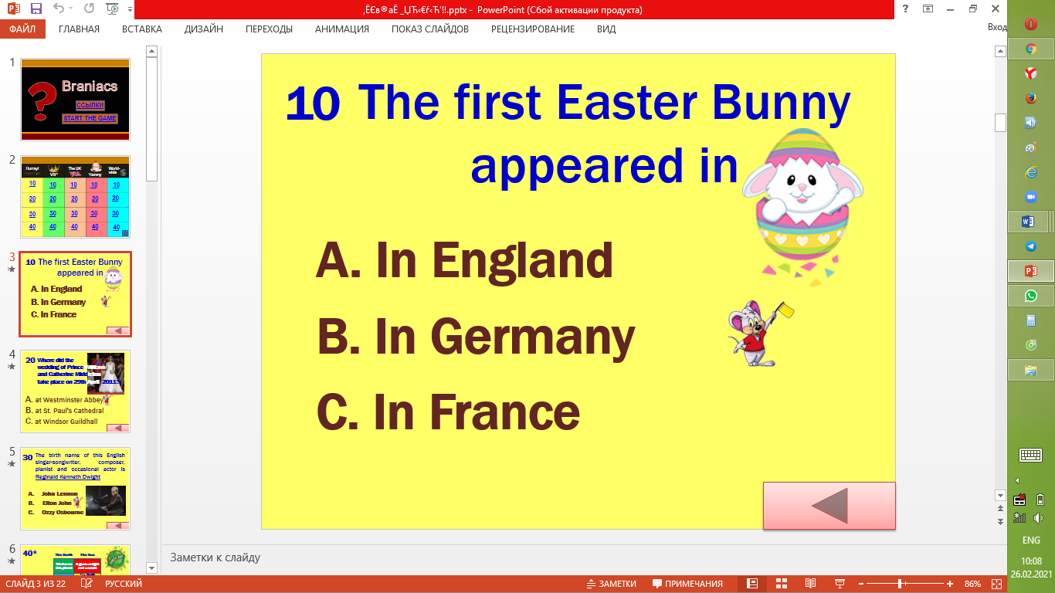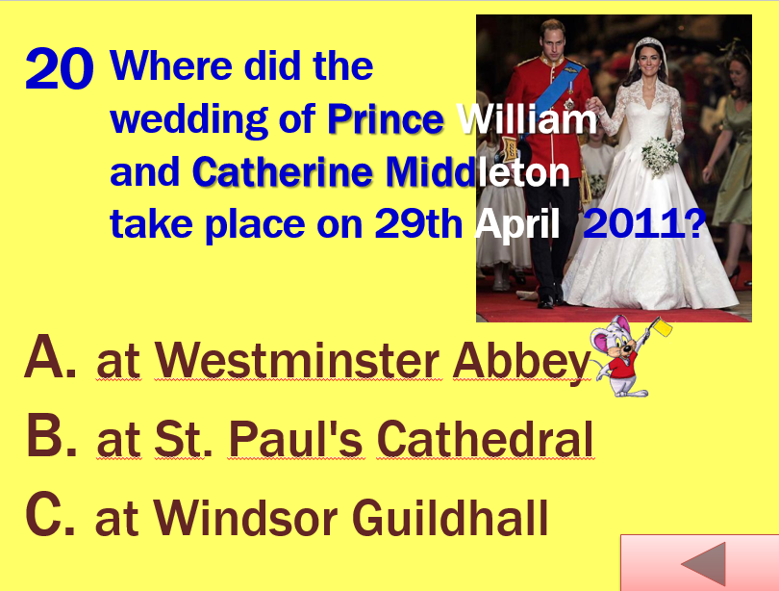
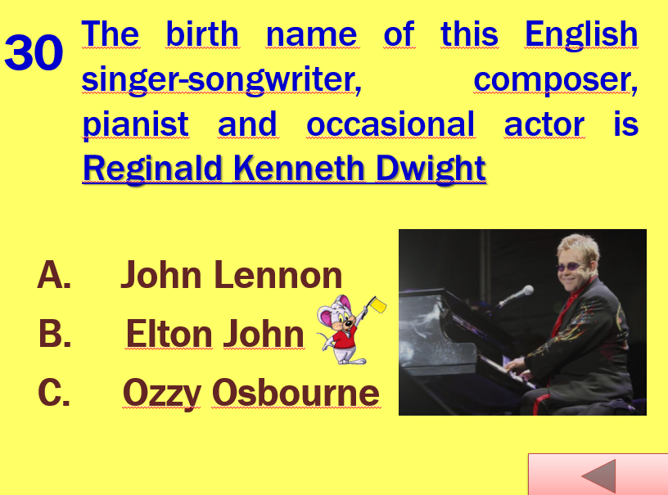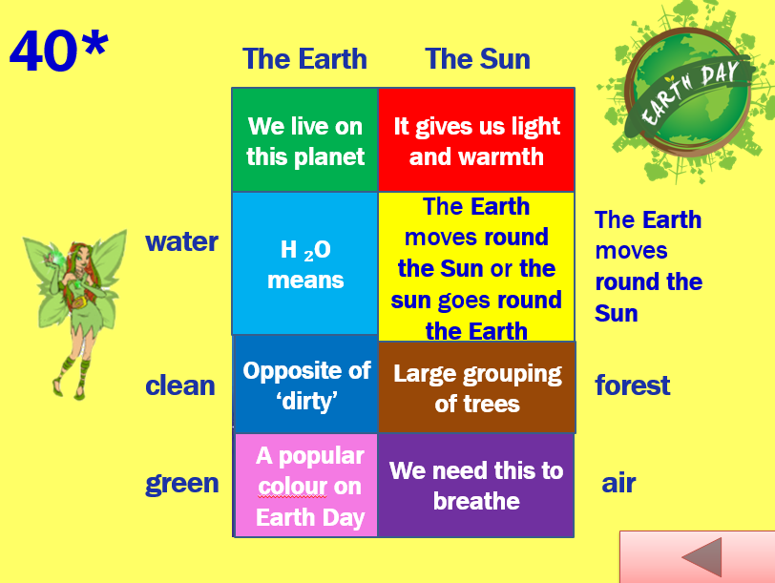
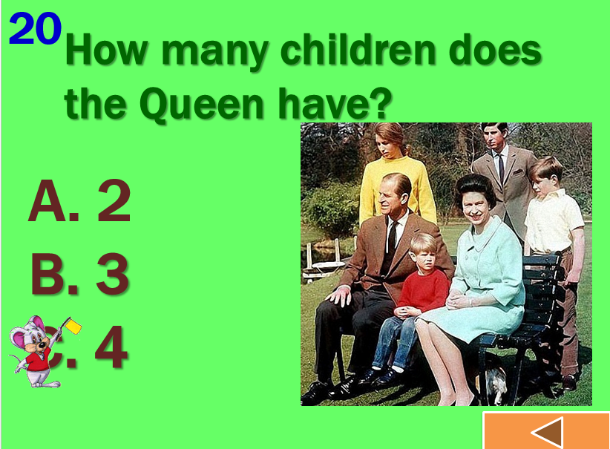
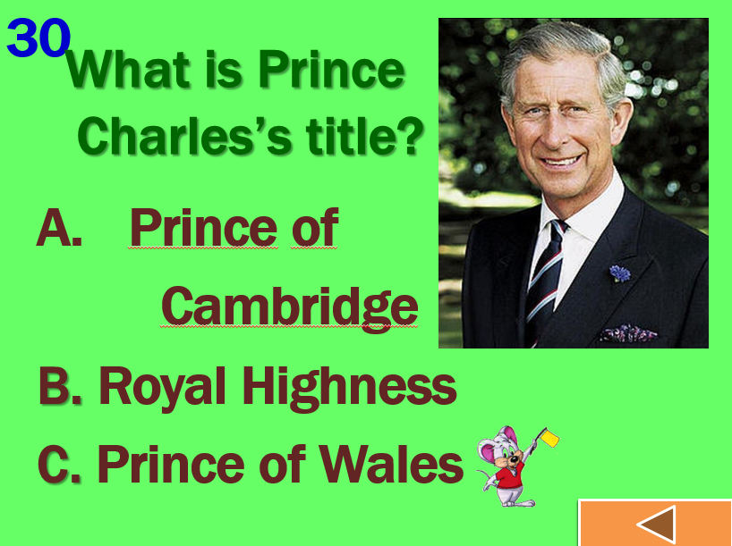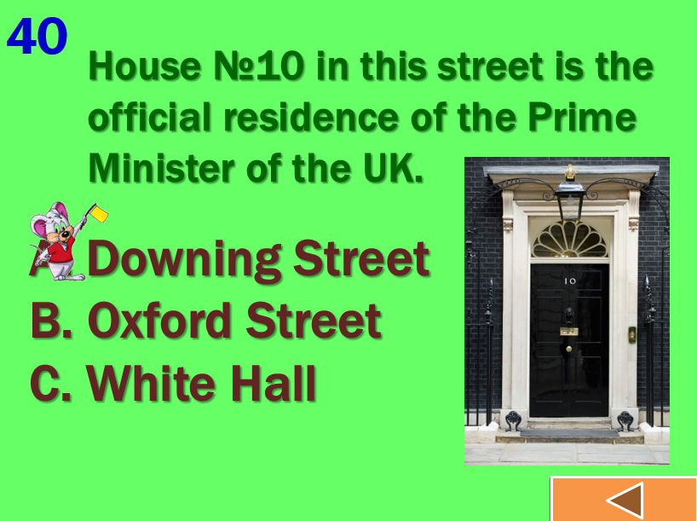

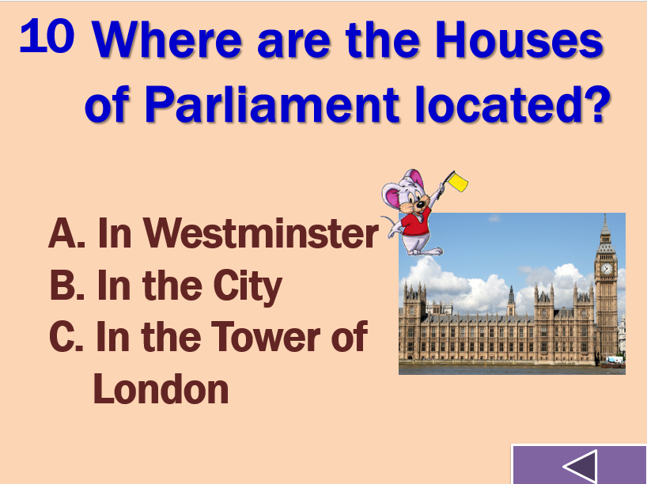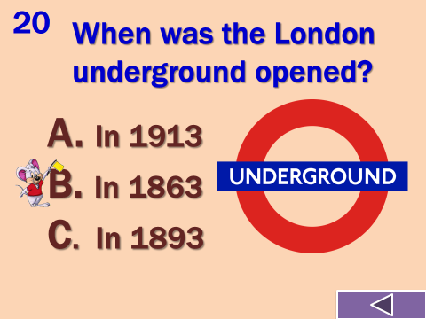
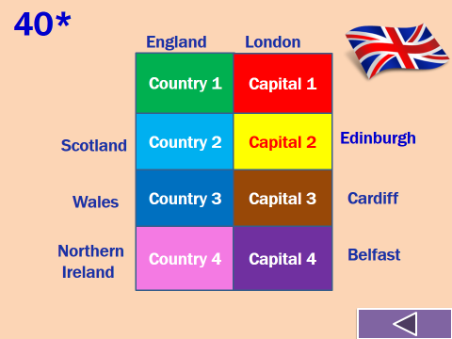

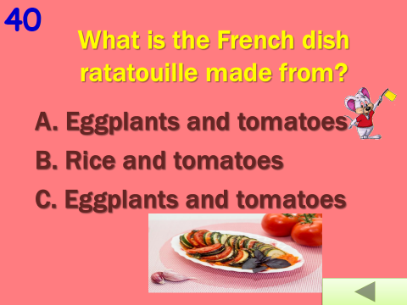
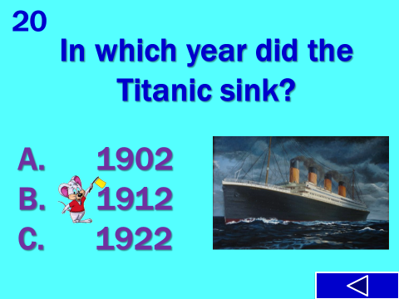
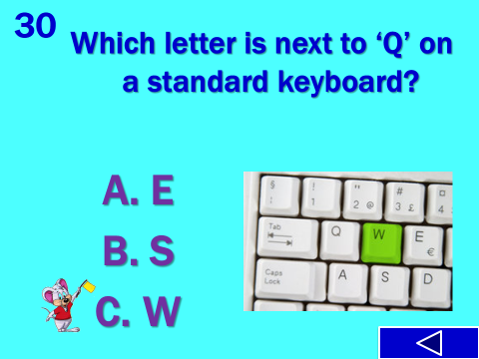

III. Conclusion
We have finished our intellectual game « Brainiacs». Thanks a lot to our participants for their active participation. I hope you enjoyed as much as I did. I wish you success in studying English! Good bye!

