Lesson plan

Unit of a long term plan 4 “ The world of work” |  |  |  |  | School: Secondary School №3 . Sharbakty
Date: |  |  |  |  | Teacher name: Lebed Svetlana Valerievna
CLASS: 5”b” |  |  |  |  | number present 14 absent0  14
Lesson title “ Outdoor, factory and service job”
Learning objectives(s) |  |  | 5.L6 deduce meaning from context in short, supported talk on an increasing range of general and curricular topics  5.S2 ask simple questions to get information about a limited range of general topics  5.W3 write with support factual descriptions at text level which describe people, places and objects
Lesson objectives |  |  | All learners will able to :  -Identify meaning from context in short dialogues about outdoor, service, factory jobs, of general and curricular topics.  -make up simple questions to get information about outdoor, service, factory jobs,of general topics.  -write factual description about outdoor, service, factory jobs, places and objects.
Assessment criteria |  |  | - Identifies meaning from context in short dialogues of general and curricular topics  - makes up simple questions to get information of general topics.  -writes factual description about outdoor, service, factory jobs, places and objects.
Language objective |  |  | Use simple present tenses
Values links |  |  | Appreciate and respect people’s work ( jobs)  Prepare yourself to choose a future profession.  Mangilik EL
Cross-curricular links |  |  | Geography and Economics
Previous learning |  |  | Professions, Present Simple Tense
Plan
Planned timings | Planned activities (replace the notes below with your planned activities) |  |  |  |  |  | Resources
Start  5- min | Warm-up ( Building a good collaborative environment)  Lets start our lesson with good mood.  1. Teacher asks learners to wish each to other good words.  For Example : I wish you today good marks, “good mood”, “many smiles”, “ productive work”, “good ideas” So we tuned in today to positive work.  Teacher asks : What did you do at the last lesson? OK.  Make up association to the word “Profession” The teacher writes the word on the board. And children name their association. ( Oral speech)  We will continue o to speak about different kind of profession outdoor, factory, service profession. ( Lesson objectives presentation.) |  |  |  |  |  | Active method.  Brainstorming
Middle  5 min  5 min  5 min  7 min  5 min | Listening.  The teacher offers learners listen to 5 conversations about different profession.  Learners listen to 5 different people talking about their jobs twice and do the matching and multiple choice tasks to practice their listening.  Learners swap their papers with each other as they finish listening to do some peer checking. Teacher elicits the correct answers and monitors as students do peer checking. ( Peer assessment)  Stages of listening:  Led in.  Teacher writes and explains the word “outdoor», «service”, “factory”. The learners look at the board and repeat the words.  Teacher asks : “How do you understand these meanings?”  Learners give their answers.  Learners do tasks during the listening.  Gist questions.  What job do you belong to service  What job do you belong to factory  What job do you belong to service  First Listening.  Listen to 5 conversation and guess what is speaker's job? ( worksheet -1)  Second Listening.( worksheet-2)  Detailed questions  What is the A- speaker's job?  Where does the A-speaker's work?  What is the B-speaker's job?  Does speaker A -enjoy his job?  Then teacher gives correctly answers and learners check each to other .  Descriptors  - Matches speakers' conversations with their professions correctly .  - Finds the right answer from the proposed questions.  Let's play game!  Vocabulary game “ Guess the profession”  Repeat and consolidate the occupation vocabulary . Let's play game!  The teacher separates the class into three teams. ( outdoor, factory, service jobs ) Then asks a learner to come to the front of the class and give a learner a profession card. (for Ex. Nurse, mechanic, teacher, bus driver )  The learners give, Yes or No answers.  Do you work in a factory? -Yes, I do/ No. I don’t  Do you work with children? -Yes, I do/ No, I don’t  Do you treat animals? - Yes, I do/ No , I don't  Have you got a tractor? -Yes, I have/ No, I haven’t  Can you dance? -Yes, I can/ No, I cannot  ( learners can ask 10 questions)  The team which guesses the job keeps the card. The winner is the one, whose team has more cards.  Descriptor :  - answers the question correctly  -uses vocabulary of the lesson.  ( Verbal praise) ( Clap each to other )  Group work. Writing  Teacher gives learners different cards with tasks A,B, levels  Learners take a cards with their tasks and work individual.  The teacher shows 4-5 slides of different job's activity. Learners answer what does farmer do? What does driver do? What does worker do? What does cook do? What does fisher do? Teacher shows examples of description.  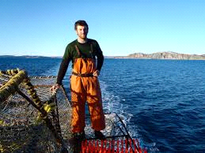  Formative assessment (W)  Differentiation  Learners in group work with individual cards with tasks.  Descriptors  - level learner – Describes picture, makes up sentences independently without a pattern.  - level learner- makes up sentences with help of basic words using a table.  For B-learners  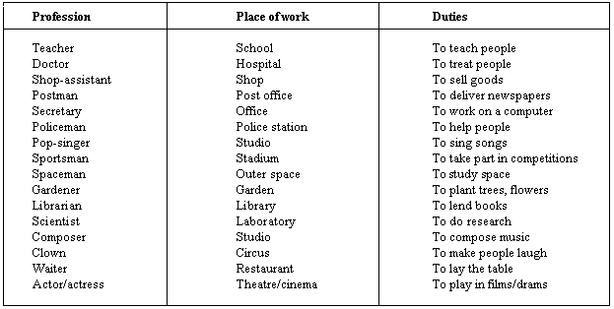  Learners with A levels listen and write: Farmers are hard working. They work outdoor.  Doctors are helpful . They work indoors.  Teachers are intelligent . They work at school. ( indoors)  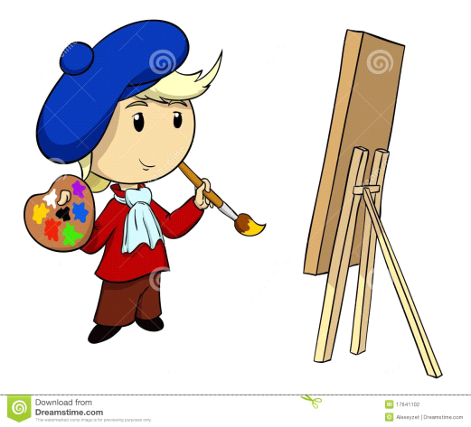  Formative assessment (W)- peer checking  A teacher shows a correctly answers .  Then explain how they can correct each to other with feltip-pen  ( Use marking in writing technique)  A- a word is missing.  I- start a new sentence  G- Grammar error. |  |  |  |  |  | Www.britishcouncil.org.teens  Cards with profession pictures  worksheet 1,2  Cards with profession pictures  PPT- slides  Www.britishcouncil.org.teens  The pattern
End  5 min  Reflection  2min | Feed back. “ Profession poster”  The teacher gives learners profession-cards and offers take any of them.  They check a card and glue on the poster, then write 1-2 adjectives . The teacher help learners and write different adjectives on the board previously. Learners voice their choose. ( For Ex. A mechanic is hard-working. A musician is creative, interesting. A farmer is strong. ( Verbal praise of the teacher)  What was interesting for you ?  What was difficult for you?  What information did you want to get at the next lesson?  Home work : Make up sink vein.
Additional information
Differentiation – how do you plan to give more support? How do you plan to challenge the more able learners? |  |  |  | Assessment – how are you planning to check learners’ learning? |  |  | Health and safety check
- By support  - By outcome (results of formative assessment)  - by interest  - by level of learners’ ability |  |  |  | - Teacher’s monitoring  - Peer checking  - Yourself assessment |  |  | Collaboration and support  Life –long learning
Reflection  Were the lesson objectives/learning objectives realistic?  What did the learners learn today?  What was the learning atmosphere like?  Did my planned differentiation work well? |  | Use the space below to reflect on your lesson. Answer the most relevant questions from the box on the left about your lesson.
Summary evaluation

What two things went really well (consider both teaching and learning)?

1:

2:

What two things would have improved the lesson (consider both teaching and learning)?

1:

2:

What have I learned from this lesson about the class or individuals that will inform my next lesson?

