Regional boarding school No. 3 for children with speech disorders

Open English lesson
grade 2«B»
Theme of lesson: «School days»
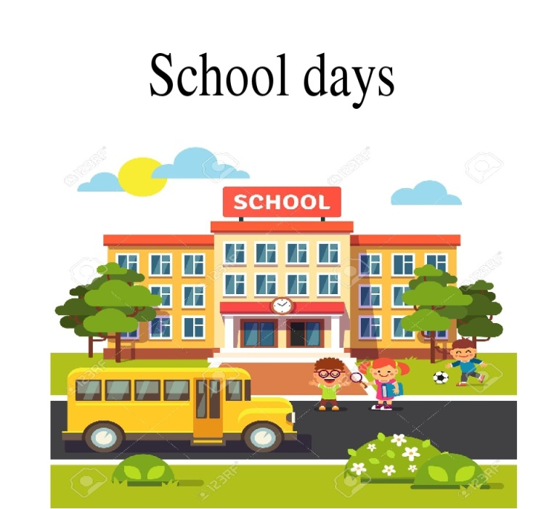

The teacher of English language mrs. Kabdusheva A.A.

Atyrau city, 2021-22

Approved:  Head teacher Hasanova S.S.  Long-term plan unit:  My school 3 |  |  | Regional boarding school №3
Date: 22 November 2021 |  |  | Teacher name: Kabdusheva Ainur Aslanovna
Grade: |  |  |  | 2B
Theme of the lesson: |  |  | School days
Learning objectives(s) that this lesson is contributing to |  | 2.L3recognise with  support common names and names of places and the spoken form of a limited range of everyday and classroom words  2.L2 recognise with support a limited range of basic common personal questions spoken slowly and distinctly
Lesson objectives |  | Learners will be able to:  recognise and write days of the week  recognise and name common verbs  listen and describe their days
Value links |  | Respect and cooperation by:  - Listening to the teacher  - Listening to each other  - Take turns  - Encourage each other
Cross curricular links |  | Home life, transportation, health practices
ICT skills |  | By teacher only, about 15 minutes
Previous learning |  | Practise lesson. Learners practised some words and letters
Plan
Planned timings | Planned activities (replace the notes below with your planned activities) |  |  |  | Resources
Beginning  Middle  25 minutes | - Warm up activity  Student come in. choose their own hats, two colors, red and green. Divided into two groups by color.  Divided into two groups by color.  Teacher: Let’s sing a song “Hello”  The teacher greets. Students sing a song “Hello”  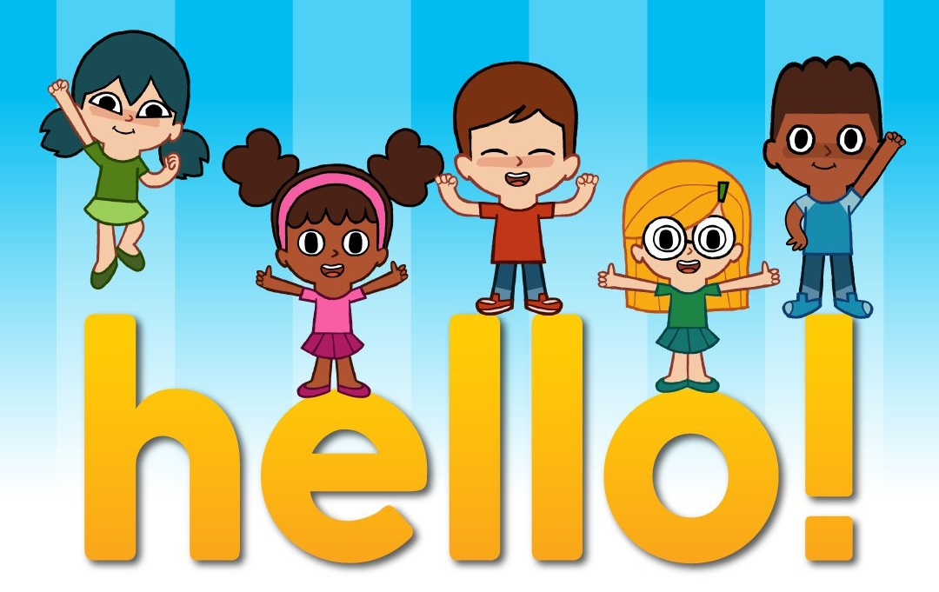  Before the lesson, numbers and commands of the teacher, passed in previous lessons.  - Learn the numbers 10-50ty  Обратите внимание что эти числительные оканчиваются на T-Y. Repeat again.  At first let’s practice our tongues! Let play a game “Tongue Twisters”. Listen to me and repeat after me.  Сначала преподаватель повторяет с детьми звуки [s], [ai], [ei], а затем и скороговорку.  Six slimy snails sailed silently.  - Watch a video on the topic.  Disclosure of the topic.  T: What do you think? What is that topic our lesson?  S: Yes, it’s about a school days!  Introducing new words  - Learning new words by topic  - Teacher demonstrates and drills.  - Whole class repeats the words after  - Teacher three times.  - Teacher ask each student to repeat the words.  New phrases  go to school have lesson have lunch  Maths lesson, Science lesson, P.E. Art lesson, Music lesson  - Look at the example  I go to school from Monday to Friday  I don’t go to school on Saturday and Sunday  - Let’s practice  I have Science on Tuesday.  - Remember the rules.  - What is it? \ Who is?  What is it?  It’s a school and etc.  Working with two groups  Working with a group  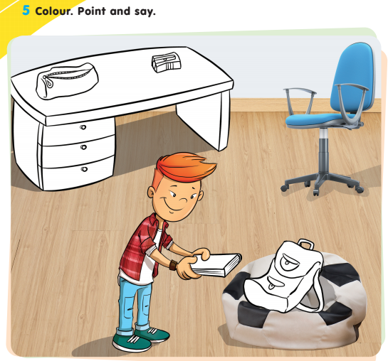  Let’s read!  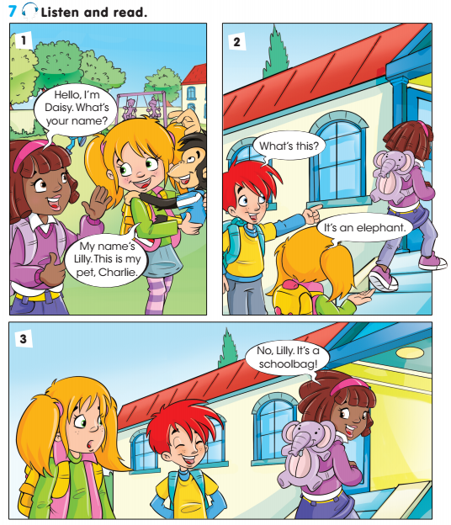  Activity book p. 22. exs. 3 Learn new words |  |  |  | Оwn hats two colors  Watch a video  PPT
End  5 minutes | - Reflection  Teacher gives 2 types of smiles and student should to choose one of them  Good –if they understand not all  Sad –if they don’t understand  Pick up an emotion. Define a lesson using emoticons.  T: We have good worked today. And it’s great!  - Teacher says goodbye to children

