Unit 1 |  | Our Class
Teacher |  | Popova L.O
Date |  | 19,09,22
Grade 6 |  | Number Present: |  |  | absent:
Theme |  | Meeting people
Learning objectives |  | 6.3.2.1- ask simple questions to get information about a growing range of general topics  6.4.4.1- read independently a limited range of short simple fiction and non-fiction texts;  6.4.8.1- use independently familiar paper and digital reference resources to check meaning and extend understanding;
Lesson objectives |  | Learner have to understand how prepositions are used, know the types of interrogative pronouns
Planned activities
Planned timings | Teacher action |  | Student action | Assessment |  | Resources
Beginning of the lesson  Warming-up  10 min. | Emotional mood  I.Greetings. Teacher greets learners.  Hello boys and girls, how are you today?  That’s good  What the weather like today?  Do you like this weather?  You can see three smiles on your desks. Please, choose and show me, what mood do you have at the beginning of our lesson?  II. Organizational moment.  How do you think what the theme of our lesson?  The topic of our lesson is « meeting people ».  -Write down the date and the topic of our lesson.  -What will we do in our lesson?  The aim: This lesson teaches common expressions for meeting people. Through listening and role play the students learn how to introduce themselves and greet other people in both formal and informal situations. |  | Children are positive about the lesson  Pupils answer the questions  -Hello teacher  -Fine thanks  -Today is…..  -Yes, I do/No, I don’t  Learners guess the theme of the lesson.  Have to listen the dialogues and try to guess the theme.  Learners have to understand the aim of the lesson  Write down the date and the topic of the lesson | Oral comments  «The praise» method to evaluate |  | https://www.linguahouse.com/ru/esl-lesson-plans/general-english/meeting-people  book  Visual aids  There are two animated videos which can be played as an interesting alternative to the audio dialogues in Ex4.
Main part | Beginning the lesson  We have new words. Look at the blackboard and repeat after me.  What was your home task?  While you will write them let’s check up your home task  Task 1    Task 2    Task 3  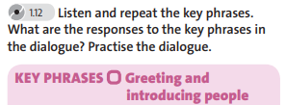  The rule  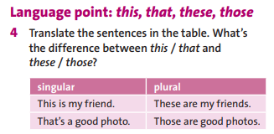  Task 4  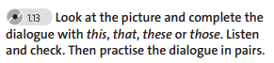  Consolidation of the studied material  Make questions  Can you talk about interrogative pronouns?  Can you express your likes and dislikes? |  | Learners have to listen the teacher  then open the dictionaries and write new words, then spell them together after the teacher.  1)Learners have to show their homework.  Learners have to look at the picture and think about what hobby does the boy interested in  2)Learners have to listen or read the dialogue then check the answers    3) Learners have to answer the question orally  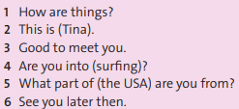  Learners have to understand the rule  Then listen and check  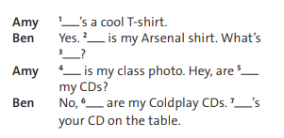 | Individually and in written form  «The praise» method to evaluate(похвала)  Oral comments  Mutual check up  Oral comments  Individually and in written form  Oral comments  Mutual check up |  | Visual aids  Flash cards  Laptop  Dictionaries  handout  blackboard  Pb p 15  Pb p15  copybooks  Pb p 15  Handout  Sheet of papers  Board  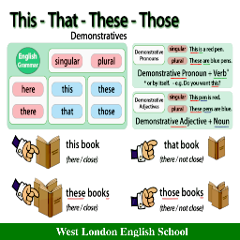  Pb p 15  Handout
The end of the lesson | Feedback  I’ll give you a table for every pair “green, yellow, red sheets of paper” complete them with your own thoughts about the lesson.  Giving the marks for the lesson  I hope you’ll be ready for the next lesson and get a good mark.  Home task: words, ex 3,4 p 15 |  | Learners complete the table what they know and want to know, knew.  Aim:define what they have learnt from today’s lesson.  Efficiency:  Helps to analyze about their understanding  - What has been learned  - What remained unclear  - What is necessary to work on | Feedback:  A method of Holly tree. |  | A table for Feedback  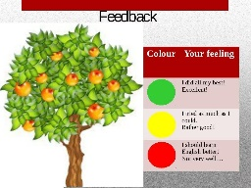

Проверено на наличие и соответствие календарному плану
Зам.директора по НМР Кашкынова Ж.А.

