Unit 8: Food and Drink
Teacher’s name:
Date:
Grade: 8 А |  |  | Number present: |  | Number absent:
Theme of the lesson: |  | Unit revision
Learning objectives |  | 8.3.7.1 - use appropriate subject-specific vocabulary and syntax to talk about a range of general topics, and some curricular topics  8.4.2.1 - understand specific information and detail in texts on a growing range of familiar general and curricular topics, including some extended texts;  8.2.5.1 - recognize the opinion of the speaker(s) with little or no support in extended talk on a wide range of general and curricular topics  8.1.1.1 - use speaking and listening skills to solve problems creatively and cooperatively in groups;
Lesson objectives |  | All learners will be able to:  use some language from the module to express views and pose some relevant activity accurately  Most learners will be able to:  use a range of language from the module to express views and pose a range of relevant activity accurately  Some learners will be able to:  use a wide range of language from the module to express views and pose a range of relevant activity accurately
Plan
Planned timings | Planned activities |  |  | Learners’ activities |  | Evaluation | Resources
Begining  5 min | GREETINGS  1.Let’s listen to the text attentively  I love parties. They are always so much fun. I can’t think of a better way to spend an afternoon or evening than going to a party. You meet people, eat delicious food, and have lots of fun. I’ve always loved parties. I remember the birthday parties I had as a child. Such wonderful memories. I also remember the first parties I went to as a teenager – all night parties where we danced and chatted until morning. I’ve lost count of the number of parties I’ve been to. Dinner parties, beach parties, New Year’s Eve parties, birthday parties… the list goes on. One party I’d really like to go to is the Queen’s garden party. Of course this is in England. If you go to this party, it means you’ve done something special in life. All I have to do now is think of something special to do!  2. Let’s fill some words from the text  I love parties. They ___________________ fun. I can’t think of a better way to spend an afternoon or evening ___________________ party. You meet people, eat delicious food, and have lots of fun. I’ve always loved parties. I remember the birthday ___________________ child. Such wonderful memories. I also remember the first parties I went to as a teenager – all night parties where we danced and ___________________. I’ve lost count of the number of ___________________. Dinner parties, beach parties, New Year’s Eve parties, birthday parties… the list goes on. One party ___________________ is the Queen’s garden party. Of course this is in England. If you go to this party, it means ___________________ special in life. All I have to do ___________________ something special to do! |  |  | Greeting  Learners listen to the text  Learners fill the words |  |  | https://listenaminute.com/p/parties.mp3
Middle  30 min | 3.Let’s correct some words.  I love parties. They are always so much fun. I can’t think of a better way to npsed an afternoon or evening than going to a party. You meet people, eat eluiiscdo food, and have lots of fun. I’ve always dvole parties. I remember the birthday parties I had as a child. Such wonderful mrioesme. I also remember the first parties I went to as a eneterag – all night parties where we danced and adhtcet until morning. I’ve lost count of the number of parties I’ve been to. Dinner parties, cbhae parties, New Year’s Eve parties, birthday parties… the list goes on. One party I’d really like to go to is the Queen’s naedgr party. Of cueros this is in England. If you go to this party, it neasm you’ve done something special in life. All I have to do now is think of something special to do!  4.Let’s put the words correctly.  I love parties. are They fun much so always. I can’t think way better a of afternoon an spend to or evening than going to a party. You meet people, eat delicious food, and have lots of fun. I’ve always loved parties. I remember a as had I parties birthday the child. Such wonderful memories. I also remember the first parties I went to as a teenager – where parties night all we danced and chatted until morning. I’ve lost count of the parties of number to been I’ve. Dinner parties, beach parties, New Year’s Eve parties, birthday parties… the list goes on. One party like really I’d the is to go to Queen’s garden party. England in is this course Of. If you go to this party, it means you’ve done something special in life. have think to of do All now I is something special to do!  5. S/B Ex.5 p.98  Song: These words appear in the song. How do you think what is the song about? Listen, read and check.  • family day • loved ones • celebrate • delicious food • dance • in style • happy songs  ----- The song is about meeting with family and friends and celebrating.  Why does the singer enjoy family celebrations? What about you?  ------ I think the singer enjoys family celebrations because he/she likes to spend time with their family and have fun.  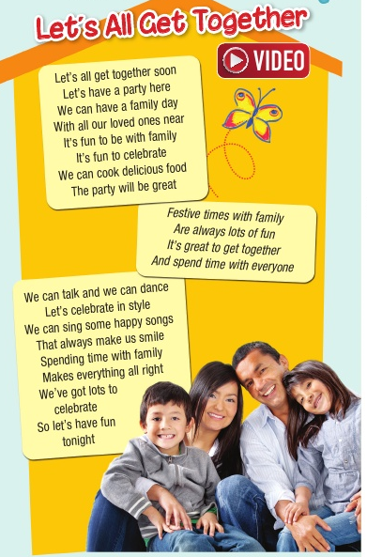  Let’s listen to the song  6. Now let’s take Questions about birthday,using our spinner  1. What do you usually do on your birthday?  Actually, the whole birthday thing is a pretty big deal for me. As to how I celebrate my birthday, I usually eat out with my family or hang out with my friends, and make a birthday wish and the icing on the cake is that I can get lots of birthday gifts.  2. What did you do on your birthday when you were young?  Actually, there were so many ways to celebrate the birthday, eating out, throwing a birthday party, singing karaoke, going clubbing and everything exciting.  3. Do you think it is important for you to celebrate your birthday?  A lot of people attach great importance to their birthdays, including myself. It marks the beginning of a new year or even a new stage in my life and offers a great chance for me to reflect on what I’ve achieved so far and what I’m planning to accomplish in the near future. It’s also a time when I could meet my loved ones all at the same place and let them know how grateful I am to have them in my life.  4. Do you usually celebrate your birthdays?  Yes, I do. Although it is not very huge party but I make sure that there is a party and that I have all my near and dear ones surrounding me during my birthday.  I usually am not a very big birthday fan. I think there should not be any reason to celebrate life and oneself. I am one of those who would give myself or any one else gifts out of the box with no reasons and at any time of the year.  5. Do you receive lots of gifts on your birthday?  Definitely. All of my family and friends know that I am a big fan of cologne. So they all buy me colognes as birthday gifts when my birthday comes.  6. With whom do you like to celebrate your birthday, family, friends or alone?  I prefer to celebrate my birthday with my family. I am a family guy, so I love to enjoy this precious time with my parents. After all, I can hang out with my friends all the time, but a birthday is a once-a-year thing.  7. Do you enjoy birthdays?  Yes, I do love them. There is so much fun associated with birthdays. You meet people, friends, play, put cakes and then sing birthday songs. We dance and sing and so much more. It is like we become kids once again.  8.Do most people celebrate their birthdays with a party in your country?  Yes. No matter a person is rich or poor, there surely is some kind of party going on during a birthday. There are people who are very extravagant and don’t think twice before spending on their birthdays while some make budgets to make sure there is a good party on birthday. Birthdays in my country are often taken as something that brings lot of people together.  7. Antonyms.Let’s find antonyms to each word  Few ------ a lot of  Sweet ----bitter  Tasteless--delicious  Easy ------heavy  Big------little  Cheap--- expensive  Solid-----soft  Lazy----industrious  Well-fed----hungry  Thin---thick  8. Find the words concerning FOOD AND DRINK  To have dinner,fresh juice,redish,berries,cucumber,to eat,grapes,milk shake,watermelon,cookies.  9. Countable and uncountable nouns  Choose the right word for countable and uncountable words  Egg,carrot,tomato,orange,sandwich,peanut,pancake,jam,meat,tea,soup,honey,flour,sugar,bottle,pear,rice,  cheese.  Countable Uncountable  Egg jam  Carrot meat  Tomato tea  Orange soup  Sandwich honey  Peanut flour  Pancake sugar  Bottle rice  Pear cheese  Match the words and containers :  A jug of water,a packet of tea, a jar of honey,a slice of bread,a can of coke,a bowl of sugar,a bar of soap,a piece of cheese,a glass of water,a cup of tea,a bottle of coke,a bottle of milk,a cartoon of milk  A bottle of water  A jug of tea  a packet of honey  a jar of bread  a slice of coke  a can of sugar  a bowl of soap  a bar of cheese  a piece of water  a glass of tea  a cup of coke  a bottle of milk  a cartoon of milk  10.Ex.1-5 p.127 (addition)  Keys: Self-Check 8  Ex. 1 p.127  1 bonfire 2 stalls 3 connection 4 memory 5 population  6 garlands  Ex.2 p.127  1 PIZZA 2 MILKSHAKE 3 CEREAL 4 CABBAGE  5 BURGER 6 BEANS  Ex. 3 p.127  1 a little 2 A lot of 3 much 4 any 5 a few 6 many  Ex. 4 p.127  1 carton 2 bag 3 box 4 packet 5 can  Ex. 5 p.127  1 Are you still serving breakfast 2 What can I get you 3 I’d like some tea, please 4 Would you like anything else |  |  | Learners correct the words  Learners put the words  Learners listen to the song and say what the song is about  Learners answer the questions  Learners find antonyms  Learners find the words  Learners find C,U,match the words  Learners do ex. |  | Verbal evaluation  Individual avaluation  Mutual avaluation | https://youtu.be/IxF0rsm6nvg  Cards,spinner  Worksheets  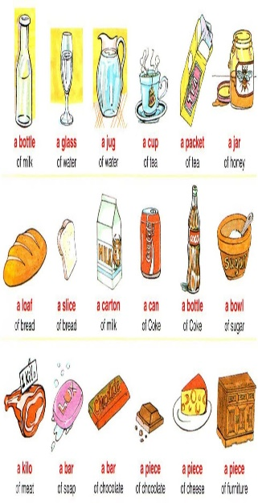  Student’s book
End  5 min | REFLECTION  “The Bullet Point” technique  -Learners get the sticky papers, write their names on them, go to the board and stick the paper on one of the four areas:  -It was interesting;  -Everything was clear;  -I have learned something new.  Home task: to revise grammar and vocabulary  Saying goodbye |  |  |  |  | Self-assessment

