7 form Summative assessment (unit “Holidays and Travel)
Task 1 (3 points). Listen to the conversation twice and answer the questions.
  - What this talk is about?
  - How many people are in a talk?
  - What preferences do a caller request?

Task 2 (5 points). Choose the right answer A, B, C or D.
Example: 0. What date is flight reservation going to be?
    - 21 B) 22 C) 23 D) 24

- What is the man's destination?
  - Salt Lake City, USA
  - New York City, USA
  - Helsinki, Finland
  - Stockholm, Sweden
- When is the man's departure date?
  - the twenty-first
  - the twenty-second
  - the twenty-third
  - the twenty-fourth
- What is the flight number for the second half of his journey?
A) 555 B) 90 C) 1070 D) 830
- How long is the man's layover between flights?
  - less than an hour
  - less than two hours
  - less than three hours
  - more than three hours
- What request did the man make regarding his flight?
  - He asked for a specially-prepared dinner.
  - He wanted an aisle seat.
  - He requested a bassinet for his baby.
  - He asked for a seat near the front of the plane.

Task 3 (4 points). Write a postcard to a friend about your town. Use modal verbs, Pr. Perfect and Past Simple

Example of the postcard Sample sheet for Postcard
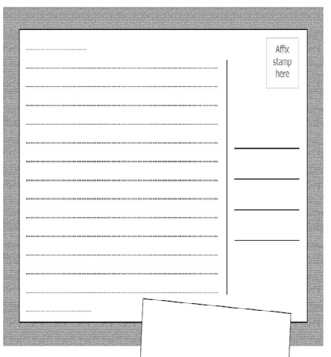
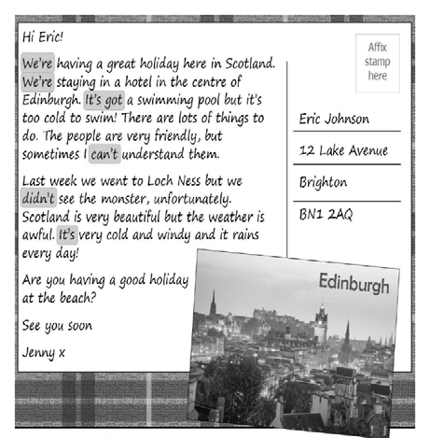

Task 4 (2 points). Complete the sentences.

- He … (can’t/couldn’t) open the window as it was hot.
- Interpreters … (may/must) translate without dictionaries.
- … (Can/May) I use me your bike for today?
- Take an umbrella. It … (may/can) rain.

Task 5 (6 points). Complete the sentences.

1. I … (never/ be) to the USA. I … (want) to go there last summer but I couldn’t.
2. He …. (live) in this street all his life.
3. His father … (come back) to London last Sunday.
4. Yan …. (write) a letter to Nick two days ago.
5. He …. (send) his letter yesterday.
6. They …. (just/ buy) some postcards.

Total – 20 points

