Садиярова Марина Анчова

DEVELOPING SPEAKING COMPETENCE THROUGH CONTEMPORARY TEACHING STRATEGIES IN ENGLISH EDUCATION
АВТОРСКАЯ ПРОГРАММА

Алматы,2024

Садиярова Марина Анчова

DEVELOPING SPEAKING COMPETENCE THROUGH CONTEMPORARY TEACHING STRATEGIES IN ENGLISH EDUCATION
АВТОРСКАЯ ПРОГРАММА

Алматы,2024
Содержание
Foreword
Relevance of the Program
Calendar thematic plan
References
Student's Workbook

УДК 371.214
ББК 74.202
D49

Авторы составитель: Туркестанская область,Шардаринский район,Город Шардара КГУ Общеобразовательная школа имени М. Горького учитель английского языка
Садиярова Марина Анчова

Рецензент:
Кандидат педагогических наук, доцент Центра повышения квалификации и
дистанционного образования КазНПУ им.Абая, гонорар профессор Бельгийской ВШ А. Оракова

Было обсуждено и одобрено на заседании учебно-методического совета республиканского центра поддержки науки и образования, передано в печать. Протокол № 1029 «12» ноябрь 2024 г.

D49 «Developing speaking competence through contemporary teaching strategies in english education» авторская программа /авторы составитель: М.А.Садиярова
– Алматы, «Bilim shuagy» баспаханасы, 2024

ISBN 978-601-381-149-9

Авторское пособие предназначено учителям общеобразовательных учебных учреждений.

УДК 371.214
ББК 74.202
D49

ISBN 978-601-381-149-9

Авторы сост: М.А.Садиярова
© «Bilim shuagy» типография, 2024

Foreword
In today's fast-changing world, where knowledge and information are key factors for success, education serves as the foundation for personal, social, and national development. The President of the Republic of Kazakhstan, Kassym-Jomart Tokayev, has emphasized that education is a "key condition for becoming a successful nation." This statement reflects the growing importance of a strong educational foundation to ensure a nation's prosperity.
One of the key competencies that underpin success in the 21st century is reading literacy. It goes beyond the ability to read words on a page; it requires students to understand, analyze, and critically evaluate texts from various perspectives. Reading literacy is essential not only for academic success but also for lifelong learning, social inclusion, and personal development.
The current educational system in Kazakhstan is undergoing significant reforms, with an emphasis on updating curricula and teaching methods to meet international standards. Modern pedagogical approaches prioritize functional literacy and competence-based learning. These approaches shift the focus from rote memorization to the development of analytical and critical thinking skills.
Reading literacy is one of the most essential skills in a child’s education. It serves as the foundation for the development of other forms of literacy, such as mathematical literacy, scientific literacy, and digital literacy. Without strong reading skills, students may struggle to understand concepts in other academic disciplines.
This program is especially relevant in the context of Kazakhstan’s transition to a new educational paradigm. It aims to address the growing need to develop students' skills in critical thinking, independent analysis, and problem-solving. The modern education system emphasizes functional literacy as an essential outcome of the learning process, and this program fully aligns with these requirements.
The program encourages students to become active participants in their own learning process, shifting them from passive recipients of information to active, engaged learners. The use of innovative techniques, such as dialogue-based learning, interactive activities, and creative projects, enables students to develop the confidence and communication skills needed for future academic and personal success.
This program is designed to be implemented in primary education, where children are at a critical stage in their cognitive, emotional, and social development. By using the methods outlined in this program, educators can create engaging, meaningful, and effective learning experiences that nurture a lifelong love for reading.
The educational program "Effective Techniques and Methods for Developing Reading Literacy in Russian Language and Literary Reading Lessons", developed by Zhanar Zhumagalievna Turarova, offers a comprehensive framework for enhancing reading literacy among primary school students. The program not only develops essential reading and comprehension skills but also fosters critical thinking, creativity, and communication skills.
By using innovative, interactive, and research-based methods, this program addresses the most pressing challenges in education today. It provides teachers with practical, ready-to-use tools for improving students' learning outcomes. Through dialogue-based learning, active reading strategies, and digital technologies, this program creates a modern, learner-centered educational environment.

Relevance of the Program

The President of the Republic of Kazakhstan, Kassym-Jomart Kemelevich Tokayev, emphasizes that "general education is a key condition for becoming a successful nation." The 21st century is a historical era where knowledge and competence are put to the test. Therefore, only by providing comprehensive educational opportunities for the younger generation can the nation achieve the status of a successful state. In this context, the education system plays a crucial role.

In accordance with modern social demands, there is an increased focus on educating creative, independent, and self-developing individuals. With the emergence of the global educational information space and the acceleration of globalization processes, large-scale reforms have been initiated in Kazakhstan to modernize its educational system. The requirements for schools and teaching methods have also changed in response to the evolving demands of society.

Today, one of the most important tasks of Kazakhstan's education system is to transition to a national educational model that enables the younger generation to achieve international educational standards. Teachers must therefore abandon old methods and adopt new, innovative approaches. To achieve this goal, educators must create favorable conditions for the development of each student's individuality by using modern teaching and educational technologies.

One of the most effective approaches in this context is the use of dialogue-based learning, especially through exploratory discussions during foreign language lessons. This approach is crucial for achieving developmental, educational, and training objectives. It encourages students to actively participate in discussions, fostering their analytical and critical thinking skills.
Focus of the Program
The focus of the author's program is on implementing dialogue-based learning in general education schools during English language lessons, highlighting its importance and necessity. The program aims to develop students' communication skills, their speaking culture, and their ability to interact effectively in social contexts.
Relevance of the Program
The relevance of the author's program is defined by the need to introduce effective teaching methods that help students master all aspects of verbal communication. The program proposes a methodology for teaching students various types of verbal interactions through dialogue-based learning.
The main goal of teaching foreign languages is to develop students' communicative competence, allowing them to use the language freely. In the modern world, knowledge of foreign languages is essential for socio-economic, technological, and cultural development. As we enter the 21st century, education must be innovative, as it serves as a beacon of hope for future generations. An educated nation is a successful nation. Therefore, providing meaningful, comprehensive, and high-quality education for future generations is a critical priority.
One of the essential aspects of modern education reform in Kazakhstan is the technologization of the learning process. This includes the integration of innovative educational technologies, such as dialogue-based learning, into the teaching process.
The Role of Dialogue in Language Teaching
To ensure that students communicate effectively in a foreign language, they must be able to understand and comprehend spoken language. The primary purpose of teaching foreign languages is to prepare students to communicate with speakers of the target language, promoting mutual understanding, shared perspectives, and the development of personal, social, and cognitive skills.
The content of foreign language education includes topics, communication situations, texts, and language materials such as vocabulary, grammar, phonetics, and practical skills. These elements collectively form the essential knowledge and skills that support effective language learning.
Mastering the English language and transforming it into a useful skill is a long-term process. One of the most important questions that educators face is how to teach students to freely express their thoughts both orally and in writing. To achieve this, educators must select effective teaching methods and technologies that engage students and foster their motivation.
Key Methods and Techniques
The effectiveness of foreign language education depends on the selection and use of appropriate methods and teaching techniques. Teachers should not merely apply numerous technologies but rather focus on result-oriented education. The ultimate goal is not the widespread use of technology but the development of independent, competent, and results-driven students.
To develop students' communication skills, teachers can employ the following methods:
- Vocabulary development – Using interactive vocabulary-building exercises.
- Text-based development – Engaging students in analysis and comprehension of texts.
- Visual aids – Incorporating visual teaching tools such as images, flashcards, and videos.
- Participation in extracurricular activities – Involving students in clubs, debate teams, and language-learning workshops.
Dialogue-based learning is one of the most effective methods for developing students' language skills. Dialogue-based activities encourage students to practice speaking in a foreign language and provide an opportunity for average-achieving students to stay engaged. By using dialogue in each lesson, teachers can engage the entire class, foster collaboration, and maintain students' focus.
Language Development Strategies
Language development activities aim to improve students' logical thinking, literacy, and fluency. The main goal of teaching English language is to develop students' proficiency in using the language. The key to successful language learning lies in active language development work.
The following strategies are essential for developing students' language skills:
- Interactive grammar exercises – Diversifying grammar tasks.
- Content-based learning – Using engaging materials like thematic illustrations.
- Dialogic interaction – Encouraging students to engage in authentic conversations.
- Narrative analysis – Teaching students to analyze, discuss, and extend stories.
- Dramatization – Creating and performing role-plays, short plays, and skits.
- Reading comprehension – Developing the ability to analyze texts, understand context, and interpret the meaning.
Effective language development requires a creative, proactive, and methodical approach from teachers. By using methods such as dialogue-based learning, teachers can foster collaboration, communication, and critical thinking.
Expected Outcomes
The following outcomes are expected from the implementation of this program:
- Enhanced grammatical competence – Students will be able to complete grammar exercises of varying complexity.
- Improved reading skills – Students will work with illustrated materials, promoting visual literacy and comprehension.
- Oral communication skills – Students will be able to engage in dialogues and conversations with one another.
- Content analysis – Students will be able to analyze and discuss the content of specific texts and thematic material.
- Creative expression – Students will be able to prepare and present role-plays and short theatrical performances.
- Reading and comprehension skills – Students will be able to engage in interactive reading activities, analyze text structure, and draw conclusions.
The author's program for implementing dialogue-based learning in English lessons is a vital resource for modern education. It aligns with the educational objectives of Kazakhstan, which emphasize the development of students' critical thinking, problem-solving, and communication skills.
Dialogue-based learning encourages students to become more active participants in the learning process, fostering independent thinking and effective communication. This method allows for the seamless integration of grammar, vocabulary, and conversational practice. It also prepares students for real-life communication and contributes to the development of well-rounded, competent individuals.
The author's emphasis on interactive and creative approaches to dialogue-based learning provides an innovative perspective on language education. The use of modern teaching methods, along with a well-structured approach to assessment and evaluation, ensures that students achieve tangible results.
This program is suitable for use in general education schools and can be adapted for various student levels and needs. It represents a progressive approach to language learning, one that prepares students for the challenges of the 21st century.

Normative section
Calendar thematic plan
1 hour per week -34 hours per year

№ | Theme of the lesson | Lesson objectives | hours |  |  | Еducational outcome
№ | Theme of the lesson | Lesson objectives | All hours | Theory | Practice | Еducational outcome
1 | Nice to meet you | Development students oral speech skills during English lessons | 1 | 1 |  | students' functional literacy will increase, creativity will increase, interest in the subject will increase
2 | Free time activities. | Improving students' functional literacy by providing information about Free time activities. | 1 | 1 |  | students' functional literacy will increase, creativity will increase, interest in the subject will increase
3 | I want to be healthy | Improving students' functional literacy by providing information about healthy life | 1 | 1 |  | students' functional literacy will increase, creativity will increase, interest in the subject will increase
4 | His name, her name | Improving students' functional literacy by providing information about pronouns | 1 | 1 |  | students' functional literacy will increase, creativity will increase, interest in the subject will increase
5 | Our classroom. | Improving students' functional literacy by providing information about classroom things | 1 | 1 |  | students' functional literacy will increase, creativity will increase, interest in the subject will increase
6 | A dog’s life | Development students oral speech skills during English lessons | 1 | 1 |  | students' functional literacy will increase, creativity will increase, interest in the subject will increase
7 | Daily routine. | Improving students' functional literacy by providing information about Daily routines | 1 | 1 |  | students' functional literacy will increase, creativity will increase, interest in the subject will increase
8 | What do you want to be? | Improving students' functional literacy by providing information about professions | 1 | 1 |  | students' functional literacy will increase, creativity will increase, interest in the subject will increase
9 | My native town | Improving students' functional literacy by providing information about city | 1 | 1 |  | students' functional literacy will increase, creativity will increase, interest in the subject will increase
10 | Singular and plural nouns. | Improving students' functional literacy by providing information about nouns | 1 | 1 |  | students' functional literacy will increase, creativity will increase, interest in the subject will increase
11 | Personality adjectives | Improving students' functional literacy by providing information about Personality adjectives | 1 | 1 |  | students' functional literacy will increase, creativity will increase, interest in the subject will increase
12 | Best places to visit in London. | Improving students' functional literacy by providing information about visiting the London | 1 | 1 |  | students' functional literacy will increase, creativity will increase, interest in the subject will increase
13 | Comparative and superlative adjectives. | Improving students' functional literacy by providing information about adjectives. | 1 | 1 | 1 | students' functional literacy will increase, creativity will increase, interest in the subject will increase
14 | Travelling. | Improving students' functional literacy by providing information about Travelling. | 1 | 1 |  | students' functional literacy will increase, creativity will increase, interest in the subject will increase
15 | Past Simple. | Improving students' functional literacy by providing information about Past Simple. | 1 | 1 |  | students' functional literacy will increase, creativity will increase, interest in the subject will increase
16 | Around the world | Improving students' functional literacy by providing information about around the world | 1 | 1 |  | students' functional literacy will increase, creativity will increase, interest in the subject will increase
17 | Extra reading | Improving students' functional literacy by providing information about around reading the text | 1 | 1 |  | students' functional literacy will increase, creativity will increase, interest in the subject will increase
18 | Personal pronouns. Reflexive pronouns. | Improving students' functional literacy by providing information about Personal pronouns. Reflexive pronouns. | 1 | 1 | 1 | students' functional literacy will increase, creativity will increase, interest in the subject will increase
19 | Are you still mine? | Improving students' functional literacy by providing information about possessive pronoun | 1 | 1 | 1 | students' functional literacy will increase, creativity will increase, interest in the subject will increase
20 | Buying clothes. | Improving students' functional literacy by providing information about Buying clothes. | 1 | 1 |  | students' functional literacy will increase, creativity will increase, interest in the subject will increase
21 | Describing a friend. | Improving students' functional literacy by providing information about Describing a friend. | 1 | 1 | 1 | students' functional literacy will increase, creativity will increase, interest in the subject will increase
22 | Holidays of the USA | Improving students' functional literacy by providing information about Holidays of the USA | 1 | 1 | 1 | students' functional literacy will increase, creativity will increase, interest in the subject will increase
23 | My ideal school | Improving students' functional literacy by providing information about My ideal school | 1 | 1 | 1 | students' functional literacy will increase, creativity will increase, interest in the subject will increase
24 | I can dance. | Improving students' functional literacy by providing information about I can dance. | 1 | 1 | 1 | students' functional literacy will increase, creativity will increase, interest in the subject will increase
25 | House and furniture. | Improving students' functional literacy by providing information about House and furniture. | 1 | 1 | 1 | students' functional literacy will increase, creativity will increase, interest in the subject will increase
26 | Be going to: affirmative and negative form | Improving students' functional literacy by providing information about Be going to: affirmative and negative form | 1 | 1 | 1 | students' functional literacy will increase, creativity will increase, interest in the subject will increase
27 | My last holidays | Improving students' functional literacy by providing information about My last holidays | 1 | 1 | 1 | students' functional literacy will increase, creativity will increase, interest in the subject will increase
28 | What does your food say about you? | Improving students' functional literacy by providing information about food. | 1 | 1 | 1 | students' functional literacy will increase, creativity will increase, interest in the subject will increase
29 | Would you like to drive a Ferrari? | Improving students' functional literacy by providing information about would like to | 1 | 1 | 1 | students' functional literacy will increase, creativity will increase, interest in the subject will increase
30 | Adverbs | Improving students' functional literacy by providing information about Adverbs | 1 | 1 | 1 | students' functional literacy will increase, creativity will increase, interest in the subject will increase
31 | Making a reservation | Improving students' functional literacy by providing information about Making a reservation | 1 | 1 | 1 | students' functional literacy will increase, creativity will increase, interest in the subject will increase
32 | A postcard. | Improving students' functional literacy by providing information about a postcard. | 1 | 1 | 1 | students' functional literacy will increase, creativity will increase, interest in the subject will increase
33 | Present Continuous. | Improving students' functional literacy by providing information about Present Continuous. | 1 | 1 | 1 | students' functional literacy will increase, creativity will increase, interest in the subject will increase
34 | Decisions, decisions. | Improving students' functional literacy by providing information about decisions | 1 | 1 | 1 | students' functional literacy will increase, creativity will increase, interest in the subject will increase

Short-term plan 1
Teacher name:
Date:
Grade: |  | Number present: | absent:
Theme of the lesson | Nice to meet you
Lesson objectives | Development students oral speech skills during English lessons

Lessonperiod / time | Teacher's action | Student’s action | Evaluation | Resources
The beginning of the lesson  10 min | Greeting learners.  Greetings. Greeting learners. Setting positive atmosphere by asking some ice breaking questions. T. listens duties report  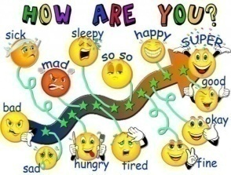 | - the mood will rise  - will be ready for the lesson. answer questions | The method of "verbal encouragement"
The middle of the lesson  30 min | Task 1. Greetings and personal information. Circle the correct answer for each question.  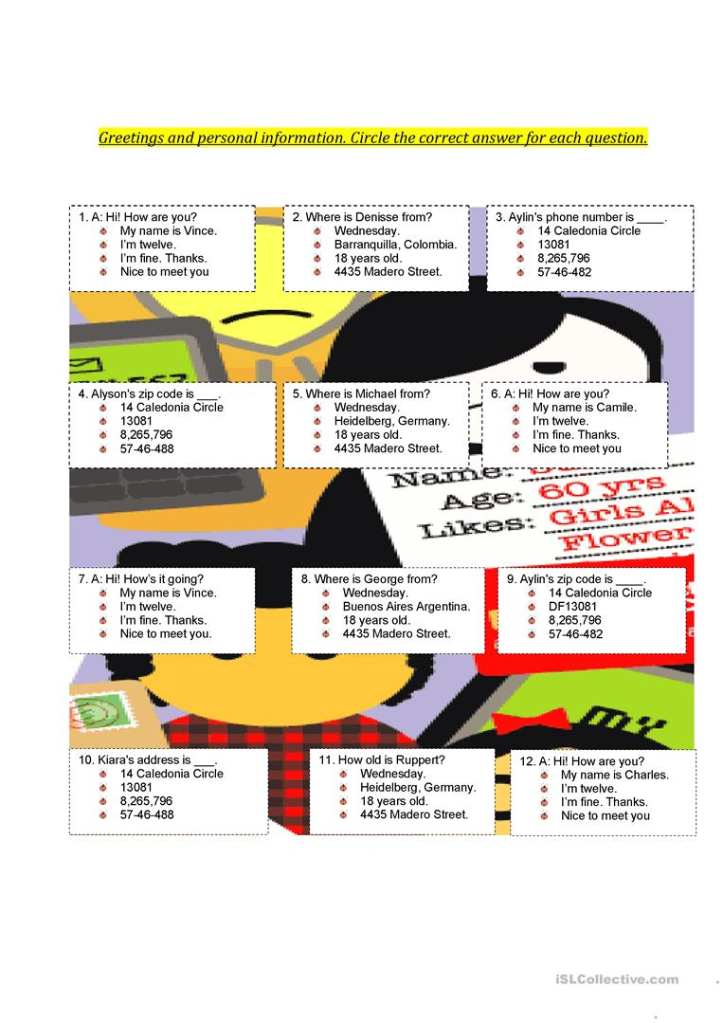  Task 2. Introduce yourself to five other students.  Karla. Nice to meet you.  Hello. I’m Jack.  What’s your name?  Task 3. Search for and circle the hidden words.  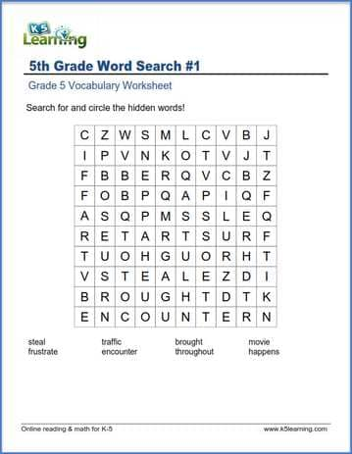  Task 4. Reading.  Environmental problems of Kazakhstan at the present stage  Ecology is a natural and humanitarian science. As a natural science it cannot exclude man, and as a humanitarian science it cannot separate itself from nature. The article deals with the problems of ecology and nature management, which occupy an important place in the socio-economic programs of developed and developing countries. Entering the new century, the Republic of Kazakhstan, like most States, faced serious problems in the field of the environment, and now their solution is elevated to the rank of state policy. In the” Strategy-2030 “of the Republic of Kazakhstan, " improving nutrition, environmental cleanliness and ecology” is one of the priorities. According to the world environmental rating, Kazakhstan is classified as an environmental disaster zone, where the deterioration of the environment has reached its critical limit, beyond which there is a direct danger to the physical and genetic health of the population, the species composition of flora and fauna, and the depletion of non-renewable natural resources.  At the threshold of the new Millennium, humanity, summing up the past and looking to the future, recognizing the achievements of civilization, can not fail to realize the global nature of environmental problems and not plan their activities taking into account the need to solve them and move towards sustainable development.  What is the science of ecology?  Name the branches of general ecological science.  Name the types of environmental factors.  What is an environmental disaster? Give an example.  What are the features of the aquatic environment?  Who first introduced the term ecology to science?  What does human ecology study?  What is meant by "monitoring"?  What is the soil environment?  The impact of human activities on nature.  In what century was the field of ecology and science formed?  What does plant ecology study?  What are natural disasters? | Performs exercises  Performs exercises  Performs text-related tasks | Using the thumb method  The "wonderful, good, wonderful" method  Through a traffic light
End of lesson  5 min | Reflection  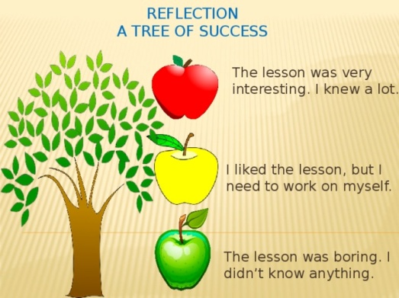 | Creates feedback

Short-term plan-2
Teacher name:
Date:
Grade: |  | Number present: | absent:
Theme of the lesson | Free time activities.
Lesson objectives | Improving students' functional literacy by providing information about Free time activities.
Lesson action
Lessonperiod / time | Teacher's action | Student's action | Evaluation | Resources
The beginning of the lesson  10 min | Greeting learners.  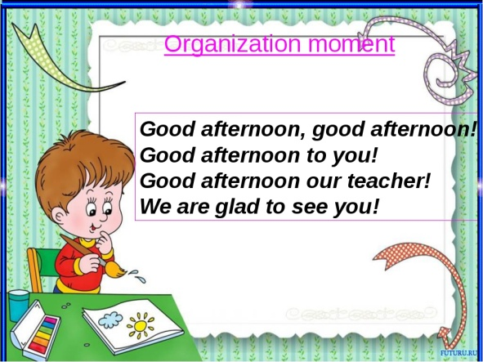 | - the mood will rise  - will be ready for the lesson. answer questions | The method of "verbal encouragement"
The middle of the lesson  30min | Task 1. Hobbies find the correct word and write it on the line below.  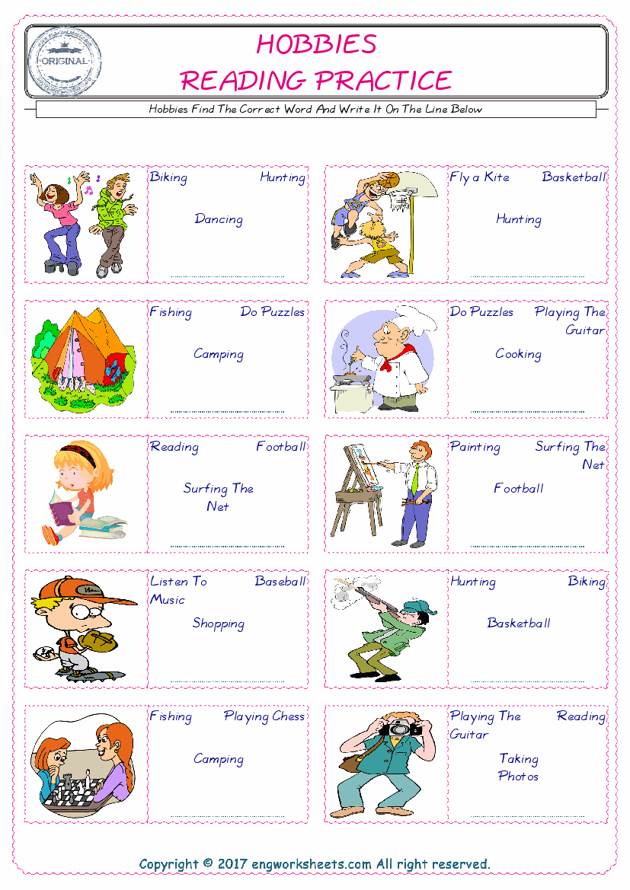  Task 2. Answer the questions.  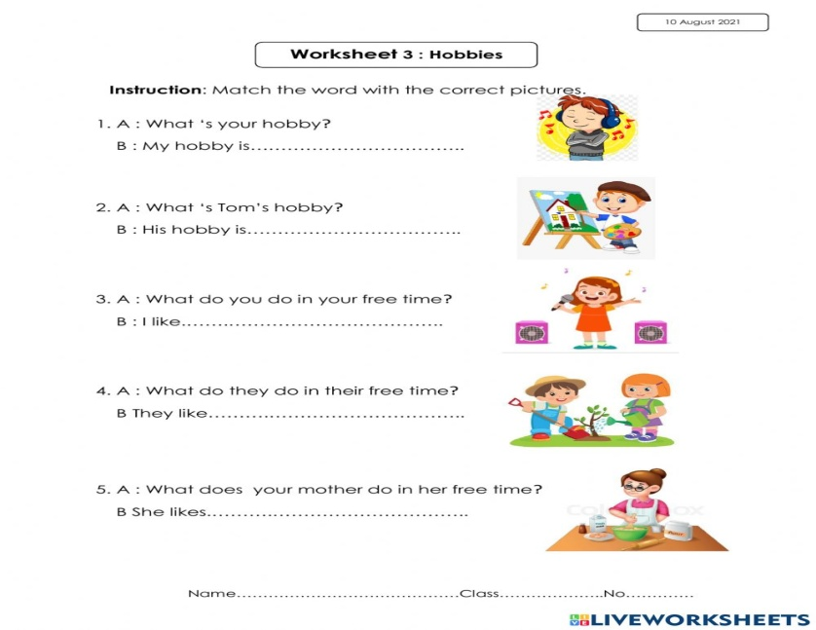  Task 3. Learn by heart tongue twister.  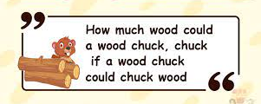  Task 4. Complete the sentences with the expression get a good job. Use the Infinitive or the -ing form of the verb get.  I want _________________________.  I suggest _________________________.  I decided _________________________.  I recommend _________________________.  I hope _________________________.  I feel like _________________________.  I managed _________________________.  I am trying _________________________.  I would appreciate _________________________.  I will not refuse _________________________.  I agree _________________________.  I have denied _________________________.
End of lesson  5 min | 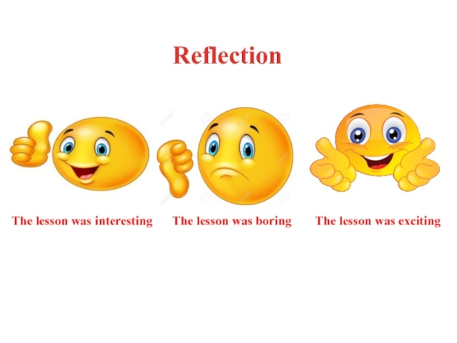 | Creates feedback

Short-term plan-3
Teacher name:
Date:
Grade: |  | Number present: | absent:
Theme of the lesson | I want to be healthy
Lesson objectives | Improving students' functional literacy by providing information about healthy life
Lessonaction
Lessonperiod / time | Teacher's action | Studentaction | Evaluation | Resources
The beginning of the lesson  10 min | Greeting learners.  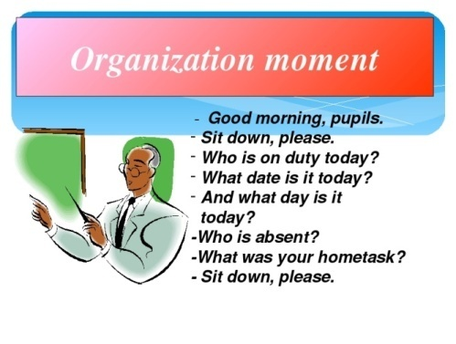 | - the mood will rise  - will be ready for the lesson. answer questions | The method of "verbal encouragement"
The middle of the lesson  30min | Task 1. We must guess some letters.  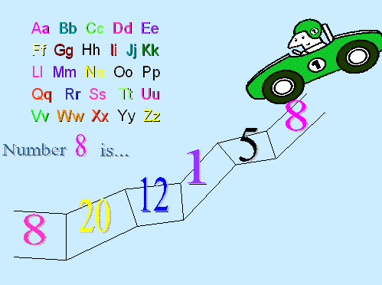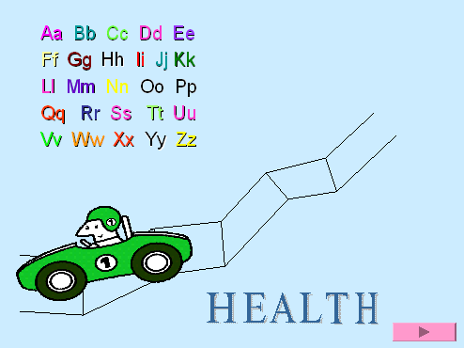  Look at the ABC.  Number 8 is… H  Number 5 is… E  Number 1 is… A  Number 12 is… L  Number 20 is… T  Number 8 is… H  Task 2. Look please at the blackboard and let's read the poem altogether!  To be healthy in your life,  Don’t forget to do all five!  Get up early, quick and bright  Exercise with all your might.  Task 3. Let's check do you know the meals and food in English. find out the odded word!  1.Ham, porridge, chicken, sausages.  2.cucumber, tomato, pepper, bread.  3.cheese, salt, banana, water.  4.bread, milk, pancakes, pie.  5.juice, tea, cabbage, milk.  6.cheese, sour cream, bread, yoghurt.  Make up sentences about healthy food  1. eat, in the morning, porridge, I.  2. She, milk, with, coffee, drink, does, not.  3. hamburgers, they, with, like, cheese.  4. we, eat, for breakfast, do, salad, not, fish, or.  5. for supper, would, I, orange, like, juice.  6. does, Lizzy, not, mineral, drink, water.
End of lesson  5 min Reflection | 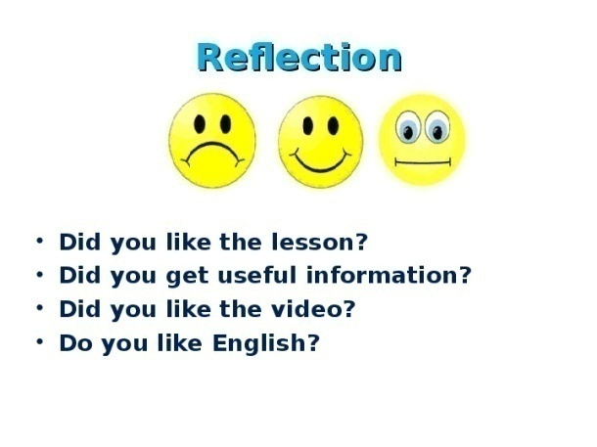 | Creates feedback

Short-term plan-4
Teacher name:
Date:
Grade: |  | Number present: | absent:
Theme of the lesson | His name, her name
Lesson objectives | Improving students' functional literacy by providing information about pronouns
Lessonaction
Lessonperiod / time | Teacher's action | Studentaction | Evaluation | Resources
The beginning of the lesson  10 min | Greeting learners.  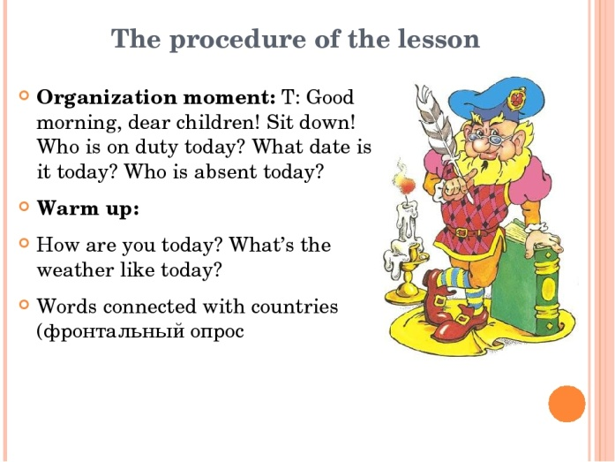 | - the mood will rise  - will be ready for the lesson. answer questions | The method of "verbal encouragement"
Task 1. Complete the sentences with your, my, his, her, their, our. Read and check.
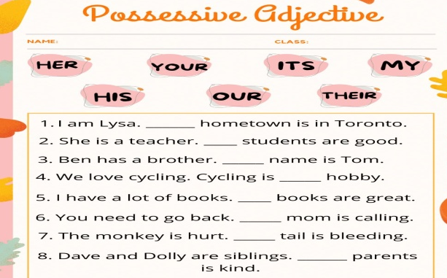

Task 2. PRONOUNCIATION. Listen and repeat.
https://www.youtube.com/watch?v=3zorVXoctEc

Task 3. Speaking. Look at the photos. In pairs, ask and answer the questions.
FAMOUS PEOPLES - BUT DO YOU KNOW THEIR NAMES?
What’s his/her name?
Where’s he/she from?
How old is he/she?


End of lesson  5 min Reflection | 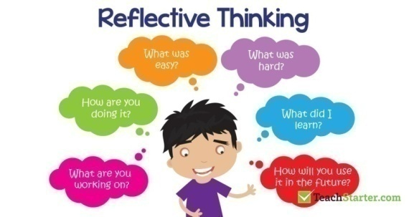 | Creates feedback

Short-term plan-5
Teacher name:
Date:
Grade: |  | Number present: | absent:
Theme of the lesson | Our classroom.
Lesson objectives | Improving students' functional literacy by providing information about classroom things
Lessonaction
Lessonperiod / time | Teacher's action | Studentaction | Evaluation | Resources
The beginning of the lesson  10 min | Greeting learners.  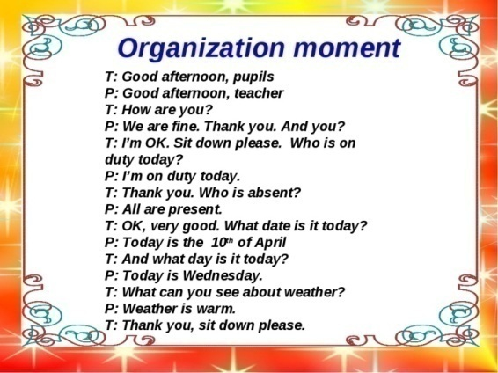 | - the mood will rise  - will be ready for the lesson. answer questions | The method of "verbal encouragement"
Task 1. Vocabulary. Can you see these things in your classroom?
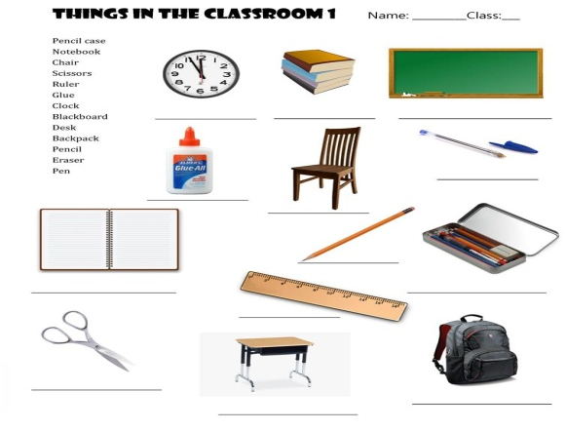
Task 2. Look at the pictures. Write a question and its correct answer by using this, these, that and those.
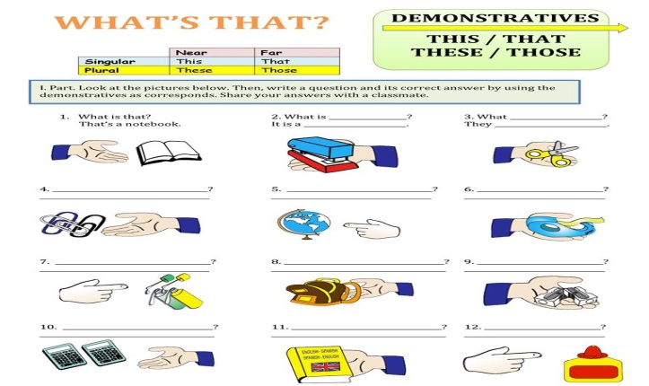
Task 3. Speaking. Work in pairs.
A: Close your eyes
B: Give A a thing from your bag
Ask What’s this? Or What are these?
A: Say It’s a … or They’re …
Task 4. Use Infinitive or -ing form.
It was quite late when they saw Martin … (come) up the other side of the street. They saw him … (pause) in front of his house, … (look) up at it and … (knock) at the door.
My parents let me (stay) at Molly’s house last weekend. They agreed … (take) me to his place in the car and they made me (promise) to behave myself.
Mel hates (answer) the phone. And very often Mel just lets it … (ring).
At first Jenny enjoyed … (listen) to Steven but after a while she got tired of … (hear) the same story.
Polly can’t (go) to the cinema today. She’s busy … (study) for her exam, which is next week, but she’s decided … (take) a break and … (phone) Megan.
I tried … (listen) carefully and in order (not/show) how I was embarrassed, I did my best … (keep) the conversation … (go) on one topic and another.
End of lesson  5 min  Reflection | 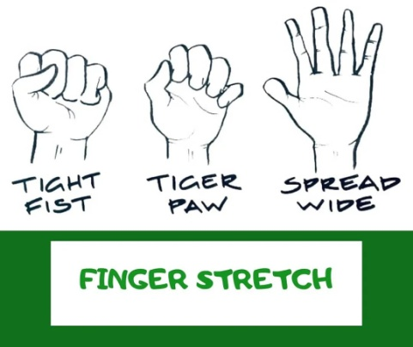 | Creates feedback

Short-term plan-6
Teacher name:
Date:
Grade: |  | Number present: | absent:
Theme of the lesson | A dog’s life
Lesson objectives | Development students oral speech skills during English lessons
Lessonaction
Lessonperiod / time | Teacher's action | Studentaction | Evaluation | Resources
The beginning of the lesson  10 min | Greeting learners. | - the mood will rise  - will be ready for the lesson. answer questions | The method of "verbal encouragement"
Task 1. Watch the story
https://learnenglishkids.britishcouncil.org/short-stories/dogs-life

Task 2. Watch the story again. Match the days with what Dino did.
https://learnenglishkids.britishcouncil.org/short-stories/dogs-life
Task 3. Discussion. Dino the dog has lots of good advice to help us stay safe on the road. What do you think is the most important thing to remember? Tell us your ideas!
Task 4. Put one of the given verbs in the correct form – infinitive or gerund:
to see, to lock, to explain, to go, to show, to play, to listen, to do, to write, to earn, to discuss, t.o drive, to look, to speak, to understand, to do, to stay, to work, to spend
I wish ... the manager.— It’s no use ... to him.
Don’t forget ... the door before ... to bed.
My mother told me not ... to anyone about it.
He tried ... but she didn’t want ...
Would you mind ... me how the lift works?
I’m beginning ... what you mean.
The boys like ... tennis but not ... this in bad weather.
Try ... this correctly.
He likes ... in his cabinet.
I prefer ... my car myself.
I advise you ... at my place and ... for a new flat.
Let’s ... this tomorrow, I’m tired now.
Most people prefer ... money. Some don’t want ... them.
End of lesson  5 min | 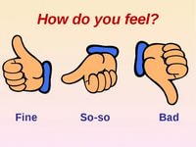 | Creates feedback

Short-term plan-7
Teacher name:
Date:
Grade: |  | Number present: | absent:
Theme of the lesson | Daily routine.
Lesson objectives | Improving students' functional literacy by providing information about Daily routines
Lessonaction
Lessonperiod / time | Teacher's action | Studentaction | Evaluation | Resources
The beginning of the lesson  10 min | Greeting learners.  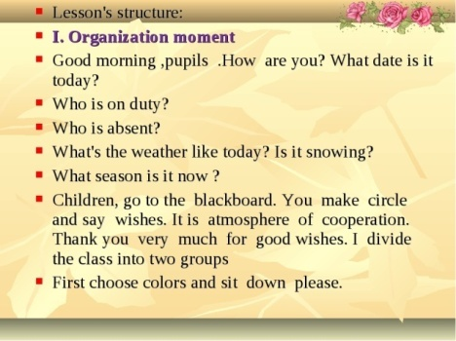 | - the mood will rise  - will be ready for the lesson. answer questions | The method of "verbal encouragement"
Task 1. Vocabulary
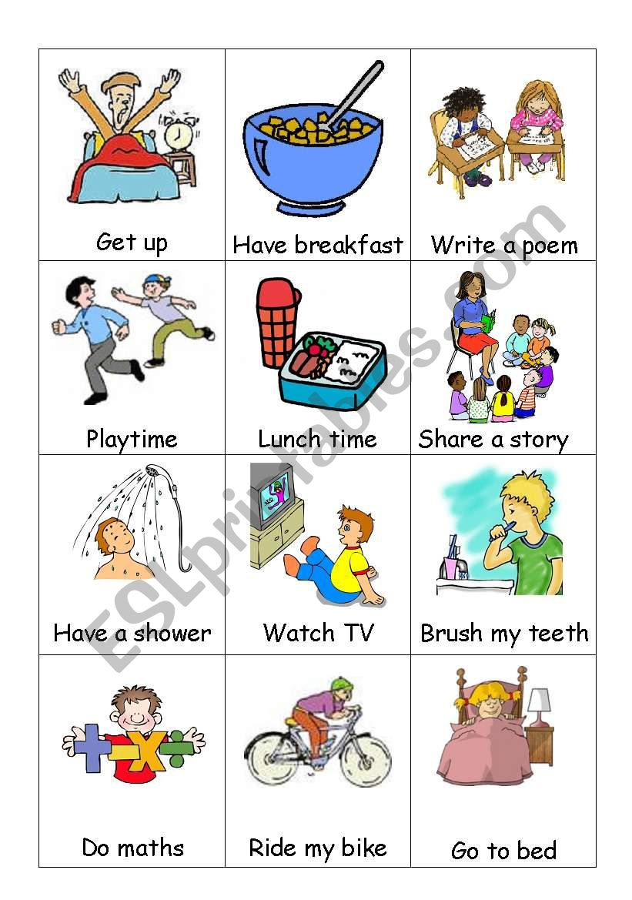
Task 2. Fill in the gaps with the correct verb form the chart in the simple present tense.
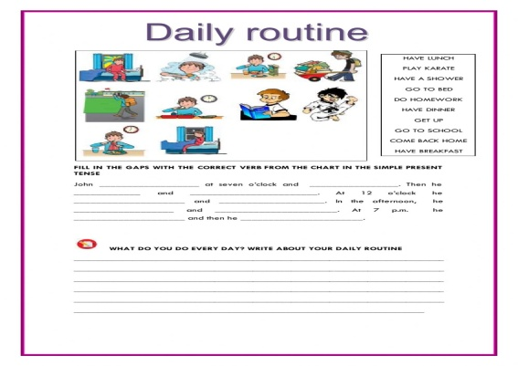
Task 3. Let’s sing a song.
https://www.youtube.com/watch?v=HqjYoUbmAPs
Task 4. Teacher suggests vocabulary activity to the learners. They solve crossword:
Across:
1. a very strong wind in west Atlantic
3. tidal wave
4. a large amount of water spread from a river, sea etc. that covers an area that is normally dry
6. a very bad event, causing harm or death
8. move somebody from a dangerous place
9. a long period without rain

Down:
2. a sudden violent movement of the ground
3. a strong wind that blows in a circle
5. hot liquid rock
7. (of a volcano) to explode and throw out fire, lava, smoke etc.
Answers:
Hurricane
Earthquake
Tsunami
Flood
Lava
Disaster
Erupt
Evacuate
Drought
Answers:
1. erupted; lava; evacuated
2. hurricane
3. drought
4. earthquake; tsunami
5. flood
6. tornadoes
7. disaster
End of lesson  5 min | 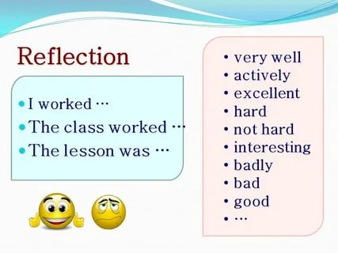

Short-term plan-8
Teacher name:
Date:
Grade: |  | Number present: | absent:
Theme of the lesson | What do you want to be?
Lesson objectives | Improving students' functional literacy by providing information about professions
Lessonaction
Lessonperiod / time | Teacher's action | Studentaction | Evaluation | Resources
The beginning of the lesson  10 min | Greeting learners.  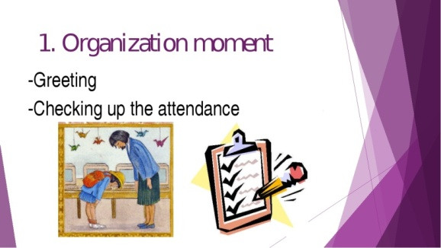 | - the mood will rise  - will be ready for the lesson. answer questions | The method of "verbal encouragement"
Task 1. Vocabulary. Write down new words vocabulary with translation.
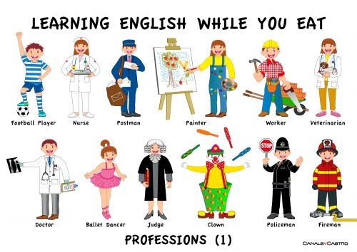
Task 2. Listen and match.
https://agendaweb.org/exercises/vocabulary/jobs/jobs-occupations-audio-1
Task 3. Choose the correct words from the list below and write them under the correct pictures.
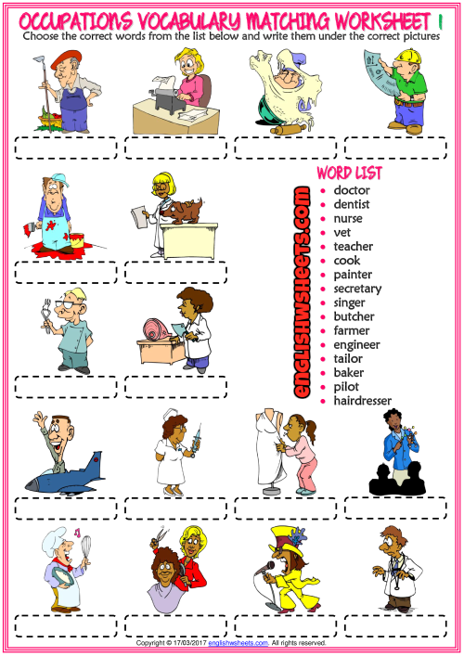
Task 4. Teacher suggests vocabulary activity to the learners. They solve crossword:
Across:
1. a very strong wind in west Atlantic
3. tidal wave
4. a large amount of water spread from a river, sea etc. that covers an area that is normally dry
6. a very bad event, causing harm or death
8. move somebody from a dangerous place
9. a long period without rain

Down:
2. a sudden violent movement of the ground
3. a strong wind that blows in a circle
5. hot liquid rock
7. (of a volcano) to explode and throw out fire, lava, smoke etc.
Answers:
Hurricane
Earthquake
Tsunami
Flood
Lava
Disaster
Erupt
Evacuate
Drought
Answers:
1. erupted; lava; evacuated
2. hurricane
3. drought
4. earthquake; tsunami
5. flood
6. tornadoes
7. disaster
End of lesson  5 min | 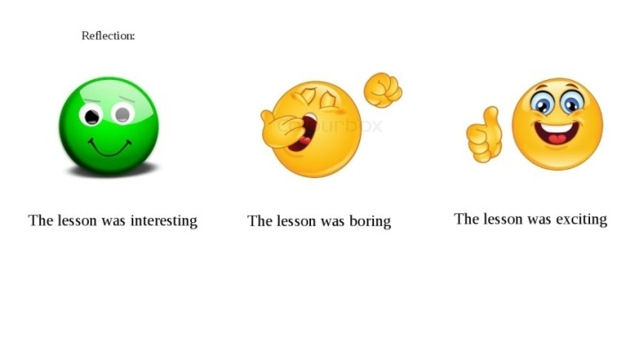 | Creates feedback

Short-term plan-9
Teacher name:
Date:
Grade: |  | Number present: | absent:
Theme of the lesson | My native town
Lesson objectives | Improving students' functional literacy by providing information about city
Lessonaction
Lessonperiod / time | Teacher's action | Studentaction | Evaluation | Resources
The beginning of the lesson  10 min | Greeting learners.  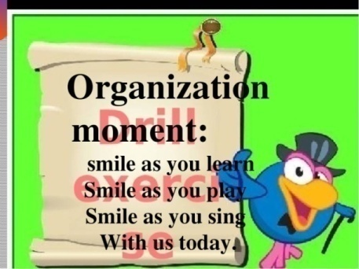 | - the mood will rise  - will be ready for the lesson. answer questions | The method of "verbal encouragement"
Task 1. Read and translate the text.

My city
My city isn’t a bad city however it’s nothing to get too excited about either. Because it’s a quiet city with very little crime lots of people move here to start families. There are plenty of schools and several parks. There are also quite a number of jobs. People work in both offices and factories.
Having grown up here, I know it well. Too well. I’m ready to move to another place. I want to see other cities and other countries. I think it’s important to learn new things and explore other cultures. I like to spend time with people who have ideas that are different from my ideas. It helps me to see things in a new way.
Task 2. Answer the questions
- How do I feel about my city?
- Why do I want to move?
- What does my city not lack?
- Which statement is true?
- Why do I like to meet new people?
Task 3. Watch the video
https://www.youtube.com/watch?v=dCIwO1flbAg
Task 4. Reading tasks
When Things Go Wrong

Our planet has many wondrous things. We plant a tiny sapling and it becomes a mighty tree. Water runs in rivers. Rainbows appear in the sky. But it is not always easy to deal with nature. For instance, sometimes the earth cracks up, slides and slips. The very hot matter inside it oozes out on the surface. Strong waves of water destroy everything in their way. All these events that result from natural processes and can harm human and other life are called natural hazards, and can lead to natural disasters. Volcanoes, earthquakes, avalanches, sinkholes, tsunamis and landslides are some examples of natural disasters. Sometimes, one disaster is related to another. For example: volcanic eruptions can cause earthquakes, and earthquakes can cause landslides and tsunamis.

Vulcan and Volcanoes

Ever wonder where the word “volcano” comes from? It comes from Vulcan—the god of fire and metalwork in Roman mythology. It was believed that he worked inside Mt. Etna, one of the world’s oldest volcanoes, located in Sicily. “Etna” means chimney or furnace. Fire, metal, chimney and furnace—do you see any similarities to a volcano?

The Basic Structure of a Volcano

A volcano is a vent (rupture/crack) in the Earth through which molten (melted) magma and ash come out. Volcanoes occur at places where tectonic plates (under the Earth’s surface) come together or move apart. The “Ring of Fire” under the Pacific Ocean is one of the places where these plates converge. It is the site of 75% of the world’s volcanoes. There are about 452 volcanoes in the Pacific Ocean’s basin. Volcanoes are of three types. An active volcano is one that is erupting or has erupted in the last 10,000 years. An extinct volcano is unlikely to erupt again. A dormant or inactive volcano is between the two. There may be no record of its eruption in the recent past, but it is likely to erupt again. Some volcanoes can remain dormant for millions of years. The study of volcanoes is called volcanology.

Pulling a Tablecloth

What do you think would happen if you quickly pulled the tablecloth off a dining table? The placemats, plates, glasses and cutlery on the table would “quake.” The plates might break into pieces as they land on the surface of the table. The water in the glasses might spill. There might be a loud noise and a mess. The movement that occurs during an earthquake is similar.
An earthquake happens when blocks of earth slide past one another and cause a “fault” on the earth’s surface. The “hypocenter” is the place where the blocks of earth slide and the earthquake starts. It is below the surface. Its corresponding point on the surface is called “epicenter.” Southern California has about 10,000 earthquakes every year. Most of these, fortunately, go unnoticed. The study of earthquakes is called seismology.

Tsunamis

Does “tsunami” sound like a word from a foreign language? That’s because it is! The word is pronounced with a silent “t” and means “harbor wave” in Japanese. It refers to a series of very long ocean waves that are caused by large disturbances in/under the ocean. Volcanoes, earthquakes, landslides and meteorites are the most common causes of a tsunami.
Who looks into tsunamis? Geologists, oceanographers, and seismologists—like earthquakes, tsunamis are caused by movements below the earth’s surface.

Avalanches

We get an idea about what an avalanche is by its other names: snow slide and snow slip. It is the sliding of snow down the slope of a mountain. We know that gravity pulls things downward on earth. A mass of snow on a slope slides down when the pull of gravity is greater than its own strength. When this mass is large, it takes things in its path along with it. A person who studies avalanches is called an avalanche meteorologist.

What Can We Do?

We cannot prevent natural disasters entirely. They arise from forces which are beyond our individual control. But there are some small ways in which we can take care of our planet. When we plant or preserve trees, we make our earth more stable. It is better able to clean polluted air and keep water in balance. We can walk to our school or the market and use less electricity. This would save our fossil fuels and keep the planet’s climate in order. We can avoid products (such as some deodorants) that are harmful to the environment. We must remember that things in nature are connected to each other. The water, soil, air and forces under the earth’s surface are all affected by our actions.

1. What natural disasters are discussed in this passage?

A rainbows, rivers, saplings, mountains, and metalwork
B volcanoes, earthquakes, tsunamis, and avalanches

C Roman mythology, Vulcan, and Mt. Etna
D Southern California, the Pacific Ocean, and Sicily

2. What does this passage describe?

A This passage describes chimneys and furnaces.
B This passage describes different natural disasters.
C This passage describes two volcanoes that have erupted within the past 10,000 years.
D This passage describes everyday life in Sicily.

3. People can take steps to prevent natural disasters.
What evidence from the passage supports this statement?

A The study of earthquakes is called seismology.
B A volcano is a vent in the earth through which magma and ash come out.
C There are three types of volcanoes: extinct, dormant, and active.
D People can plant trees to make life on earth more stable.

4. What is a natural disaster?

A an event caused by nature that harms human life
B the study of earthquakes, tsunamis, volcanoes, and avalanches
C the process by which a tiny sapling grows into a mighty tree
D a way that people can take care of their planet

5. What is this passage mostly about?

A saplings and rainbows
B avalanches and geologists
C natural disasters
D what causes tsunamis

6. Read the following sentence: “The water, soil, air and forces under the earth’s surface are all affected by our actions.”
What does the word surface mean?

A a body of water where a tsunami is likely to happen
B the movement of land during an earthquake
C the outer layer or part of something
D the innermost layer or part of something

7. Choose the answer that best completes the sentence below.
There are several kinds of natural disasters, _______ earthquakes, volcanoes, and avalanches.

A in contrast
B in the end
C meanwhile
D such as

8. Where do volcanoes occur?
9. When do earthquakes occur?
10. What are some things that the natural disasters described in this passage have in common?
Answers
B
B
C
A
C
C
D
Suggested answer: Ideally, students will answer that volcanoes occur where tectonic plates come together or move apart. Another acceptable response is that volcanoes occur in the Pacific Ocean.
Suggested answer: Earthquakes occur when blocks of earth slide past one another and cause a fault on the earth’s surface.
Suggested answer: Answers may vary but should have a basis in the passage. For example, students may respond that earthquakes and volcanoes are caused by movements below the earth’s surface. They may also respond that all natural disasters defy complete prevention but that steps can be taken to make the earth more stable.
Descriptor
A learner

comprehends the task and chooses A,B,C or D;
gives full answers for open-ended questions

End of lesson  5 min | 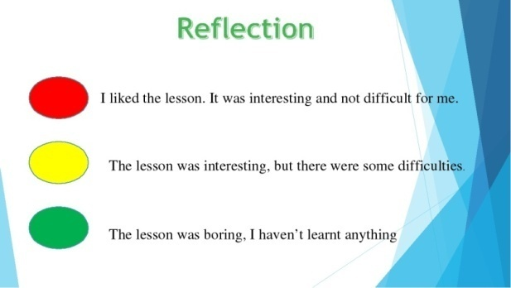 | Creates feedback

Short-term plan-10
Teacher name:
Date:
Grade: |  | Number present: | absent:
Theme of the lesson | Singular and plural nouns.
Lesson objectives | Improving students' functional literacy by providing information about nouns
Lessonaction
Lessonperiod / time | Teacher's action | Studentaction | Evaluation | Resources
The beginning of the lesson  10 min | Greeting learners.  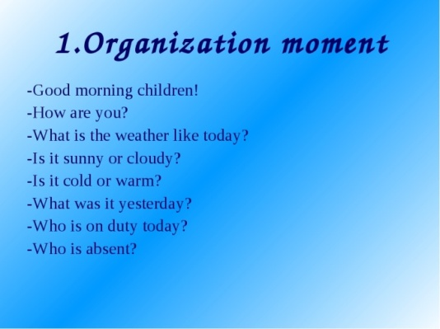 | - the mood will rise  - will be ready for the lesson. answer questions | The method of "verbal encouragement"
Task 1. Read and write the answer.
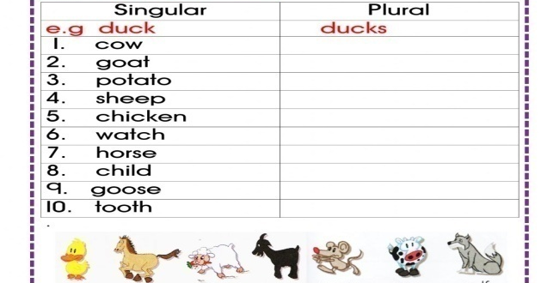
Task 2. Look, count and write.
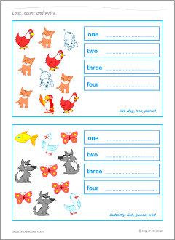
Task 3. Listen and watch the video
https://www.youtube.com/watch?v=L4B7XxuJO6A
Task 4. READING
You should spend about 20 minutes on Questions 1–13, which are based on Reading Passage 1 below.
The Earth
(A) The Earth is the third planet from the Sun and it is the only planet known to have life on it. The Earth formed around 4.5 billion years ago. It is one of four rocky planets on the inside of the Solar System. The other three are Mercury, Venus, and Mars.
(B) The large mass of the Sun makes the Earth move around it, just as the mass of the Earth makes the Moon move around it. The Earth also turns round in space, so different parts face the Sun at different times. The Earth goes around the Sun once (one "year") for every 365¼ times it turns all the way around (one "day").
(C) The Moon goes around the Earth about every 27⅓ days, and reflects light from the Sun. As the Earth goes round the Sun at the same time, the changing light of the Moon takes about 29½ days to go from dark to bright to dark again. That is where the idea of "month" came from. However, now most months have 30 or 31 days so they fit into one year.
(D) The Earth is the only planet in our Solar System that has a large amount of liquid water. About 71% of the surface of the Earth is covered by oceans. Because of this, it is sometimes called the "Blue Planet".
(E) Because of its water, the Earth is home to millions of species of plants and animals. The things that live on Earth have changed its surface greatly. For example, early cyanobacteria changed the air and gave it oxygen. The living part of the Earth's surface is called the "biosphere".
(F) The Earth is part of the eight planets and many thousands of small bodies that move around the Sun as its Solar System. The Solar System is moving through the Orion Arm of the Milky Way Galaxy now, and will be for about the next 10,000 years.
(G) The Earth is generally 150,000,000 kilometers or 93,000,000 miles away from the Sun (this distance is named an "Astronomical Unit"). The Earth moves along its way at an average speed of about 30 km or 19 mi a second. The Earth turns all the way around about 365¼ times in the time it takes for the Earth to go all the way around the Sun. To make up this extra bit of a day every year, an additional day is used every four years. This is named a "leap year".
(H) The Moon goes around the Earth at an average distance of 400,000 kilometers (250,000 mi). It is locked to Earth, so that it always has the same half facing the Earth; the other half is called the "dark side of the Moon". It takes about 27⅓ days for the Moon to go all the way around the Earth but, because the Earth is moving around the Sun at the same time, it takes about 29½ days for the Moon to go from dark to bright to dark again. This is where the word "month" came from, even though most months now have 30 or 31 days.
Questions 1–8
Reading Passage 1 has eight paragraphs A-H. Which paragraph contains the following information? Write the correct letter, A–H, in boxes 1–8 on your answer sheet.

1. Earth’s natural satellite
2. Distance between Earth and Sun
3. General information about Earth
4. The Solar System
5. Length of most moths
6. Another name for Earth
7. The living part of the Earth's surface
8. The movements of Earth around the Sun

Questions 9-13
Complete the sentences below.
Choose NO MORE THAN THREE WORDS from the text for each answer.
Write your answers in boxes 9-13 on your answer sheet.

9. Apart from Earth, other rocky planets in our Solar Systems are Venus, Mars and .
10. Moon from the Sun on Earth.
11. There are millions of of plants and animals that inhabit Earth.
12. Now the Solar System is travelling through .
13. The dark side of the Moon is the side, which faces Earth.
ANSWERS
Each question correctly answered scores 1 mark. Correct spelling is needed in all answers.
Section 1
H
G
A
F
C
D
E
B
Mercury
Reflects light
Species
The Orion Arm
Never
End of lesson  5 min | 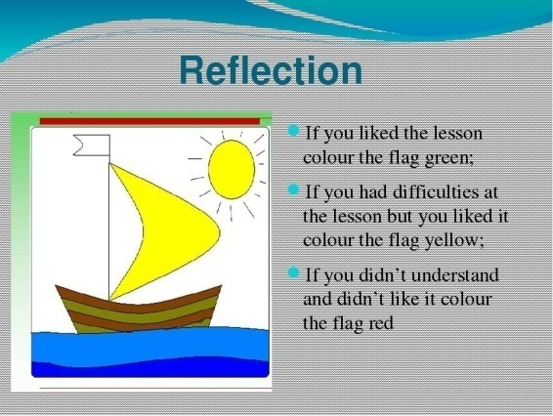 | Creates feedback

Short-term plan-11
Teacher name:
Date:
Grade: |  | Number present: | absent:
Theme of the lesson | Personality adjectives
Lesson objectives | Improving students' functional literacy by providing information about Personality adjectives

Lessonaction
Lessonperiod / time | Teacher's action | Studentaction | Evaluation | Resources
The beginning of the lesson  10 min | Greeting learners.  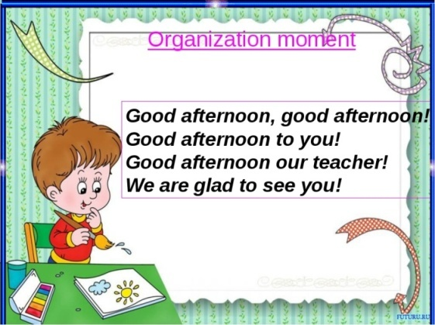 | - the mood will rise  - will be ready for the lesson. answer questions | The method of "verbal encouragement"
Task 1. Put the adjectives in the correct column.
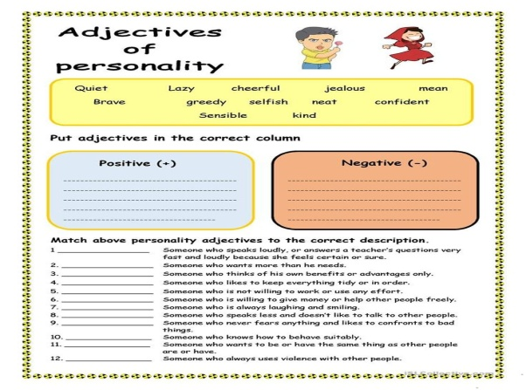
Task 2. Speaking. Describe personality
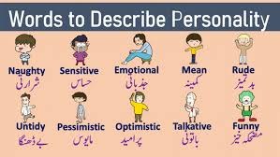
Task 3. Watch and listen to the video. Natural conversation.
https://www.youtube.com/watch?v=NFCfeoWcEqw
Task 4. Reading
Pollution and its Negative Effects
Pollution is the degradation of natural environment by external substances introduced directly or indirectly. Human health, ecosystem quality and aquatic and terrestrial biodiversity maybe affected and altered permanently by pollution. Pollution occurs when ecosystems cannot get rid of substances introduced into the environment. The critical threshold of its ability to naturally eliminate substances is compromised and the balance of the ecosystem is broken.The sources of pollution are numerous. The identification of these different pollutants andtheir effects on ecosystems is complex. They can come from natural disasters or the result ofhuman activity, such as oil spills, chemical spills, nuclear accidents ... These can have terrible consequences on people and the planet where they live: destruction of the biodiversity,increased mortality of the human and animal species, destruction of natural habitat, damagecaused to the quality of soil, water and air ...Preventing pollution and protecting the environment necessitate the application of theprinciples of sustainable development. we have to consider to satisfy the needs of today without compromising the ability of future generations to meet their needs. This means that we should remedy existing pollution, but also anticipate and prevent future pollution sources in order toprotect the environment and public health. Any environmental damage must be punishable bylaw, and polluters should pay compensation for the damage caused to the environment
Comprehension
1. The damage caused by pollution might be irreversible:
a. Trueb. False
2. The ecosystema. can always cope with pollutantsb. may not always be able to cope with pollution.
3. Pollutiona. is always caused by humans.b. may sometimes be caused by natural disasters.
4. An ideal solution to prevent pollution would be toa. refrain the development of some countries.b. continue developmental projects.c . take into consideration the future generations need to live in a healthy environment.

End of lesson  5 min | 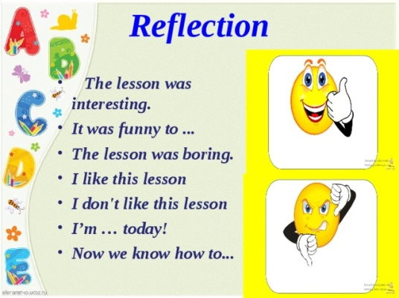 | Creates feedback

Short-term plan-12
Teacher name:
Date:
Grade: |  | Number present: | absent:
Theme of the lesson | Best places to visit in London.
Lesson objectives | Improving students' functional literacy by providing information about visiting the London
Lessonaction
Lessonperiod / time | Teacher's action | Studentaction | Evaluation | Resources
The beginning of the lesson  10 min | Greeting learners.  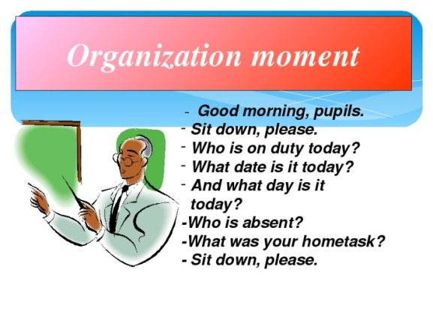 | - the mood will rise  - will be ready for the lesson. answer questions | The method of "verbal encouragement"
Task 1. Work with the text.
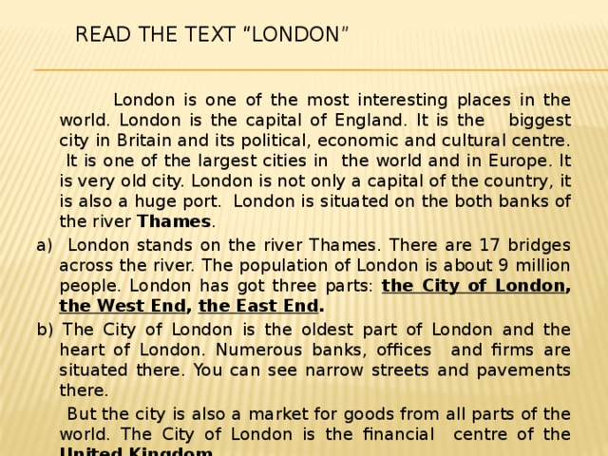
Task 2. Match the pictures and the words.
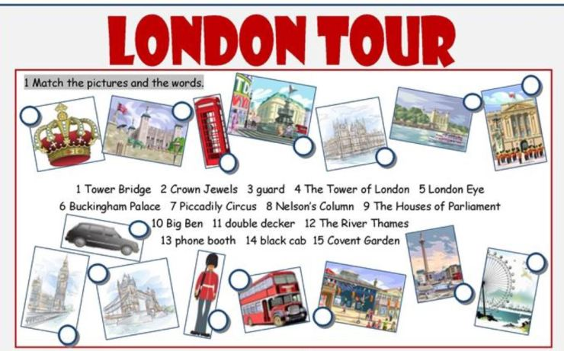
Task 3. Answer the questions.
- What is the Tower famous for?
- What is Downing Street, 10 famous for?
- What is Big Ben?
- What is the colour of the London buses, and telephone booths?
- What is Whitehall?
- What is the official home of the queen?
Task 4. Replace adjectives with infinitive verbs.
EXAMPLE: He is so old that he cannot skate. He is too old to skate.
1. The problem is so difficult that it is impossible to solve it. 2. The box is so heavy that nobody can carry it. 3. The baby is so little that it cannot walk. 4. He is so weak that he cannot lift this weight. 5. She is so busy that she cannot talk with you. 6. She was so inattentive that she did not notice the mistake. 7. The rule was so difficult that they did not understand it. 8. He was so stupid that he did not see the joke. 9. She has got so fat that she cannot wear this dress now. 10. The accident was so terrible that I don't want to talk about it. 11. They were so empty-headed that they could not learn a single thing. 12. The window was so dirty that they could not see through it. 13. She was so foolish that she could not understand my explanation. 14. I have very little wool: it won't make a sweater.
End of lesson  5 min | 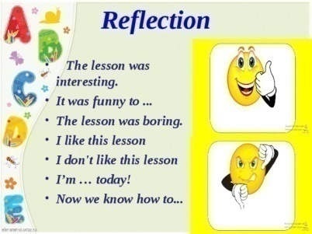 | Creates feedback

Short-term plan-13
Teacher name:
Date:
Grade: |  | Number present: | absent:
Theme of the lesson | Comparative and superlative adjectives.
Lesson objectives | Improving students' functional literacy by providing information about adjectives.
Lessonaction
Lessonperiod / time | Teacher's action | Studentaction | Evaluation | Resources
The beginning of the lesson  10 min | Greeting learners.  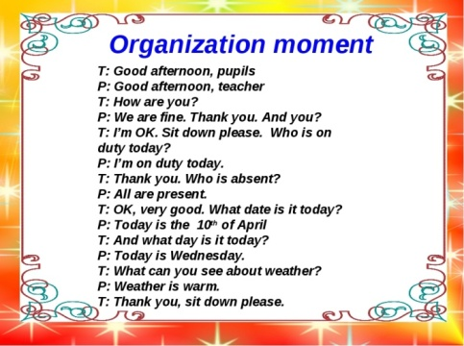 | - the mood will rise  - will be ready for the lesson. answer questions | The method of "verbal encouragement"
Task 1. Fill in the blanks using comparative and superlative adjectives.
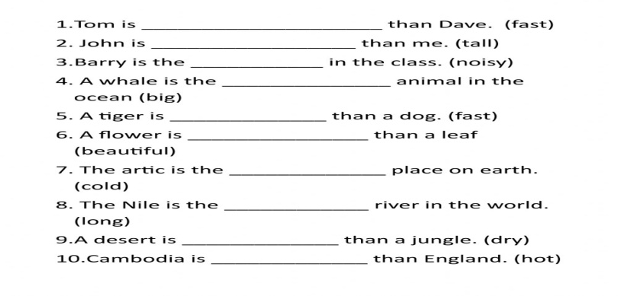
Task 2. Listen and watch the video then describe the peoples.
https://www.youtube.com/watch?v=FHqwBYdEJWQ
Task 3. Look at the picture. Make sentences with comparative adjectives.
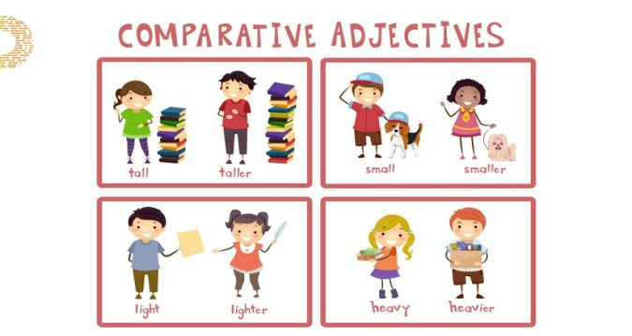
Task 4. Where do you need to go? Give some advice to your friend: you need to go to…
1. I want to get a newspaper.
2. I’d like to buy food for a week.
3. I need some stamps.
4. We must get Jim a present.
5. I’d like to buy a book.
6. I want to buy some clothes for myself and my children in one shop.

End of lesson  5 min | 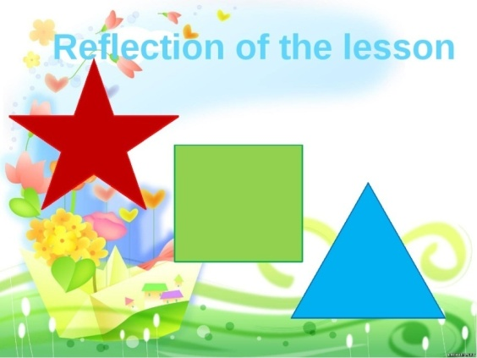 | Creates feedback

Short-term plan-14
Teacher name:
Date:
Grade: |  | Number present: | absent:
Theme of the lesson | Travelling.
Lesson objectives | Improving students' functional literacy by providing information about Travelling.
Lessonaction
Lessonperiod / time | Teacher's action | Studentaction | Evaluation | Resources
The beginning of the lesson  10 min | Greeting learners.  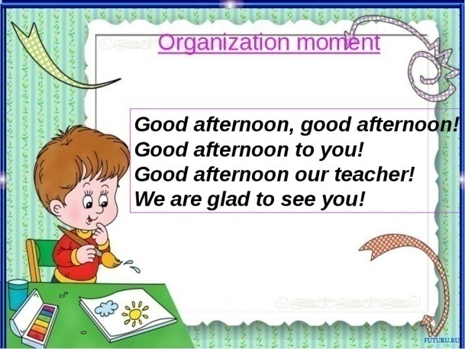 | - the mood will rise  - will be ready for the lesson. answer questions | The method of "verbal encouragement"
Task 1. Complete the sentences with the words and phrases below.
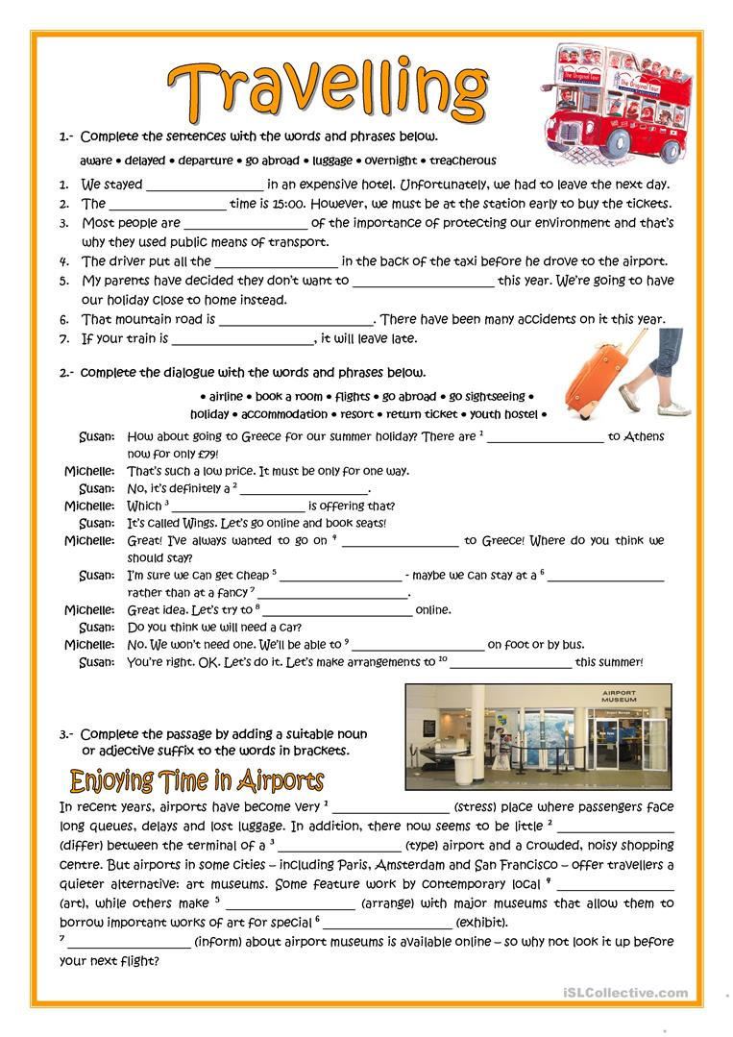
Task 2. Speaking. What do you see at the picture?
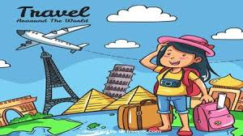
Task 3.Writing. Write an essay about “Travelling”
Task 4. Complete the sentences with the correct idioms
1. What a mess! There are empty boxes all … .
2. Women like shopping but what is really exciting is not buying but … .
3. The police are looking for the famous … who has already robbed ten shops.
4. I have problems with buying Easy English. It always … .
In the department store.A department store is a large shop which sells a lot of different things – clothes, beauty products, toys, etc.
End of lesson  5 min | 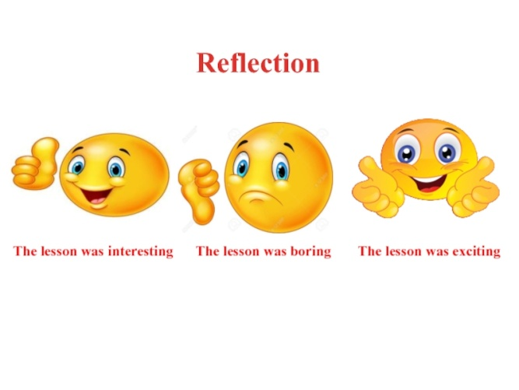 | Creates feedback

Short-term plan-15
Teacher name:
Date:
Grade: |  | Number present: | absent:
Theme of the lesson | Past Simple.
Lesson objectives | Improving students' functional literacy by providing information about Past Simple.
Lesson action
Lessonperiod / time | Teacher's action | Studentaction | Evaluation | Resources
The beginning of the lesson  10 min | Greeting learners.  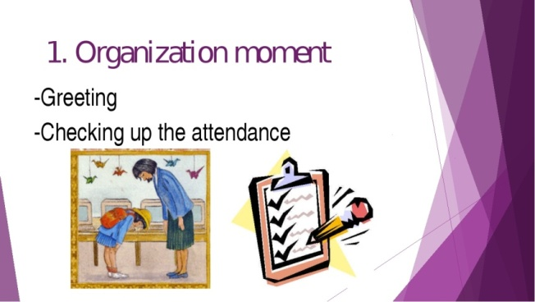 | - the mood will rise  - will be ready for the lesson. answer questions | The method of "verbal encouragement"
Task 1. Write the Past Simple form of the verbs.
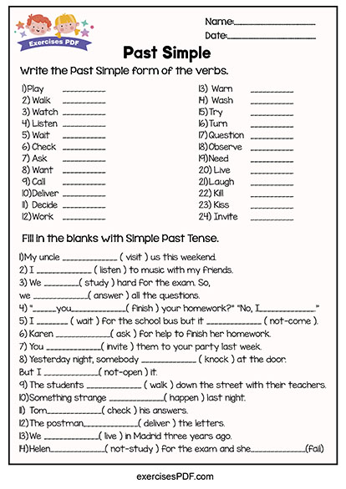
Task 2. Listen and watch the video. Talking about a trip using the Past Simple.
https://www.youtube.com/watch?v=mngiqrT44Pk
Task 3. Speaking. Make up the dialogue using the past time expressions.
Task 4. Match the words in column a with the definitions in column b:
A | B
1. chemist’s | A. The shop where you buy meat
2. off-license | B. A place with many shops, either outside or indoors
3. window shopping | C. A person who works in a shop
4. shop/sales assistant | D. The place where you can try on clothes in a shop
5. butcher’s | E. The place where you pay for things in a shop
6. shopping centre | F. To look around the shops without planning to buy anything
7. cash desk/counter | G. A shop where you buy wine, beer and soft drinks.
8. changing/fitting room | H. A shop where you buy medicines, baby products, shampoo, etc.

End of lesson  5 min |  | Creates feedback

Short-term plan-16
Teacher name:
Date:
Grade: |  | Number present: | absent:
Theme of the lesson | Around the world
Lesson objectives | Improving students' functional literacy by providing information about around the world
Lessonaction
Lessonperiod / time | Teacher's action | Studentaction | Evaluation | Resources
The beginning of the lesson  10 min | Greeting learners. | - the mood will rise  - will be ready for the lesson. answer questions | The method of "verbal encouragement"
Task 1. Role play dialogue. Read and translate.
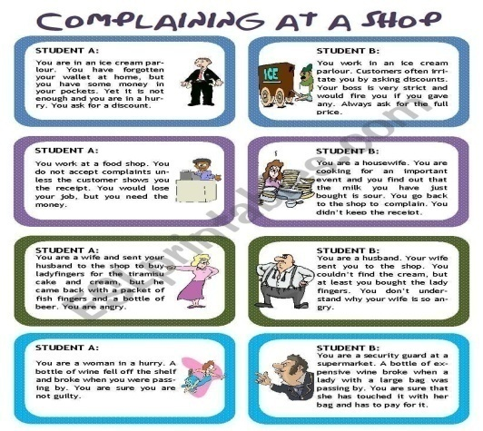
Task 2. Say the name of each picture out loud and circle the beginning sound.
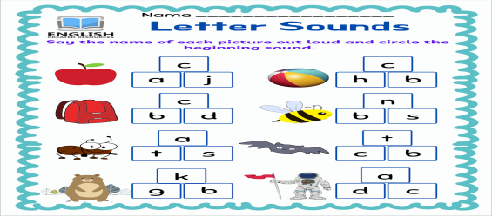
Task 3. Learn by heart tongue twister.

Task 4. Let’s talk about FASHION

This is not a career choice for the meek. First ask yourself - Do I want to be a model? Are you willing to put the time and energy into competing with pretty much everyone you meet, 24 hrs a day?

You have to understand that there are lots of other people who want to be models, it’s a very competitive business. Unless you are seriously committed about modeling, willing to work at it on your own time, live a healthy life style, etc., you will not succeed as a model. Not all jobs pay well.

Modeling is a lifestyle, not a 9-5 job. Prepare to be constantly rejected, get ready for some major ups and downs. It’s boring (sometimes) and it can be tedious. Despite the glamour and hype you have seen about the modeling profession, it’s hard work. You need to have tough skin in this business.
Mark true (T) or false (F) according to the text and explain when it’s false:
- You have to be sure you really want to be a model. ( )
__________________________________________
- You’ll compete all the time with many people every day in your life. ( )
__________________________________________
- Few people want to be models because it’s a tough job. ( )
__________________________________________
- Being a model doesn’t require much commitment. ( )
__________________________________________
- Some jobs don’t pay well in modeling business. ( )
__________________________________________
- It’s an exciting job all the time. ( )
__________________________________________
- It’s hard work. ( )
__________________________________________
- You need to treat your skin to become tough to be a model. ( )

End of lesson  5 min | 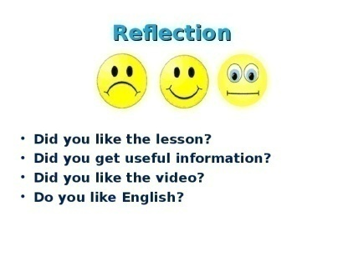 | Creates feedback

Short-term plan-17
Teacher name:
Date:
Grade: |  | Number present: | absent:
Theme of the lesson | Extra reading
Lesson objectives | Improving students' functional literacy by providing information about around reading the text

Lessonaction
Lessonperiod / time | Teacher's action | Studentaction | Evaluation | Resources
The beginning of the lesson  10 min | Greeting learners. | - the mood will rise  - will be ready for the lesson. answer questions | The method of "verbal encouragement"
Task 1. Reading and speaking. Make presentations on the topics: Texts for the groups:
I. Different food
There are different kinds of food. They are traditional food, meat and milk products, bakery, vegetables, fruits. People cannot live without food. Some of them are healthy food. Some are not healthy. Different food comes from different countries. We get food from animals, from plants. We grow some food. We buy food from shops.
II. British food
British people eat four meals a day. They eat cornflakes with milk, toasts with marmalade, honey and tea. They eat a large meal at midday. The midday meal is the chief one of the day. They eat roast beef, roast potatoes and Yorkshire pudding. British people eat a lot of meat. In the evening they have a simple supper. British people drink a lot of tea like Kazakh people.
Task 2. Writing an essay about healthy food and unhealthy food.
Task 3. Listen and watch the video
https://www.youtube.com/watch?v=9YiJj10yqp0
End of lesson  5 min |  | Creates feedback

Short-term plan-18
Teacher name:
Date:
Grade: |  | Number present: | absent:
Theme of the lesson | Personal pronouns. Reflexive pronouns.
Lesson objectives | Improving students' functional literacy by providing information about Personal pronouns. Reflexive pronouns.
Lessonaction
Lessonperiod / time | Teacher's action | Studentaction | Evaluation | Resources
The beginning of the lesson  10 min | Greeting learners. | - the mood will rise  - will be ready for the lesson. answer questions | The method of "verbal encouragement"
Task 1. Write the correct pronouns in the table.
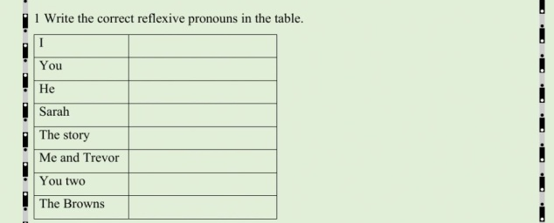
Task 2. Fill in the correct reflexive pronouns.
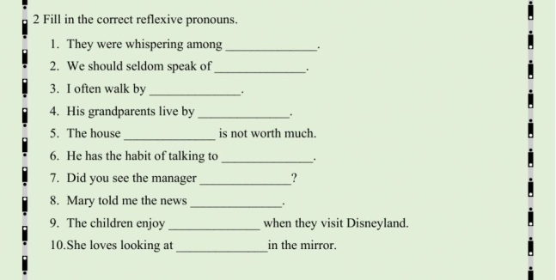
Task 3. Change these sentences: using by personal pronouns
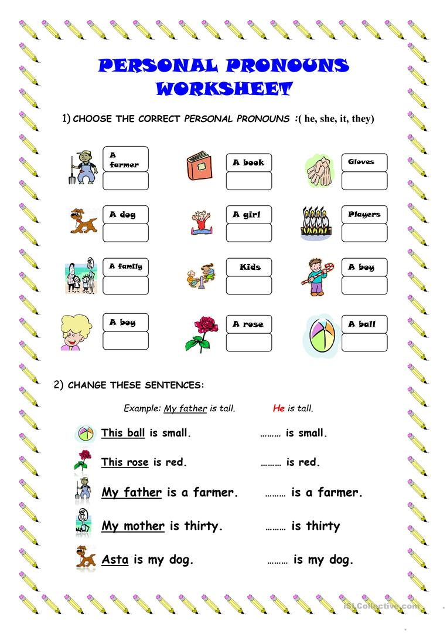
Task 4. Choose the correct option.
1 I like reading. My favourite / best books are the Harry Potter books.
2 My brother, Jack always plays computers game / computer games.
3 If you watch TV all the time, you’re a couch potato / fan.
4 What are you interested in / for?
5 We usually go at / to the cinema on Saturdays.
End of lesson  5 min |  | Creates feedback

Short-term plan-19
Teacher name:
Date:
Grade: |  | Number present: | absent:
Theme of the lesson | Are you still mine?
Lesson objectives | Improving students' functional literacy by providing information about possessive pronoun
Lessonaction
Lessonperiod / time | Teacher's action | Studentaction | Evaluation | Resources
The beginning of the lesson  10 min | Greeting learners. | - the mood will rise  - will be ready for the lesson. answer questions | The method of "verbal encouragement"
Task 1. Fill on the blanks with the correct possessive pronoun
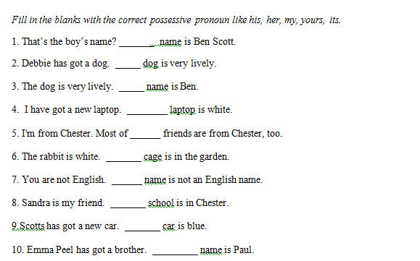
Task 2. Grammar quiz
https://www.youtube.com/watch?v=HHuOl3QHb5E
Task 3. Learn by heart tongue twister
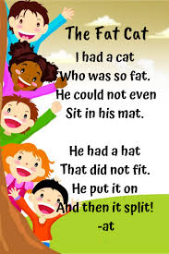
Task 4. Work in pairs. Make the dialogue
1. Hotel Reservation
R: Hello, Ashley Hotel.
C: Hello. I'd like to make reservations for 3 nights beginning March 6.
R: Yes, of course. What kind of room would you like?
C: I'd like a double room. How much would that be?
R: A double room is $42.00 a night.
C: O.K. I'll take it.
R: What is the name, please?
C: The name is Scott, Nil and Susan.
R: And what time are you arriving?
C: We're planning to arrive around8:00 in the evening.
R: Very well, Mam. We'll have your room ready for you.
C: OK. Thank you.
R: Thank you for calling Ashley Hotel.
2. Checking in
R: Welcome to the Sheraton. May I help you?
C: I’d like to check in. I have a reservation.
R: What’s your name, please?
C: Phillip Mallow.
R: Yes Mr. Mallow. You requested a single room for three nights, is that correct?
C: Yes, could I have a room on the upper floors, away from the ice machine?
R: No problem. Do you prefer a smoking or non-smoking floor?
C: Non-smoking please.
R: Could you fill out the registration form, please. Thank you. And will you be paying by cash or creditcard?
C: Cash, if you accept American dollars.
R: Of course, sir. If you require local currencies we can also exchange money foryou.
C: That’s great, I do need some cash.
R: Your room number is 1109. Here’s your key. Enjoy your stay at the Sheraton. If you requireanything further,feelfree to call the front desk. Would you like assistance with your bags?
C: No thanks, I only have one. I can manage.
3. Hotel Services
Room service: Hello. Room service.
C: Hello, I'm calling from room 113.I would like to order dinner.
RS: What would you like to order?
C: I'd like the roast beef dinner, with mashed potatoes and green beans.
RS: Would you care for something to drink with dinner'?
C: Ah, yes a large glass of milk.
RS: Any dessert?
C: A dish of vanilla ice cream
RS: Thank you. We'll bring it up in about thirty minutes.
4. Checking out
R: Good morning. May I help you?
A: Yes, I´d like to check out now. My name´s Adams, room 312. Here´s the key.
R: One moment, please, sir. ... Here´s your bill. Would you like to check and see if the amount is correct?
A: What´s the 14 pounds for?
R: That´s for the phone calls you made from your room.
A: Can I pay with traveller´s cheques?
R: Certainly. May I have your passport, please?
A: Here you are.
R: Could you sign each cheque here for me?
A: Sure.
R: Here are your receipt and your change, sir.
Thank you.
A: Thank you. Goodbye.

End of lesson  5 min |  | Creates feedback

Short-term plan-20
Teacher name:
Date:
Grade: |  | Number present: | absent:
Theme of the lesson | Buying clothes.
Lesson objectives | Improving students' functional literacy by providing information about Buying clothes.
Lessonaction
Lessonperiod / time | Teacher's action | Studentaction | Evaluation | Resources
The beginning of the lesson  10 min | Greeting learners. | - the mood will rise  - will be ready for the lesson. answer questions | The method of "verbal encouragement"
Task 1. Match the words and pictures.
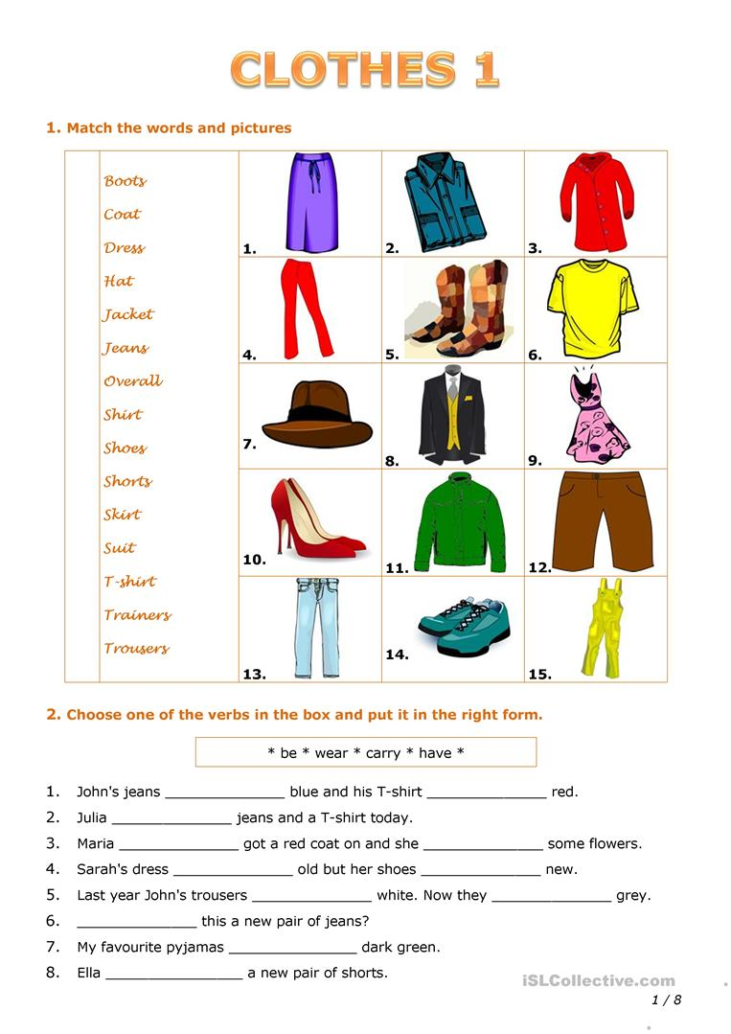
Task 2. Choose one of the verbs in the box and put it in the right form.
Task 3. Work in pair. Make the dialogue on the topic “At the shop”

End of lesson  5 min |  | Creates feedback

Short-term plan-21
Teacher name:
Date:
Grade: |  | Number present: | absent:
Theme of the lesson | Describing a friend.
Lesson objectives | Improving students' functional literacy by providing information about Describing a friend.
Lessonaction
Lessonperiod / time | Teacher's action | Studentaction | Evaluation | Resources
The beginning of the lesson  10 min | Greeting learners. | - the mood will rise  - will be ready for the lesson. answer questions | The method of "verbal encouragement"
Task 1. Read the text
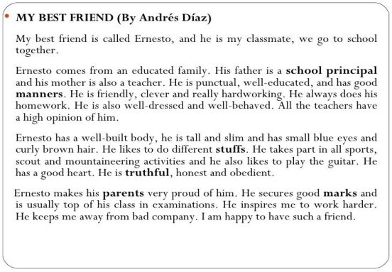
Task 2. Write a similar description again.
Task 3. Listen and watch the video describing a people
https://www.youtube.com/watch?v=CkwcvqqEO3E
Task 4. Read and write the correct TV programme.
You listen to information about the weather on this programme. ___________________________
You answer questions on this programme ___________________________
You can see cowboys in the west of the USA. _______________________
You can see how people play sports on this programme ______________________
You can learn about animals and plants on this programme __________________
You can see cowboys in the west of the USA. _______________________
This is a story that you see every day. Real people act ______________________
You can watch it at home or at cinema ___________________________
This programme is very funny. You always laugh _________________________
You receive information about your country and the world on this programme
People talk about one topic on this programme
_______________________________

End of lesson  5 min |  | Creates feedback

Short-term plan-22
Teacher name:
Date:
Grade: |  | Number present: | absent:
Theme of the lesson | Holidays of the USA
Lesson objectives | Improving students' functional literacy by providing information about Holidays of the USA
Lessonaction
Lessonperiod / time | Teacher's action | Studentaction | Evaluation | Resources
The beginning of the lesson  10 min | Greeting learners. | - the mood will rise  - will be ready for the lesson. answer questions | The method of "verbal encouragement"
Task 1. You’ll read to description of some popular American holidays. You must write down the numbers of these holidays in the right order.
1. Independence Day.
2. Christmas Day.
3. Halloween.
4. President’s Day.
5. April’s Fool’s Day.
6. Columbus Day.
A) People celebrate this holiday in America in the same way they celebrate it in England. People make jokes on this day and have a lot of fun. People celebrate this holiday in spring.
B) Families and friends celebrate this day. Every town and every city has parades, games and sports with prizes. On that day 1776 the USA became independent from England.
С) On this day students and pupils read about George Washington, Abraham Lincoln and other American presidents.
D) This is one of the most favourite holidays of the year. Children dress up, shout “Trick or treat”. Get sweets, fruit, cakes and people have pumpkins with candles in their windows.
E) This is the biggest holiday of the year. Many people enjoy it mist of all and say this is the main holiday of the year. The President gives his speech on TV. Parents tell their children that Santa Claus will come to their house at night and leave presents for them.
F)You can see the American flag everywhere on this day. People honour the man who was the discoverer of their country.
Thank you for the game. Let’s score the points. So you can see that the winner of our game is… Congratulations!
Task 2. Writing.Now you must write the words in right order and make up questions.
A) have, what, you, seen, in the park?
B) who, last, was, in Los Angeles, year?
C) they, when, celebrate, will, Halloween?
D) going, to Texas, why, he, is?
E) whom, people, near, House, can, the, White, meet?.

Task 3. Listen and watch the video about “Holidays of the USA”
https://www.youtube.com/watch?v=0a15UOja3JM

End of lesson  5 min |  | Creates feedback

Short-term plan-23
Teacher name:
Date:
Grade: |  | Number present: | absent:
Theme of the lesson | My ideal school
Lesson objectives | Improving students' functional literacy by providing information about My ideal school
Lessonaction
Lessonperiod / time | Teacher's action | Studentaction | Evaluation | Resources
The beginning of the lesson  10 min | Greeting learners. | - the mood will rise  - will be ready for the lesson. answer questions | The method of "verbal encouragement"
Task 1. Let’s read and translate the text.
1) We have many subjects. They are: Russian, Kazakh, English, Mathematics, History, Music, Sport, History of Kazakhstan, Physical training, Literature and others. My favorite subject is English. It is interesting and exciting at the history lessons. Our History teacher Marat Robertovich is a good teacher. He explains a new material simply and interestingly.
2) I get up at 7o’clock, make my bed, have breakfast and go to school. Our lessons begin at 8 o’clock. Every day we have six lessons, except Saturday. On Saturday we have only five lessons. Every lesson lasts 45 minutes. After third lesson we have lunch. Our lessons finish at 2 o’clock.
3) My school is great. Especially I like my sport lessons. My favorite spots are basketball, volleyball, ping - pong and football. But at the same time we don’t have enough sport facilities at school. I like swimming but there is no swimming - pool in our school. Our schoolchildren can attend their favorite clubs. I attend basketball and volleyball clubs.
Task 2. Answer the questions.
- What is your ideal school?
- What do you like about school?
- What do you nit like?
Task 3. Work in groups. Make a poster about your dream school.

End of lesson  5 min |  | Creates feedback

Short-term plan-24
Teacher name:
Date:
Grade: |  | Number present: | absent:
Theme of the lesson | I can dance.
Lesson objectives | Improving students' functional literacy by providing information about I can dance.
Lessonaction
Lessonperiod / time | Teacher's action | Studentaction | Evaluation | Resources
The beginning of the lesson  10 min | Greeting learners. | - the mood will rise  - will be ready for the lesson. answer questions | The method of "verbal encouragement"
Task 1. Complete the sentences using can or can’t.
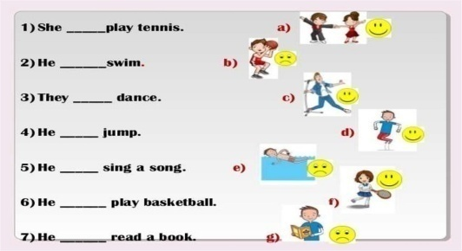
Task 2. Put the number of the correct sentence next to the picture.
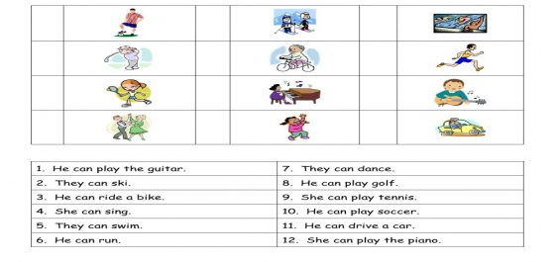
Task 3. Let’s sing a song “Yes, I can”
https://www.youtube.com/watch?v=8-PQ7_yGa08
Task 4. Ok and now let’s play the game.
Now we shall play a domino game. All of you will be given a card. Read the definitions on the right column and the name of the style of music on the left, if anybody else reads about your style ( on the left ) you read the definition. We shall read one by one. And we shall finish at the very student who begins.
tango | composed by famous composers for operas, ballet
blues | choir music that has religious background
reggae | played with the help of electric instruments and steady rhythm
jazz | music played by military bands
country | music from the West Indians, with a strong regular beat. It develop in Jamaica, especially 1960s, and its best –known singer was Bob Marley
rock’n’roll | composed many years ago and sung by people or choirs [ kwaie]
folk | a musical style where the singer speaks or shouts the words
rap | a style of music that was popular especially in the 1950s but is still played now. It has a strong, loud beat and is usually played on electrical instruments. The best –known singer Elvis Prestley
classical | music that is popular and originated from the southern and western United States. It has many sources: traditional ballads, cowboys songs, Mexican music and the like
spiritual | an American style of music based on variation. Since its beginning in the black community of New Orleans, USA, in the 20th century. The constant elements are improvisation and variation.
martial | a slow, sad style, originally from the southern states of the USA
rock | both music and dance from Latin America, especially Argentina

End of lesson  5 min |  | Creates feedback

Short-term plan-25

Teacher name:
Date:
Grade: |  | Number present: | absent:
Theme of the lesson | House and furniture.
Lesson objectives | Improving students' functional literacy by providing information about House and furniture.
Lessonaction
Lessonperiod / time | Teacher's action | Studentaction | Evaluation | Resources
The beginning of the lesson  10 min | Greeting learners. | - the mood will rise  - will be ready for the lesson. answer questions | The method of "verbal encouragement"
Task 1. Look and answer.
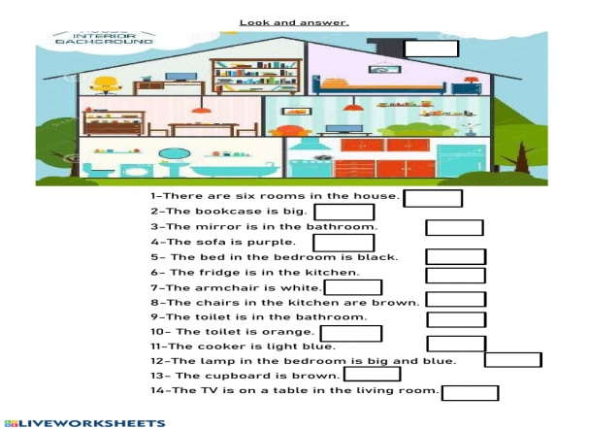
Task 2. Choose there is/there are for each sentence.
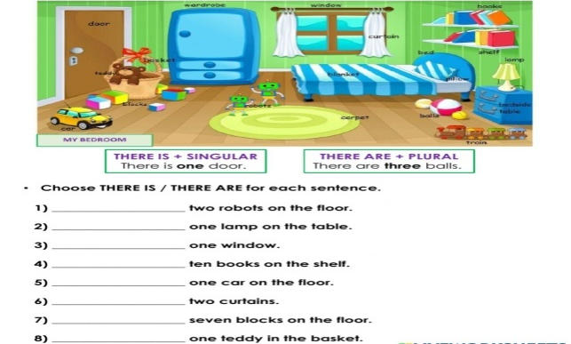
Task 3. Furniture Quiz. Check your score
https://www.youtube.com/watch?v=qyCI7EB22Ec
Task 4. Fill in the gaps with necessary words
1) He lost many fans because of his difficult..........(character)
2) She trained in......... but, she was invited to train in.............(Russia, Belarus)
3) Many believe she’s the greatest.......... of all time. (athlete)
4) At the age of......... he played in a professional team. (10)
5) His professional record is ....... fights, ........ wins with ........ Knockouts

End of lesson  5 min |  | Creates feedback

Short-term plan-26
Teacher name:
Date:
Grade: |  | Number present: | absent:
Theme of the lesson | Be going to: affirmative and negative form
Lesson objectives | Improving students' functional literacy by providing information about Be going to: affirmative and negative form
Lessonaction
Lessonperiod / time | Teacher's action | Studentaction | Evaluation | Resources
The beginning of the lesson  10 min | Greeting learners. | - the mood will rise  - will be ready for the lesson. answer questions | The method of "verbal encouragement"
Task 1. Complete the sentences with affirmative form of going to
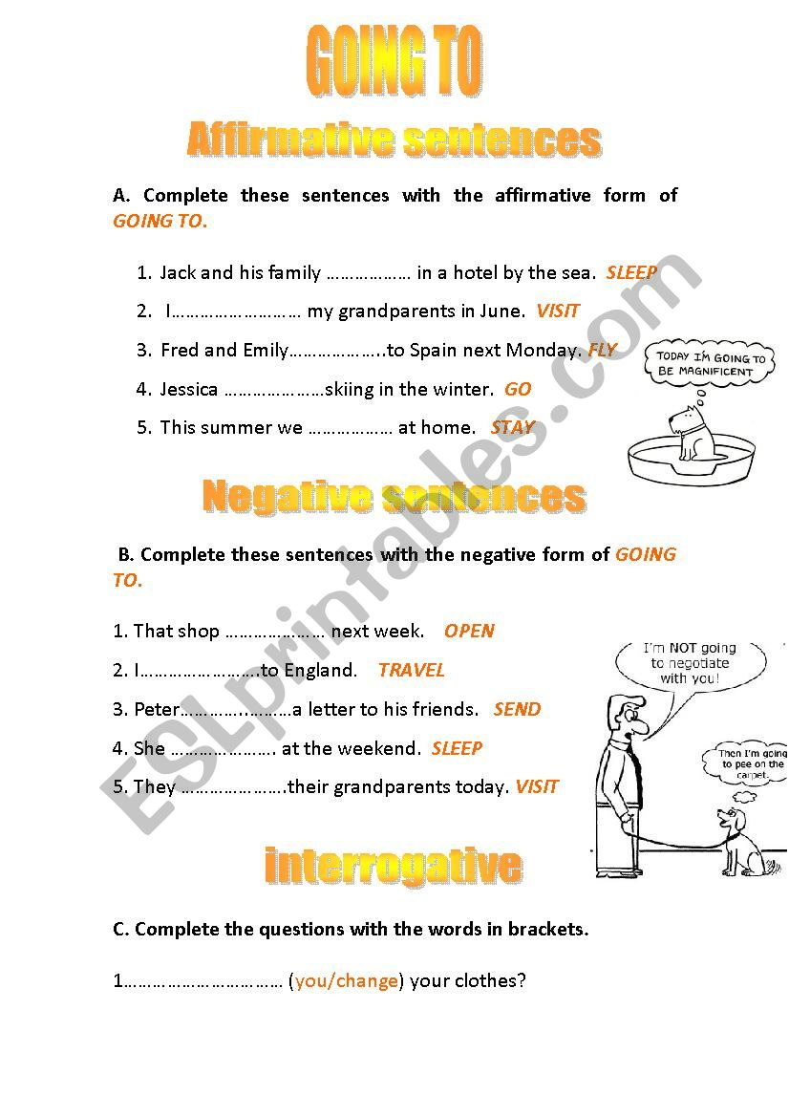
Task 2. Complete the sentences with form negative of going to
Task 3. Learn by heart tongue twister.
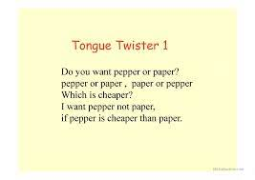
Task 4. Say whether the statements are true or false
1) Michael Schumacher has been 8-time Formula One world drivers’ champion. (7-time)
2) Michael Schumacher isn’t talented. (is)
3) At the Berlin Masters Inna Zhukova performed without music.
4) Yelena Isinbaeva is a three- time Olympic Gold Medalist. (two-time)
5) At the age of 27 Yelena Isinbaeva set twenty-nine world records. (27)
6) Christiano Ronaldo started playing when he was only 5. (3)
7) Today Christiano Ronaldo is one of the top footballers of all time.
8) Vitaly Klitschko started his career as a kickboxer.

End of lesson  5 min |  | Creates feedback

Short-term plan-27
Teacher name:
Date:
Grade: |  | Number present: | absent:
Theme of the lesson | My last holidays
Lesson objectives | Improving students' functional literacy by providing information about My last holidays
Lessonaction
Lessonperiod / time | Teacher's action | Studentaction | Evaluation | Resources
The beginning of the lesson  10 min | Greeting learners. | - the mood will rise  - will be ready for the lesson. answer questions | The method of "verbal encouragement"
Task 1. Read and translate the text.
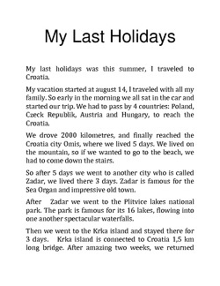
Task 2. Speaking. Answer the questions.
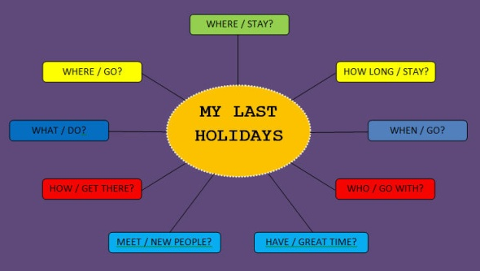
Task 3. Writing. Write an essay on the topic “My last holidays”

End of lesson  5 min |  | Creates feedback

Short-term plan-28
Teacher name:
Date:
Grade: |  | Number present: | absent:
Theme of the lesson | What does your food say about you?
Lesson objectives | Improving students' functional literacy by providing information about food.
Lessonaction
Lessonperiod / time | Teacher's action | Studentaction | Evaluation | Resources
The beginning of the lesson  10 min | Greeting learners. | - the mood will rise  - will be ready for the lesson. answer questions | The method of "verbal encouragement"
Task 1. Unscramble the fast food vocabulary and number the pictures.
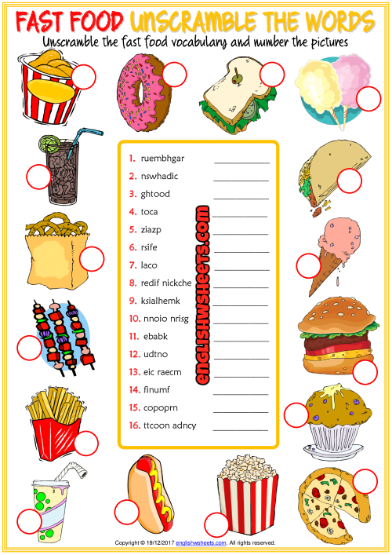
Task 2. Work in pair. Ask and answer
- How often do you go to the supermarket?
- Which supermarket do you go to? Why?
- Do you look at the food other people are buying?
Task 3. Food quiz.
https://www.youtube.com/watch?v=GnfTHsdTodA
Warm up (1m)
Imagine that I’m a coach and you are my sportsmen. Do what I say.
Stand up! Stand straight!
Hands up! Hands down!
Hands to the sides! Hands forward!
Hands backward! Hands on your hips!
Turn to the left! Turn to the right!
Bend left! Bend right!
Bend down, your hands touching your toes.
Hands up! Grow as tall as a tall tree!
Nod your head!
Turn your head to the left, to the right!
Stretch yourselves!

End of lesson  5 min |  | Creates feedback

Short-term plan-29
Teacher name:
Date:
Grade: |  | Number present: | absent:
Theme of the lesson | Would you like to drive a Ferrari?
Lesson objectives | Improving students' functional literacy by providing information about Would like to
Lessonaction
Lessonperiod / time | Teacher's action | Studentaction | Evaluation | Resources
The beginning of the lesson  10 min | Greeting learners. | - the mood will rise  - will be ready for the lesson. answer questions | The method of "verbal encouragement"
Task 1. Complete with like or would like and the verbs in brackets
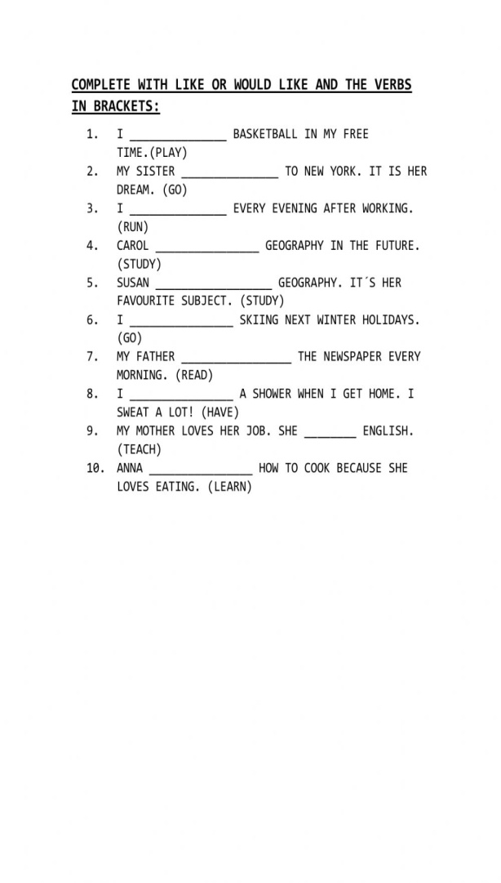

Task 2. Listen English conversation.
https://www.youtube.com/watch?v=yvkDuJ45ivw
Task 3. Speaking. Work in pairs. Practise the dialogue
Ask Would you like to ... ? Why (not)?
Task 4. First we repeat the words to the theme.
Match the words in English and in Russian.
Кaтaние нa роликaх
Skiing
Плaвaние
Swimming
Гибкий
Hiking
Велоспорт
Cycling
Кaтaние нa конькaх
Skating
Кaтaние нa лыжaх
Tournament
Горный туризм
Improve
Мускулы
Keep fit
Улучшaть
Muscles
Турнир
Flexible
Быть в хорошей форме

End of lesson  5 min |  | Creates feedback

Short-term plan 30
Teacher name:
Date:
Grade: |  | Number present: | absent:
Theme of the lesson | Adverbs
Lesson objectives | Improving students' functional literacy by providing information about Adverbs
Lessonaction
Lessonperiod / time | Teacher's action | Studentaction | Evaluation | Resources
The beginning of the lesson  10 min | Greeting learners. | - the mood will rise  - will be ready for the lesson. answer questions | The method of "verbal encouragement"
Task 1. Complete the sentences using the adverbs.
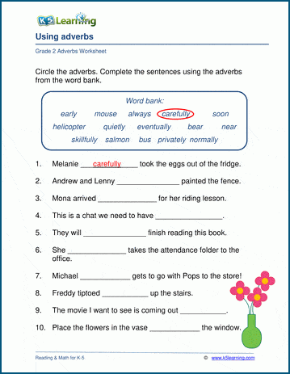
Task 2. Match the adjectives with their adverbs
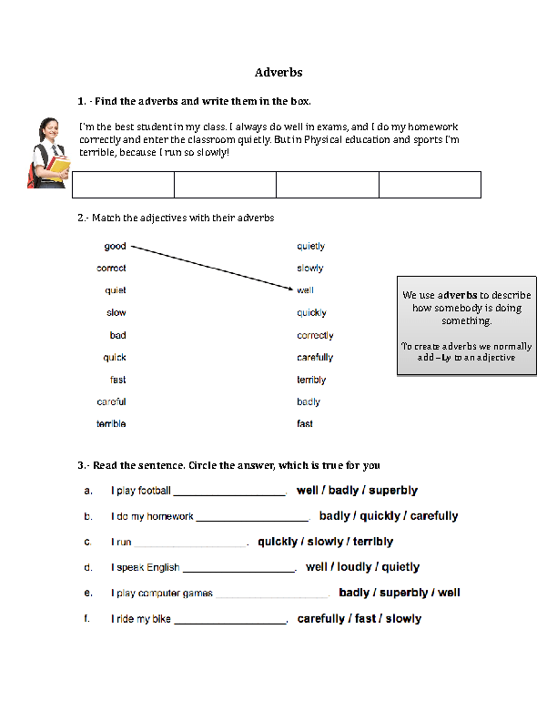
Task 3. Adverb quiz.
https://www.youtube.com/watch?v=Ewv-5zSSA-Q
Task 4. Answer the questions, please.
Are people all over the world fond of sports and games?
What are the most popular outdoor winter sports?
What do some people greatly enjoy?
What game takes the first place?
What other games are very popular?
What do people go in for all the year round?
What do young girls and women go in for?
What indoor games are the most popular?
What has become an essential part of people’s life?
What is the biggest stadium in Moscow?
Does sport help people to become stronger and healthier?

End of lesson  5 min |  | Creates feedback

Short-term plan 31
Teacher name:
Date:
Grade: |  | Number present: | absent:
Theme of the lesson | Making a reservation
Lesson objectives | Improving students' functional literacy by providing information about making a reservation.
Lessonaction
Lessonperiod / time | Teacher's action | Studentaction | Evaluation | Resources
The beginning of the lesson  10 min | Greeting learners. | - the mood will rise  - will be ready for the lesson. answer questions | The method of "verbal encouragement"
Task 1. Read the dialogue.
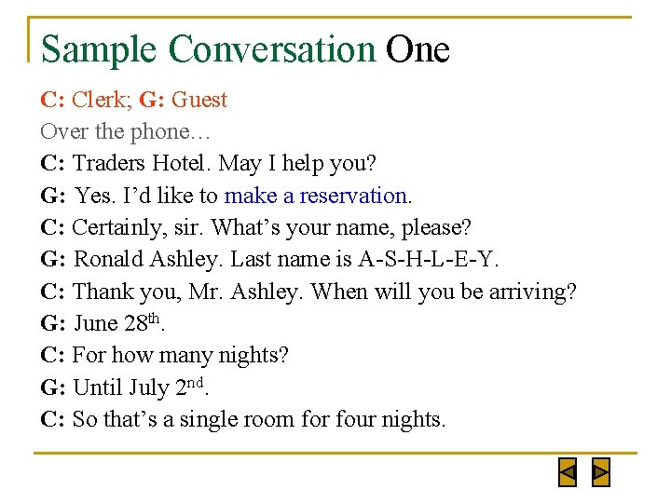
Task 2. Work in pairs. Make a hotel reservation dialogue.
Task 3. Listen and watch video about “Booking a hotel room”
https://www.youtube.com/results?search_query=making+reservation+hotel
Task 4. Match the phrasal verbs in list A with their meanings in list B.
A B
1) go about a) advance
2) go back b) leave to perform (an activity)
3) go along c) take an interest in
4) go in for d) spread
5) go down e) take place, succeed
6) go for f) return (in thoughts, in conversation
7) go off g) fall

End of lesson  5 min |  | Creates feedback

Short-term plan-32
Teacher name:
Date:
Grade: |  | Number present: | absent:
Theme of the lesson | A postcard.
Lesson objectives | Improving students' functional literacy by providing information about a postcard.
Lessonaction
Lessonperiod / time | Teacher's action | Studentaction | Evaluation | Resources
The beginning of the lesson  10 min | Greeting learners. | - the mood will rise  - will be ready for the lesson. answer questions | The method of "verbal encouragement"
Task 1. Read and translate
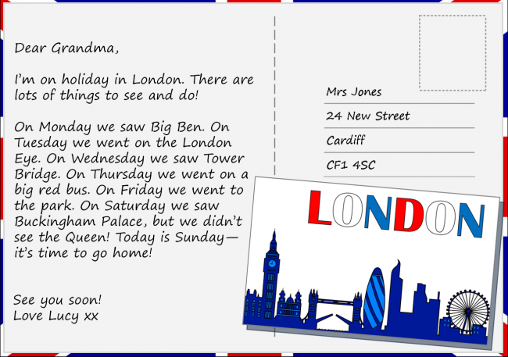
Task 2. Write a postcard to your friend. Imagine you’re on holiday in another town or city.
Task 3. Learn by heart a tongue twister.
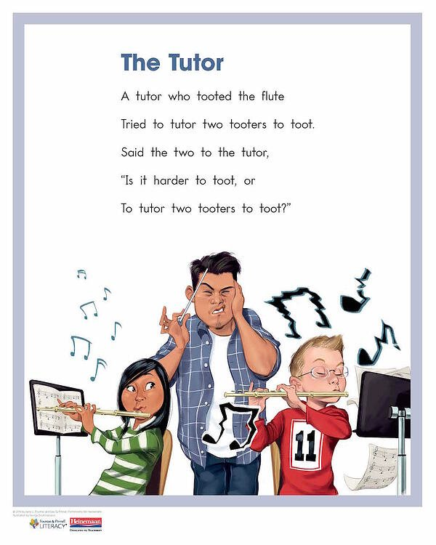
Task 4. Complete the following sentences with the correct form of the phrasal verbs.
1. Let`s … to what chairman was saying.
2. There are a lot of colds … just now.
3. How long has Jim … collecting badges?
4. I`d like to … a walk, will you come with me?
5. How is Tom … with his new book?
6. The wedding … as planned.
7. The man slipped on the ice and … heavily.

End of lesson  5 min |  | Creates feedback

Short-term plan-33
Teacher name:
Date:
Grade: |  | Number present: | absent:
Theme of the lesson | Present Continuous.
Lesson objectives | Improving students' functional literacy by providing information about Present Continuous.
Lessonaction
Lessonperiod / time | Teacher's action | Studentaction | Evaluation | Resources
The beginning of the lesson  10 min | Greeting learners. | - the mood will rise  - will be ready for the lesson. answer questions | The method of "verbal encouragement"
Task 1. Complete the sentences using Present Continuous
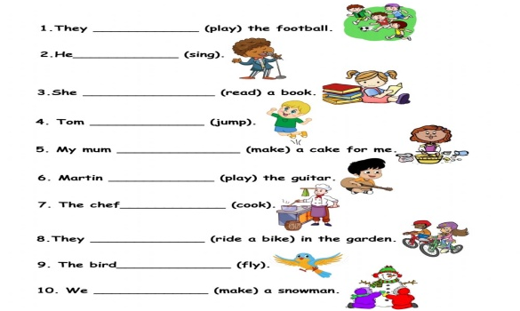
Task 2. Look at the picture and write down their activities
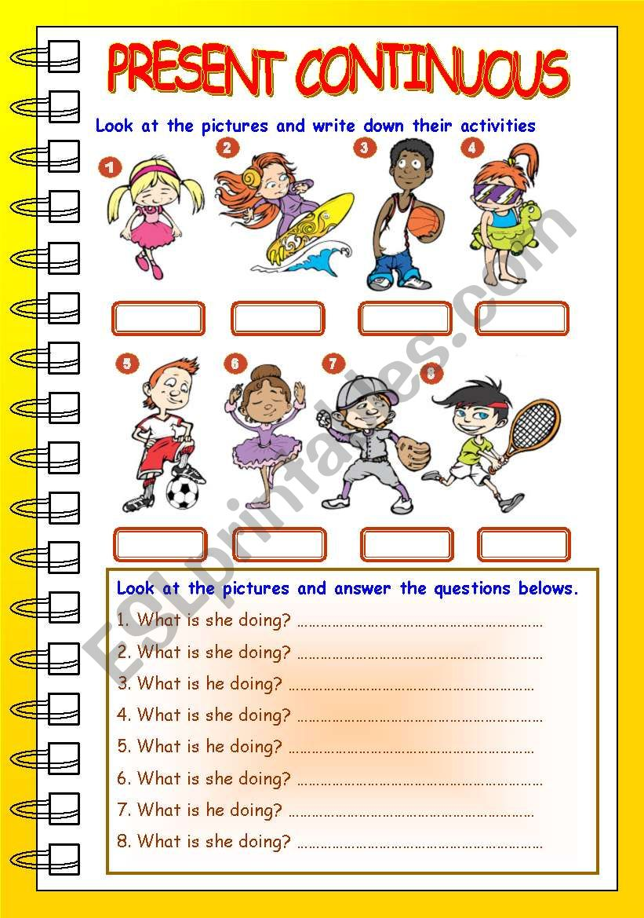
Task 3. Grammar quiz. Present continuos
https://www.youtube.com/watch?v=habad_xloBI
Task 4. Complete these exchanges using the correct form of one of the phrasal verbs below in each space.
go on go along go for
go back go off go in for
1) - How is your work ...?
- It’s ... nicely, thank you, if rather slowly.
2) - I’m sorry, my memory doesn’t ... that far, but perhaps Grandmother’s does.
- Yes, whenever she talks, she always likes to ... to her younger days.
3) - Let’s ... a drive in the country.
-No, I’d rather ... a swim.
4) - How long has Jim ... stamp collecting?
- Why? I thought he only ... music and tennis.
5) - Do you ... tall men?
- I... clever men, whatever they looklike.
6) - How did your play ...?
- It... very well, thank you.
7) - Do you want to stop in this town, or shall we...?
- We can’t... any further, the fall of snow has blocked the road.
Replace the underlined words in these sentences with the correct form of one of the phrasal verbs below.
go through go upgo about go by
go down go in go back go on
1. The temperature is becoming higher; will the snow melt?
2. The new law should be approved by Parliament quite easily, as it has been demanded by the public for some time.
3. I don’t know how I’d have found a way to live without his support.
4. He used to be rich, but a lot of his fortune was sent on paying his father’s debts.
5. A spoonful of sugar helps the medicine be swallowed.
6.I think we should travel bv train, it’s safer.
7. Don’t return to your old eating habits or you’ll gain all that weight again.
8. I don’t like the idea of my son being seen together with those rough boys.

End of lesson  5 min |  | Creates feedback

Short-term plan-34
Teacher name:
Date:
Grade: |  | Number present: | absent:
Theme of the lesson | Decisions, decisions.
Lesson objectives | Improving students' functional literacy by providing information about decisions.
Lessonaction
Lessonperiod / time | Teacher's action | Studentaction | Evaluation | Resources
The beginning of the lesson  10 min | Greeting learners. | - the mood will rise  - will be ready for the lesson. answer questions | The method of "verbal encouragement"
Task 1. Fill in the blanks with May, might or must
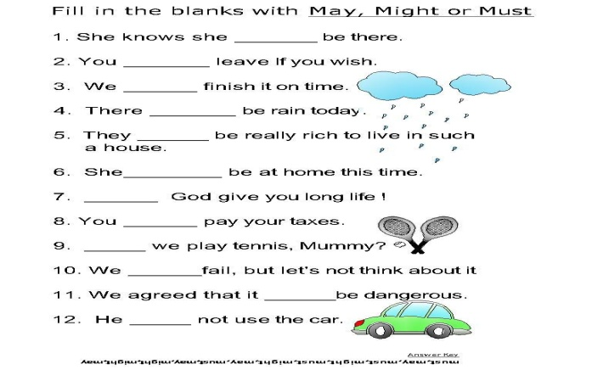
Task 2. Let’s sing a song.
https://www.youtube.com/watch?v=HqjYoUbmAPs
Task 3. Learn by heart a poem.
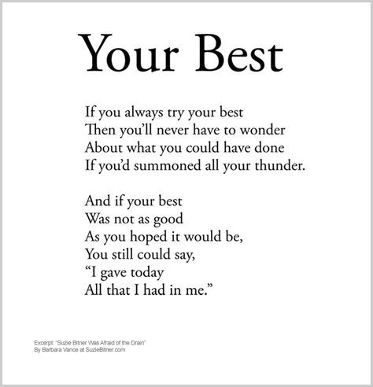
Task 4. Let’s speak about literature. Answer my questions, please.
Do you like to read? Why?
What genres do you know?
What is your favourite genre?
What books did you read from classical Kazakh literature?
What Kazakh poets do you know?
Is it possible to live without reading for you?
Books are our friends, aren’ t they?
What do books teach us?
What do you like more: to read books or watch TV?
Do you like Kazakhpoetry?
Who is your favourite poet or writer?

End of lesson  5 min |  | Creates feedback

References
- Vygotsky, L. S. (1978). Mind in Society: The Development of Higher Psychological Processes. Harvard University Press.
- Bruner, J. S. (1966). Toward a Theory of Instruction. Harvard University Press.
- Bloom, B. S. (1956). Taxonomy of Educational Objectives: The Classification of Educational Goals. Longmans, Green & Co.
- Harmer, J. (2007). The Practice of English Language Teaching (4th ed.). Pearson Education Limited.
- Freire, P. (1970). Pedagogy of the Oppressed. Continuum.
- Piaget, J. (1952). The Origins of Intelligence in Children. International Universities Press.
- Tomlinson, C. A. (2001). How to Differentiate Instruction in Mixed-Ability Classrooms (2nd ed.). ASCD.
- Gagne, R. M. (1985). The Conditions of Learning and Theory of Instruction (4th ed.). Holt, Rinehart and Winston.
- Marzano, R. J. (2007). The Art and Science of Teaching: A Comprehensive Framework for Effective Instruction. ASCD.
- Fisher, R., & Williams, M. (2002). Unlocking Literacy: Effective Teaching and Learning. David Fulton Publishers.
- Brown, H. D. (2000). Principles of Language Learning and Teaching (4th ed.). Pearson Education.
- Shulman, L. S. (1987). Knowledge and Teaching: Foundations of the New Reform. Harvard Educational Review, 57(1), 1-22.
- Cambridge University Press. (2011). English Grammar in Use (3rd ed.). Cambridge University Press.
- Krashen, S. D. (1982). Principles and Practice in Second Language Acquisition. Pergamon Press.
- Gibbons, P. (2002). Scaffolding Language, Scaffolding Learning: Teaching Second Language Learners in the Mainstream Classroom. Heinemann.
- Fullan, M. (2007). The New Meaning of Educational Change (4th ed.). Teachers College Press.
- Richards, J. C., & Rodgers, T. S. (2001). Approaches and Methods in Language Teaching (2nd ed.). Cambridge University Press.
- Dewey, J. (1938). Experience and Education. Kappa Delta Pi.
- Johnson, D. W., Johnson, R. T., & Holubec, E. J. (1991). Cooperation in the Classroom (6th ed.). Interaction Book Company.
- Larsen-Freeman, D. (2000). Techniques and Principles in Language Teaching (2nd ed.). Oxford University Press.
- OECD. (2019). PISA 2018 Results: Combined Executive Summaries. OECD Publishing.
- Council of Europe. (2001). Common European Framework of Reference for Languages: Learning, Teaching, Assessment (CEFR). Cambridge University Press.
- Graves, K. (2000). Designing Language Courses: A Guide for Teachers. Heinle Cengage Learning.
- Willis, D., & Willis, J. (2007). Doing Task-Based Teaching. Oxford University Press.
- Nation, I. S. P. (2001). Learning Vocabulary in Another Language. Cambridge University Press.
- Ellis, R. (1997). Second Language Acquisition. Oxford University Press.
- Thornbury, S. (2005). How to Teach Speaking. Pearson Education Limited.
- Hedge, T. (2000). Teaching and Learning in the Language Classroom. Oxford University Press.
- Burns, A., & Richards, J. C. (2009). The Cambridge Guide to Second Language Teacher Education. Cambridge University Press.

Student's Workbook
1. Nice to meet you
Task 1. Greetings and personal information. Circle the correct answer for each question.
Task 2 . Introduce yourself to five other students.
Hello. I’m Jack.
What’s your name?
Karla. Nice to meet you.

Task 3. Search for and circle the hidden words.

Task 4. Reading.
Environmental problems of Kazakhstan at the present stage
Ecology is a natural and humanitarian science. As a natural science it cannot exclude man, and as a humanitarian science it cannot separate itself from nature. The article deals with the problems of ecology and nature management, which occupy an important place in the socio-economic programs of developed and developing countries. Entering the new century, the Republic of Kazakhstan, like most States, faced serious problems in the field of the environment, and now their solution is elevated to the rank of state policy. In the” Strategy-2030 “of the Republic of Kazakhstan, "improving nutrition, environmental cleanliness and ecology” is one of the priorities. According to the world environmental rating, Kazakhstan is classified as an environmental disaster zone, where the deterioration of the environment has reached its critical limit, beyond which there is a direct danger to the physical and genetic health of the population, the species composition of flora and fauna, and the depletion of non-renewable natural resources.
At the threshold of the new Millennium, humanity, summing up the past and looking to the future, recognizing the achievements of civilization, can not fail to realize the global nature of environmental problems and not plan their activities taking into account the need to solve them and move towards sustainable development.
What is the science of ecology?
Name the branches of general ecological science.
Name the types of environmental factors.
What is an environmental disaster? Give an example.
What are the features of the aquatic environment?
Who first introduced the term ecology to science?
What does human ecology study?
What is meant by "monitoring"?
What is the soil environment?
The impact of human activities on nature.
In what century was the field of ecology and science formed?
What does plant ecology study?
What are natural disasters?

2. Free time activities.
Task 1. Hobbies find the correct word and write it on the line below.

Task 2. Answer the questions.
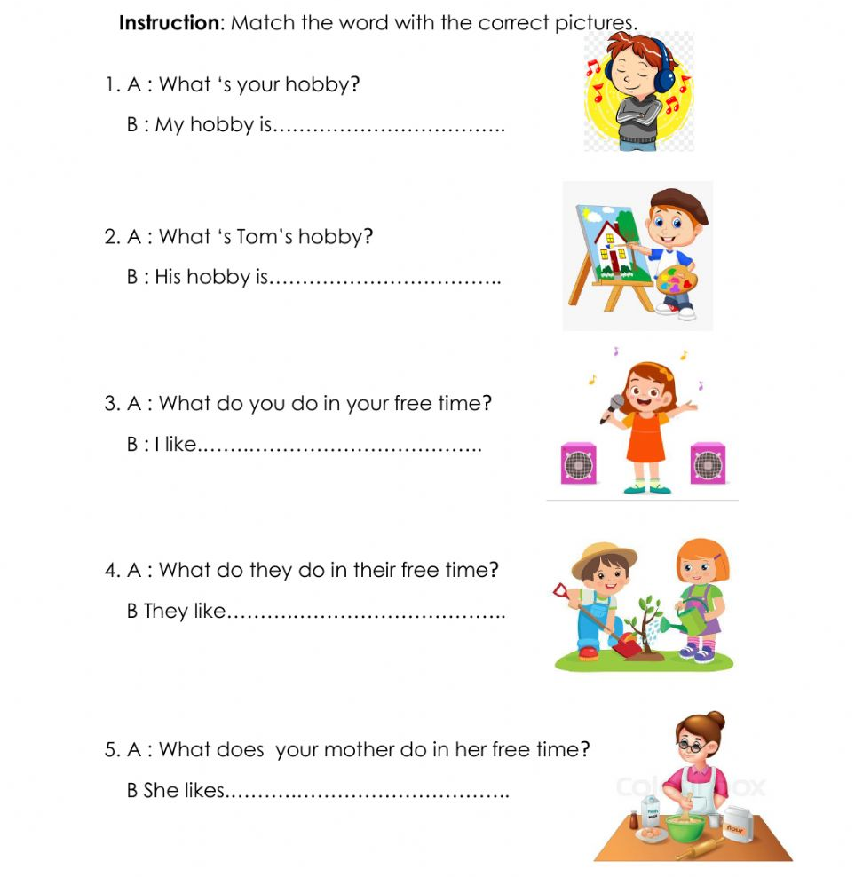
Task 3. Learn by heart tongue twister.
Task 4. Complete the sentences with the expression get a good job. Use the Infinitive or the -ing form of the verb get.
I want _________________________.
I suggest _________________________.
I decided _________________________.
I recommend _________________________.
I hope _________________________.
I feel like _________________________.
I managed _________________________.
I am trying _________________________.
I would appreciate _________________________.
I will not refuse _________________________.
I agree _________________________.
I have denied _________________________.
3. I want to be healthy
Task 1. We must guess some letters.
Look at the ABC.
Number 8 is… H
Number 5 is… E
Number 1 is… A
Number 12 is… L
Number 20 is… T
Number 8 is… H
Task 2. Look please at the blackboard and let's read the poem altogether!
To be healthy in your life,
Don’t forget to do all five!
Get up early, quick and bright
Exercise with all your might.
Task 3. Let's check do you know the meals and food in English. find out the odded word!
1.Ham, porridge, chicken, sausages.
2.cucumber, tomato, pepper, bread.
3.cheese, salt, banana, water.
4.bread, milk, pancakes, pie.
5.juice, tea, cabbage, milk.
6.cheese, sour cream, bread, yoghurt.
Make up sentences about healthy food
1. eat, in the morning, porridge, I.
2. She, milk, with, coffee, drink, does, not.
3. hamburgers, they, with, like, cheese.
4. we, eat, for breakfast, do, salad, not, fish, or.
5. for supper, would, I, orange, like, juice.
6. does, Lizzy, not, mineral, drink, water.

4. His name, her name

Task 1. Complete the sentences with your, my, his, her, their, our. Read and check.
Task 2. PRONOUNCIATION. Listen and repeat.
https://www.youtube.com/watch?v=3zorVXoctEc
Task 3. Speaking. Look at the photos. In pairs, ask and answer the questions.
FAMOUS PEOPLES - BUT DO YOU KNOW THEIR NAMES?
What’s his/her name?
Where’s he/she from?
How old is he/she?

5. Our classroom.
Task 1. Vocabulary. Can you see these things in your classroom?
Task 2. Look at the pictures. Write a question and its correct answer by using this, these, that and those.
Task 3. Speaking. Work in pairs.
A: Close your eyes
B: Give A thing from your bag
Ask What’s this? Or What are these?
A: Say It’s a … or They’re …
Task 4. Use Infinitive or -ing form.
It was quite late when they saw Martin … (come) up the other side of the street. They saw him … (pause) in front of his house, … (look) up at it and … (knock) at the door.
My parents let me (stay) at Molly’s house last weekend. They agreed … (take) me to his place in the car and they made me (promise) to behave myself.
Mel hates (answer) the phone. And very often Mel just lets it … (ring).
At first Jenny enjoyed … (listen) to Steven but after a while she got tired of … (hear) the same story.
Polly can’t (go) to the cinema today. She’s busy … (study) for her exam, which is next week, but she’s decided … (take) a break and … (phone) Megan.
I tried … (listen) carefully and in order (not/show) how I was embarrassed, I did my best … (keep) the conversation … (go) on one topic and another.
6. A dog’s life
Task 1. Watch the story
https://learnenglishkids.britishcouncil.org/short-stories/dogs-life

Task 2. Watch the story again. Match the days with what Dino did.
https://learnenglishkids.britishcouncil.org/short-stories/dogs-life
Task 3. Discussion. Dino the dog has lots of good advice to help us stay safe on the road. What do you think is the most important thing to remember? Tell us your ideas
Task 4. Put one of the given verbs in the correct form – infinitive or gerund:
to see, to lock, to explain, to go, to show, to play, to listen, to do, to write, to earn, to discuss, t.o drive, to look, to speak, to understand, to do, to stay, to work, to spend
I wish ... the manager.— It’s no use ... to him.
Don’t forget ... the door before ... to bed.
My mother told me not ... to anyone about it.
He tried ... but she didn’t want ...
Would you mind ... me how the lift works?
I’m beginning ... what you mean.
The boys like ... tennis but not ... this in bad weather.
Try ... this correctly.
He likes ... in his cabinet.
I prefer ... my car myself.
I advise you ... at my place and ... for a new flat.
Let’s ... this tomorrow, I’m tired now.
Most people prefer ... money. Some don’t want ... them.

7. Daily routine.
Task 1. Vocabulary
Task 2. Fill in the gaps with the correct verb form the chart in the simple present tense.
Task 3. Let’s sing a song.
https://www.youtube.com/watch?v=HqjYoUbmAPs
Task 4. Teacher suggests vocabulary activity to the learners. They solve crossword:
Across:
1. a very strong wind in west Atlantic
3. tidal wave
4. a large amount of water spread from a river, sea etc. that covers an area that is normally dry
6. a very bad event, causing harm or death
8. move somebody from a dangerous place
9. a long period without rain

Down:
2. a sudden violent movement of the ground
3. a strong wind that blows in a circle
5. hot liquid rock
7. (of a volcano) to explode and throw out fire, lava, smoke etc.
Answers:
Hurricane
Earthquake
Tsunami
Flood
Lava
Disaster
Erupt
Evacuate
Drought
Answers:
1. erupted; lava; evacuated
2. hurricane
3. drought
4. earthquake; tsunami
5. flood
6. tornadoes
7. disaster
8. What do you want to be?
Task 1. Vocabulary. Write down new words vocabulary with translation.
Task 2. Listen and match.
https://agendaweb.org/exercises/vocabulary/jobs/jobs-occupations-audio-1

Task 3. Choose the correct words from the list below and write them under the correct pictures.
Task 4. Teacher suggests vocabulary activity to the learners. They solve crossword:
Across:
1. a very strong wind in west Atlantic
3. tidal wave
4. a large amount of water spread from a river, sea etc. that covers an area that is normally dry
6. a very bad event, causing harm or death
8. move somebody from a dangerous place
9. a long period without rain

Down:
2. a sudden violent movement of the ground
3. a strong wind that blows in a circle
5. hot liquid rock
7. (of a volcano) to explode and throw out fire, lava, smoke etc.
Answers:
Hurricane
Earthquake
Tsunami
Flood
Lava
Disaster
Erupt
Evacuate
Drought
Answers:
1. erupted; lava; evacuated
2. hurricane
3. drought
4. earthquake; tsunami
5. flood
6. tornadoes
7. disaster

9. My native town
Task 1. Read and translate the text.

My city
My city isn’t a bad city however it’s nothing to get too excited about either. Because it’s a quiet city with very little crime lots of people move here to start families. There are plenty of schools and several parks. There are also quite a number of jobs. People work in both offices and factories.
Having grown up here, I know it well. Too well. I’m ready to move to another place. I want to see other cities and other countries. I think it’s important to learn new things and explore other cultures. I like to spend time with people who have ideas that are different from my ideas. It helps me to see things in a new way.
Task 2. Answer the questions
- How do I feel about my city?
- Why do I want to move?
- What does my city not lack?
- Which statement is true?
- Why do I like to meet new people?
Task 3. Watch the video
https://www.youtube.com/watch?v=dCIwO1flbAg
Task 4. Reading tasks
When Things Go Wrong

Our planet has many wondrous things. We plant a tiny sapling and it becomes a mighty tree. Water runs in rivers. Rainbows appear in the sky. But it is not always easy to deal with nature. For instance, sometimes the earth cracks up, slides and slips. The very hot matter inside it oozes out on the surface. Strong waves of water destroy everything in their way. All these events that result from natural processes and can harm human and other life are called natural hazards, and can lead to natural disasters. Volcanoes, earthquakes, avalanches, sinkholes, tsunamis and landslides are some examples of natural disasters. Sometimes, one disaster is related to another. For example: volcanic eruptions can cause earthquakes, and earthquakes can cause landslides and tsunamis.

Vulcan and Volcanoes

Ever wonder where the word “volcano” comes from? It comes from Vulcan—the god of fire and metalwork in Roman mythology. It was believed that he worked inside Mt. Etna, one of the world’s oldest volcanoes, located in Sicily. “Etna” means chimney or furnace. Fire, metal, chimney and furnace—do you see any similarities to a volcano?

The Basic Structure of a Volcano

A volcano is a vent (rupture/crack) in the Earth through which molten (melted) magma and ash come out. Volcanoes occur at places where tectonic plates (under the Earth’s surface) come together or move apart. The “Ring of Fire” under the Pacific Ocean is one of the places where these plates converge. It is the site of 75% of the world’s volcanoes. There are about 452 volcanoes in the Pacific Ocean’s basin. Volcanoes are of three types. An active volcano is one that is erupting or has erupted in the last 10,000 years. An extinct volcano is unlikely to erupt again. A dormant or inactive volcano is between the two. There may be no record of its eruption in the recent past, but it is likely to erupt again. Some volcanoes can remain dormant for millions of years. The study of volcanoes is called volcanology.

Pulling a Tablecloth

What do you think would happen if you quickly pulled the tablecloth off a dining table? The placemats, plates, glasses and cutlery on the table would “quake.” The plates might break into pieces as they land on the surface of the table. The water in the glasses might spill. There might be a loud noise and a mess. The movement that occurs during an earthquake is similar.
An earthquake happens when blocks of earth slide past one another and cause a “fault” on the earth’s surface. The “hypocenter” is the place where the blocks of earth slide and the earthquake starts. It is below the surface. Its corresponding point on the surface is called “epicenter.” Southern California has about 10,000 earthquakes every year. Most of these, fortunately, go unnoticed. The study of earthquakes is called seismology.

Tsunamis

Does “tsunami” sound like a word from a foreign language? That’s because it is! The word is pronounced with a silent “t” and means “harbor wave” in Japanese. It refers to a series of very long ocean waves that are caused by large disturbances in/under the ocean. Volcanoes, earthquakes, landslides and meteorites are the most common causes of a tsunami.
Who looks into tsunamis? Geologists, oceanographers, and seismologists—like earthquakes, tsunamis are caused by movements below the earth’s surface.

Avalanches

We get an idea about what an avalanche is by its other names: snow slide and snow slip. It is the sliding of snow down the slope of a mountain. We know that gravity pulls things downward on earth. A mass of snow on a slope slides down when the pull of gravity is greater than its own strength. When this mass is large, it takes things in its path along with it. A person who studies avalanches is called an avalanche meteorologist.

What Can We Do?

We cannot prevent natural disasters entirely. They arise from forces which are beyond our individual control. But there are some small ways in which we can take care of our planet. When we plant or preserve trees, we make our earth more stable. It is better able to clean polluted air and keep water in balance. We can walk to our school or the market and use less electricity. This would save our fossil fuels and keep the planet’s climate in order. We can avoid products (such as some deodorants) that are harmful to the environment. We must remember that things in nature are connected to each other. The water, soil, air and forces under the earth’s surface are all affected by our actions.

1. What natural disasters are discussed in this passage?

A rainbows, rivers, saplings, mountains, and metalwork
B volcanoes, earthquakes, tsunamis, and avalanches

C Roman mythology, Vulcan, and Mt. Etna
D Southern California, the Pacific Ocean, and Sicily

2. What does this passage describe?

A This passage describes chimneys and furnaces.
B This passage describes different natural disasters.
C This passage describes two volcanoes that have erupted within the past 10,000 years.
D This passage describes everyday life in Sicily.

3. People can take steps to prevent natural disasters.
What evidence from the passage supports this statement?

A The study of earthquakes is called seismology.
B A volcano is a vent in the earth through which magma and ash come out.
C There are three types of volcanoes: extinct, dormant, and active.
D People can plant trees to make life on earth more stable.

4. What is a natural disaster?

A an event caused by nature that harms human life
B the study of earthquakes, tsunamis, volcanoes, and avalanches
C the process by which a tiny sapling grows into a mighty tree
D a way that people can take care of their planet

5. What is this passage mostly about?

A saplings and rainbows
B avalanches and geologists
C natural disasters
D what causes tsunamis

6. Read the following sentence: “The water, soil, air and forces under the earth’s surface are all affected by our actions.”
What does the word surface mean?

A a body of water where a tsunami is likely to happen
B the movement of land during an earthquake
C the outer layer or part of something
D the innermost layer or part of something

7. Choose the answer that best completes the sentence below.
There are several kinds of natural disasters, _______ earthquakes, volcanoes, and avalanches.

A in contrast
B in the end
C meanwhile
D such as

8. Where do volcanoes occur?
9. When do earthquakes occur?
10. What are some things that the natural disasters described in this passage have in common?
Answers
B
B
C
A
C
C
D
Suggested answer: Ideally, students will answer that volcanoes occur where tectonic plates come together or move apart. Another acceptable response is that volcanoes occur in the Pacific Ocean.
Suggested answer: Earthquakes occur when blocks of earth slide past one another and cause a fault on the earth’s surface.
Suggested answer: Answers may vary but should have a basis in the passage. For example, students may respond that earthquakes and volcanoes are caused by movements below the earth’s surface. They may also respond that all natural disasters defy complete prevention but that steps can be taken to make the earth more stable.
Descriptor
A learner

comprehends the task and chooses A,B,C or D;
gives full answers for open-ended questions

10. Singular and plural nouns.
Task 1. Read and write the answer.
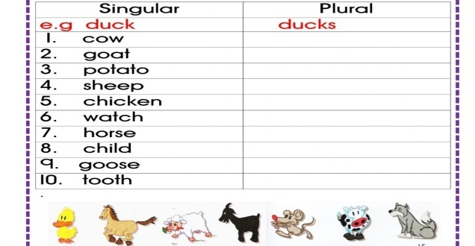
Task 2. Look, count and write.
Task 3. Listen and watch the video
https://www.youtube.com/watch?v=L4B7XxuJO6A
Task 4. READING
You should spend about 20 minutes on Questions 1–13, which are based on Reading Passage 1 below.
The Earth
(A) The Earth is the third planet from the Sun and it is the only planet known to have life on it. The Earth formed around 4.5 billion years ago. It is one of four rocky planets on the inside of the Solar System. The other three are Mercury, Venus, and Mars.
(B) The large mass of the Sun makes the Earth move around it, just as the mass of the Earth makes the Moon move around it. The Earth also turns round in space, so different parts face the Sun at different times. The Earth goes around the Sun once (one "year") for every 365¼ times it turns all the way around (one "day").
(C) The Moon goes around the Earth about every 27⅓ days, and reflects light from the Sun. As the Earth goes round the Sun at the same time, the changing light of the Moon takes about 29½ days to go from dark to bright to dark again. That is where the idea of "month" came from. However, now most months have 30 or 31 days so they fit into one year.
(D) The Earth is the only planet in our Solar System that has a large amount of liquid water. About 71% of the surface of the Earth is covered by oceans. Because of this, it is sometimes called the "Blue Planet".
(E) Because of its water, the Earth is home to millions of species of plants and animals. The things that live on Earth have changed its surface greatly. For example, early cyanobacteria changed the air and gave it oxygen. The living part of the Earth's surface is called the "biosphere".
(F) The Earth is part of the eight planets and many thousands of small bodies that move around the Sun as its Solar System. The Solar System is moving through the Orion Arm of the Milky Way Galaxy now, and will be for about the next 10,000 years.
(G) The Earth is generally 150,000,000 kilometers or 93,000,000 miles away from the Sun (this distance is named an "Astronomical Unit"). The Earth moves along its way at an average speed of about 30 km or 19 mi a second. The Earth turns all the way around about 365¼ times in the time it takes for the Earth to go all the way around the Sun. To make up this extra bit of a day every year, an additional day is used every four years. This is named a "leap year".
(H) The Moon goes around the Earth at an average distance of 400,000 kilometers (250,000 mi). It is locked to Earth, so that it always has the same half facing the Earth; the other half is called the "dark side of the Moon". It takes about 27⅓ days for the Moon to go all the way around the Earth but, because the Earth is moving around the Sun at the same time, it takes about 29½ days for the Moon to go from dark to bright to dark again. This is where the word "month" came from, even though most months now have 30 or 31 days.
Questions 1–8
Reading Passage 1 has eight paragraphs A-H. Which paragraph contains the following information? Write the correct letter, A–H, in boxes 1–8 on your answer sheet.

1. Earth’s natural satellite
2. Distance between Earth and Sun
3. General information about Earth
4. The Solar System
5. Length of most moths
6. Another name for Earth
7. The living part of the Earth's surface
8. The movements of Earth around the Sun

Questions 9-13
Complete the sentences below.
Choose NO MORE THAN THREE WORDS from the text for each answer.
Write your answers in boxes 9-13 on your answer sheet.

9. Apart from Earth, other rocky planets in our Solar Systems are Venus, Mars and .
10. Moon from the Sun on Earth.
11. There are millions of of plants and animals that inhabit Earth.
12. Now the Solar System is travelling through .
13. The dark side of the Moon is the side, which faces Earth.
ANSWERS
Each question correctly answered scores 1 mark. Correct spelling is needed in all answers.
Section 1
H
G
A
F
C
D
E
B
Mercury
Reflects light
Species
The Orion Arm
Never

11. Personality adjectives
Task 1. Put the adjectives in the correct column.
Task 2. Speaking. Describe personality
Task 3. Watch and listen to the video. Natural conversation.
https://www.youtube.com/watch?v=NFCfeoWcEqw
Task 4. Reading
Pollution and its Negative Effects
Pollution is the degradation of natural environment by external substances introduced directly or indirectly. Human health, ecosystem quality and aquatic and terrestrial biodiversity maybe affected and altered permanently by pollution. Pollution occurs when ecosystems cannot get rid of substances introduced into the environment. The critical threshold of its ability to naturally eliminate substances is compromised and the balance of the ecosystem is broken. The sources of pollution are numerous. The identification of these different pollutants andtheir effects on ecosystems is complex. They can come from natural disasters or the result ofhuman activity, such as oil spills, chemical spills, nuclear accidents ... These can have terrible consequences on people and the planet where they live: destruction of the biodiversity,increased mortality of the human and animal species, destruction of natural habitat, damagecaused to the quality of soil, water and air ...Preventing pollution and protecting the environment necessitate the application of theprinciples of sustainable development. we have to consider to satisfy the needs of today without compromising the ability of future generations to meet their needs. This means that we should remedy existing pollution, but also anticipate and prevent future pollution sources in order toprotect the environment and public health. Any environmental damage must be punishable bylaw, and polluters should pay compensation for the damage caused to the environment
Comprehension
1. The damage caused by pollution might be irreversible:
a. Trueb. False
2. The ecosystema. can always cope with pollutantsb. may not always be able to cope with pollution.
3. Pollutiona. is always caused by humans.b. may sometimes be caused by natural disasters.
4. An ideal solution to prevent pollution would be toa. refrain the development of some countries.b. continue developmental projects.c . take into consideration the future generations need to live in a healthy environment.
12. Best places to visit in London.
Task 1. Work with the text.
Task 2. Match the pictures and the words.
Task 3. Answer the questions.
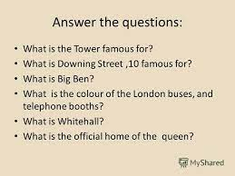
Task 4. Replace adjectives with infinitive verbs.
EXAMPLE: He is so old that he cannot skate. He is too old to skate.
1. The problem is so difficult that it is impossible to solve it. 2. The box is so heavy that nobody can carry it. 3. The baby is so little that it cannot walk. 4. He is so weak that he cannot lift this weight. 5. She is so busy that she cannot talk with you. 6. She was so inattentive that she did not notice the mistake. 7. The rule was so difficult that they did not understand it. 8. He was so stupid that he did not see the joke. 9. She has got so fat that she cannot wear this dress now. 10. The accident was so terrible that I don't want to talk about it. 11. They were so empty-headed that they could not learn a single thing. 12. The window was so dirty that they could not see through it. 13. She was so foolish that she could not understand my explanation. 14. I have very little wool: it won't make a sweater.
13. Comparative and superlative adjectives.
Task 1. Fill in the blanks using comparative and superlative adjectives.
Task 2. Listen and watch the video then describe the peoples.
https://www.youtube.com/watch?v=FHqwBYdEJWQ
Task 3. Look at the picture. Make sentences with comparative adjectives.
Task 4. Where do you need to go? Give some advice to your friend: you need to go to…
1. I want to get a newspaper.
2. I’d like to buy food for a week.
3. I need some stamps.
4. We must get Jim a present.
5. I’d like to buy a book.
6. I want to buy some clothes for myself and my children in one shop.

14. Travelling.
Task 1. Complete the sentences with the words and phrases below.
Task 2. Speaking. What do you see at the picture?
Task 3.Writing. Write an essay about “Travelling”
Task 4. Complete the sentences with the correct idioms
1. What a mess! There are empty boxes all … .
2. Women like shopping but what is really exciting is not buying but … .
3. The police are looking for the famous … who has already robbed ten shops.
4. I have problems with buying Easy English. It always … .
In the department store.A department store is a large shop which sells a lot of different things – clothes, beauty products, toys, etc.
15. Past Simple.
Task 1. Write the Past Simple form of the verbs.
Task 2. Listen and watch the video. Talking about a trip using the Past Simple.
https://www.youtube.com/watch?v=mngiqrT44Pk
Task 3. Speaking. Make up the dialogue using the past time expressions.
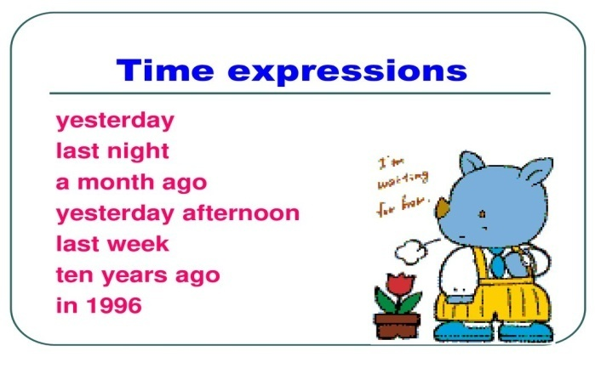
Task 4. Match the words in column a with the definitions in column b:
A | B
1. chemist’s | A. The shop where you buy meat
2. off-license | B. A place with many shops, either outside or indoors
3. window shopping | C. A person who works in a shop
4. shop/sales assistant | D. The place where you can try on clothes in a shop
5. butcher’s | E. The place where you pay for things in a shop
6. shopping centre | F. To look around the shops without planning to buy anything
7. cash desk/counter | G. A shop where you buy wine, beer and soft drinks.
8. changing/fitting room | H. A shop where you buy medicines, baby products, shampoo, etc.

16. Round the world
Task 1. Role play dialogue. Read and translate.
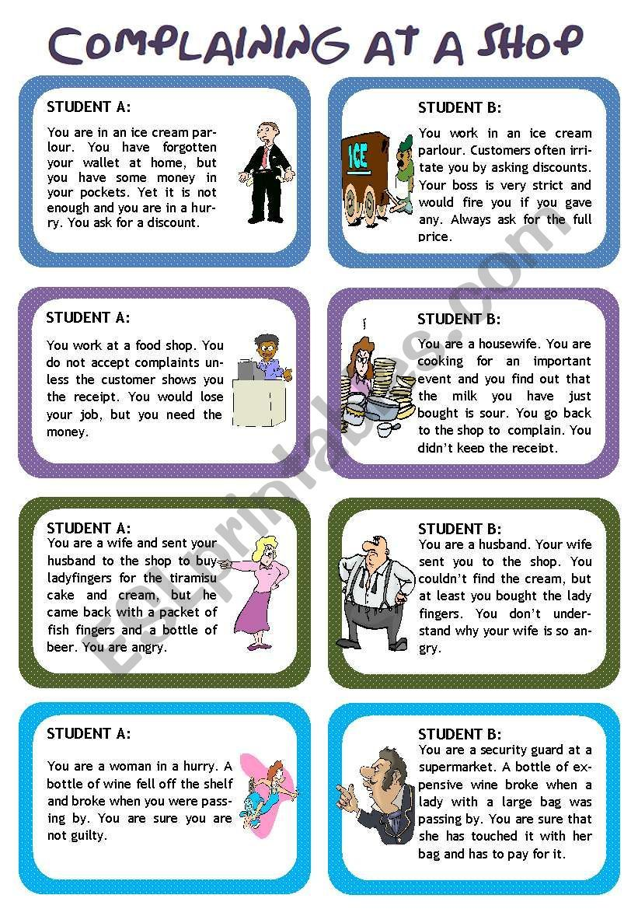

Task 2. Say the name of each picture out loud and circle the beginning sound.
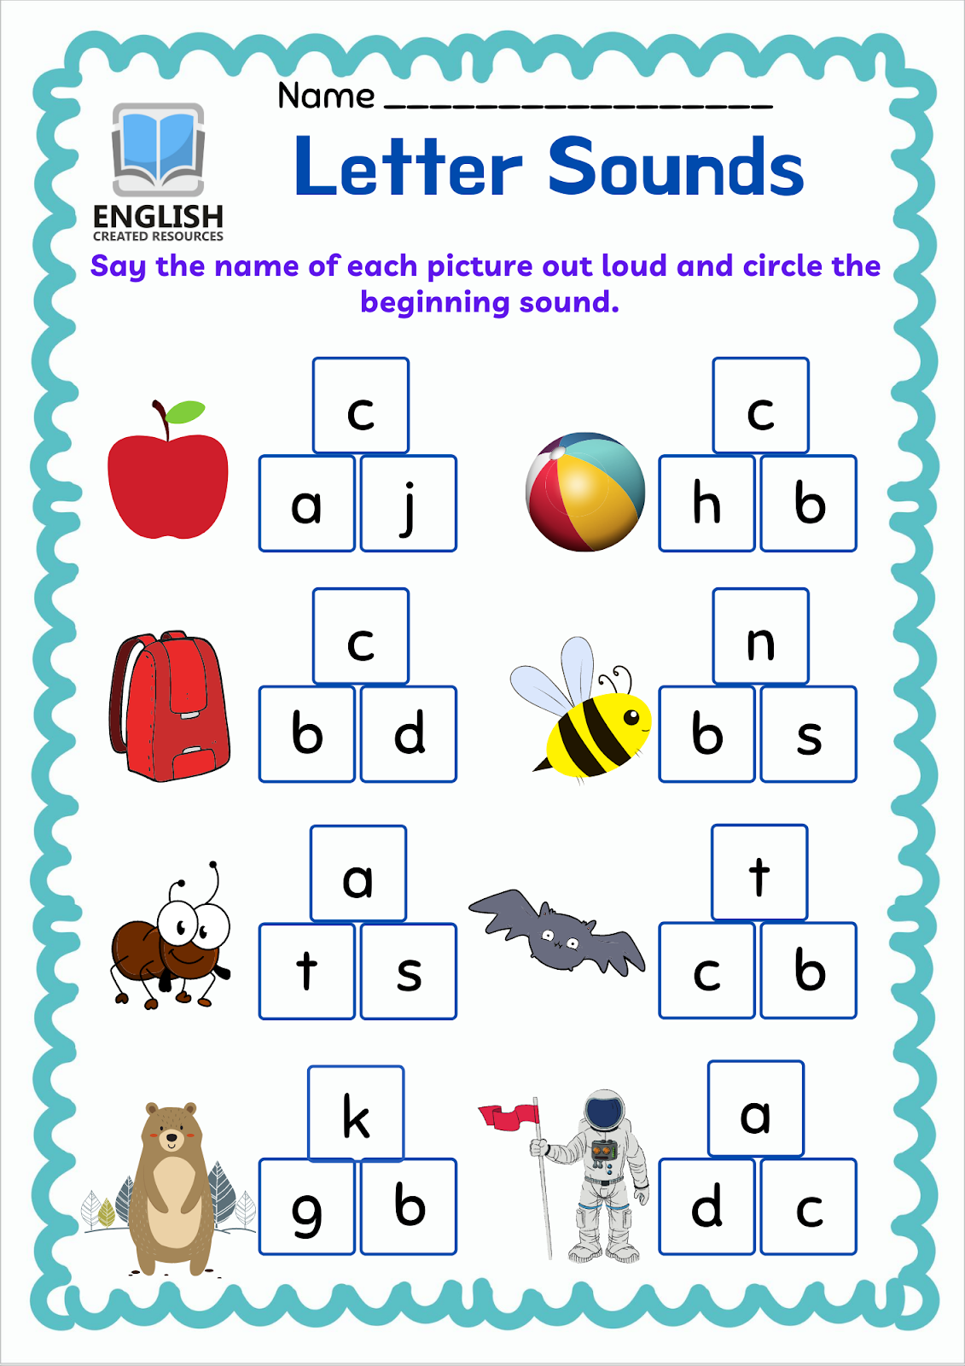
Task 3. Learn by heart tongue twister.
Task 4. Let’s talk about FASHION

This is not a career choice for the meek. First ask yourself - Do I want to be a model? Are you willing to put the time and energy into competing with pretty much everyone you meet, 24 hrs a day?

You have to understand that there are lots of other people who want to be models, it’s a very competitive business. Unless you are seriously committed about modeling, willing to work at it on your own time, live a healthy life style, etc., you will not succeed as a model. Not all jobs pay well.

Modeling is a lifestyle, not a 9-5 job. Prepare to be constantly rejected, get ready for some major ups and downs. It’s boring (sometimes) and it can be tedious. Despite the glamour and hype you have seen about the modeling profession, it’s hard work. You need to have tough skin in this business.
Mark true (T) or false (F) according to the text and explain when it’s false:
- You have to be sure you really want to be a model. ( )
__________________________________________
- You’ll compete all the time with many people every day in your life. ( )
__________________________________________
- Few people want to be models because it’s a tough job. ( )
__________________________________________
- Being a model doesn’t require much commitment. ( )
__________________________________________
- Some jobs don’t pay well in modeling business. ( )
__________________________________________
- It’s an exciting job all the time. ( )
__________________________________________
- It’s hard work. ( )
__________________________________________
- You need to treat your skin to become tough to be a model. ( )

17. Extra reading
Task 1. Read and speak. Make presentations on the topics: Texts for the groups:
I. Different food
There are different kinds of food. They are traditional food, meat and milk products, bakery, vegetables, fruits. People cannot live without food. Some of them are healthy food. Some are not healthy. Different food comes from different countries. We get food from animals, from plants. We grow some food. We buy food from shops.
II. British food
British people eat four meals a day. They eat cornflakes with milk, toasts with marmalade, honey and tea. They eat a large meal at midday. The midday meal is the chief one of the day. They eat roast beef, roast potatoes and Yorkshire pudding. British people eat a lot of meat. In the evening they have a simple supper. British people drink a lot of tea like Kazakh people.
Task 2. Writing an essay about healthy food and unhealthy food.
Task 3. Listen and watch the video
https://www.youtube.com/watch?v=9YiJj10yqp0

18. Personal pronouns. Reflexive pronouns.
Task 1. Write the correct pronouns in the table.
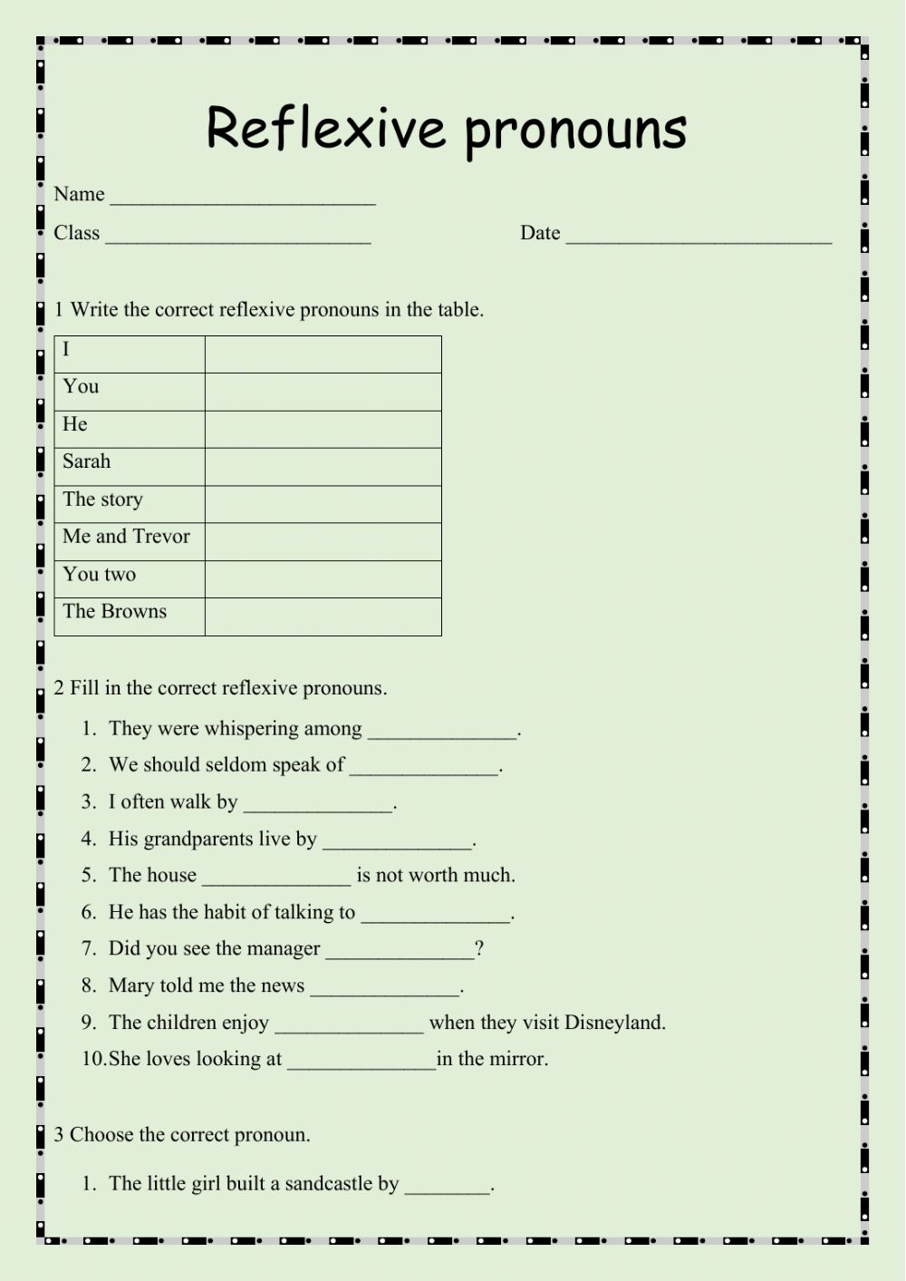
Task 2. Fill in the correct reflexive pronouns.

Task 3. Change these sentences: using by personal pronouns
Task 4. Choose the correct option.
1 I like reading. My favourite / best books are the Harry Potter books.
2 My brother, Jack always plays computers game / computer games.
3 If you watch TV all the time, you’re a couch potato / fan.
4 What are you interested in / for?
5 We usually go at / to the cinema on Saturdays.
19. Are you still mine?
Task 1. Fill on the blanks with the correct possessive pronoun
Task 2. Grammar quiz
https://www.youtube.com/watch?v=HHuOl3QHb5E

Task 3. Learn by heart
Task 4. Work in pairs. Make the dialogue
1. Hotel Reservation
R: Hello, Ashley Hotel.
C: Hello. I'd like to make reservations for 3 nights beginning March 6.
R: Yes, of course. What kind of room would you like?
C: I'd like a double room. How much would that be?
R: A double room is $42.00 a night.
C: O.K. I'll take it.
R: What is the name, please?
C: The name is Scott, Nil and Susan.
R: And what time are you arriving?
C: We're planning to arrive around8:00 in the evening.
R: Very well, Mam. We'll have your room ready for you.
C: OK. Thank you.
R: Thank you for calling Ashley Hotel.
2. Checking in
R: Welcome to the Sheraton. May I help you?
C: I’d like to check in. I have a reservation.
R: What’s your name, please?
C: Phillip Mallow.
R: Yes Mr. Mallow. You requested a single room for three nights, is that correct?
C: Yes, could I have a room on the upper floors, away from the ice machine?
R: No problem. Do you prefer a smoking or non-smoking floor?
C: Non-smoking please.
R: Could you fill out the registration form, please. Thank you. And will you be paying by cash or creditcard?
C: Cash, if you accept American dollars.
R: Of course, sir. If you require local currencies we can also exchange money foryou.
C: That’s great, I do need some cash.
R: Your room number is 1109. Here’s your key. Enjoy your stay at the Sheraton. If you requireanything further,feelfree to call the front desk. Would you like assistance with your bags?
C: No thanks, I only have one. I can manage.
3. Hotel Services
Room service: Hello. Room service.
C: Hello, I'm calling from room 113.I would like to order dinner.
RS: What would you like to order?
C: I'd like the roast beef dinner, with mashed potatoes and green beans.
RS: Would you care for something to drink with dinner'?
C: Ah, yes a large glass of milk.
RS: Any dessert?
C: A dish of vanilla ice cream
RS: Thank you. We'll bring it up in about thirty minutes.
4. Checking out
R: Good morning. May I help you?
A: Yes, I´d like to check out now. My name´s Adams, room 312. Here´s the key.
R: One moment, please, sir. ... Here´s your bill. Would you like to check and see if the amount is correct?
A: What´s the 14 pounds for?
R: That´s for the phone calls you made from your room.
A: Can I pay with traveller´s cheques?
R: Certainly. May I have your passport, please?
A: Here you are.
R: Could you sign each cheque here for me?
A: Sure.
R: Here are your receipt and your change, sir.
Thank you.
A: Thank you. Goodbye.

20. Buying clothes.
Task 1. Match the words and pictures.
Task 2. Choose one of the verbs in the box and put it in the right form.

Task 3. Work in pair. Make the dialogue on the topic “At the shop”
21. Describing a friend.
Task 1. Read the text
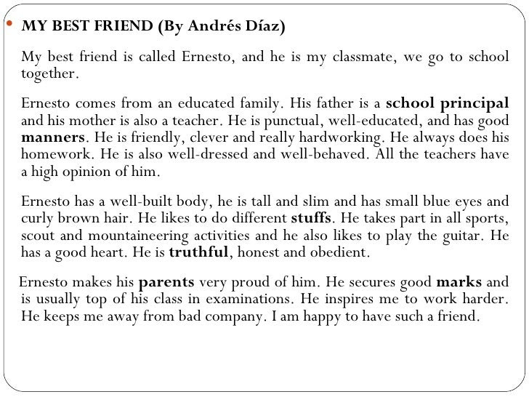
Task 2. Write a similar description again.
Task 3. Listen and watch the video describing a people
https://www.youtube.com/watch?v=CkwcvqqEO3E
Task 4. Read and write the correct TV programme.
You listen to information about the weather on this programme. ___________________________
You answer questions on this programme ___________________________
You can see cowboys in the west of the USA. _______________________
You can see how people play sports on this programme ______________________
You can learn about animals and plants on this programme __________________
You can see cowboys in the west of the USA. _______________________
This is a story that you see every day. Real people act ______________________
You can watch it at home or at cinema ___________________________
This programme is very funny. You always laugh _________________________
You receive information about your country and the world on this programme
People talk about one topic on this programme

22. Holidays of the USA
Task 1. You’ll read to description of some popular American holidays. You must write down the numbers of these holidays in the right order.
1. Independence Day.
2. Christmas Day.
3. Halloween.
4. President’s Day.
5. April’s Fool’s Day.
6. Columbus Day.
A) People celebrate this holiday in America in the same way they celebrate it in England. People make jokes on this day and have a lot of fun. People celebrate this holiday in spring.
B) Families and friends celebrate this day. Every town and every city has parades, games and sports with prizes. On that day 1776 the USA became independent from England.
С) On this day students and pupils read about George Washington, Abraham Lincoln and other American presidents.
D) This is one of the most favourite holidays of the year. Children dress up, shout “Trick or treat”. Get sweets, fruit, cakes and people have pumpkins with candles in their windows.
E) This is the biggest holiday of the year. Many people enjoy it mist of all and say this is the main holiday of the year. The President gives his speech on TV. Parents tell their children that Santa Claus will come to their house at night and leave presents for them.
F)You can see the American flag everywhere on this day. People honour the man who was the discoverer of their country.
Thank you for the game. Let’s score the points. So you can see that the winner of our game is… Congratulations!
Task 2. Writing.Now you must write the words in right order and make up questions.
A) have, what, you, seen, in the park?
B) who, last, was, in Los Angeles, year?
C) they, when, celebrate, will, Halloween?
D) going, to Texas, why, he, is?
E) whom, people, near, House, can, the, White, meet?.

Task 3. Listen and watch the video about “Holidays of the USA”
https://www.youtube.com/watch?v=0a15UOja3JM

23. My ideal school
Task 1. Let’s read and translate the text.
1) We have many subjects. They are: Russian, Kazakh, English, Mathematics, History, Music, Sport, History of Kazakhstan, Physical training, Literature and others. My favorite subject is English. It is interesting and exciting at the history lessons. Our History teacher Marat Robertovich is a good teacher. He explains a new material simply and interestingly.
2) I get up at 7o’clock, make my bed, have breakfast and go to school. Our lessons begin at 8 o’clock. Every day we have six lessons, except Saturday. On Saturday we have only five lessons. Every lesson lasts 45 minutes. After third lesson we have lunch. Our lessons finish at 2 o’clock.
3) My school is great. Especially I like my sport lessons. My favorite spots are basketball, volleyball, ping - pong and football. But at the same time we don’t have enough sport facilities at school. I like swimming but there is no swimming - pool in our school. Our schoolchildren can attend their favorite clubs. I attend basketball and volleyball clubs.
Task 2. Answer the questions.
- What is your ideal school?
- What do you like about school?
- What do you nit like?
Task 3. Work in groups. Make a poster about your dream school.
24. I can dance.
Task 1. Complete the sentences using can or can’t.
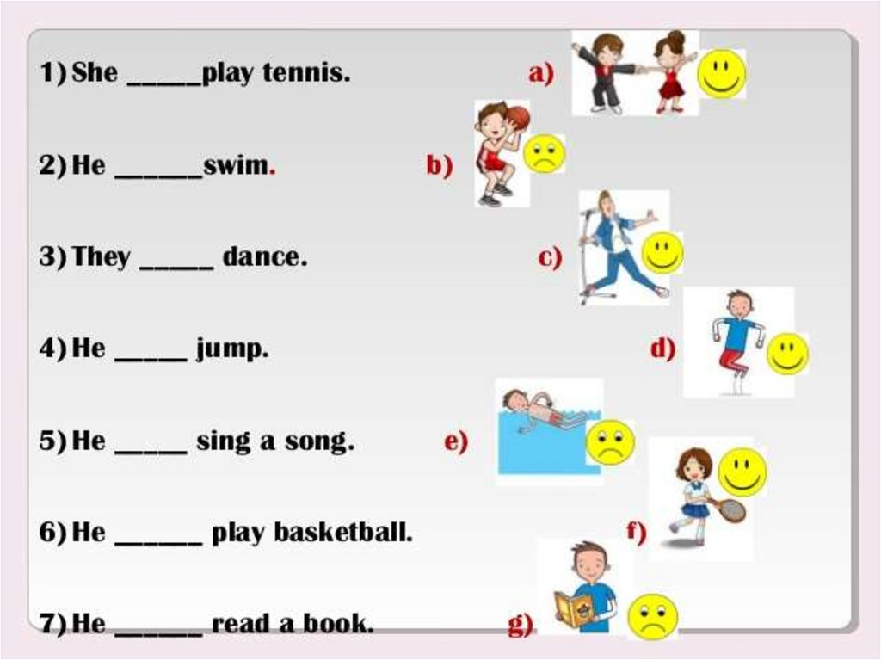
Task 2. Put the number of the correct sentence next to the picture.
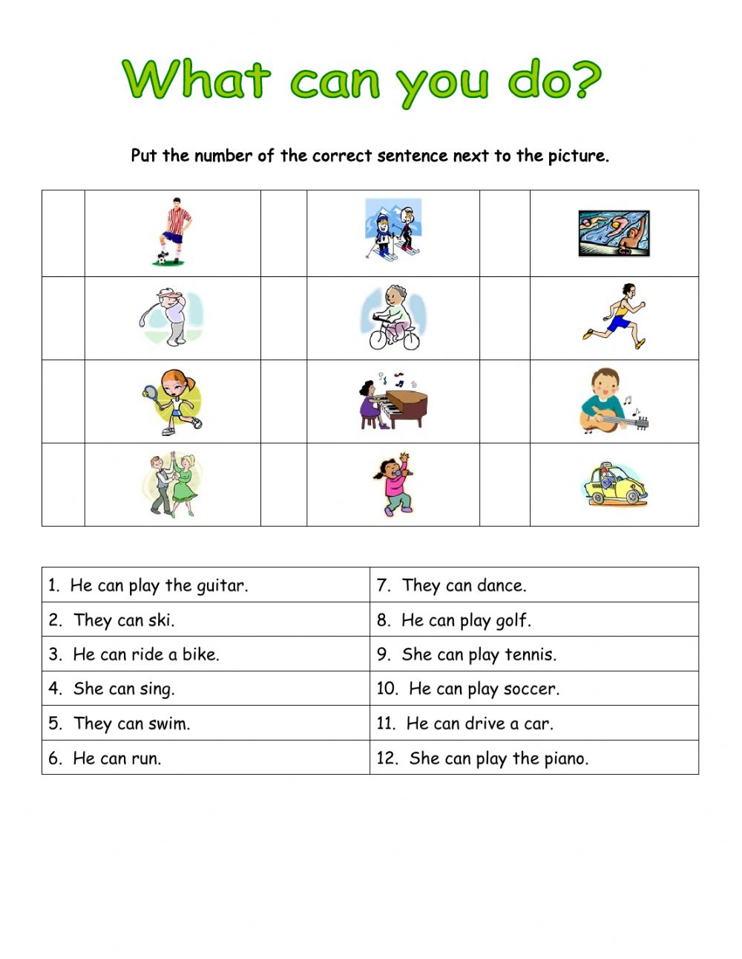
Task 3. Let’s sing a song “Yes, I can”
https://www.youtube.com/watch?v=8-PQ7_yGa08
Task 4. Ok and now let’s play the game.
Now we shall play a domino game. All of you will be given a card. Read the definitions on the right column and the name of the style of music on the left, if anybody else reads about your style ( on the left ) you read the definition. We shall read one by one. And we shall finish at the very student who begins.
tango | composed by famous composers for operas, ballet
blues | choir music that has religious background
reggae | played with the help of electric instruments and steady rhythm
jazz | music played by military bands
country | music from the West Indians, with a strong regular beat. It develop in Jamaica, especially 1960s, and its best –known singer was Bob Marley
rock’n’roll | composed many years ago and sung by people or choirs [ kwaie]
folk | a musical style where the singer speaks or shouts the words
rap | a style of music that was popular especially in the 1950s but is still played now. It has a strong, loud beat and is usually played on electrical instruments. The best –known singer Elvis Prestley
classical | music that is popular and originated from the southern and western United States. It has many sources: traditional ballads, cowboys songs, Mexican music and the like
spiritual | an American style of music based on variation. Since its beginning in the black community of New Orleans, USA, in the 20th century. The constant elements are improvisation and variation.
martial | a slow, sad style, originally from the southern states of the USA
rock | both music and dance from Latin America, especially Argentina

25. House and furniture.
Task 1. Look and answer.
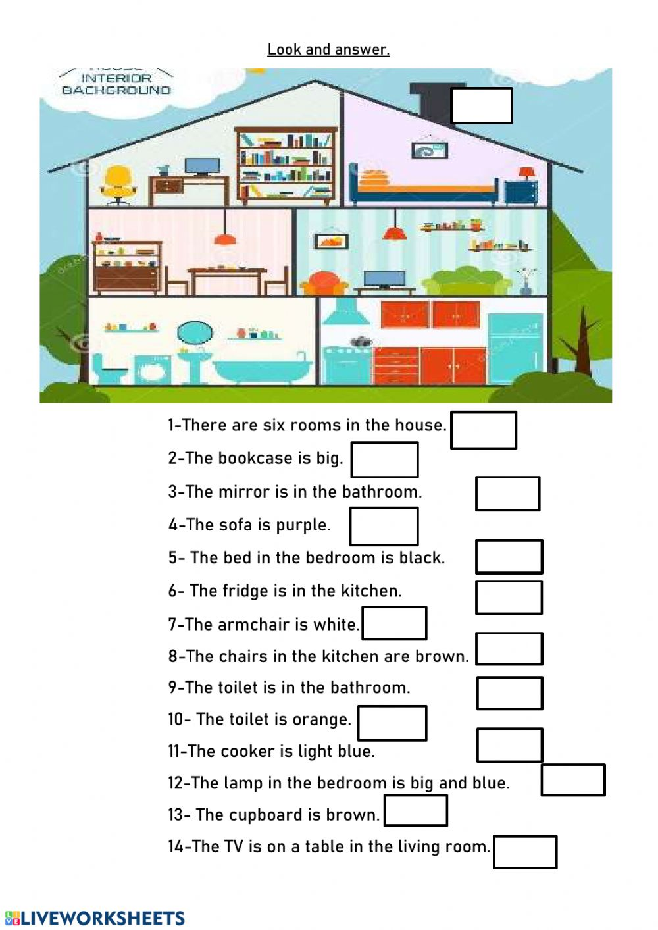Task 2. Choose there is/there are for each sentence.
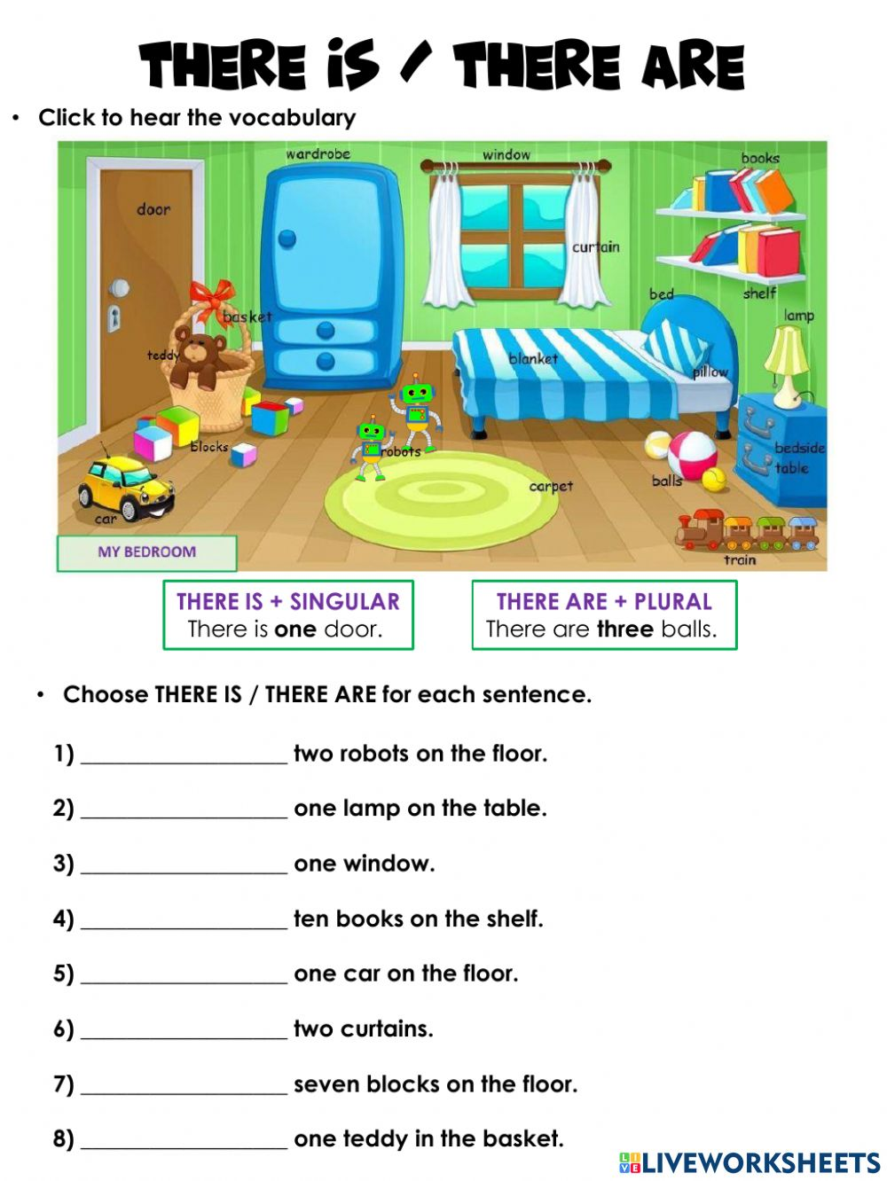

Task 3. Furniture Quiz. Check your score
https://www.youtube.com/watch?v=qyCI7EB22Ec
Task 4. Fill in the gaps with necessary words
1) He lost many fans because of his difficult..........(character)
2) She trained in......... but, she was invited to train in.............(Russia, Belarus)
3) Many believe she’s the greatest.......... of all time. (athlete)
4) At the age of......... he played in a professional team. (10)
5) His professional record is ....... fights, ........ wins with ........ Knockouts

26. Be going to: affirmative and negative form
Task 1. Complete the sentences with affirmative form of going to
Task 2. Complete the sentences with form negative of going to
Task 3. Learn by heart tongue twister.
Task 4. Say whether the statements are true or false
1) Michael Schumacher has been 8-time Formula One world drivers’ champion. (7-time)
2) Michael Schumacher isn’t talented. (is)
3) At the Berlin Masters Inna Zhukova performed without music.
4) Yelena Isinbaeva is a three- time Olympic Gold Medalist. (two-time)
5) At the age of 27 Yelena Isinbaeva set twenty-nine world records. (27)
6) Christiano Ronaldo started playing when he was only 5. (3)
7) Today Christiano Ronaldo is one of the top footballers of all time.
8) Vitaly Klitschko started his career as a kickboxer.
27. My last holidays
Task 1. Read and translate the text.

Task 2. Speaking. Answer the questions.
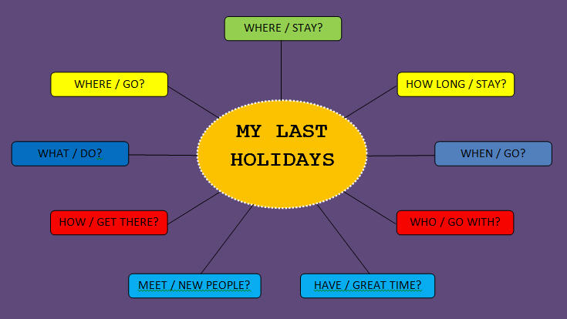
Task 3. Writing. Write an essay on the topic “My last holidays”
28. What does your food say about you?
Task 1. Unscramble the fast food vocabulary and number the pictures.

Task 2. Work in pair. Ask and answer
- How often do you go to the supermarket?
- Which supermarket do you go to? Why?
- Do you look at the food other people are buying?
Task 3. Food quiz.
https://www.youtube.com/watch?v=GnfTHsdTodA
Warm up (1m)
Imagine that I’m a coach and you are my sportsmen. Do what I say.
Stand up! Stand straight!
Hands up! Hands down!
Hands to the sides! Hands forward!
Hands backward! Hands on your hips!
Turn to the left! Turn to the right!
Bend left! Bend right!
Bend down, your hands touching your toes.
Hands up! Grow as tall as a tall tree!
Nod your head!
Turn your head to the left, to the right!
Stretch yourselves!

29. Would you like to drive a Ferrari?
Task 1. Complete with like or would like and the verbs in brackets
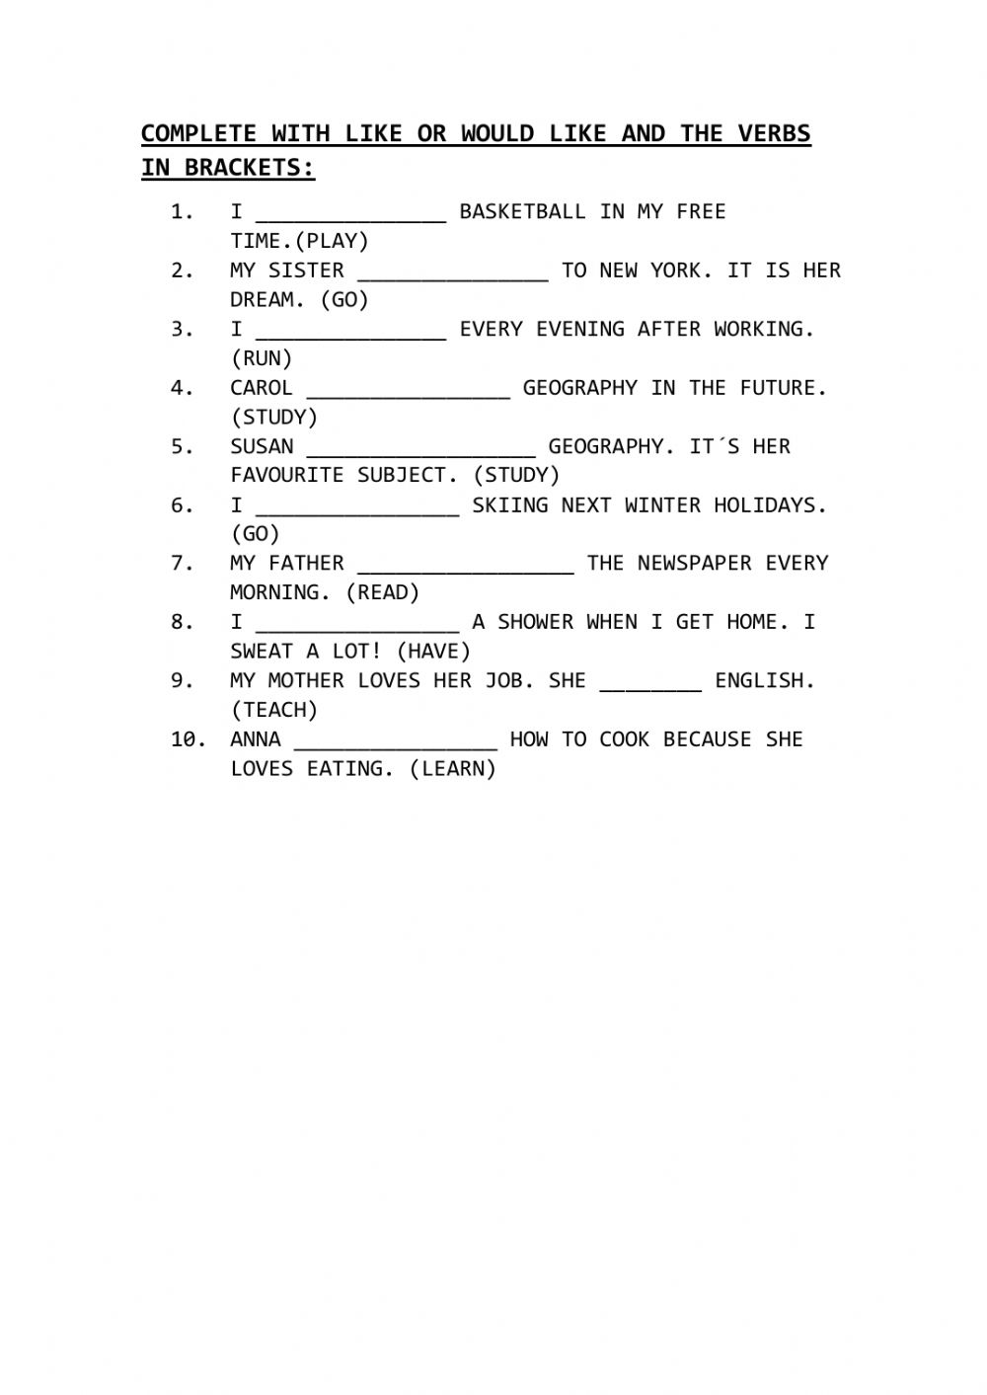

Task 2. Listen English conversation.
https://www.youtube.com/watch?v=yvkDuJ45ivw

Task 3. Speaking. Work in pairs. Practise the dialogue
Ask Would you like to ... ? Why (not)?
Task 4. First we repeat the words to the theme.
Match the words in English and in Russian.
Катание на роликах
Skiing
Плавание
Swimming
Гибкий
Hiking
Велоспорт
Cycling
Катание на коньках
Skating
Катание на лыжах
Tournament
Горный туризм
Improve
Мускулы
Keep fit
Улучшать
Muscles
Турнир
Flexible
Быть в хорошей форме
30. Adverbs
Task 1. Complete the sentences using the adverbs.

Task 2. Match the adjectives with their adverbs
Task 3. Adverb quiz.
https://www.youtube.com/watch?v=Ewv-5zSSA-Q
Task 4. Answer the questions, please.
Are people all over the world fond of sports and games?
What are the most popular outdoor winter sports?
What do some people greatly enjoy?
What game takes the first place?
What other games are very popular?
What do people go in for all the year round?
What do young girls and women go in for?
What indoor games are the most popular?
What has become an essential part of people’s life?
What is the biggest stadium in Moscow?
Does sport help people to become stronger and healthier?
31. Making a reservation
Task 1. Read the dialogue.
Task 2. Work in pairs. Make a hotel reservation dialogue.
Task 3. Listen and watch video about “Booking a hotel room”
https://www.youtube.com/results?search_query=making+reservation+hotel
Task 4. Match the phrasal verbs in list A with their meanings in list B.
A B
1) go about a) advance
2) go back b) leave to perform (an activity)
3) go along c) take an interest in
4) go in for d) spread
5) go down e) take place, succeed
6) go for f) return (in thoughts, in conversation
7) go off g) fall

32. A postcard.
Task 1. Read and translate
Task 2. Write a postcard to your friend. Imagine you’re on holiday in another town or city.
Task 3. Learn by heart a tongue twister.

Task 4. Complete the following sentences with the correct form of the phrasal verbs.
1. Let`s … to what chairman was saying.
2. There are a lot of colds … just now.
3. How long has Jim … collecting badges?
4. I`d like to … a walk, will you come with me?
5. How is Tom … with his new book?
6. The wedding … as planned.
7. The man slipped on the ice and … heavily.

33. Present Continuous.
Task 1. Complete the sentences using Present Continuous
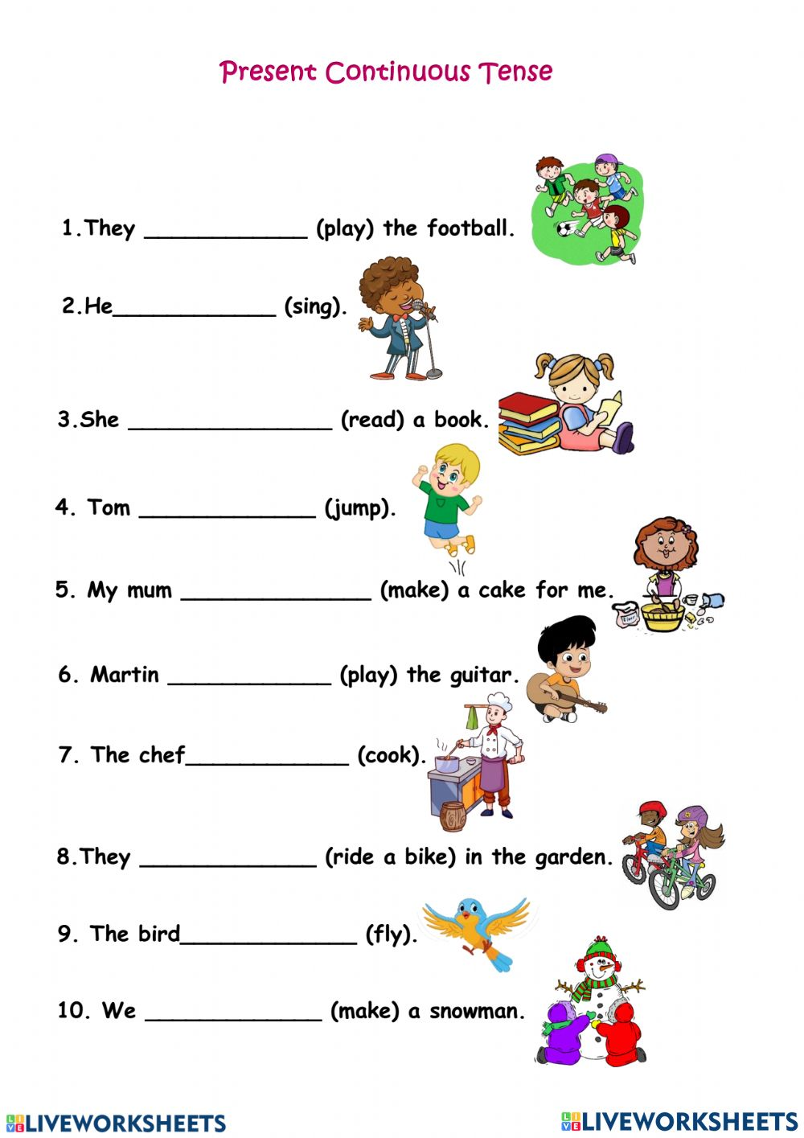
Task 2. Look at the picture and write down their activities

Task 3. Grammar quiz. Present continuos
https://www.youtube.com/watch?v=habad_xloBI
Task 4. Complete these exchanges using the correct form of one of the phrasal verbs below in each space.
go on go along go for
go back go off go in for
1) - How is your work ...?
- It’s ... nicely, thank you, if rather slowly.
2) - I’m sorry, my memory doesn’t ... that far, but perhaps Grandmother’s does.
- Yes, whenever she talks, she always likes to ... to her younger days.
3) - Let’s ... a drive in the country.
-No, I’d rather ... a swim.
4) - How long has Jim ... stamp collecting?
- Why? I thought he only ... music and tennis.
5) - Do you ... tall men?
- I... clever men, whatever they looklike.
6) - How did your play ...?
- It... very well, thank you.
7) - Do you want to stop in this town, or shall we...?
- We can’t... any further, the fall of snow has blocked the road.
Replace the underlined words in these sentences with the correct form of one of the phrasal verbs below.
go through go upgo about go by
go down go in go back go on
1. The temperature is becoming higher; will the snow melt?
2. The new law should be approved by Parliament quite easily, as it has been demanded by the public for some time.
3. I don’t know how I’d have found a way to live without his support.
4. He used to be rich, but a lot of his fortune was sent on paying his father’s debts.
5. A spoonful of sugar helps the medicine be swallowed.
6.I think we should travel bv train, it’s safer.
7. Don’t return to your old eating habits or you’ll gain all that weight again.
8. I don’t like the idea of my son being seen together with those rough boys.

34. Decisions, decisions.
Task 1. Fill in the blanks with May, might or must
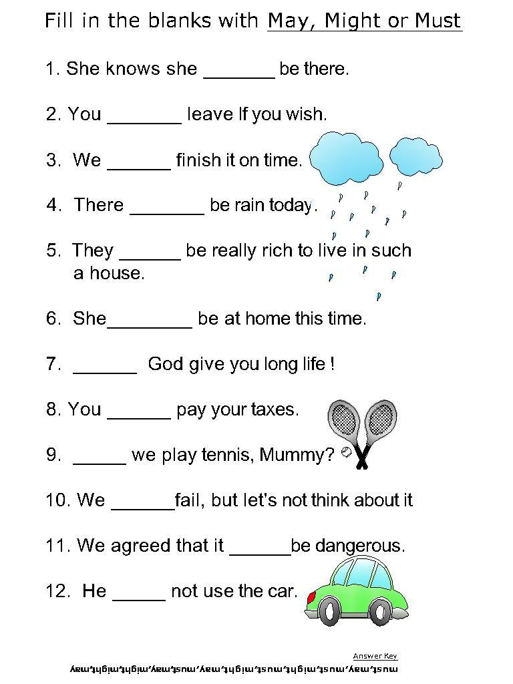
Task 2. Let’s sing a song.
https://www.youtube.com/watch?v=HqjYoUbmAPs
Task 3. Learn by heart a poem.

Task 4. Let’s speak about literature. Answer my questions, please.
Do you like to read? Why?
What genres do you know?
What is your favourite genre?
What books did you read from classical Kazakh literature?
What Kazakh poets do you know?
Is it possible to live without reading for you?
Books are our friends, aren’ t they?
What do books teach us?
What do you like more: to read books or watch TV?
Do you like Kazakhpoetry?
Who is your favourite poet or writer?

List of references:
1. Abiyev Zh, Kudiyarova, Babayev pedagogy "Nurly Alem"
2. Borodulina M. K. "learning a foreign language" - M., Begaliyev T. pedagogy-Taraz: Tarsu, 1999
3. Polat E. S. "Internet in foreign languages".
4. Movie Talk. English, interactive video course: for Windows and
Methodological development of English language for the development of skills
The Purpose Of The Seminar Is To Familiarize Students With The History Of The University.
"What's The Matter?"
5.Inkina I. I. use of ICT in teaching foreign language.
6.information and communication technologies in teaching the English language. "I'm sorry," she said. — 2006.
7. Albrecht K. N. application of ICT in English lessons// electronic journal "Information and communication technologies in pedagogical education". – 2010.
8. Belyaeva L. A., Ivanova N. V. presentation PowerPoint and its opportunities for teaching foreign languages // foreign language in school. - 2008. - № 4.

Садиярова Марина Анчова

Рецензент:
Кандидат педагогических наук, доцент Центра повышения квалификации и
дистанционного образования КазНПУ им.Абая, гонорар профессор Бельгийской ВШ А. Оракова

Было обсуждено и одобрено на заседании учебно-методического совета республиканского центра поддержки науки и образования, передано в печать. Протокол № 1029 «12» ноябрь 2024 г.

Developing speaking competence through contemporary teaching strategies in english education

Алматы, «Bilim shuagy» баспаханасы, 2024

ISBN 978-601-381-149-9
УДК 371.214
ББК 74.202
D49

Авторское пособие предназначено учителям общеобразовательных учебных учреждений.

© Садиярова Марина Анчова
2024 год

Министерство информации и общественного развития Республики Казахстан Комитет информации №KZ25VPY00087946
Подпись для печати —212.11.2024 г.
Объем — 5.0 условных печатных листов.
Формат — A4. Шрифт — Times.
Тираж — 20 экземпляров.

