LESSON PLAN

Unit 2 Value |  |  |  | School: Vasilkovka primary school
Date: 15.09.2020 y |  |  |  | Teacher name: Litsenberger I.A.
Grade: 5 б |  |  |  | Number present: |  | absent:
Theme of the lesson |  |  |  | Friendship. Listening a story about friends
Learning objectives(s) that this lesson is contributing to |  |  |  | 5.L2 understand an increasing range of unsupported basic questions which ask for personal information  5.L8 understand supported narratives, including some extended talk, on an increasing range of general and curricular topics  5.C9 use imagination to express thoughts, ideas, experiences and feelings  5.S6 communicate meaning clearly at sentence level during, pair, group and whole class exchanges  5.UE 13 apply might may could to express the attitude to the term «friendship » on a limited range of familiar general and curricular topics  (http//smk.edu.kz )
Lesson objectives |  |  |  | All learners will be able to:  - Identify the meaning of the word «friendship » through watching a story about “Lion and mouse”  - improve speaking skills by working in pairs, groups and whole class  - repeat the vocabulary from the text, give their thoughts using the new vocabulary  - answer the questions, according to the theme and express their ideas including emotions and senses  - portray various characters, according to the story without the text  (http//smk.edu.kz )
Assessment Criteria |  |  |  | - Distinguish basic questions with support  - Tell the clear expressions  - demonstrate the ability to infer main ideas while listening;  - Recognize the meaning of a story and extended talk  Connect sentences with basic coordinating connectors . (http//smk.edu.kz) ОШ_ФО_Англ.яз 5 кл_англ )
Previous learning |  |  |  | Lion, mouse, smack, jungle, neck, roar, rope
Value links |  |  |  | Patriotic Act ‘Mangilik Yel’, Secular Image with high spirituality. health keeping; support the friends; respect each other's opinion.
Cross-curricular links |  |  |  | Self-knowledge and Psychology
Previous learning |  |  | Friendship 1
Planned timings | Planned activities |  |  |  |  |  | Resources
Start  Middle | CLASS ROUTINE  Greeting learners.  Good-afternoon, children!  L: Hello, teacher!  How are you? I am very glad to see you!  L: We are fine! And you?  I am -ok! Let's begin our lesson  STARTER  Warm up. «WORD GAMES »  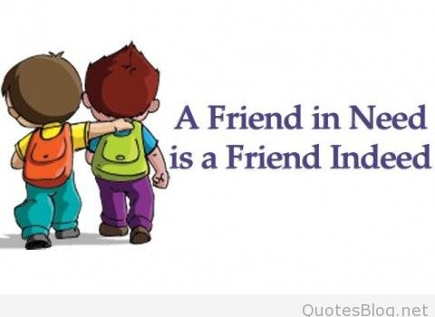  Learners stand in the circle and teacher saуs: « You are my friend, because…» Next learner answers to this question and turns to his neighbor and says : « You are my friend, because…», etc.  Then, the learners take their own places.  INTRODUCTION  Teacher asks learners what about will they be able to speak? And introduces learners learning and lesson objectives.  DEVELOPMENT  DRILLING  Activity 1  Pre-listening  [W] Teacher asks learners if they value the friendship?  And asks learners if a mouse and a lion can be friends? Teacher offers to listen to the story about friendship between lion and a mouse?  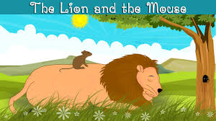  Then the teacher shows the video.  Learners asks the questions .  [W] Vocabulary  Teacher asks learners to repeat the words from the story: “Lion and mouse”  Then the teacher shows the video.  Learners asks the questions . |  |  |  |  |  | PPT  https://learnenglishkids.britishcouncil.org/ru/short-stories/the-lion-and-the-mouse
 | Interactive pattern T-S  Descriptor: a learner  -- recognize information during listening;  - use might may could to express the content of the text using topical vocabulary with little support;  Assessment : T: Do you like this story? Thumb up and down    While-listening  Activity 2  Differentiation by roles within group  [G]Teacher divides learners into 3 groups. In each group learners should choose a leader, time-keeper and speaker. Then gives papers with tasks to the video.  What’s the word?  Write the word under the pictures.  Lion asleep sun mouse neck back  Mouth laugh king tree rope friend  Interactive pattern S-S  Descriptor: a learner  - chooses the leader, time-keeper and speaker;  - ticks the appropriate grid;  - pronounces the chosen words correctly;  - gives the answers to the tasks without teacher’s support  Assessment: traffic light   Teacher gives 3 cards: yellow, red and green. Then asks learners the questions to checks learner’s abilities of working with the text. If the learner understood the topic and ready to move on shows green circle, learners who fairly comfortable with the topic shows yellow circle, learners who need further instructions shows red circle. |  |  |  |  |  | https://www.google.com/search?q=thumb+up&rlz=1C1EJFB_enKZ831KZ831&oq=thumb&aqs=chrome.0.69i59j69i57j0l4.5395j0j8&sourceid=chrome&ie=UTF-8  https://learnenglishkids.britishcouncil.org/ru/short-stories/the-lion-and-the-mouse  https://www.google.com/search?q=%D1%81%D0%B2%D0%B5%D1%82%D0%BE%D1%84%D0%BE%D1%80+%D0%BA%D0%B0%D1%80%D1%82%D0%B8%D0%BD%D0%BA%D0%B8&tbm=isch&source=iu&ictx=1&fir=0hIO5FsfGOyeBM%253A%252COtEPJTwuybvBYM%252C_&usg=AI4_-kSxNrkJl78EzqlH2XWkgDHDBLOcAQ&sa=X&ved=2ahUKEwjxiIPp-
  lion
 | Activity 3  [W] «Think, pair and shair »  What′s the order?  Teacher gives the task to each group. Learners will be able to put the sentences in order, according to the watching the fairy-tale.  Watch the story and put the sentences in order.  The little mouse ran up the lion’s neck.  He saw the king of the jungle tied to a tree.  1 A lion was asleep in the sun one day.  ‘You were right, little mouse – thank you, I’m free.’  ‘Be kind to me and one day I’ll help you.’  The mouse worked quickly and chewed through the rope.  The lion caught him with a great big smack!  The mouse was out walking the very next day.  Interactive pattern T-S  Descriptor: a learner  - does the task;  - puts the sentences in the right order, according to the text;  Assessment: checking yourselves in groups with the list of answers ( pair- assessment )  Post-listening  Activity 4  [W] 1. «Snowballing »  Watch the story. Write answers to the questions.  1. What animal does the lion catch?  A mouse.  2. What does the lion want to do with the mouse  3. What does the mouse promise the lion?  4. Does the lion think the mouse can help him?  5. What happens to the lion the next day?  6. How does the mouse help the lion?  2. What do you think is the moral of the story? Circle the best answer  - Don’t go to sleep in the sun or you will get caught  - Remember that everyone has different talents and abilities.  - Everyone will help you even if you are not nice.  Interactive pattern S-S  Descriptor: a learner  - write answers to the questions;  - choose the answer which is the best moral of the story ( give arguments )  - talking about it if necessary  Assessment: « The tree of success »  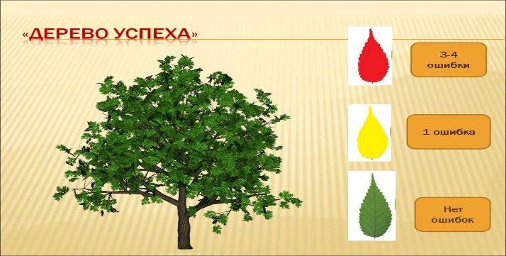 |  |  |  |  |  | https:www.youtube.com/watch?v=7lKclr67ajY  https://www.google.com/search?rlz=1C1EJFB_enKZ831KZ831&biw=1536&bih=706&tbm=isch&sa=1&ei=zO1yXMzHHqSimwWE4JiwDQ&q=tree+of+sucsess
Teacher gives the picture with the tree and leaves. Learners will be able to fasten to the leaves which they choose in each group.
Red leaf- 3-4 mistakes
Yellow- leaf- 1 mistake
Green leaf- no mistakes
End | PLENARY  [S] Express their own emotions about the story  - Say the opinions about the moral aspect of their results and success  «Success ladder»  At the end of the lesson children reflect on?  Teacher gives the comments about learners*s work and gives them stickers. Pupils choose one of them and put it on the blackboard , according their opinion about results of the lesson. |  |  |  |  |  | https://www.google.com/search?q=%D1%81%D0%BC%D0%B0%D0%B9%D0%BB%D0%B8%D0%BA%D0%B8+i+know+i+can&source=lnms&tbm=isch&sa=X&ved=0ahUKEwi7men1nNngAhXltIsKHSYXDN4Q_AUIDigB&biw=1280&bih=657
I KNOW
I CAN SPEAK
I NEED A HELP!

Lesson routine-
-Write your hometask, please
Dear children, our lesson is over. Good-bye. Thank you for the lesson. See you soon

Additional information
Differentiation – how do you plan to give more support? How do you plan to challenge the more able learners? |  | Assessement-how you are planning to check learner*s learning? |  |  | Healthy lifestyle  Power point  WEB  PE  He interactive board will be switched on 10 minutes
More able learners can be encouraged to say oral answers.  Differentiations:  by time  by tasks  by support of the teacher |  | «Thumb up and down »- if the learners like the story, they show «Thumb up », if they dislike it- they show «Thumb down »;  « traffic light »- If the learner understood the topic and ready to move on shows green circle, learners who fairly comfortable with the topic shows yellow circle, learners who need further instructions shows red circle;  « list of assessment »- checking yourselves in groups with the list of answers;  « The tree of success »- Teacher gives the picture with the tree and leaves. Learners will be able to fasten to the leaves which they choose in each group.  Red leaf- 3-4 mistakes  Yellow- leaf- 1 mistake  Green leaf- no mistakes  «Success ladder»- feedback. Teacher gives the comments about learners*s work and gives them stickers. Pupils choose one of them and put it on the blackboard , according their opinion about results of the lesson. according their opinion about results of the lesson.

