**TERM 1**

**SUMMATIVE ASSESSMENT TASKS**

**Summative assessment for the cross curricular unit « Animals»**

**Learning objectives** 3.L5 Distinguish between phonetically distinct words

3.S 1 Make basic statements which provide personal information on a limited

range of general topic

**Assessment criteria** Differentiate clearly between phonemically words

Make personal statements on general topics

**Level of thinking skills** Knowledge and comprehension

Application

**Duration**  20 minutes

**Listening**

**Task 1.** Listen to the words. Fill in the gaps. Use the letters from the table.

Teacher reads the words:

1.C_w

2.Ra_ _it

3.Sn_ke

4.G_at

|  |  |  |  |
| --- | --- | --- | --- |
| o | bb | a | o |

**Speaking**

Task 2. Look at the pictures. Choose one and tell about the animal or the bird. Use the ideas to help.

|  |  |  |
| --- | --- | --- |
| D:\Desktop\pen.jpg | D:\Desktop\duck.jpg | Name of the animal  Where it lives  Food  Type of the animal  Your opinion |
| D:\Desktop\elephant.jpg | D:\Desktop\horse.jpg |

|  |  |  |  |
| --- | --- | --- | --- |
| **Assessment criteria** | **Task**  **№** | **Descriptor** | **Mark** |
| **A learner** |
| Differentiate clearly between phonemically words | 1 | Writes letter ‘o’ for the first word; | 1 |
| Writes letter ‘bb’ for the second word; | 1 |
| Writes letter ‘a’ for the third word; | 1 |
| Writes letter ‘o’ for the fourth word; | 1 |
| Make personal statements on general topics | 2 | Names the animal/bird; | 1 |
| Says where it lives; | 1 |
| Tells what it eats; | 1 |
| Defines wild/ domestic; | 1 |
| Says has got/hasn’t got, have got/ haven’t got | 1 |
| Total marks | | | 9 |

Rubrics for providing information to parents on the results of Summative Assessment for the curricular unit “Animals”

Learner’s name _____________________________

|  |  |  |  |
| --- | --- | --- | --- |
| Assessment  Criteria | Level of learning achievements | | |
| Low | Middle | High |
| Differentiate clearly between phonemically words | Recognizes words and writes the correct letters under the picture. Makes spelling mistakes in writing the majority of the letters. | Recognizes words and writes the letters under the picture with a slight uncertainty. Makes some spelling mistakes in writing the letters. | Recognizes words and writes the letters under the pictures correctly. Makes few spelling mistakes in writing the letters. |
| Make personal statements on general topics | Makes up 1-2 sentences while talking about animals or birds. Experiences difficulties in making correct sentences about animal’s habitat/ food it eats/it’s type/ giving personal opinion about it. | Makes up sentences while telling about animals and birds. Names animals/birds in the picture. Makes mistakes in talking about animal’s habitat/ food it eats/ in defining animal’s type/ in giving personal opinion about it. | Makes up correct sentences while telling about animals Talks confidently about the animal. Defines correctly its type, and gives personal opinion about it. |

**Summative assessment for the cross curricular unit « Light and Dark»**

**Learning objectives** 3.L5 Distinguish between phonetically distinct words

3.S 1 Make basic statements which provide personal information on a limited

range of general topic

**Assessment criteria** Differentiate clearly between phonemically words

Make personal statements on general topics

**Level of thinking skills** Knowledge and comprehension

Application

**Duration**  20 minutes

**Reading**

Task 1. Read the text about dolphins. Tick the correct answer.

Dolphins live in water but they are not fish. There are small dolphins and big dolphins. Some dolphins live in the sea; some dolphins live in rivers.

They can swim very fast- up to 55 kilometers an hour. They are light- blue or dark –blue. They are very clever and kind and they love playing.

1. 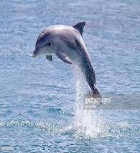Are the dolphins fish?

* Yes, they are.
* No, they are not.

1. Do they live in the lakes or the rivers ?

* They live in the lakes .
* They live in the rivers.

1. Are they clever and kind?

* No, they are not.
* Yes , they are.

**Writing**

Task 2. Fill in the gaps with the words from the boxes. Write them in the sentences.

|  |  |  |  |
| --- | --- | --- | --- |
| Light-blue | in | water | Love |

1. Some dolphins live ____ the sea; some dolphins live ___ rivers.

2. They are _________ or dark – blue.

3. Dolphins live in ____ but they are not fish.

4. They are very clever and kind and they______ playing.

|  |  |  |  |
| --- | --- | --- | --- |
| **Assessment criteria** | **Task** | **Descriptor** | **Mark** |
| **A learner** |
| Identify the main ideas of a short simple text using clues. | 1 | Tick ‘ No ,they are not.’ for the 1 st answer; | 1 |
| Tick ‘They live in the rivers.’ for the 2nd answer; | 1 |
| Tick ‘Yes, they are ‘ for the 3 rd answer; | 1 |
| Connect the parts of the sentences with basic coordinating words with support | 2 | Writes ‘in’ for the 1st sentence; | 1 |
| Writes ‘light-blue’ for the2 nd sentence; | 1 |
| Writes ‘water’ for the 3rd sentence; | 1 |
| Writes ‘love’ for the 4 th sentence | 1 |
| **Total marks** | | | 7 |

**Rubrics for providing information to parents on the results of Summative Assessment for the cross curricular unit “ Light and Dark”**

**Learner’s name______________________**

|  |  |  |  |
| --- | --- | --- | --- |
| **Assessment**  **criteria** | **Level of learning achievements** | | |
| **Low** | **Middle** | **High** |
| Identify the main ideas of a short simple text using clues | Experiences difficulties in identifying the main idea of the text and answers most of the questions incorrectly | Make some mistakes in identifying the main idea. The task is partially complete. | Identifies confidently the main idea of the text. Answers the majority of the questions correctly. |
| Connect the parts of the sentences with basic coordinating words with support | Experiences difficulties in linking the parts of the sentences correctly using basic connectors | Feels rather confident writing sentences. Makes few mistakes in linking the parts of the sentences . | Identifies the main words well. Feels confident to use them. Links the parts of the sentences using basic words. Completes the task correctly |

**Tasks for the Summative Assessment for the term 1**

**Listening**

Task 1. Listen and write **T** if the sentence is TRUE and **F** if the sentence is FALSE. You will listen twice.

1. I always get up at nine o’ clock. _____

2. I have breakfast in the bedroom with her family. _____

3. I come home at half past seven. _____

4. I do my homework in the morning. _____

**Teacher reads:**

I always get up at eight o’clock. I have breakfast in the kitchen with my family. I go to school at 1p.m. I go by car or by bus. I come home at half past seven. I always watch TV and play with my toys. In the evening I do my homework. At half past nine I say ‘Goodnight’ to my mother and my father and I go to bed.

**Reading**

**Task 2.** Read the text and answer the questions.

**The Sun and the Moon**

The Sun gives us lots of light. It is big and yellow. It gets up in the morning and goes to bed at night. The Sun helps us to live and to work. It makes our life warm and happy. The Moon helps us to see at night. It is round and yellow. It reflects the natural light too.

1. What does give us the Sun? __________________________________________________
2. What kind of is it?

__________________________________________________

1. When does it get up and go to bed? __________________________________________________
2. How does the Moon help us?

_________________________________________________

**Writing**

**Task 3.**

Choose one animal. Write 3-4 sentences about the animal. Use the words in the table to help.

Example:

Name the animal**: This is a rabbit**.

|  |  |  |  |  |
| --- | --- | --- | --- | --- |
| Animal | Size | Colour | Action | Food |
| Rabbit | Small | White | Run | Grass |
| Penguin | Big | Black and white | Swim | Fish |
| snake | small | grey | crawl | Meat |

Name the animal:________________________________________

1. Its size:__________________________________________
2. Its colour ________________________________________
3. Its actions:________________________________________
4. Its food: _________________________________________

**Speaking:**

**Task 4.** Look at the pictures. Tell about animal you like. Answer the questions.

1. Which animal do you like?
2. Where can you see it?
3. What does it eat?
4. Why do you like it?

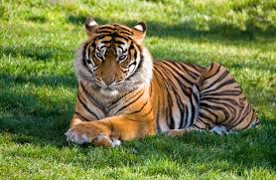 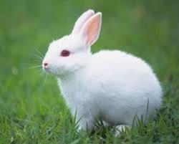

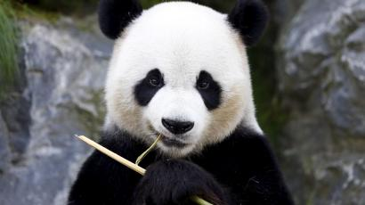 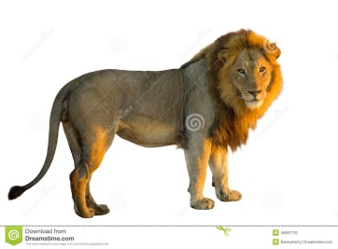

|  |  |  |  |
| --- | --- | --- | --- |
| Task | Answer | Mark | Additional information |
| 1 | 1.F | 1 |  |
| 2.F | 1 |  |
| 3.T | 1 |  |
| 4.F | 1 |  |
| 2 | 1.Lots of light; | 1 |  |
| 2.Big and yellow; It is big and yellow | 1 |  |
| 3.In the morning/ at night; | 1 |  |
| 4.To see at night; | 1 |  |
| 3 | 1.It is small. | 1 |  |
| 2.It is white. | 1 |  |
| 3.It can run | 1 |  |
| 4.It eats grass | 1 |  |
| 4 | I like a tiger | 1 |  |
| I can see it in the Zoo | 1 |  |
| It eats meat. | 1 |  |
| I like it because it is strong | 1 |  |
| **Total marks** | | **16** |  |

|  |  |  |  |  |  |
| --- | --- | --- | --- | --- | --- |
| **Cross**  **curricular**  **unit** | **Strand** | **Learning objective** | **Task**  **№** | **Type of question/**  **Task description** | **Total**  **marks** |
| Animals  Light and  Dark | Listening | 3. L6 Understand some specific information and detail of short, supported information or talk on a limited range of general and some curricular topics | 1 | True/ false task  Learners listen to the teacher’s speech about the girl’s activities at day and night time twice. There are 4 sentences that learners should identify. They should decide if the sentences are True or False. | 4 |
| Reading | 3. R5 Understand the main points of short simple texts on a limited range of familiar general and some curricular topics by using contextual clues | 2 | Open ended task.  Learners read the text about The Sun and the Moon and answer the questions. They find the information in the text and write the answers to the questions. | 4 |
|  | Writing | 3. W1 Plan, write and check short sentences with considerable support on a limited range of personal, general and some curricular topics  3. UE3 Use adjectives, including possessive adjectives, on a limited range of general and some curricular topics to describe things. | 3 | Open ended task.  Learners choose one animal from the table and describe it using appropriate information and adjectives from the table. Learners should write full sentences as in example. |  |
| Speaking | 3.S1 Make basic statements which provide personal information on a limited range of general topics. | 4 | Open ended task.  Learners look at the pictures and give answers to the questions. |  |