Research Work

“The Amazing
World Of
Idiomatic Expressions”

Any language has a lot of idioms. Idiomatic expressions are a vital component of English in particular. They reflect mentality and culture of the people, speaking this language. If we compare English and Russian language, we will also find out a great number of idioms, like “has remained with a nose”, “to sit in a pool” or “ate a dog” and so on in Russian language.
All over the world free using idioms in speech is a difficult problem for people, learning English language as a foreign one. Idioms often cause serious difficulties even with people, who know English very well. And if they intentionally avoid using idioms, in this case their oral and written speech, most likely, will be dull and high-flown.
So, in my work I’ll try to get you to be interested in the beautiful world of idioms. I’ve realized the necessity of knowing idioms and using them in our daily speech before starting my work. I was interested in the history of idioms, so, the results of this investigation you’ll see on the next pages.
The world of idioms can be very difficult for people that’s why I’ll give you some exercises and I hope it will be a good stream for teachers and students.
I’ll illustrate a lot of idioms myself for the best understanding of them; of course, I’ll do it according to my point of view, but I hope it’ll help you.
In my work, I’ll try to apply received knowledge in practice, composing different texts, that’s way to show how you can easily work with idioms.
Analyzing the history of idioms I’ll draw some conclusions. Moreover, I’ll analyze my school textbooks and make my comments on them.
Reading my report, I think, you should remember that idioms make our speech more expressive, vivid, imaginative. Having a rich vocabulary of idioms, you can not only understand shades of meaning, stylistics, emotion, but you also will enrich your speech, made it more natural, that, of course, will make your intercourse easier with foreign colleagues and friends.
One more thing I’d like to add that people, who improving in English language, should precisely understand that using idioms in daily intercourse isn’t foppery or tribute to a style of the end of XX century. On the contrary, understanding and right using idioms testifies about high level of possession of English language.

- a primary purpose was to explore the world of English and American idioms, prove, that we can use them in our everyday speech
- to analyze school textbooks and show how to use idioms in practice

- to research the history of idioms
- to demonstrate a variety of them in our textbooks
- to help other students to use idioms

- analysis
- comparison
- illustrative method
- method of material evaluation

I would like to tell you about idioms. An idiom is a phrase or expression that has a meaning different from what the words suggest in their usual meaning. All idioms have some sort of meaning behind them such as “Butterflies in my stomach”. The meaning is a feeling caused by nervousness. Idioms can be really funny but some are really tricky.
Idiom (noun) - an expression conforming or appropriate to the peculiar structural form of a language; in extend use, an expression sanctioned by usage, having a sense peculiar to itself and not agreeing with the logical sense of its structural form; The term red herring, an idiom meaning 'false trail', is used of something which is neither red nor a herring.
Such American phrase as to put one's foot into it, meaning to make a public offence, in British English is passed by phrase to drop a brick, which won’t be clear for the majority of the people, living in USA.

Idioms are very widespread in modern English language. We can divide all idioms into different parts. They’re everywhere around us.
birds animals

the animal kingdom
sport fish
food
heart head

Idioms
parts of the body arm
clothes professional
eyes
business medical

money

People, who improving in English language, should precisely understand that using idioms in daily intercourse isn’t foppery or tribute to a style of the end of XX century. On the contrary, understanding and right using idioms testifies about high level of possession of English language.

The establishment of American studies as a scholarly field can be traced back to the 1970's, the years when it was instituted as a discipline (or, rather, inter-discipline) speaking in terms of theory, its institutional contexts, and method. But some 30 - 40 years earlier there were authors who raised theoretical issues. So, formal history of American Studies development as an academic discipline numbers 60 years in the United States and about 50 years in Europe. (Ickstadt, 1996: 11). As J. Mechling, R. Merideth, and D. Wilson observed, "According to a standard account, it began in the 1930's with stirrings of discontent within single departments, usually English, sometimes history, over what seemed arbitrary limitations on teaching and writing." (1973: 364). The spread of American Studies throughout Europe after World War II began from the Salzburg Seminar in Austria and often a chair was established within an English or history department. (Ickstadt, 1996: 11).
It may be noted in passing that, to some extent, it explains the history of simultaneously establishing American Studies programs at two departments at Far Eastern State University in 1994: those of English Philology and History. Since its emergence as a scholarly field American Studies has had two contradictory trends: on the one hand, it "promotes a broad humanistic understanding of American culture past and present, encourages scholars from diverse disciplines to exchange ideas on America, and examines the ways American life relates to world society." (Stephens, 1996: 5). On the other hand, it faces many challenges the major of which "include the relationship between American studies and the traditional disciplines, the relationship between American studies and its subject (the United States), and the relationship between domestic American studies and its international variations." (Stephens, 1996: 9). There are problems and challenges but, clearly, being multi-disciplinary and interdisciplinary, American Studies offers a broad range of possible fields of research. In this context, it will be of great interest to see the relationship between history and language. Perhaps the most obvious demonstration of this relationship will come from identification and analysis of those idioms, which reflect American history or rather American culture of this, or that historic period.
Studying idioms many authors call attention to the fact that they can more easily than other language units cumulate and store facts about the past, cultural semantics of a nation, traditions, customs, folklore, etc. because of the so called "cumulative" function of a language. The element, which renders the information, is called "national-cultural component". (See for example, Vereshchagin and Kostomarov, 1982: 89). There exist many definitions of an idiom, but most theorists stress three main features: that this linguistic unit consists of more than one word, it is stable, and idiomatic, that is the meaning of a whole unit does not emerge from the meaning of words it consists of. (Kunin, 1984: 7; Baranov and Dobrovol'skii, 1996: 51).
The material for the analysis was obtained from The Wordaworth Dictionary of Idioms (Kirkpatrick and Schwarz, 1995) and comprised 132 units marked "Originally US" or "An American Expression..." since my intention was to concentrate on American idioms. While American and British Englishes share a lot of common vocabulary stock – idioms including - there are, in my view, two diachronically distinct types of idioms: those inherited from British English but which changed some components (one or two words) on the American soil those the prototypes of which appeared on the American soil. British English borrows some of these idioms.
So, to tell one from the other we must know the origin.
To illustrate the first diachronic type I will quote some examples from Collins COBUILD Idioms Workbook: British English: Not see the wood for the trees; American English: not see the forest for the trees; BE: A storm in a teacup; AE: a tempest in a teapot (Goodale, 1995: 3).
The second type is more numerous and it will be illustrated in detail. For the purposes of the article I would like to focus on the idioms the prototypes of which appeared in the United States. Out of 132 only 15 idioms reflect different historic events, customs of this or that historic period.
Etymological analysis of the data obtained showed that it is possible to distinguish several groups of idioms according to the period in the history of the U.S. they reflect.
Idioms reflecting the way of life on the American frontier. So much has been written on the frontier that it is difficult to find any subject not covered in the literature. The role of the frontier is tremendous not only in the history but also in contemporary life of Americans. Thus, R.A.Billington sees the impact of frontier in some characteristics of the American people, "during three centuries of expansion their attitudes toward democracy and nationalism and individualism were altered, and they developed identifiable traits not shared in like degree by their European ancestors: wastefulness, inventiveness, mobility, and a dozen more." (Billington, 1991: V). Other authors describe the image of the frontier. For example, L. Schlissel underlines how different the image of frontier may be, "it could mean deep forests or grasslands stretching for a thousand miles; it could mean red dirt flats or outcroppings of rock surging up against the sky." (Schlissel, 1988: 81). The impact of the frontier can be seen in many spheres of American culture.
The material under study provides examples, which imply the way of life on the frontier. The idiom “rope someone in” reflects the experience of catching and collecting cattle with the help of lassoes by the frontiersmen in the West. That is the direct meaning and the idiomatic meaning is "to include (someone); to persuade (someone) to join in doing something: We roped him in to help." (Kirkpatrick and Schwarz, 1995).
The prototype of the idiom “this neck of the woods” originally denoted a remote community in the woods, later the idiomatic meaning "a particular place or part of the country" developed which can be seen from the example: What do you do in the evening in this neck of the woods? (Kirkpatrick and Schwarz, 1995). Though the frontier was different a lot is connected with a life in the woods that predetermined many typical American characteristics. Billington writes, "No matter how nationalistic the frontiersmen might be, they were backwoodsmen, living in comparable isolation from the main currents of life..." (Billington, 1991: 212-213).
One more facet of frontier history, the gold rush of the 1850's and 1860's, can be found out in the idiom “strike (it) lucky”, the etymological meaning of which expressed anticipation of gold miners (forty-niners) to find gold or silver. Idiomatic meaning: "to have good luck in a particular matter: We certainly struck lucky in choosing that school" (Kirkpatrick and Schwarz, 1995).

Idioms reflecting events of the 17th century.

A very important historic event is reflected in the idiom “a witch-hunt”, the idiomatic meaning of which is: "a search for, and persecution of, people whose views are regarded as evil: The McCarthy witch-hunt in the United States from 1950-54 sought out members of the Communist Party." (Kirkpatrick and Schwarz, 1995). The prototype of the idiom refers to the organized hunts for witches. And though it took place both in America and in Britain the idiom originally appeared in the United States. Against the background of extreme stress (being a colony of England, the country was in a state of war with the French and their Indian allies and in 1690 northern frontiers of New England and New York were devastated by enemy attacks) there occurred an outbreak of witch-hunt that led to accusations in witchcraft. It was especially severe in Salem Village. In 1692 nineteen people were hanged, another was pressed to death by heavy stones, and more than one hundred people were jailed. To explain this puzzling episode, the authors of the book “A People and A Nation” write, "to be understood it must be seen in its proper context -one of political and legal disorder, of Indian war, and of religious and economic change. It must have seemed to Puritan New Englanders as though their entire world was collapsing."(1990: 67-68).

Idioms referring to the 18th century.

There are some idioms, which reflect everyday life of people during the 18th century. It refers to the idiom “have an axe to grind”, the idiomatic meaning of which is "to have a personal, often selfish, reason for being involved in something: I have no axe to grind - I just want to help you." (Kirkpatrick and Schwarz, 1995). The etymology of this idiom presents a great interest. It represents a story as it is believed, told by Benjamin Franklin (1706-1790), American statesman, diplomat, author, scientist, and inventor, about a man who "had once asked him to demonstrate how his father's grindstone worked - and had then produced an axe which he wanted to sharpen". (Kirkpatrick and Schwarz, 1995).

Idioms referring to the 19th century.

Most idioms describe the everyday life; they are connected with the tools. “Fly off the handle” idiomatically means "to lose one's tempo: He flew off the handle when he heard that the boys had raided his garden again." (Kirkpatrick and Schwarz, 1995). The metaphor is based on the possibility of an axe head to fly off the handle while one is using it. According to D. Boorstin, the idioms came into use in 1825 (1993: 74).
Tools and implements play an important role in the life of Americans, as in a life of any people. They are often used in idioms. The prototype of the idiom “get the hang of (something)” originally meant, "to learn to use this or that tool." Idiomatic meaning is "to learn, or begin to understand, how to do (something): It may seem difficult at first, but you'll get the hang of it after a few weeks." (Kirkpatrick and Schwarz, 1995).
A very important facet of life is disclosed in the idiom “bark up the wrong tree”, which presently means "to attempt to do the wrong thing or to do something in the wrong way or from the wrong direction: You're barking up the wrong tree if you think you will be able to influence the judge." The metaphor comes from racoon-hunting, where dogs were used to locate racoons up in trees. (Kirkpatrick and Schwarz, 1995). There are many idioms including elements denoting hunting in the common vocabulary stock, most of them were inherited by American English. It is noteworthy to underline that the idioms describes hunting a new animal, racoon, the habitat of which is the North America. D.Boorstin refers this idiom to 1833 (1993: 74).

Idioms referring to the 20th century.

The period of Prohibition gave rise to several idioms pertaining to the organized crime. Many Americans first heard about this type of crime in the early 1920s when it was started by notorious Al Capone with bootlegging in Chicago. Later he came to control much of illegal activities: extortion, gambling, prostitution, narcotics, etc. (Flexner, 1982: 435). The activity of gangsters is reflected in the idiom “take (someone) for a ride”, which had a variant take (someone) for a one-way ride, the etymological meaning was "to kill someone in a moving car"; it was originally gangster's slang reflecting a common practice of exterminating a person without attracting attention. Metaphorical meaning is: "to trick, chit or deceive (someone)": He doesn't actually work for a charity at all, so the people who have sent him money have been taken for a ride. (Kirkpatrick and Schwarz, 1995).
“Give (someone) the works” metaphorically means "to give someone the full treatment: They’ve certainly given her the works at the hairdresser's - she's had her hair cut, tinted and permed." The prototype meant, "to kill someone" (Kirkpatrick and Schwarz, 1995).
Though the prototype of the idiom “stool-pigeon” meaning "a pigeon tied to a stool and used as a decoy" goes back to the 1830's, the spread and active use refers to the 1920's (Flexner, 1982: 436). Idiomatic meaning is "an informer or spy especially for the police: The police received information about the planned robbery from a stoolpigeon." (Kirkpatrick and Schwarz, 1995).
A later period can be seen in the idiom “on the breadline” meaning "with barely enough money to live on: The widow and her children were living on the breadline." (Kirkpatrick and Schwarz, 1995). The idiom reminds about The Great Depression (1929 - the late 1930's). But the worst period was between 1929 - 1933, when unemployment reached 13 million people in 1933, which comprised one fourth of the labor force. It is at that time that soup kitchens were opened by such organizations as Red Cross and Salvation Army in the United States, the poorest people queued in breadlines. (A People..., 1990: 730) So, the prototype of the idiom meant literally "queues of destitute people waiting for free food from soup-kitchens, especially run by the government." (Kirkpatrick and Schwarz, 1995).
To sum up, I would like to underline that American studies perspective enabled to find cultural elements in idioms which store the information about historic events, ethnographic details, ways of life of different periods in the history of the U.S.A. Albeit history is only implied in the idioms under study but the information is very important for the students majoring in American studies as well as for those who are interested in the United States.

Now, I would like to give some examples of American idioms and make my comments on them.
Rain cats and dogs = to rain very heavily.
- The children should take their raincoats, umbrellas and boots because it's raining cats and dogs.
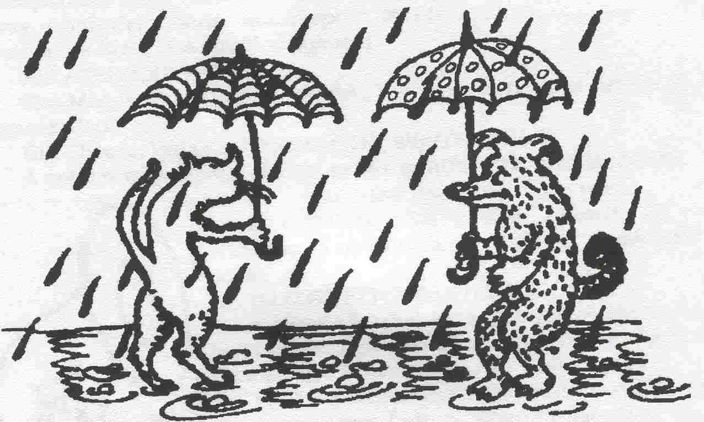
I've never seen such rain! Look how fast it's coming down. It's raining cats and dogs.
(to) Beat to the draw
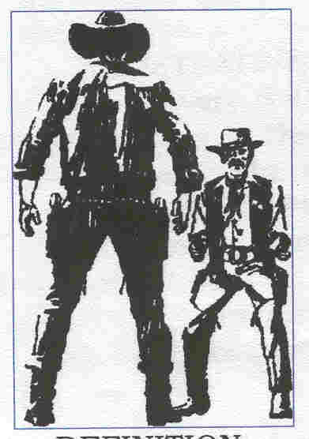
or
(to) Beat to the punch
DEFINITION: To do something before another person has a chance to do it.
ILLUSTRATIVE SENTENCES:
• I had hoped to get that job in New Orleans, but Jake beat me to the draw. (Paraphrase: Jake applied and got the job before I did.)
• Leah wanted to buy that painting by Orsky, but Janice beat her to the punch. (Paraphrase: Leah couldn't buy the painting because Janice bought it first.)
Big frog (fish) in a small pond
DEFINITION: someone who is considered to be important in a small place or position; a leader in a small group.
ILLUSTRATIVE SENTENCES:
• In his hometown, he was a big frog in a small pond, but after he moved to a large city, he was just one person among many millions. (Paraphrase: In his hometown he was respected and honored, but in the large city no one knew him.)
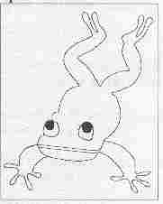
• Grant preferred being president of a small company - a big frog in a small pond - rather than becoming a vice-president of a large corporation at a large salary. (Paraphrase: More money couldn't lure him away from the honor and respect of his position as head of a small company.)
RELATED EXPRESSIONS:
The Man = The boss, the leader, the most important person in an organization.

Big Cheese/Big Gun/Big Shot/Big Wig/Big Wheel
A person with a great deal of power or influence; a high official.
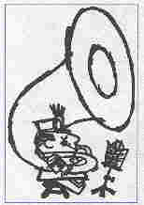
(to) Blow (toot) one's own horn
DEFINITION: To praise oneself; to call attention to one's skill, intelligence, or success; to boast.
ILLUSTRATIVE SENTENCES:
• Poor Charlie! He's always tooting his own horn about how good he is at golf. (Paraphrase: He s always praising his own skill at golf.)
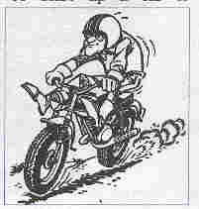
• The person who habitually blows his own horn soon loses friends. (Paraphrase: One who is always boasting alienates friends.)
(to) Burn rubber
DEFINITION №1: To start up a car or motorcycle from a dead stop so fast that the rubber of the tires leaves a mark on the road.
ILLUSTRATIVE SENTENCES:
- Every Saturday they burn a lot of rubber at the motorcycle races. (Paraphrase: The motorcycle tires leave a lot of rubber marks on the racetrack, or: There’re many fast starts at the racetrack on Saturdays.)
- Every time that he leaves a stop sign, my brother likes to burn rubber. (Paraphrase: He starts his car fast and leaves a rubber mark on the pavement.)
DEFINITION №2: To leave in a hurry (on foot or by vehicle).
ILLUSTRATIVE SENTENCES:
- If we expect to get to the airport on time, we’ll have to burn rubber. (Paraphrase: We’ll have to leave in a hurry in order to be on time.)
- “Let’s burn rubber!” the leader shouted as all the drivers ran toward their motorcycles. (Paraphrase: Let’s leave in a hurry!)
(to) Butt in
DEFINITION: To interfere in other people’s business; join in with what other people are doing without asking or being asked
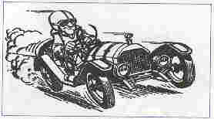
ILLUSTRATIVE SENTENCES:
- Mother had just started to explain to Jane how to fix her sweater when Alice butted in. (Paraphrase: Alice interfered when mother started explaining something to Jane.)
- Let’s go into the other room so Albert won’t butt in. (Paraphrase: Let’s go into another room to avoid Albert’s interference.)
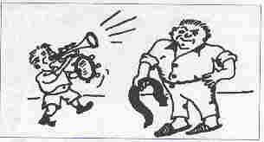
There you will find synonymous expressions, which, I think, have the same meaning of the idiom butt in:
Horn in = To come in without invitation; interfere
Stick One’s Nose Into = To meddle in things not one’s business; interfere (somewhat impolitely)
Pay the piper = to pay for one's mistakes; to live with the consequences of one's (wrong) actions.
            - Catherine thought she could play her way through school. Now she has to stay after school to make up her failed grades. She should have known she would have to pay the piper.
            - I cheated several people out of their money. I got caught and I'll spend years in prison. Now I'm paying the piper for what I did.
In the same boat = in the same bad situation.
- Jake and I both lost our jobs yesterday. Now we're in the same boat.
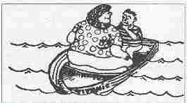
2. The landlord came around to each tenant last night and raised the rent on each apartment. None of us can afford to stay here any longer so we'll have to move out. We're all in the same boat.
I think the expression suggests that people in the same boat share the same bad fate. They will all sink together if the boat capsizes.
Hook, line and sinker (fall for/swallow something) = to believe something completely, usually in the sense of being fooled.
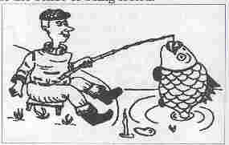
- The children made up such a believable story that their mother fell for it hook, line and sinker.
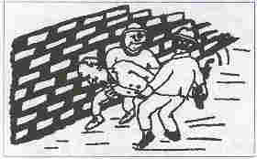
. The salesman was such a smooth talker, he could make anyone believe his stories. People always swallowed them hook, line and sinker. The expression originates from fishing. One expects the fish to bite only the hook, but in some cases the fish might be taken in so completely and foolishly that it swallows not only the hook but the fishing line and the sinker as well.
Hook, line and sinker is used frequently with the verbs fall and swallow.
Brainstorm = to suggest any idea that comes to mind in an attempt to find a solution to a problem (sentence 1). A brainstorm means a suddenly inspired idea (sentence 2).
- The company wanted a new advertising campaign but no one could think of a good idea for it. The boss decided to ask the workers if they could think of one. He got them all together in one office and asked them to brainstorm.
- At first I couldn't think of how to raise enough money for the school, but I've just had a brainstorm. We can buy candy from a manufacturer at a discount and sell it to the community at a profit.
To my mind the expression suggests the storm that goes on inside one's brain when thinking of as many ideas as possible without worrying about whether they are organized or well thought out.
Ships that pass in the night = two people whose lives come together or whose paths cross for a short time.
- Dan met the woman of his dreams, but he wasn't quite ready to get married. They dated for a while and then went their separate ways. They were ships that pass in the night.
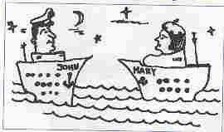
- I came to this city in 1985 and left shortly after I met Robert. Our lives touched only briefly. We were ships that pass in the night.
I am sure that the expression is frequently used to describe a romance that is not meant to be because it is the wrong time or the wrong place.
Now, I think, you aren’t afraid of using such kind of idioms in your speech, so, we’re in the same boat, but in the boat of American idioms – it’s a good boat.

This is my own example of using American
idioms in our daily speech:
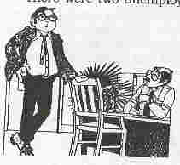
There were two unemployed men. They both wanted to receive the same job as journalists in one company, so, they had to write an essay and present it. Jim was working for a whole week very hard, but Jeffrey didn’t want to do anything, he thought how to get a ready made. Suddenly, he had a brainstorm: he decided to steal it. That day was raining cats and dogs. He came to see Jim due to bad weather explaining his visit with absence of the umbrella, and his desire to wait for the clearness in the sky. Jim fell for it hook, line and sinker. While he was in the kitchen, Jeffrey noticed the ready made essay and put it into his bag. The next morning Jeffrey brought the essay to the editor who promised to publish it. Of course, Jim recognized his work from the article in the newspaper, but he couldn’t prove that that was his. Fortunately, the big frog of that town butted in and Jeffrey paid the piper for his crime, and the job of a journalist was received by Jim. It was fair. So, crime doesn’t pay.

I’ve just written about American idioms and what about English? I could find a lot of them, but I’ll give examples only about some of them which I consider the most interesting and I’d recommend my classmates to use them working with British literature classes, making analyses of different creative works and writing project tasks. Moreover, almost all of these drawings were made by me.
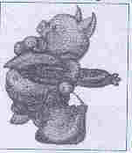
Q. What does the idiom “to bring home the bacon” mean?
A. This idiom is used only in informal English. If you bring home the bacon, it means you earn a salary. For example: I need to get a job; now I’m the one who has to bring home the bacon.

Q. What's the meaning of the idiom "out of the frying pan into the fire" ?
A. If you go out of the frying pan into the fire, then you go from a bad situation to one that is even worse. For example: Mary was finding her biology course too difficult so she changed to chemistry. But to her horror, the new course was even more difficult. It was a case of out of the frying pan into the fire.
Q. What does the expression "willy-nilly" mean?
A. This is an expression used only in informal spoken English. If something happens willy-nilly, then it happens whether you want it or not; you can't stop or prevent it from happening. For example: As he was sitting right near the front of the room, he was forced willy-nilly to sit through the whole boring meeting before he could leave.
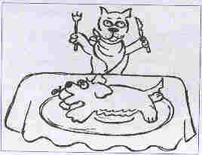
Q. What's the meaning of the idiom "it's dog eat dog" ?
A. It's dog eat dog is an expression used to describe a situation, usually in business or politics, in which people compete strongly and will do anything to get what they want. For example: My friend Joseph used the information I gave him informally to take some business from me. I was really angry with him, but the world of business can be very hard. It's dog eat dog out there.
While we're on subject of dogs, there are a few other "doggy" idioms that are commonly used in English. For example, we can describe something that is a mess or a muddle as a dog's breakfast or a dog's dinner. For example: He's made a real dog's breakfast of this job. But if you are dressed (up) like a dog's dinner, that means that you are dressed too smartly or showily for a social event, and other people will think you are silly.
It's a dog's life is used to say that life is difficult and full of hard work and worry, with very little pleasure. For example: I work six days a week, and I only get two weeks' holiday a year. It's a dog life. And to lead somebody a dog's life means to make someone's life very difficult or worrying. For example: That young man has always been getting into trouble with the police. He’s led his parents a dog’s life. He’s made the lives of his parents very difficult and sad because of his criminal behaviour.
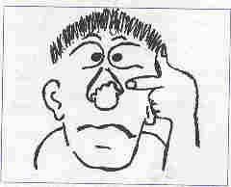
Q. What does the idiom "it's no skin off my nose" mean?
A. This is an informal expression, which is used to say that you don't care what someone else thinks or does because it doesn't affect you. For example: It's no skin off my nose if you waste your money. Or: I offered to help her out, but if she doesn't want me to, it's no skin off my nose!
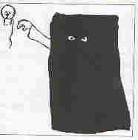
Q. What does the expression "to keep somebody in the dark" mean?
A. If you keep somebody in the dark, you don't tell him or her your plans - you keep them secret. For example: The public was kept in the dark about the assassination attempt.

Q. What is the meaning of "vis-à-vis" ?
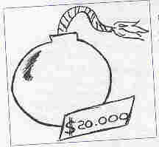
A. Vis-à-vis is a formal English expression, which has been borrowed from the French language. It means in relation to or in comparison with something. For example: The country's economy is very successful vis-à-vis the economies of other countries in the region. This means that the economy of the country is very successful in comparison with the economies of the other countries in the region.
Q. What does it mean when people say that something is "going for a song" ? And if something "costs a bomb", is it very cheap or very expensive?
A. If something is described as going for a song, then it means that it is for sale very cheaply. For example: That secondhand car is "going for a song". I'd buy it if I were you. If something costs a bomb, then it is very expensive. For example: I have seen a really lovely wedding dress in a shop but it costs a bomb. My mother can make me a similar dress much more cheaply.
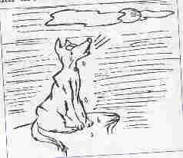
Q. What does the expression "to cry wolf” mean?
A. To cry wolf means to keep asking for help that you do not really need, with the result that when you do need help, people do not believe you. For example: She had cried wolf so many times that her claims for attention were ignored.
Q. What is the meaning of the expression "a chicken and egg situation" ?
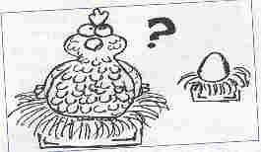
A. This is an informal expression, which describes a situation or problem in which it is impossible to decide which of two things was the cause of the other. For example: The connection between lack of education and poverty is a chicken and egg situation. Are people poor because they have no education or do they not get an education because they are poor?
The expression comes from the idea of a chicken and its egg. Does the egg come from the chicken or the chicken from the egg?
Q How do you use the expression "laughing stock" ?
A. A or the laughing stock is someone or something that is regarded as foolish, and causes unkind laughter. You use it in the following ways: Her silly behaviour made her a laughing stock or Her silly behaviour made her the laughing stock of the office.
Q. What does the idiom "on a knife-edge" mean exactly?
A. A person on a knife-edge is very anxious about the future result of something. For example: He's on a knife-edge about his exam results.
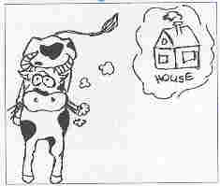
On a knife-edge also refers to a situation, which is delicately balanced, with the result extremely uncertain. For example: Negotiations are on a knife-edge. Nobody knows if there will be peace or more fighting. Or: The success or failure of the plan was balanced on a knife-edge.
Q. What does the expression "till the cow come home" mean?

A. Till the cows come home is an informal expression, which is used only in spoken English and is now a little old-fashioned. It means "for a very long time, possibly forever". For example: You can sit there till the cows come home, but I don't think he'll turn up.
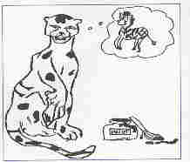
Q. What does the saying "a leopard can't change its spots" mean?
A. This is a saying, which means that people can't change their basic character or temperament. For example: We've tried again and again to persuade Tim to come out to the pub with us, but a leopard can't change its spots - he always refuses.
Q. What does the expression “bread and butter” mean?
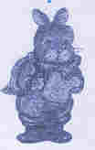
A. When we use the idiom “bread and butter” we mean someone’s livelihood or income. For example: I don’t especially like doing this job, but it’s my bread and butter.
Q. What does it mean when something is done "behind closed doors" ?
A. If something is discussed or decided behind closed doors, then it is done privately or secretly. It's not an open discussion that everybody can join in. For example: The inquiry was held behind closed doors.



Idiomatic expressions are a vital component of English in particular. The common idioms will increase our understanding, though most of us instinctively avoid trying to use them and I suggest a variety of exercise practice in recognition and production of idioms. I offer you some idioms around themes such as health, school, accommodation, family relationship, everyday life. I’ve selected them according to my point of view and my understanding but I hope it will be a good stream for teachers and students.

School, students, exams

The other students passed with flying colours.
The written exam was difficult, but the oral exam was a peace of cake.
a. It’s very easy! b. Let’s go together!
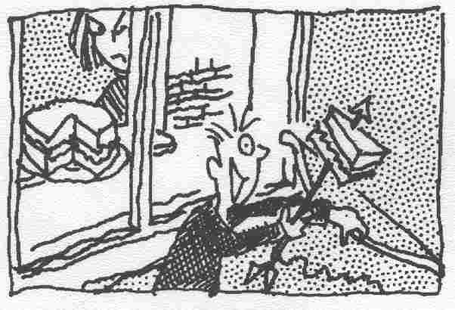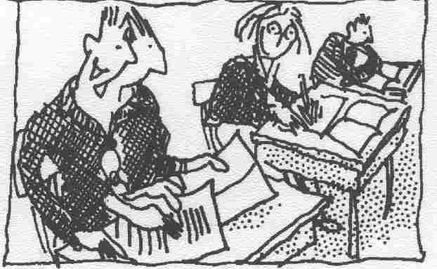

__________________________ ___________________________

c. Exams soon! d. Fantastic!
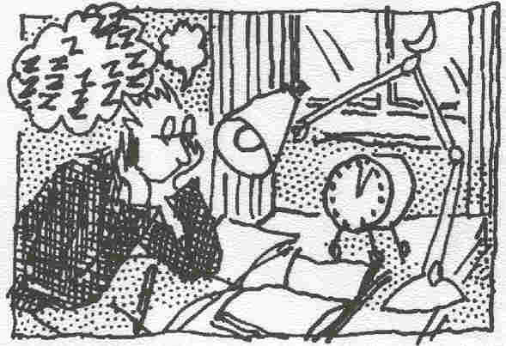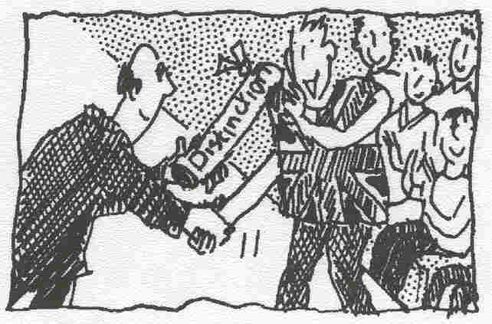

__________________________ ___________________________

It will be easier if we work on this exercise together. Two heads are better than one.
Her teacher told her that if she wanted to catch up with the rest of the class and pass her exams, she would have to burn the midnight oil for several weeks.

- To pass with flying colours = to pass an exam with high marks
- A peace of cake = something that is very easy to do (informal)
- Two heads are better than one = More ideas or solutions will be produced if you work with someone else rather than on your own.
- To burn the midnight oil = to work or study late into the night

Home

    - Home, sweet home: used to show pleasure when one is returning home after a period of absence.
    - An Englishman’s home is his castle: no one can enter an Englishman’s home without permission and nobody can tell him how to behave there.
    - Make yourself at home: an invitation to someone to make 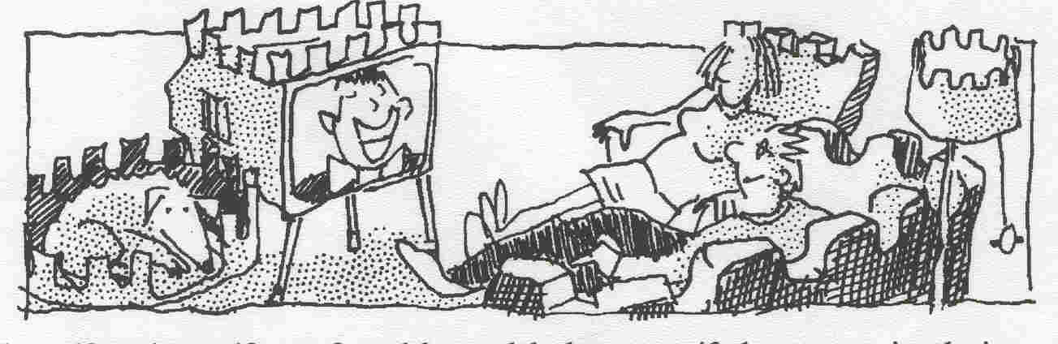himself or herself comfortable and behave as if they were in their own home.
    - It’s home from home: a place as pleasant and comfortable as one’s own home.
- Come in and have a seat. I want you to feel you can behave as if you were in your house. So ______ while I make a cup of tea.
- They made me feel very welcome. It was like being in my own house. It was _______.
- He had enjoyed travelling round the world and seeing different places, but at last he had returned. He walked towards his house and thought ‘_____’.
- I can do what I want in my own house. You know what they say, ‘____’.

General condition

to burn the candle at both ends = to work hard during the day and stay up late at night in order to get everything done, usually resulting in mental and physical exhaustion
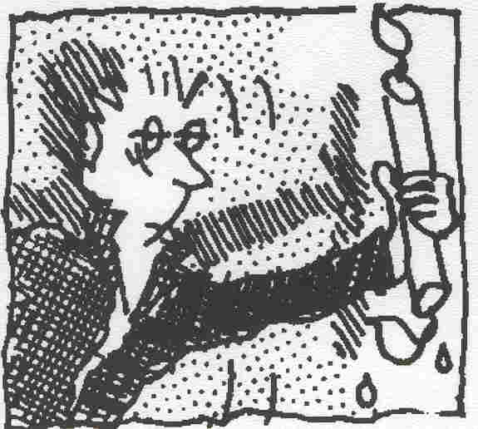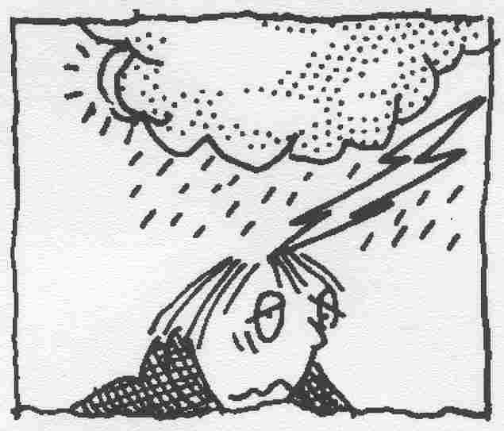
to feel under the weather = to feel unwell
I think these two idioms are connected with each other. Because, if you burn the candle at both ends, the next day you will feel under the weather.

Relationship

There you’ll find some idioms concerning relationship between people. When I firstly saw the idiom “to see eye to eye” I thought that it means “to see somebody tête-à-tête”, but what it really means you will see on one of the examples.
To have/get one’s own way = to do what you want to do, often against the advice of others. Most often used in relation to children.
To see eye to eye (with someone) (on something) = to agree completely, have the same opinion
To be close to someone = to like someone very much, have similar attitudes and emotions.
To be black sheep of the family = someone whose conduct is considered to be a disgrace to the family.
To take someone’s side = to support someone
Now, try to express the main idea of sentences using these idioms.
The problem is that her parents never stop her doing anything that she wants to do. She’s become a very spoil child as a result.
My family is very ashamed of my brother and never talks him. He was expelled from school and has been in prison twice.
Whenever I had an argument with my mother or father, I could always rely on my grandparents to support me.
My father and I usually agree about most things, but when it comes to politics we have completely different views.
I can talk to my sister about my problems because I know she will understand me and share my feelings

Beauty

There is one more type of idioms. They are about beauty. Some people think the beauty rules the world, but I am sure a soul of person is more important than his/her appearance.
a wolf in sheep’s clothing = someone who pretends to be friendly in order to hide selfish or bad intentions
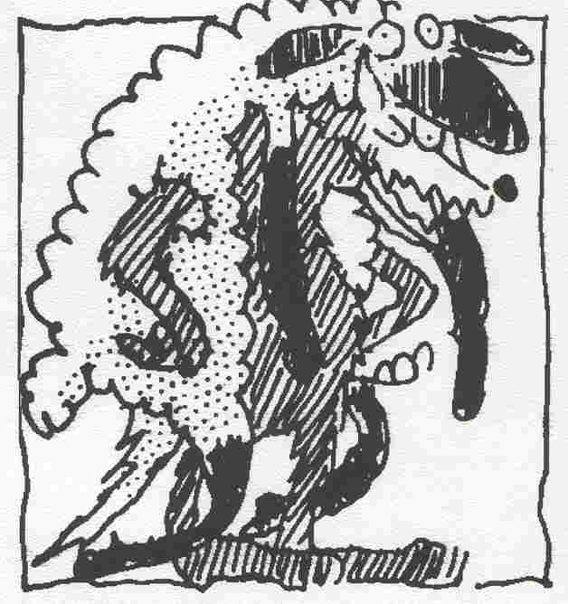
there’s no arguing about tastes = everybody has different likes and dislikes, and taste is a very personal thing, so it is a waste of time to argue about it.
beauty is only skin deep = a beautiful appearance can hide very different qualities.
you can’t go by appearances = you can’t judge someone by the way they dress, behave, or look.
one man’s meat is another man’s poison = what is good or pleasing to one person may be bad or unsuitable for another.
beauty is in the eye of the beholder = different people have different opinions about what is beautiful.
Try to use these idioms about beauty in these four sentences.
You think a peace of modern sculpture is ugly but your friend thinks it’s beautiful.
Your sister is in love with a man who seems very nice and friendly, but you think that underneath he’s a horrible, selfish person who only wants her money.
You meet someone who gives the impression of being very poor. You find out later that in fact this person is very rich.
You meet an attractive looking person who seems very nice, but you later find out this person is unkind and unfriendly.

Crime and punishment

Crime doesn't pay = crime doesn’t provide you with any real profit because you’re usually caught and punished in the end. 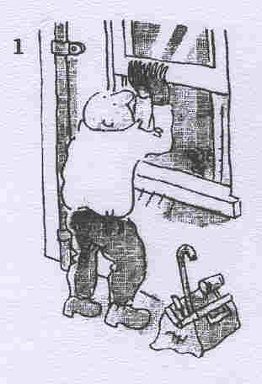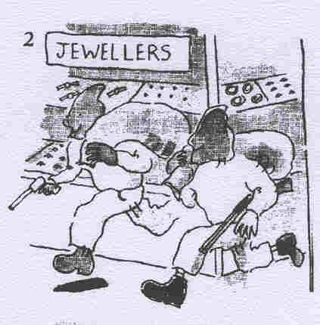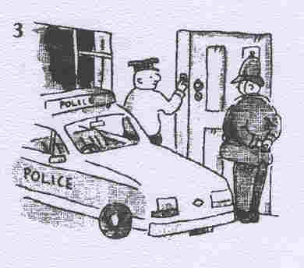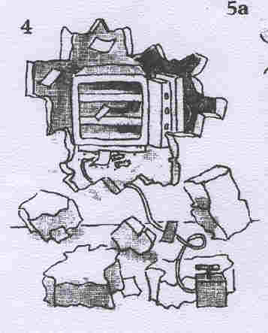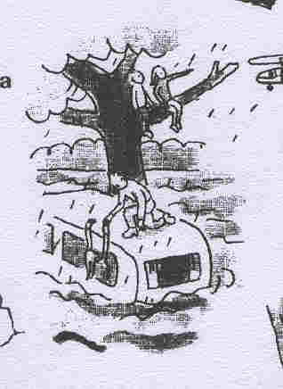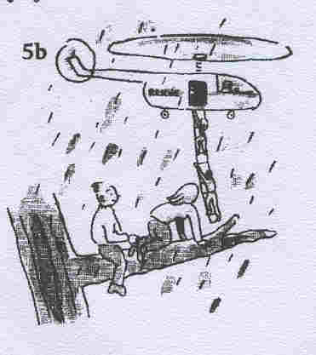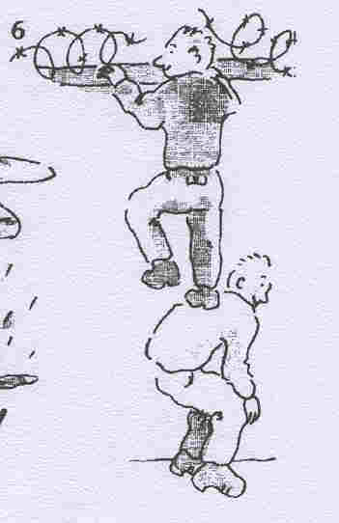

Love

- the eternal triangle = a situation of emotional conflict in which two men love the same woman, or two women love the same man
- an old flame = a former boyfriend or girlfriend, someone with whom you once had a romantic relationship
- a one-sided relationship = a relationship in which one of the two people feels and does much more than the other
- There’s no love lost between them = two people or groups who greatly dislike one another
- a love-hate relationship = a relationship in which there are strong feelings of both love and hate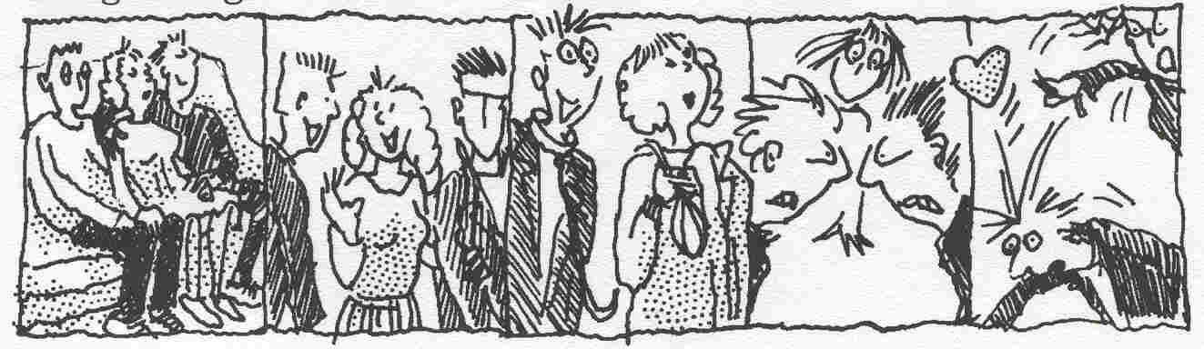

Your abilities

to be cut out for something = to have the right qualities and abilities for a job, to be naturally well suited for something. Note: We can say ‘I’m not cut out for teaching’ or ‘I’m not cut out to be a teacher’.
That’s the last straw! = an additional problem to an already difficult situation which makes it intolerable. As a result you take action (e.g. you complain, resign, lose your temper, etc.). The complete expression is ‘It’s the last straw that breaks the camel’s back’.
The world is one’s oyster. = you can do anything, go anywhere (because you’re young, successful and/or rich).

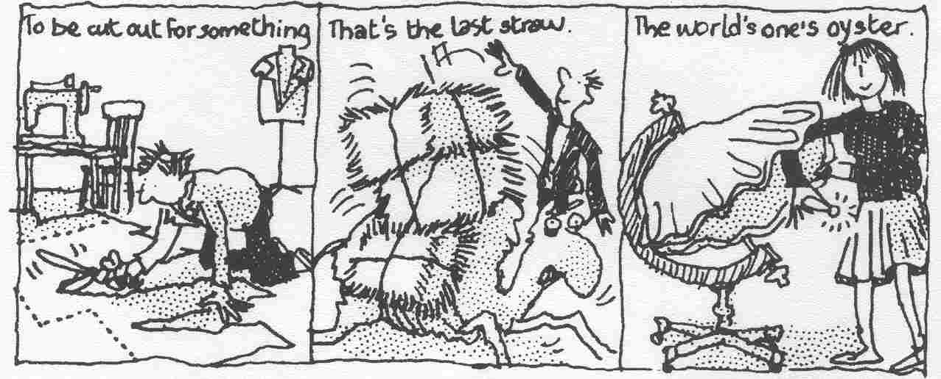

I had a narrow escape this morning. I was cycling to work when a lorry knocked me off my bike. The driver stopped and got out to see if I was all right. He was as white as a sheet and I was shaking like a leaf. Fortunately I had landed on some grass and I wasn’t hurt.
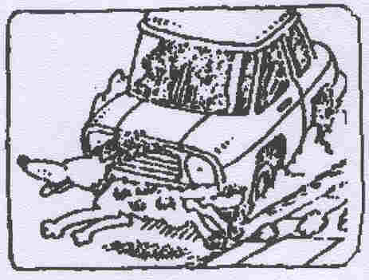
To have a narrow escape = to be very close to danger or something terrible but manage to escape
To be/go as white as a sheet = to be very pale in the face, especially because of illness or great fear
Shaking like a leaf = to tremble with fear or great anxiety


Now, I would like to give you some examples from my school textbooks “Hotline”.

Introduction Unit:
- to have got the message = to understand
Unit 2:
- We’d better be off = it’s time to come out
Unit 3:
- The sky’s the limit = you haven’t got any limits to improve yourself

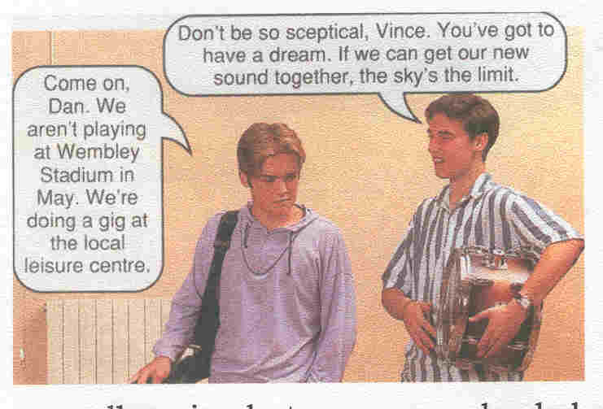
Unit 5:
- That’s beside the point = it doesn’t concern the matter
Kim I think we should all think about the environment. That’s why I’m buying a car with a small engine hat runs on unleaded petrol.
Vince Huh! It’s all that you can afford. You’d buy that gas-guzzler, too, if you had the money.
Kim That’s beside the point!
Unit 7:
- I’ve made up my mind = to decide to do something, to be going to do
- to get one’s hand on somebody = to interfere in somebody’s business

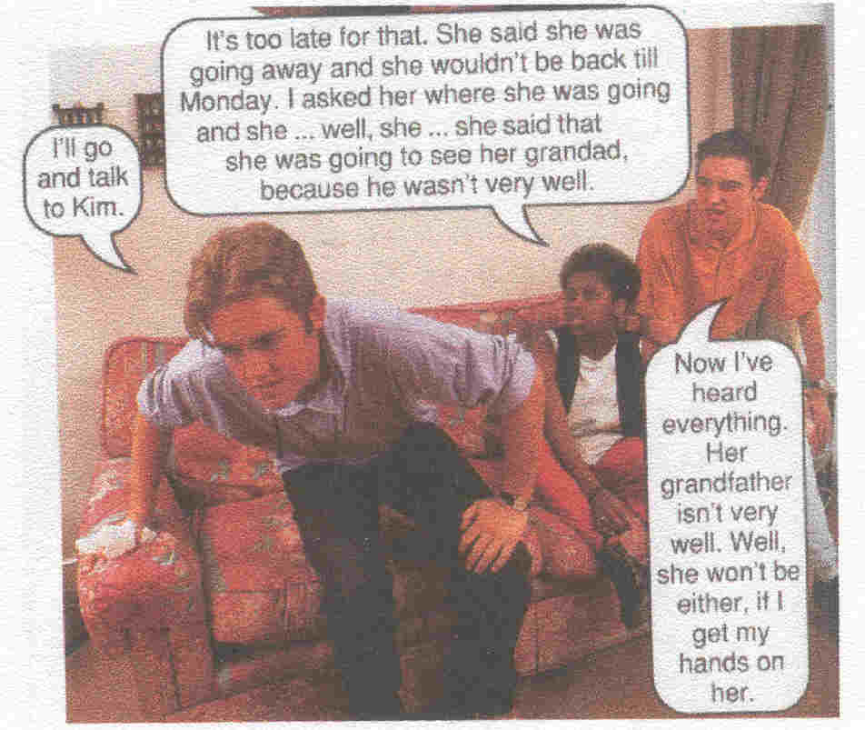
Unit 10:
- to lose one’s temper = to lose one’s head/wits, to blow up
- to want a word with somebody = to want to talk with somebody
- a write-off (car) = completely destroyed
Rosy If Kim hadn’t been driving so fast, she wouldn’t have had an accident. She might lose her licence. The car’s a write-off.

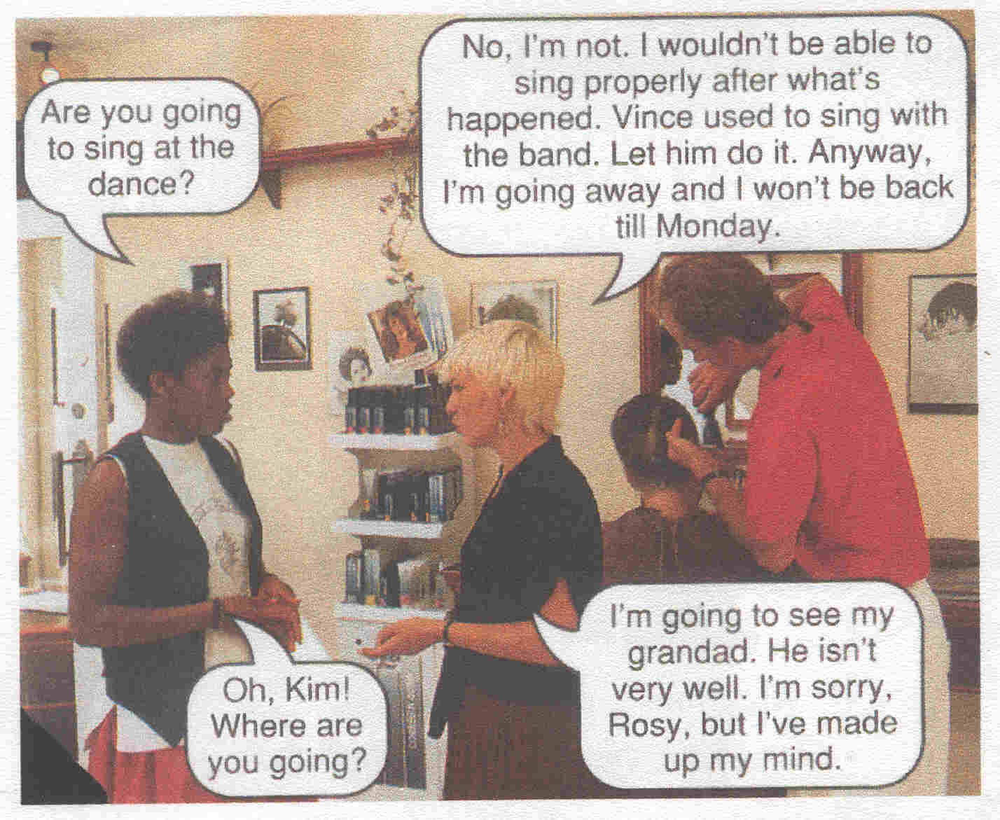
Unit 11:
- to have a real heart-to-heart with (someone) = to have a friendly conversation
- That’s all water under the bridge = to forget everything (esp., bad things) which were in the past
Kim I had a real heart-to-heart with Andrea when she came. So that’s all water under the bridge now. Mind you, Vince hasn’t said anything about it!
You see: one of the characters, Kim, has used not one, but two idiomatic expressions in the conversation.

Thus, you see that my classmates and I meet and use in our every day speech idioms. The authors of this textbook understand the necessity of using idioms fluently. Well, they give us a lot of idioms, but, of course, I can’t write down all of them, so, I’ve chosen the most interesting.

SPEAKING NOT VERY STRICTLY,
or

Mastering the English of everyday life

I. For the colloquial expression or the idiom given in the first line choose its definition (the standard English equivalent) from the two choices (a or b).
II. If in doubt, try to get the clue to the meaning of an idiom from the example sentences.
III. Only after that see for the correct answers. They are given at the bottom.
- That's the way to go!
or Way to go! a) Nicely done!
b) Go away! Get lost!

That's the way to go! You did it, pal!
Way to go, Bob! Everything's been fine!
- What's the good word? a) It can't be that bad! Is there any solution?
b) Hello, how are you?

Morning, Jane! What's the good word?
Long time no see, boys! What's the good word?
- My foot! a) I can't wait! Hurry up!
b) I do not believe it!

You are the best in the team, my foot!
She is going to marry you? My foot!
- That's the ticket! a) That's exactly what is needed!
b) That's the heart of the problem!

Good! That's the ticket! Now you don't have to worry.
That's the ticket! Perfect! Go ahead!
- Nothing to it! a) It's so easy!
b) Nothing doing! No way to settle the matter!

Look, anybody can do it! Nothing to it!
Operating fax machine is easy. Nothing to it!
- That does it! a) Well done, that's the solution!
b) That's the end! That is too much!

Okay! That does it! I can't take it any more. Out you go!
Stop it! That does it! I'm leaving.
- Bully for you! a) Shame on you!
b) Very good for you!

You managed it, somehow! Bully for you!
You are the winner. Bully for you!
- Don't sweat it! a) Say it as it is, don't make things look better than they are.
b) Don't worry about it!

No problem! Don't sweat it!
Don't sweat it! We'll see to the problem.
- Nuts to you! a) Stop it! Go away!
b) That's great of you!

Oh, nuts to you! You are just plain rude!
Nuts to you! I will not give you the thing.
- Shake it (up)! a) Hurry! Move faster!
b) Take it easy and forget it.

We gotta be there in ten minutes. Shake it!
Get going, guys. Shake it up!
Answers:
1-a; 2-b; 3-b; 4-a; 5-a; 6-b; 7-b; 8-b; 9-a; 10-a;

You have just read my research work. I hope you were interested in it. As for me, it was difficult, but very interesting, amazing work, and I am happy that I've attained all my tasks and aims.
May be, you’ll ask me why I've chosen exactly this topic, and 111 answer you that I'm very interested in the English language. To my mind, it's very enjoyable to discover new things about the language. It's the way to improve your own language and knowledge.
So, researching the history of American idioms I've known that many authors call attention to the fact that idioms can more easily than other language units cumulate and store facts about the past, cultural semantics of a nation, traditions, folklore, etc. because of the so called "cumulative" function of the language. When I've read it I've tried to prove or disprove this affirmation, so, I've run through a great number of different books and came to some conclusions, which were expressed in my work.
In my work I've composed small stories trying to apply the received knowledge about idioms in practice.
I've illustrated some idioms with my pictures and drawings for the best understanding. Of course, I've done it according to my own understanding of some of the most difficult idiomatic expressions.
Moreover, I've analyzed my school textbooks and made my comments on some idioms, which we've touched upon at the lessons.
I've also appended a lot of exercises and examples how to understand idioms and use them in practice.
Well, all my aims have been achieved and I hope my work will be a good stream for teachers and students in their work with idioms. I think my classmates should precisely understand that using idioms in daily speech isn't foppery or tribute to a style of the end of XX century. On the contrary, understanding and using idioms testifies about/high level of your English language.

- Baranov A. N., Dobrovol'skiy D. O. Idiomati^nost' i
idiomi // Voprosi azikoznania, No 5, cc. 51 - 64
- Burstin, D. Amerikanci: Nacional'niy opit. M:
Progress, Litera, 1993
- Vereschagin E. M., Kostomarov V.G. Nacional'no-
kul'turnaa semantika russkih frazeologizmov// Slovari i
lingvostranovedenie. M: Russkiy azik - 1982, ss. 89 - 98
- Billington, R. A. America's Frontier Heritage.
Albuquerque: University of New Mexico Press, 1991
- Flexner, S.B. Listening to America. New York: Simon
and Schuster, 1982
- Goodale, M. Collins COBUILD Idioms Workbook.
London: Harper Collins Publishers, 1995
- Ickstadt, H. Teaching American Studies Abroard: the
European Experience. In U.S. Society & Values. Electronic
Journals of the U.S. Information Agency, 1996, vol. 1, No 15,
pp 11- 15
- Mechling, J., Meredith, R., Wilson, D. American
Culture Studies: The Discipline and the Curriculum. In
American Quarterly, vol. XXV, No 4, October, 1973, pp. 363 -
389
- (A)People and A Nation: A History of the United
States. Boston: Houghton Mifflin Company, 1990
- Schlissel, L. The Frontier Family: Dislocation and the
American Experience. In Making America. The Society and
Culture of the UNITED STATES. Washington, D.C. United
States Information Agency, 1988, pp 81 - 90
- Stephens, J. F. American Studies in the United
States. In U.S. Society & Values. Electronic Journals of the
U.S. Information Agency, 1996, vol. l,Nol5, pp5-10
- Workman, G. Phrasal verbs and idioms, 1996
- Hutchinson, T. Hotline, Oxford University Press, 1995
- English and American newspapers
- Internet

Semantics - the historical and psychological study and the classification of changes in the signification of words or forms viewed as factors in linguistic development
Diachrony - change extending through time
Etymology - the history of a linguistic form (as a word) shown by tracing its development since its earliest recorded occurrence in the language where it is found, by tracing its transmission from one language to another, by analyzing it into its component parts, by identifying its cognates in other languages, or by tracing it and its cognates to a common ancestral language.
Frontier - a region that forms the margin of
settled or developed territory
Facet - any. of the definable aspects that make up a subject (as of contemplation) or an object (as of consideration)
Metaphor - a figure of speech in which a word or phrase literally denoting one kind of object or idea is used in place of another to suggest a likeness or analogy between them
Mentality - mental power or capacity
Dull - lacking rest or vivacity
High-flown - having an excessively embellished or
inflated character
Stylistics - an aspect of literary study that
emphasizes the analysis of various element of style (as
metaphor and diction); the study of the devices in a
language that produce expressive value
Arbitrary - based on or determined by individual preference or convenience rather than by necessity or the intrinsic nature of something
Alter - to make different without changing into something else
Devastate - to bring to ruin or desolation by
violent action; to reduce to chaos, disorder or
helplessness
Foppery - foolish character or action
Appropriate - especially suitable or compatible
Peculiar - different from the usual or normal
Cumulate - to gather or pile in a heap; to combine into one

The amazing world of
idiomatic expressions
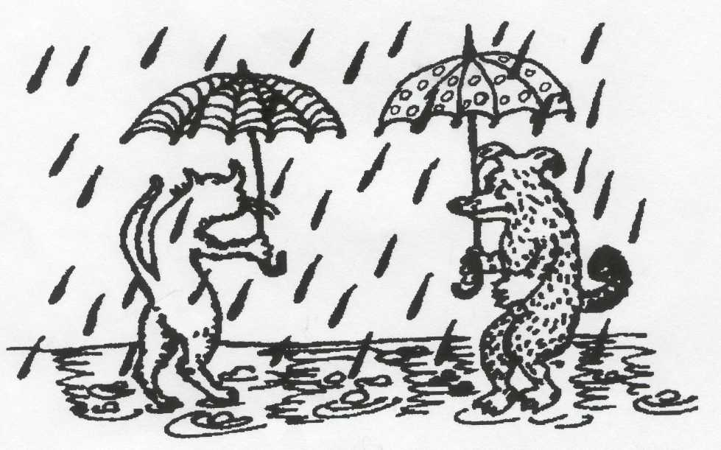

Completed by:
Chubina Valeria
School №12, 11 "A"
Headmaster:
Markova G. P.

Norilsk, 2005

My research work is about amazing world of idiomatic expressions. Firstly, I'd like to tell you that any language has a lot of idioms. Idiomatic expressions are a vital component of English in particular. They reflect mentality and culture of the people, speaking this language. If we compare English and Russian language, we will also find out a great number of idioms, like "has remained with a nose", "to sit in a pool" or "ate a dog" and so on in Russian language.
All over the world free using idioms in speech is a difficult problem for people, learning English language as a foreign one. Idioms often cause serious difficulties even with people, who know English very well. And if they intentionally avoid using idioms, in this case their oral and written speech, most likely, will be dull and high-flown.
So, an idiom is a phrase or expression that has a meaning
different from what the words suggest in their usual meaning.
English and American idioms are very different. Such American phrase as to put one's foot into it, meaning to make a public offence, in British English is passed by phrase to drop a brick, which won't be clear for the majority of the people, living in USA.
Studying idioms many authors call attention to the fact that they can more easily than other language units cumulate and store facts about the past, cultural semantics of a nation, traditions, customs, folklore, etc. because of the so called "cumulative" function of a language. The element, which renders the information, is called "national-cultural component".
There are two diachronically distinct types of idioms: those inherited from British English but which changed some components (one or two words) on the American soil, those the prototypes of which appeared on the American soil.
The first type: British English - Not see the wood for the trees; American English - not see the forest for the trees.
The second type is more numerous. These idioms reflect a great number of different themes. They are about the way of life on
The history of idioms began in 17th century, but I'd like to tell you about idioms of 18th century.
It refers to the idiom "have an axe to grind", the idiomatic meaning of which is "to have a personal, often selfish, reason for being involved in something: I have no axe to grind - I just want to help you." The etymology of this idiom presents a great interest. It represents a story as it is believed, told by Benjamin Franklin (1706-1790), American statesman, diplomat, author, scientist, and inventor, about a man who "had once asked him to demonstrate how his father's grindstone worked - and had then produced an axe which he wanted to sharpen".
And now I'd like to present you an idiom of 20th century.
It was time of Al Capone from Chicago, period of organized crime. "Give (someone) the works" metaphorically means "to give someone the
full treatment: They've certainly given her the works at the hairdresser's - she's had her hair cut, tinted and permed." The prototype meant, "to kill someone".
To sum up, I would like to underline that American studies perspective enabled to find cultural elements in idioms which store the information about historic events, ethnographic details, ways of life of different periods in the history of the U.S.A.
Now I'd like to give you some examples of American idioms.
Rain cats and dogs = to rain very heavily.
For example: The children should take their raincoats, umbrellas and boots because it's raining cats and dogs.
(to) Blow (toot) one's own horn
DEFINITION: To praise oneself; to call attention to one's skill, intelligence, or success; to boast.
ILLUSTRATIVE SENTENCES:
• Poor Charlie! He's always tooting his own horn about how good he is at golf. (Paraphrase: He’s always praising his own skill at golf.)
My own example of using American idioms in our speech:
There were two unemployed men. They both wanted to receive the
same job as journalists in one company, so, they had to write an essay
and present it. Jim was working for a whole week very hard, but
Jeffrey didn't want to do anything, he thought how to get a ready
made. Suddenly, he had a brainstorm: he decided to steal it. That day
was raining cats and dogs. He came to see Jim due to bad weather
explaining his visit with absence of the umbrella, and his desire to
wait for the clearness in the sky. Jim fell for it hook, line and sinker.
While he was in the kitchen, Jeffrey noticed the ready made essay and
put it into his bag. The next morning Jeffrey brought the essay to the
editor who promised to publish it. Of course, Jim recognized his work
from the article in the newspaper, but he couldn't prove that that was
his. Fortunately, the big frog of that town buttered in and Jeffrey paid the piper for his crime, and the job of a journalist was received by Jim. It was fair. So, crime doesn*t pay.
I've just written about American idioms and what about English? I could find a lot of them, but I'll give examples only about some of them which I consider the most interesting and I'd recommend my classmates to use them working with British literature classes, making analyses of different creative works and writing project tasks. Moreover, almost all of these drawings were made by me.
a chicken and egg situation =_This is an informal expression, which describes a situation or problem in which it is impossible to decide which of two things was the cause of the other. For example: The connection between lack of education and poverty is a chicken and egg situation. Are people poor because they have no education or do they not get an education because they are poor?
The expression comes from the idea of a chicken and its egg. Does the egg come from the chicken or the chicken from the egg?
bread and butter = When we use the idiom "bread and butter" we mean someone's livelihood or income. For example: I don't especially like doing this job, but it's my bread and butter.
Idiomatic expressions are a vital component of English in particular. The common idioms will increase our understanding, though most of us instinctively avoid trying to use them and I suggest a variety of exercise practice in recognition and production of idioms. In my work I offer you some idioms around themes such as health, school, accommodation, family relationship, everyday life. I've selected them according to my point of view and my understanding but I hope it will be a good stream for teachers and students. But now I'd like to give you some idioms about school.
The other students passed with flying colours.
The written exam was difficult, but the oral exam was a peace of .
It will be easier if we work on this exercise together. Two heads are better than one.
Her teacher told her that if she wanted to catch up with the rest of the class and pass her exams, she would have to burn the midnight oil for several weeks.
- To pass with flying colours = to pass an exam with high marks
- A peace of cake = something that is very easy to do (informal)
- Two heads are better than one = More ideas or solutions will be
produced if you work with someone else rather than on your
own.
- To burn the midnight oil = to work or study late into the night
Now, I would like to give you some examples from my school textbooks "Hotline".
* to have got the message = to understand
* The sky's the limit = you haven't got any limits to improve yourself
Well, in conclusion Id like to tell you that people, who improving in English language, should precisely understand that using idioms in daily intercourse isn't foppery or tribute to a style of the end of XX century. On the contrary, understanding and right using idioms testifies about high level of possession of English language.


