LESSON: Unit 6  Traditions and folklore:  Happy birthday |  |  |  | School: Raisovka secondary school
Date: |  |  |  | Teacher`s name: Dzhangashkarova G.T.
CLASS: 1 |  |  |  | Number present: | absent:
Learning objectives(s) that this lesson is contributing to |  |  | 1.S1 make basic personal statements and simple statements about objects  1.S6 exchange simple greetings and use the words: please, sorry and thank you  1.L1 recognize short instructions for basic classroom routines spoken slowly and distinctly  1 R3 recognize some very high frequency words from their immediate environment  1 W2 form some lower case letters of regular size and shape
Lesson objectives |  |  | All learners will be able to:
- say numerals intelligibly
- say names of some birthday items intelligibly
- produce some approval/disapproval sounds
- understand some factual questions about their age
 |  |  | Most learners will be able to:
- use some short form answers correctly
- respond to some questions about their birthday correctly
- say all the names of birthday items intelligibly with support
 |  |  | Some learners will be able to:
- produce words of birthday presents and narrate to the class
- use present simple forms correctly in narration
- give some information about themselves using covered grammatical structures correctly
Previous learning |  |  | plural ‘s’ forms, personal pronoun I am, numbers 1-10
Plan
Planned timings | Planned activities (replace the notes below with your planned activities) |  |  |  |  | Resources
Beginning | ORGANIZATIONAL MOMENT  Дети стоят в ряд у доски.  Teacher: Good morning, boys and girls!  Pupils: Good morning, Good morning ,  Good morning to you!  Good morning , Good morning.  We are glad to see you!  How do you think what is the theme of our lesson?  Pupils: Birthday!  Teacher: Yes, Today we are celebrating a Birthday Party. Be active and I`ll give you stars.  Look! This is our guest.    He is a Winnie the Pooh.  Repeat after me: Winnie the Pooh.  Please meet him!  Winnie the Pooh: Good morning children!  Pupils: Good morning!  Teacher: А знаете, Винни очень хочет выучить казахский язык. А ну-ка давайте поздороваемся с ним на казахском языке.  Winnie the Pooh: How are you, pupils?  Pupils: OK  Teacher: Let’s sing a song “ Good morning” and move!    Teacher: Would you like to ask Winnie the Pooh questions?  Children: -How are you?  Winnie the Pooh: I am fine, thank you!  Children: What’s your name?  Winnie the Pooh: My name is Winnie.  Winnie the Pooh: What’s your name?  P1: My name is…  Winnie the Pooh: Nice to meet you! |  |  |  |  | A teddy bear  Winnie the Pooh  https://www.youtube. com/watch?v= U9Q7Y3t4m3g  Кто задает вопрос или правильно отвечает тому звездочка.  Speaking
Middle | Teacher: Take your sits, please.  Ok, let`see the interesting film.  Как вы, думаете, о чем этот мультфильм?  P1:…  Повторите, пожалуйста:  -How old you?  - I am 7.  А давайте сами придумаем мультфильм.  Учитель раздает карточки с названиями цвета. Встаньте в ряд у кого слова написаны на английском языке.  Red- красный қызыл  Blue- синий көк  Green- зеленый жасыл  Yellow-желтый сары  Pink- розовый қызғылт  Винни очень интересно как эти цвета звучат на казахском языке.  Дети называют цвета на казахском языке.  Разделимся на пары и выберем себе героев.  Take your sits, please and make a dialogue.  Вам необходимо поздороваться друг с другом, спросить о возрасте и попрощаться.  А другие ребята вас будут слушать и оценивать.  Если все верно мы вам будем хлопать! и вы получите по звездочке.  P1 Hello!  P2Hello!  P1. How old are you? – p 2. I am 7.  P2. How old are you? – p 1. I am 7.  P1 Good-bye!  P2 Gоod- bye!  Teacher: Very good!  Look at the pictures and ask a new question.  Children: How old are you? – I am 5.  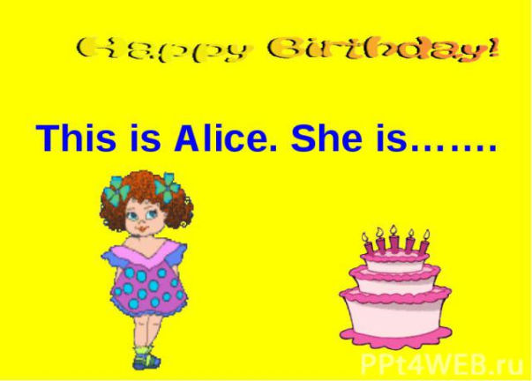  Children: How old are you? – I am 8.  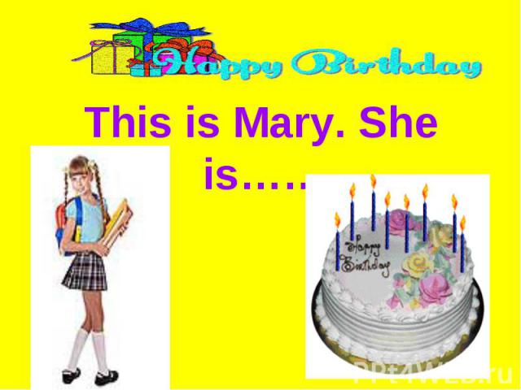  Children: How old are you? – I am 7.  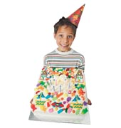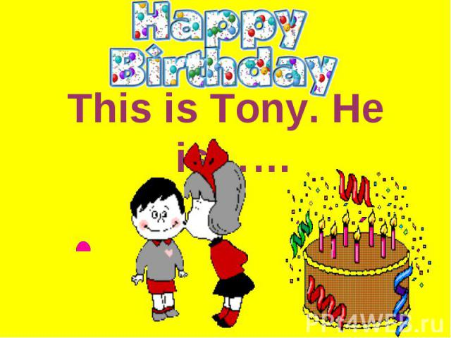  Children: How old are you? – I am 1.  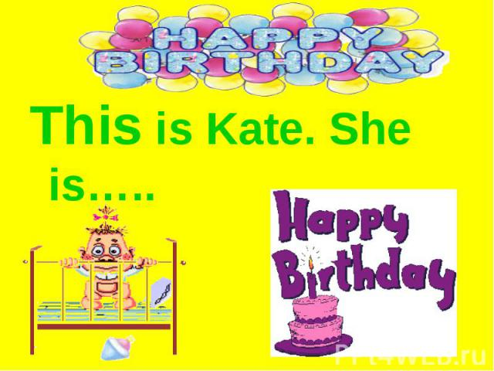  INTRODUCTION OF NEW VOCABULARY  Teacher: Winnie! And how old are you?  Winnie the Pooh: I'm 7. It's my birthday today.  Children: Happy birthday!!!  Teacher: Look! I have a "Surprise Box"!    Come to the board one by one and get objects from the box.  Teacher: Repeat after me three times!  CAKE!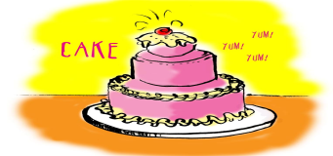  CANDLES!   BALLOONS!   PRESENTS!  CARDS! 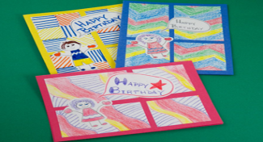  HAT!   Party 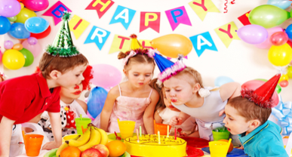  Now let`s practice the NEW WORDS  Смотрят презентацию.  Называют слова.  Are you tired? Let`s play!  Я буду показывать вам слова, а вы должны их отгадать и назвать на казахском языке. А Винни- Пух будет поднимать лапу вверх, если вы верно справитесь.  Balloons - шарлар  Cards- ашықхаттар  Cake - торт  Presents- сыйлықтар  Hat - қалпақ  Candles- шырақтар  Party- той  Учитель показывает слова, а дети отгадывают.  Угаданные слова вешаем на доску.  Game “ Hands up, hands down”  Teacher:  Stand up!  Hands down! Hands up!  Is it little? Is it big?  What is it?  READING ASSESSMENT  Teacher: Well done. And, now, can you help me to underwrite these pictures? Look at my words, read them and match words and pictures.  Balloons Cards  Cake Presents  Hat Candles  Party  LISTENING  Teacher: Listen to and watch a story about Gogo. Answer the questions:  1. How old is Tony?  2. How old is Gogo?  3. How old is Jane?  4. What present did Tony get?  Поднимите руку у кого все, верно, получите звездочку.  А теперь, ребята, поделимся на две группы, посмотрите за стульчиком спряталась картинка. У нас получится две команды:  Cats and dogs.  - Group work.  - Task  Teacher: Let’s make a birthday card for Winnie.  Teacher gives instructions about making and decorating the card for learners to follow e.g.:  - Draw a cake on the card.  - Draw 7 candles.  - Colour the cake red and yellow  - Draw 1 green and 2 blue, 3 orange, 4 pink, balloons.  That's a good job!  2.Task  Teacher: I see you have nice presents for  Winnie the Pooh. He wants to study at school and your presents are very useful for him. There are school things. По очереди выходим и говорим, что у вас есть для Винни.  I have got a…  - Book  - pen  - pencil  - ruler  - school-bag  - rubber  - copy-book  - pencil-case  - desk  - board  I have got a…  Now you make Individual work.  Match the images with the appropriate words.  Давайте проверим, как вы выполнили эту работу. |  |  |  |  | https://www.youtube. com/watch?v= huQSbAff8xQ  Выходят делятся на пары.  трехязычие  за правильный диалог звездочка.  За правильный вопрос-ответ звездочка.  Взаимооценивание  РРТ  Box with objects:  cake, balloons, candles, cards, presents,  birthday hats  РРТ  За правильный ответ -звездочка  Отвечают хором.  READING  За правильный ответ звездочка  LISTENING  За правильный ответ звездочка  Gogo  https://www.youtube. com/watch?v= EkpmtaUlaVQ  За правильный вопрос-ответ звездочка  Взаимооценивание  За правильный вопрос-ответ звездочка  Formative assessment task  Вывести слайд  на экран.
End | Раздать колпачки на правую руку.  Teacher: Let’s sing a song “Happy birthday!” to Winnie  Teacher: Our Winnie is in a hurry. Tell him Good-bye. Сау бол!  Children: Bye! Good-bye, Winnie!  REFLECTION  9-10 stars –a red flower – I can do this  8-7 stars – a blue flower – I am getting there  6-5 stars –a orange flower – I need help  During the lesson you evaluate your work yourself. Now let`s discuss our results. |  |  |  |  | Колпачки  Цветы.

\

