# Summative assessment for the cross curricular unit

# «Kazakhstan in the World of Sport»

|  |  |
| --- | --- |
| **Learning objectives** | 4.1.6.1 understand some specific information and detail of short, supported talk on an increasing range of general and some curricular topics  4.2.1.1 make basic statements which provide information on an increasing range of general and some curricular topics |
| **Assessment criteria** | • Identify some specific information in a talk with support  • Give information using basic statements |
| **Level of thinking skills** | Knowledge and comprehension  Application |
| **Duration** | 20 minutes |

**Listening (10min)**

**Task 1.** Listen and mark the statement True or False. You will listen twice.

*Go to this link to listen* [*https://youtu.be/-89LoqnHv_U*](https://youtu.be/-89LoqnHv_U)

1. There lived many mice in a baker’s shop ______________

2. The baker bought a fat cat to catch the mice ______________

3. The mice were scared ______________

4. One mouse suggested to tie a bell around the cat’s neck ______________

5. Everybodyagreed to this decision

**Speaking (10min)**

**Task 2.** Look at the pictures, choose **ONE** and answer the questions.

1. What game are the children playing?

2. How do you usually play the game?

3. What do you need to play the game?

4. Is it a team sport or an individual sport?

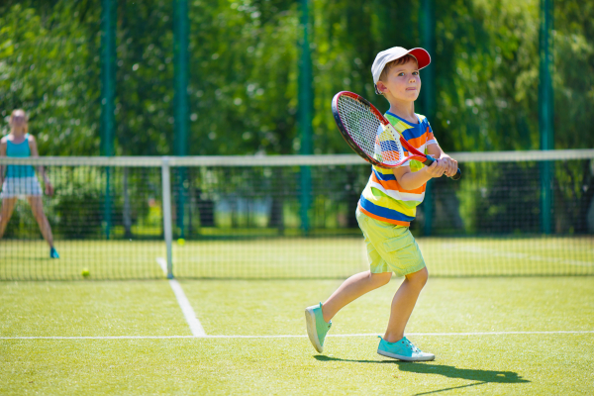 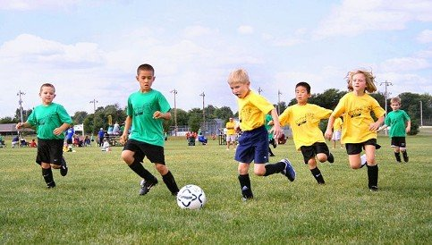

# <https://goo-gl.ru/fHq7k> <https://goo-gl.ru/Wl2M4>

|  |  |  |  |  |
| --- | --- | --- | --- | --- |
| **Assessment criteria** | **Task** | **Descriptor** | **Mark** | **Additional information** |
| *A learner* |  |
| Identify some specific information in a talk with support | 1 | 1. writes “False” | 1 |  |
| 2. writes “False” | 1 |
| 3. writes “True” | 1 |
| 4. writes “True” | 1 |
| 5. writes “False” | 1 |
| Give information using basic statements | 2 | |  |  |  | | --- | --- | --- | | *Possible answers:*  I can see the boy is playing tennis/ children are playing football |  | 1 point is given for the correct answer | | 1 | Ot answers are also acceptable if they answer the question. 1 point for each grammatically correct answer. |
| I usually play chess/ play video games/ play hopscotch | 1 |
| I need a ball to play football/ a racket to play tennis | 1 |
| It’s a team sport/ It is an individual sport | 1 |
| **Total marks** | | | **9** |  |

*Transcript for listening task*

# Belling The Cat

There lived many mice in a grocer’s shop, which ate plenty of food, and the grocer suffered very much. So, he brought a fat cat to catch the mice. The mice were worried. They held a meeting to send away the cat.

One mouse said to tie a bell around the cat’s neck because the cat moved softly and swiftly. So that when the cat moves, the mice would become aware of the cat. All the mice agreed to this decision.

The old mouse asked, “Can you tell me who is to bell the cat?” There was no reply.